Cowpens National Battlefield

338 New Pleasant Road
Gaffney, SC 29341

864-461-2828 Phone
864-461-7077 Fax
www.nps.gov/cowp
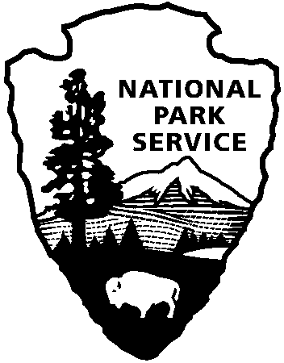
National Park Service
U.S. Department of the Interior

Cowpens National Battlefield News Release

Release Date: April 2, 2016
Contact: Margo Blewett (864) 461-2828, margo_blewett@nps.gov

Oh My Stars: Night Sky Program at Cowpens National Battlefield

GAFFNEY, SC – Cowpens National Battlefield will host a Night Sky Program on Saturday, April 16, 2016 from 8:00 pm – 10:30 pm, with the best visibility beginning about 9:30. The Carolina Skygazers Astronomy club will have various sized telescopes available for visitors to see Saturn and Jupiter and other heavenly bodies. As they set up their telescopes, club members will be available to talk to visitors about how colonial people used stars for navigation. Visitors can also learn about lightscapes and the effects of light pollution on the night sky.

This program is heavily dependent upon having a clear sky, so please contact the park the day of the program to verify that it is still on schedule in case there is any cloud coverage in the forecast. The phone number for the park is (864) 461-2828. You may also contact Margo Blewett at margo_blewett@nps.gov for further information.

Cowpens National Battlefield is a unit of the Southern Campaign of the American Revolution Parks Group within the National Park Service. The group mission is to protect, preserve, and interpret the significance of the decisive battles where America earned its freedom. For more information about activities at Cowpens National Battlefield, call (864) 461-2828 or visit the park’s webpage at www.nps.gov/cowp/. Follow us on Twitter @CowpensNB. Like us on Facebook at www.facebook.com/CowpensNationalBattlefield.

www.nps.gov

About the National Park Service. More than 20,000 National Park Service employees care for America’s 410 national parks and work with communities across the nation to help preserve local history and create close-to-home recreational opportunities. Learn more at www.nps.gov.

