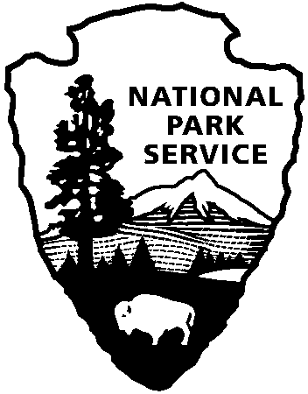
Cowpens National Battlefield
PO Box 308
Chesnee, SC 29323

864-461-2828
www.nps.gov/cowp/
National Park Service
U.S. Department of the Interior
National Park Service News Release

FOR IMMEDIATE RELEASE – DATE: February 2, 2012
CONTACT: John Slaughter, (864)-461-2828
Donna Davis, (864)-461-2828

Cowpens National Battlefield to Conduct a Prescribed Burn

CHESNEE, SOUTH CAROLINA: Cowpens National Battlefield is planning a 100-acre prescribed burn within the park loop road. Favorable weather and site conditions will determine the exact date of the burn, tentatively scheduled for February16. The burn will be cancelled if weather and site conditions become unsatisfactory. Although the Visitor Center will remain open from 9:00 am – 5:00 pm, other sections of the park may be closed for visitor safety on the day of the burn.

Area residents will be able to see the smoke. Small areas of smoke and flames may be visible for several days; however, this is not a cause for concern. The National Park Service will continue to monitor these areas until the fire is out.

“We’ve identified areas where a planned burn will help control non-native plant species and further our work to return the battlefield to its 1781 appearance. The National Park Service has to account for a lot of details in these burns,” said Superintendent John Slaughter. “We don’t just contain the fire, we plan for the direction the smoke will blow and the effect the burn will have on the experience of visitors traveling through the park. We also want to make certain that park neighbors aren’t alarmed when they see the smoke.”

The National Park Service’s Wildland Fire Module from Cumberland Gap National Historical Park will oversee the burn. They have extensive fire experience in the southeastern United States. If weather permits, the burn will begin in the late morning and continue into the late afternoon. In the event that someone needs to contact the park concerning the burn at 864-461-2828.
www.nps.gov

About the National Park Service. More than 20,000 National Park Service employees care for America’s 395 national parks and work with communities across the nation to help preserve local history and create close-to-home recreational opportunities. Learn more at www.nps.gov.

