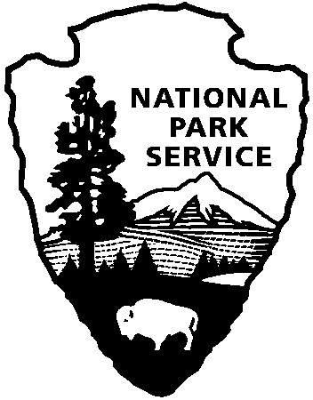 | National Park Service  U.S. Department of the Interior
National Park Service News Release

FOR IMMEDIATE RELEASE – DATE: February 25, 2014
CONTACT: Virginia Fowler 864-461-2828

Encampment, 18th Century Weapons Demonstrations, and Book Signing: Mid-March Events at Cowpens National Battlefield

The Upper Broad Regiment, a loyalist living history group, will give 18th century weapons firing demonstrations at 10:30, 11:30, 1:30, and 2:30 on March 15 and 16, and will answer visitors’ questions all day Saturday and until 3:00 on Sunday.

During the American Revolution, many southern backcountry settlers remained loyal to the British. Some had sentimental attachments to England, and others simply believed that rebelling against the authority of the king was morally wrong. When the regular American and British armies were not in the area, defending it fell to the various bands of both patriot and loyalist militia (volunteers). The Upper Broad Regiment will demonstrate the different ways that loyalists would have helped the British military.

Also, on Sunday, March 16, one day after the 233rd anniversary of the Battle of Guilford Courthouse, John Buchanan, author of The Road to Guilford Courthouse, will talk informally with visitors while signing copies of his book in the visitor center from 3:00 – 4:45. The Road to Guilford Courthouse discusses several Southern Campaign battles during a critical period of the American Revolution. It has been several years since Mr. Buchanan has visited Cowpens National Battlefield, and the park staff is excited to have him return.

All activities are free and open to the public.

Cowpens National Battlefield is the site of the American victory over the British on January 17, 1781 and is located 10 miles west of Gaffney, SC, and 3 miles east of Chesnee, SC at the intersection of Highways 11, 110, and 221-A. For more information about activities at Cowpens National Battlefield, call (864) 461-2828 or visit the park’s webpage at www.nps.gov/cowp/. Follow us on Twitter @CowpensNB. Like us on Facebook at www.facebook.com/CowpensNationalBattlefield.

www.nps.gov

About the National Park Service. More than 20,000 National Park Service employees care for America’s 401 national parks and work with communities across the nation to help preserve local history and create close-to-home recreational opportunities. Learn more at www.nps.gov.

