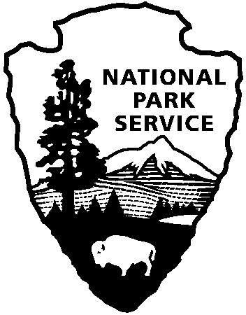 | National Park Service  U.S. Department of the Interior
National Park Service News Release

FOR IMMEDIATE RELEASE – DATE: May 28, 2016
CONTACT: Katherine Lynn 864-461-2828

Upcoming Events at Cowpens National Battlefield

Cowpens National Battlefield will hold several special “edu-tainment” events in June and July, all of which are free and open to the public. Visitors will have the opportunity on three (3) consecutive weekends to learn about the American Revolution and who fought it on June 4-5, June 11, and June 18, and the annual Celebration of Freedom will be on July 2.

On the weekend of June 4-5, members of the 1st Maryland – Southern Campaign reenacting unit, will present a living history weekend behind the Visitor Center. These reenactors, who portray Maryland Continental Soldiers during the Southern Campaign of the American Revolution, will demonstrate how soldiers lived in the 18th century on both days. On Saturday only, they will demonstrate the artillery drill, and will give weapons firing demonstrations at 11:15, 1:45, and 3:15.

The following Saturday, June 11, the New Acquisition Militia, a group of living historians who portray life in the area of South Carolina that had previously been part of North Carolina, will demonstrate such things as re-caning a chair and the inner workings of a rifle throughout the day. They will also teach children the musket drill, using wooden dummy guns. At 2:30 Robert Ryals will discuss the battles and skirmishes leading up to the Battle of Cowpens and the role that the militia played, and the group will fire muskets and rifles at 10:30, 12:30, and 1:30.

The SC Rangers will be available to talk about military life in the 18th century and will give weapons firing demonstrations at 10:30, 12:30, 1:30, and 2:30 on June 18th. The SC Rangers portray the militia and ranging units on the frontier of the south from the 1740s-1780s.

Save the date for July 2, when the park will hold the annual Celebration of Freedom. The event will feature ranger-guided battlefield walks, weapons demonstrations by reenactors, and children’s activities. A schedule of events should be available by the end of June.

Cowpens National Battlefield is a unit of the Southern Campaign of the American Revolution Parks Group within the National Park Service. The group mission is to protect, preserve, and interpret the significance of the decisive battles where America earned its freedom. For more information about activities at Cowpens National Battlefield, call (864) 461-2828 or visit the park’s webpage at www.nps.gov/cowp/. Follow us on Twitter @CowpensNB. Like us on Facebook at www.facebook.com/CowpensNationalBattlefield.
www.nps.gov

About the National Park Service. More than 20,000 National Park Service employees care for America’s 409 national parks and work with communities across the nation to help preserve local history and create close-to-home recreational opportunities. Learn more at www.nps.gov.

