Cowpens National Battlefield
338 New Pleasant Road
Gaffney, SC 29341

(864) 461-2828 phone
www.nps.gov/cowp/
Cowpens National Battlefield News Release

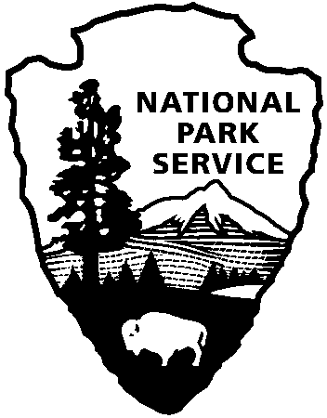
National Park Service
U.S. Department of the Interior

Release Date: August 15, 2013
Contact: Virginia Fowler, (864) 461-2828, Virginia_Fowler@nps.gov

Cowpens National Battlefield Celebrates National Park Service Founding with Encampment and Firing Demonstrations
On August 25, 1916, President Woodrow Wilson created “America’s Best Idea” when he signed the National Park Service into legislation. In honor of the 97th anniversary of Founders Day, on August 24 - 25, Cowpens National Battlefield will host a free weekend encampment of the Upper Broad Regiment, a group of Revolutionary War loyalist reenactors.
In addition to the weekend encampment, on Saturday, August 24, the park will have 18th century weapons firing demonstrations at 9:30, 11:30, 1:30, and 2:30. On both Saturday and Sunday, Park Rangers will offer a 15-minute talk about the Green River Road at 10:30, a guided battlefield walk at 12:30, and a non-firing cannon demonstration at 3:30.
During the American Revolution, many southern backcountry settlers remained loyal to the British. Many had sentimental attachments to England, and others simply believed that rebelling against the authority of the king was morally wrong. At the time of the Battle of Cowpens, Brigadier General Daniel Morgan had been ordered to the Ninety Six District of South Carolina (the backcountry) to bolster patriot support, and Lieutenant Colonel Banastre Tarleton had been ordered to stop Morgan’s treasonous activity.
The Upper Broad Regiment plans to portray a cattle drover, a hunter/trapper, a doctor, an herbalist, and a loyalist officer disguised as a Cherokee. They will show what life was like for typical backcountry settlers in the period leading up to the Battle of Cowpens.
On the same weekend (August 24-25) at Walnut Grove Plantation, the South Carolina Rangers, a patriot Revolutionary War reenactor unit, will drill, fire their weapons, demonstrate military survival techniques and discuss the militia’s importance during the American Revolution. Walnut Grove Plantation is located at 1200 Otts Shoals Road, Roebuck, SC 29376. For more information, visit their webpage at http://www.spartanburghistory.org/index.php.
The staffs of Cowpens National Battlefield and the Spartanburg Historical Association invite you to visit both sites to get both the loyalist and the patriot perspectives of the Revolutionary War in the backcountry. Additionally, both sites, along with Kings Mountain National Military Park, will hold the Upstate Revolutionary War Weekend, a joint event at their respective sites, on the weekend of October 4 - 7. For more information on the Upstate Revolutionary War Weekend, go to www.RevWarWeekend.com.
Cowpens National Battlefield is located 10 miles west of Gaffney, SC, and 3 miles east of Chesnee, SC at the intersection of Highways 11, 110, and 221-A. Normal Visitor Center hours are 9:00 a.m. – 5:00 p.m. daily, closed on Thanksgiving, Christmas, and New Years Day. For more information about Cowpens National Battlefield or the Upper Broad Regiment encampment, call (864) 461-2828, or visit the Cowpens National Battlefield webpage at http://www.nps.gov/cowp/.
www.nps.gov
About the National Park Service: More than 20,000 National Park Service employees care for America’s 401 national parks.

