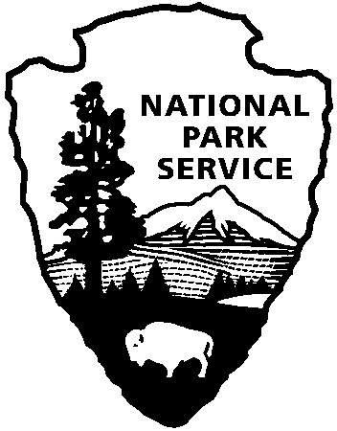 | National Park Service  U.S. Department of the Interior
Cowpens National Battlefield News Release

FOR IMMEDIATE RELEASE – DATE: January 5, 2017
CONTACT: Katherine Lynn 864-461-2828

Cowpens National Battlefield Celebrates 236th Battle Anniversary January 13 – 21, 2017

To celebrate the 236th anniversary of the decisive American victory over the British, Cowpens National Battlefield will celebrate special events from January 13 - 21, 2017.

The commemoration will begin with the Sons, Daughters, and Children of the American Revolution laying flowers at the Daniel Morgan Monument in Spartanburg at 2:30 pm on Friday, January 13.

At 7:00 pm that evening will be a free, family-friendly program in the Barrett Room of the Spartanburg County Library Headquarters on South Church Street in Spartanburg. Cowpens National Battlefield is proud to partner with the Greenville Chautauqua, the Spartanburg County Library System, and the Sons of the American Revolution to present Ken Johnson portraying Lieutenant Colonel Banastre Tarleton, British commander at the Battle of Cowpens.

Throughout the day on Saturday and Sunday, January 14 and 15, the park will host free activities including a wreath-laying, 18th century weapons firing and cavalry demonstrations, ranger-led battlefield walks, and author and historian talks.

On January 14, the park will continue the annual Saturday evening lantern tours. This year, however, instead of presenting what might have happened the night before the battle of Cowpens, reenactors will interpret scenes that took place immediately after the battle through the pre-dawn hours of the following day. Each stop will be based on primary sources or supporting documents. Although this program is free, reservations are required. Please make reservations for a lantern tour by calling 864-461-2828. Tours begin at 6:00 pm at the Visitor Center, will depart every 15 minutes, and are limited to 50 people each.

In addition, visitors can experience what it was like for Morgan’s “Flying Army” to arrive at the Cow Pens by registering for Morgan’s Victory March. The 25-mile walk/ride retraces the route that Daniel Morgan’s men took to the Cow Pens, a well-known landmark in 1781. Participants will march to the park visitor center, arriving on Sunday afternoon at 1:30. For more information about Morgan’s Victory March, call the Cherokee Historical and Preservation Society (CHAPS) at 864-489-3988. Marchers should register at http://www.cherokeecountyhistory.org/upcoming-events.html.

The commemoration will end with the Race for the Grasshopper on Saturday, January 21. For over thirty years, Cowpens National Battlefield has worked with the Spartanburg Running Club to honor the race to capture the two British “grasshopper” cannons at the end of the Battle of Cowpens into an annual competitive 5k run/walk and a 1-mile fun run. This year the fun run will begin at 8:30 am, and the 5k at 9:00.

Cowpens National Battlefield is a unit of the Southern Campaign of the American Revolution Parks Group within the National Park Service. The group mission is to protect, preserve, and interpret the significance of the decisive battles where America earned its freedom. For more information about activities at Cowpens National Battlefield, call (864) 461-2828 or visit the park’s webpage at www.nps.gov/cowp/. Follow us on Twitter @CowpensNB. Like us on Facebook at www.facebook.com/CowpensNationalBattlefield.
www.nps.gov

About the National Park Service. More than 20,000 National Park Service employees care for over 400 of America’s national parks and work with communities across the nation to help preserve local history and create close-to-home recreational opportunities. Learn more at www.nps.gov.

