338 New Pleasant Road
Gaffney, SC 29341

864-461-2828 Phone
864-461-7077
www.nps.gov/cowp
National Park Service
U.S. Department of the Interior
Cowpens National Battlefield
Cowpens National Battlefield

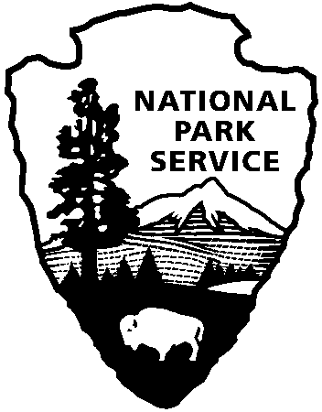

Release Date: March 13, 2017
Contact: John Slaughter, 864-461-2828

A Reason to Celebrate: Cowpens National Battlefield Welcomes Over 213,299 Visitors in 2016

Chesnee, SC – Cowpens National Battlefield recorded 213,299 visits in 2016, the National Park Service’s centennial year.
“The centennial celebration of the NPS brought increased visitation across the nation and the Southern Campaign of the American Revolution Parks Group fit right in with that trend,” said Superintendent John Slaughter. “Cowpens saw an increase of 3.2%, Kings Mountain visitation increased 2.4% but by far the greatest opportunity to increase awareness of the places where the Revolutionary War was won occurred at Ninety Six National Historic Site where the park realized a 47% increase at the gate to set a record at 118,002 visitors in 2016!"
To celebrate the 100th anniversary of the National Park Service’s founding in 2016, the service launched the Find Your Park/Encuentra Tu Parque campaign with the National Park Foundation to reach new audiences and highlight smaller National Park Service sites throughout the country. In addition, Cowpens National Battlefield participated in the popular Every Kid in a Park Program. The Every Kid in a Park program encouraged visitation by offering every fourth grader in America a free one-year national parks pass for the student and his or her family. Entering its second year with the start of the fall school term, more than 2 million signed up for the program through its online portal in its first year.

Southern Campaign of the American Revolution Parks Group highlights:
- Cowpens National Battlefield visitation increased from 206,740 in 2015 to 213,299 visitors in 2016.
- Kings Mountain National Military Park visitation increased from 257,077 in 2015 to 263,357 in 2016.
- Ninety Six National Historic Site visitation jumped from 80,223 in 2015 to 118,002 visitors in 2016.

National Park System 2016 visitation highlights include:
- 330,971,689 recreation visits in 2016 – up by 23.7 million visits (7.7%) over 2015.
- 382 of the 417 parks in the National Park System count visitors and 77 of those parks set a new record for annual recreation visits. This is about 20% of reporting parks.
- 4 parks had more than 10 million recreation visits (1% of reporting parks) – Golden Gate NRA, Blue Ridge Parkway, Great Smoky Mountains NP, George Washington Memorial Parkway

Detailed park visitation information and additional information on how these statistics are calculated is available online at https://irma.nps.gov/Stats/Reports/Park .

