Cowpens National Battlefield
PO Box 308
Chesnee, SC 29323

(864) 461-2828 phone
www.nps.gov/cowp/
Cowpens National Battlefield News Release

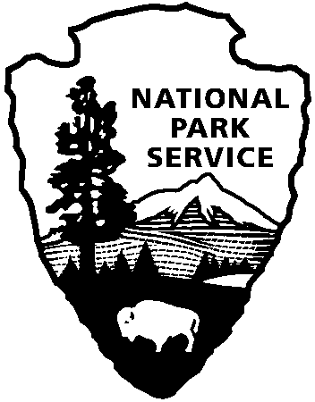
National Park Service
U.S. Department of the Interior

Release Date: August 28, 2012
Contact: Virginia Fowler, Virginia_Fowler@nps.gov, (864) 461-2828

Don’t Miss These Autumn Events at Cowpens National Battlefield

GAFFNEY, SC – Cowpens National Battlefield invites you to several upcoming late summer and autumn events. At 2:00 on September 2, Col (ret) Joel Rexford will lead a special guided battlefield walk, focusing on leadership. The South Carolina Rangers will give weapons firing demonstrations at 10:30, 11:30, 1:30, and 2:30 on September 15. The Sunday in the Park series continues with special family activities at the Robert Scruggs log cabin on September 23 and October 28 from 1:30 – 4:00. There will be a special after-hours event in the Visitor Center museum-auditorium on September 27. Converse College’s Dr. Melissa Walker, the George Dean Johnson, Jr. Professor of History, will give a talk on Women Who Risked Their Necks: Backcountry Women in the Revolution. September 29 marks Public Lands Day, when volunteers can help the small park maintenance staff weed the islands in the Visitor Center parking lot and remove exotic plants (species that were not native to the park in 1781). This volunteer opportunity is limited to 15 people. Please contact Ashley Barrows at 864-461-2828 to pre-register.

Save the date for a Revolutionary Weekend on October 6-7, when Cowpens National Battlefield, Overmountain Victory National Historic Trail, Kings Mountain National Military Park, and Walnut Grove Plantation will all hold special events to celebrate the role that the SC Backcountry played in winning the Revolutionary War. On October 6, spend the day at Walnut Grove Plantation for FestiFall from 10:00 – 5:00. Then come to Cowpens National Battlefield, a stop on the Overmountain Victory National Historic Trail, at 6:00 for a free dramatic presentation, “The Night before Kings Mountain.” At this program, members of the Overmountain Victory Trail Association and volunteer actors will present a program about the march to the Cow Pens and what happened the night before the Battle of Kings Mountain. Patriots on their way to fight Maj. Patrick Ferguson at Kings Mountain gathered at the Cow Pens before selecting the most able to continue on to Kings Mountain. Sunday, October 7 marks the 232nd anniversary of the Battle of Kings Mountain, where patriots defeated loyalists in an important battle of the Southern Campaign of the American Revolution. Complete your Revolutionary Weekend at Kings Mountain National Military Park, where festivities marking the battle’s anniversary begin with a wreath-laying ceremony at 11:00 and end with a speaker at 3:00.

Cowpens National Battlefield, a unit of the National Park Service, is located at 4001 Chesnee Highway, Gaffney, SC 29341. It commemorates a decisive American victory over regular British forces that helped turn the tide of war in the Southern Campaign of the American Revolution. The park is open daily from 9:00-5:00 except for Thanksgiving, Christmas, and New Year's Days. For more information, call (864) 461-2828 or visit us on the Web at www.nps.gov/cowp/.

www.nps.gov

About the National Park Service. More than 20,000 National Park Service employees care for America’s 395 national parks and work with communities across the nation to help preserve local history and create close-to-home recreational opportunities. Learn more at www.nps.gov.

