Cowpens National Battlefield
PO Box 308
Chesnee, SC 29323

(864) 461-2828 phone
www.nps.gov/cowp/
Cowpens National Battlefield News Release

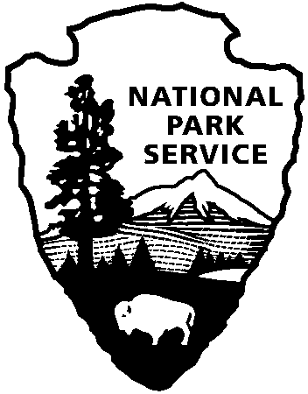
National Park Service
U.S. Department of the Interior

Release Date: June 19, 2012
Contact: Virginia Fowler, Virginia_Fowler@nps.gov, (864) 461-2828

Celebration of Freedom at Cowpens National Battlefield

GAFFNEY, SC – Cowpens National Battlefield invites you to celebrate our nation’s independence with a free afternoon and evening of special programs on Saturday, July 7. The event features guided battlefield walks at 12:30 and 3:30, Revolutionary War musket and cannon demonstrations at 1:15, 2:15, 3:15, 4:15, and 5:15, children’s programs from 5:00 – 8:55, music by the Spartanburg Community Band from 7:00 – 9:00, and a 20-minute fireworks show by Zambelli Fireworks beginning a little after 9:00. The Visitor Center will be open from 9:00 a.m. to 8:55p.m.

This year will mark the 20th year that the park has celebrated our independence with fireworks. John Adams, Second President of the United States, wrote to his wife about Independence Day, “I believe that it will be celebrated by succeeding generations as the great anniversary festival… it ought to be celebrated by pomp and parade, with shows, games, sports, guns, bells, bonfires and illuminations from one end of this continent to the other…”

Superintendent John Slaughter states, “This is one of the park’s most popular events, and it has grown exponentially through the years. Visitors who are only coming for fireworks should plan to come early, between 6:00 and 7:00, be prepared to walk, bring a flashlight, and be prepared to wait in traffic after the show.” Visitors should also note that some areas of the battlefield will be closed to the public for safety at 5:30, and there will not be food vendors on site. The park encourages families to bring a picnic. Please note that federal regulations prohibit personal fireworks, including sparklers and glow sticks.

Cowpens National Battlefield, a unit of the National Park Service, is located at 4001 Chesnee Highway, Gaffney, SC 29341. It commemorates a decisive American victory over regular British forces. The battle helped turn the tide of war in the Southern Campaign of the American Revolution. The park is open daily from 9:00-5:00 except for Thanksgiving, Christmas, and New Year's Days. For more information, call (864) 461-2828 or visit us on the Web at www.nps.gov/cowp/.

www.nps.gov

About the National Park Service. More than 20,000 National Park Service employees care for America’s 395 national parks and work with communities across the nation to help preserve local history and create close-to-home recreational opportunities. Learn more at www.nps.gov.

