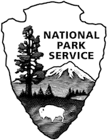
CHICKAMAUGA & CHATTANOOGA NATIONAL MILITARY PARK
2022
Compendium of Designations, Closures, Use and Activity Restrictions, Permit Requirements and Other Regulations

In accordance with regulations and the delegated authority provided in Title 36, Code of Federal Regulations (“36 CFR”), Chapter 1, Parts 1-7, authorized by Title 16 United States Code, section 3, the following provisions apply to all lands and waters administered by the National Park Service, within the boundaries of Chickamauga and Chattanooga National Military Park.

Unless otherwise stated, these regulatory provisions apply in addition to the requirements contained elsewhere in Title 36 Code of Federal Regulations, Chapter 1, Parts 1 through 7.

The closures and restrictions delineated in this compendium do not apply to official/administrative use or applications (36 CFR 1.2(d) and 1.5(a)).

This compendium supersedes all previous releases. All prior releases are rescinded.

Approved:

Brad Bennett_____ 011/09/2022______
Brad Bennett Date
Superintendent

Recommended:
Todd Milsaps______ 11/09/2022______
Todd Milsaps Date
Chief Ranger, Acting

Prepared:
Ian Morton _________ 11/09/2022______
Ian Morton Date
Supervisory Park Ranger, Acting

Table of Contents

Introduction 3
36 CFR Part 1: General Provisions 4
36 CFR § 1.4: Definitions 4
36 CFR § 1.5: Closures and Public Use Limits 6
36 CFR § 1.6: Permits…………………………………………………………………………………………12

36 CFR Part 2: Resource Protection, Public Use & Recreation 14
36 CFR § 2.1: Preservation of Natural, Cultural & Archeological Resources 15
36 CFR § 2.2: Wildlife Protection 15
36 CFR § 2.11: Picnicking 16
36 CFR § 2.15: Pets 16
36 CFR § 2.16: Horses & Pack Animals 17
36 CFR § 2.21: Smoking 17
36 CFR § 2.23: Recreation Fees 17
36 CFR § 2.35: Alcoholic Beverages & Controlled Substances 17
36 CFR Part 3: Boating & Water Use Activities 18
36 CFR § 3.16: Swimming and Bathing: 18
36 CFR Part 4: Vehicles & Traffic Safety 18
36 CFR § 4.21: Speed Limits 18
36 CFR § 4.30: Bicycles 18
36 CFR Part 5: Commercial Vehicles 19
Maps of Designated First Amendment Areas 20

Superintendent's Compendium

of Designations, Closures, Use and Activity Restrictions, Permit Requirements and Other Regulations

In accordance with regulations and the delegated authority provided in Title 36, Code of Federal Regulations (“36 CFR”), Chapter 1, Parts 1-7, authorized by Title 16 United States Code, section 3, the following provisions apply to all lands and waters administered by the National Park Service, within the boundaries of Chickamauga and Chattanooga National Military Park. Unless otherwise stated, these regulatory provisions apply in addition to the requirements contained in 36 CFR, Chapter 1, Parts 1-7.

Introduction
The purpose of the compendium is to provide the public and park employees with a document that lists the special designations, closures, public use limits, permit requirements and other restrictions imposed under the discretionary authority of the Superintendent. The Superintendent’s authority to implement these provisions is found in Title 36, Code of Federal Regulations (CFR), § 1.5(a). The compendium is available to the public upon request. The compendium will be reviewed and updated annually or as needed to ensure adequate protection of the park’s resources, provide for public safety and enjoyment and to address changes in public use patterns.

The provisions found in this compendium constitute only one of many tools designed to manage and protect Chickamauga and Chattanooga National Military Park. It is important to utilize this document in conjunction with Title 36, Code of Federal Regulations, which includes the full text of National Park Service regulations, including those authorizing the provisions outlined in this compendium. Chapter I, Parts 1-7, of Title 36, include sections addressing resource protection, public use, recreation, boating, vehicles and traffic safety, commercial operations, and special regulations. These regulations are applicable on all federally owned lands and waters within the boundaries of Chickamauga and Chattanooga National Military Park and on lands and waters under the administrative control of the National Park Service. The closures and restrictions delineated in this compendium do not apply to official/administrative use or applications (36 CFR 1.2(d) and 1.5(a)). Interested parties may also wish to review Chickamauga and Chattanooga National Military Park planning documents such as the General Management Plan.

Fines and mandatory court appearances for violations of the regulations set forth in the Superintendent’s Compendium for Chickamauga and Chattanooga National Military Park are set by the U.S District Court.

It is the intent of this compendium, in conjunction with park brochures, maps, signs and other media, to help provide the public and park employees with a clear understanding of park rules and regulations. Any questions or requests for additional information should be addressed to the Superintendent’s office. We welcome your comments and suggestions.

36 CFR Part 1: General Provisions

36 CFR § 1.4: Definitions

Bicycle means every device propelled by human power upon which any person may ride, having only two wheels which are in tandem and either of which is more than 13 inches in diameter.

E-Bicycle (e-bike) means NPS regulations define e-bikes at 36 CFR 1.4 as:
a two- or three-wheeled cycle with fully operable pedals and an electric motor of not more than 750 watts that meets the requirements of one of the following three classes:
(1) “Class 1 electric bicycle” shall mean an electric bicycle equipped with a motor that provides assistance only when the rider is pedaling, and that ceases to provide assistance when the bicycle reaches the speed of 20 miles per hour.
(2) “Class 2 electric bicycle” shall mean an electric bicycle equipped with a motor that may be used exclusively to propel the bicycle, and that is not capable of providing assistance when the bicycle reaches the speed of 20 miles per hour.
(3) “Class 3 electric bicycle” shall mean an electric bicycle equipped with a motor that provides assistance only when the rider is pedaling, and that ceases to provide assistance when the bicycle reaches the speed of 28 miles per hour.

Electric Personal Assistive Mobility Device (EPAMD) means a device such as an electric scooter, Segway®, or any self-balancing, non-tandem, two-wheeled device that is not greater than 20 inches deep and 25 inches wide and can turn in place, is designed to transport only one person with an electric propulsion system averaging less than 750 watts (1 horsepower), the maximum speed of which, when powered solely by a propulsion system on a paved level surface, is no more than 12.5 miles per hour. An EPMAD and is considered a motor vehicle as defined in 36 CFR Section 1.4

Firewood means any wood cut, sold or intended for use as firewood, including chips, limbs, branches, etc. with or without bark. Kiln-dried, finished and cut lumber or lumber scraps from which the bark has been cut, like that purchased from a hardware store, and commercially produced compressed wood logs, such as Duraflame, are not considered firewood and are not regulated as firewood.

Golf Carts means any motorized vehicle designed for the purpose and exclusive use of conveying one or more persons and equipment to play the game of golf in an area designated as a golf course. For such a vehicle to be considered a golf car or golf cart, its average speed shall be less than 15 miles per hour (24 kilometers per hour) on a level road surface with a 0.5% grade (0.3 degrees) comprising a straight course composed of a concrete or asphalt surface that is dry and free from loose material or surface contamination with a minimum coefficient of friction of 0.8 between tire and surface.

Low Speed Vehicles means any four-wheeled electric vehicle whose top speed attainable in one mile is greater than 20 miles per hour but not greater than 25 miles per hour on a paved level surface and which is manufactured in compliance with those federal motor vehicle safety standards for low-speed vehicles set forth in 49 C.F.R. Section 571.500 and in effect on January 1, 2001.

Models means a person or object that serves as the subject for commercial filming or still photography for the purpose of promoting the sale or use of a product or service. Models include, but are not limited to, individuals, animals, or inanimate objects, such as vehicles, boats, articles of clothing, and food and beverage products, placed on agency lands so that they may be filmed or photographed to promote the sale or use of a product or service. For the purposes of this part, portrait subjects such as wedding parties and high school graduates are not considered models if the image will not be used to promote or sell a product or service.
News means information that is about current events or that would be of current interest to the public, gathered by news-media entities for dissemination to the public. Examples of news-media entities include, but are not limited to, television or radio stations broadcasting to the general public and publishers of periodicals (but only if such entities qualify as disseminators of “news”) who make their products available for purchase by or subscription by or free distribution to the general public. 43 C.F.R 5.12

News-gathering activities means filming, videography, and still photography activities carried out by a representative of the news media.

Para Glider means a lightweight, free-flying, foot-launched glider aircraft with no rigid primary structure. The pilot sits in a harness suspended below a fabric wing.

Picnicking means an excursion or outing in which the participants carry food with them and have a
meal in the open air.

Personal Transportation Vehicle (Motorized Cart) means any motor vehicle having no fewer than three wheels, an unladen weight of 1,300 pounds or less, which cannot operate at more than 20 miles per hour, and capable of transporting not more than eight persons. The term does not include mobility aids, including electric personal assistive mobility devices, power wheelchairs, and scooters. The term also does not include any all-terrain vehicle or multipurpose off-highway vehicle.

Printed matter and other message-bearing items means message-bearing textual printed material such as books, pamphlets, magazines, and leaflets, provided that it is not solely commercial advertising. The term “other message-bearing items” means a message-bearing item that is not “printed matter” and is not solely commercial advertising. Other message-bearing items include but are not limited to: readable electronic media such as CDs, DVDs, and flash drives; clothing and accessories such as hats and key chains; buttons; pins; and bumper stickers.

Sets and Props means items constructed or placed on agency lands to facilitate commercial filming or still photography including, but not limited to, backdrops, generators, microphones, stages, lighting banks, camera tracks, vehicles specifically designed to accommodate camera or recording equipment, rope and pulley systems, and rigging for climbers and structures. Sets and props also include trained animals and inanimate objects, such as camping equipment, campfires, wagons, and so forth, when used to stage a specific scene. The use of a camera on a tripod, without the use of any other equipment, is not considered a prop. 43 C.F.R 5.12

Unmanned Aircraft means a device that is used or intended to be used for flight in the air without the possibility of direct human intervention from within or on the device, and the associated operational elements and components that are required for the pilot or system operator in command to operate or control the device (such as cameras, sensors, communication links). This term includes all types of devices that meet this definition (e.g., model airplanes, quadcopters, drones) that are used for any purpose, including for recreation or commerce.

36 CFR § 1.5: Closures and Public Use Limits

General

The Superintendent may temporarily close park roadways, parking areas, facilities, waters, and all or portions of the park when such actions are deemed necessary to ensure public safety, protection of resources, or the avoidance of visitor use conflicts. The posting of signs, maps, media announcements, and the use of barricades and/or gates will identify such closures.

While these areas are closed to the public, the Superintendent retains the right to grant special or routine access to park staff and/or administrative users for park management and/or research interests.

(a)(1) Establish, for all or a portion of a park area, a reasonable schedule of visiting hours, impose public use limits, or close all or a portion of a park area to all public use or to a specific use or activity.

- Visiting Hours: All outdoor areas of Chickamauga and Chattanooga National Military Park are open for visitation from one half hour before sunrise to one half hour after sunset except where listed below under closures or publicly posted.

(Protection of park resources would be diminished with unrestricted “after hours” use. Closure of identified sites and restriction placed on motor vehicle use does not interfere with normal or legitimate visitation to park resources.)

- CLOSURES: Consistent with applicable legislation and Federal administrative policies, the Superintendent has closed the following park locations and facilities to all visitors;

- Sanders Road Picnic Area

The following areas are closed seasonally:

- US Highway 27 Picnic Area is closed December 01 through March 15
- Wilder Brigade Monument is closed December 01 through March 15
- Signal Point restrooms are closed December 01 through March 15

(These restrictions are necessary to provide for the orderly management of the park, resource protection, and for public safety.)

(a)(2) Designate areas for a specific use or activity or impose conditions or restrictions on a use or activity.

The Superintendent has determined that use of this discretionary authority is necessary for resource protection and public safety

(Continued on next page)

- When mask-wearing requirements are in place, the number of visitors in the following indoor locations may not exceed the maximum occupancy identified for each location.
Indoor Location | Maximum Occupancy
Chickamauga Battlefield Visitor Center  Atrium | 30
Chickamauga Battlefield Visitor Center  America’s National Parks Bookstore | 10
Chickamauga Battlefield Visitor Center  West Exhibit Room (outside theater) | 20
Chickamauga Battlefield Visitor Center  Theater | 38
Chickamauga Battlefield Visitor Center  East Exhibit Room  (between Atrium and Gun Collection Room) | 15
Chickamauga Battlefield Visitor Center  Gun Collection Room | 15
Lookout Mountain Battlefield Visitor Center  and America’s National Parks Bookstore  (one room/shared space) | 15
Lookout Mountain Battlefield Visitor Center  Painting Exhibit Room | 10
Ochs Museum  (in Point Park) | 4

Entering or remaining in any of the indoor locations identified in the table above after being asked not to enter or to leave the location because the maximum occupancy has been reached is prohibited.

- When the COVID-19 Community Level is LOW or MEDIUM in all three counties where the park facilities are located (Catoosa and Walker Counties in Georgia; and Hamilton County in Tennessee) based on data provided by the Centers for Disease Control and Prevention (CDC)--individuals are not required to wear masks.

When the COVID-19 Community Level is HIGH in all three counties where the park facilities are located based on data provided by the CDC, all individuals over the age of two must wear masks, regardless of vaccination status, in all common areas and shared workspaces in buildings owned by the National Park Service, including, but not limited to, park visitor centers, bookstores, and administrative offices.

When the COVID-19 Community Level is HIGH in one or more, but not all, of the three counties where the park facilities are located based on data provided by the CDC, the Superintendent has determined that individuals are required to wear masks in all facilities within the park.

Masks must cover the nose and mouth and fit snugly around the nose and chin with no large gaps around the sides of the face. Masks not designed to be protective, masks with ventilation valves, and face shields do not meet the requirement.

Regardless of the COVID-19 Community Level, individuals may wear masks if they choose to do so. Where a state, local, tribal, or territorial government where the park is located imposes more protective mask-wearing requirements than those indicated by the COVID-19 Community Level, individuals must follow those more protective requirements within the park. More protective state, local, tribal, or territorial mask-wearing requirements are hereby adopted as federal requirements in all units of the National Park System located within that state, locality, area subject to a federally recognized Indian tribe’s regulatory jurisdiction, or territory, regardless of a particular park’s jurisdictional status.

Additionally, all individuals must wear masks in or on public transportation conveyances and transportation hubs/facilities, to the extent required by current orders or directives issued by the CDC, the Transportation Security Administration (TSA), or other federal agencies with jurisdiction over those conveyances or areas. As of March 4, 2022, CDC and TSA orders or directives require all individuals regardless of vaccination status to wear masks in indoor areas of all forms of public transportation conveyances, including busses, trains, and boats/ferries, and in the indoor premises of transportation hubs/facilities. Individuals are not required to wear masks while outdoors on conveyances or while outdoors on the premises of transportation hubs/facilities.

This requirement relies on the best available data and science-based public health measures recommended by the Centers for Disease Control and Prevention [CDC] to protect the health and safety of National Park employees, volunteers, partners, contractors, and other park visitors.

- Caves – Closed to Public: Because of their sensitive and sometimes dangerous nature, public presence, use, and access in all caves, as defined above, is prohibited.

(This restriction is necessary to protect human health and safety, unrecorded features, archaeological resources, and wildlife habitat.)

- Chickamauga Creek – Restricted Access: Launching or retrieving watercraft from anywhere along West Chickamauga Creek within the Chickamauga Battlefield is prohibited.

(This restriction is necessary to protect cultural and natural resources by preventing additional erosion and ground disturbance by accessing the creek)

- Electric Personal Assistive Mobility Device– Restricted: The use of an EPAMD (e.g Segways) is permitted on park secondary roads and in the area of the Chickamauga Battlefield Visitor Center and Point Park Visitor Center by individuals with mobility disabilities only. Segway use is prohibited on LaFayette Road, Reeds Bridge Road, McFarland Gap Road, and on all administrative roads.

(It is the park’s goal to provide the visitor with a safe, quality park experience. Segway use provides an opportunity for an additional demographic to enjoy an experience that is often taken for granted.)

- Firewood - Restricted: The transportation or possession of firewood, imported from outside the park, which is not in the original packaging, and which is not labeled and does not bear a certification seal from the US Department of Agriculture (USDA) or a state agency as heat treated firewood, is prohibited. Campers may collect wood, which is both dead and down, inside the park to burn at park campsites.

(This closure is intended to prevent or slow the introduction of exotic insects or diseases into Chickamauga and Chattanooga National Military Park. For example, the emerald ash borer (EAB) has already killed tens of millions of trees in those states that have been infested. As a result, the movement of firewood within and from infested areas is regulated by the states and the federal government. The USDA has documented that a number of other harmful species can be transported in firewood. This requirement eliminates the risk of transporting pests, since insects and diseases do not survive heat treatment. Therefore, it has been determined that this action is necessary to protect the natural resources of the park.)

- Golf Carts and Personal Transportation Vehicles – Restricted: Vehicles in this category are prohibited from operating on all administrative roads, LaFayette Road, Reeds Bridge Road, and McFarland Gap Road. Crossing over LaFayette Road is permitted at the following intersections only:
  - Alexander Bridge Road and Glenn-Kelly Road
  - Brotherton Road and Dyer Road

(This order is issued to provide guidance to operators of these devices and to increase the level of safety to those operators and the motoring public.)

- Hammocks – Prohibited: The use of hammocks and slack lines is prohibited in all areas of the park.

(The use of hammocks and slack lines create modern visual intrusions within the park’s cultural landscapes,
interfering with visitors’ opportunities to appreciate the historic scene and resources.)

- Idling -- Restricted: All motorized vehicles (passenger cars, busses, vans, school buses, etc.) are only allowed to idle while actively (passengers are physically getting on or off the bus) loading and unloading passengers. All operators of motorized vehicles must turn off vehicle engines at all times when parked or when not actively loading or unloading passengers. This restriction does not apply to vehicles stopped on roadways in obedience to traffic control devices or orders, or as needed in response to legitimate traffic safety concerns.

(This restriction is consistent with park management’s plan of reducing air and noise emissions to the maximum extent feasible. These reductions add to and enhance the visitor’s experience in the areas of landscape, solitude, and the inspirational value of the park.)

- Moccasin Bend National Archeological District – Restricted Access: Accessing Moccasin Bend National Archeological District from the Tennessee River and accessing the Tennessee River from the bank of Moccasin Bend is prohibited. Fishing from the bank of Moccasin Bend into the Tennessee River is also prohibited.

(This restriction is necessary to protect natural resources by preventing additional erosion and ground disturbance caused by gaining access to the riverbank along the Tennessee River’s shoreline.)

- National Park Service Maintenance Facilities– Closed to Public / Restricted Area: Public access, use, and presence is prohibited in the maintenance facility area beyond the points marked by a “Do Not Enter” sign, inside of the fenced area, the employee parking area, and the materials area with the dumpsters (Designated by interior of red Restricted Area on map inset).

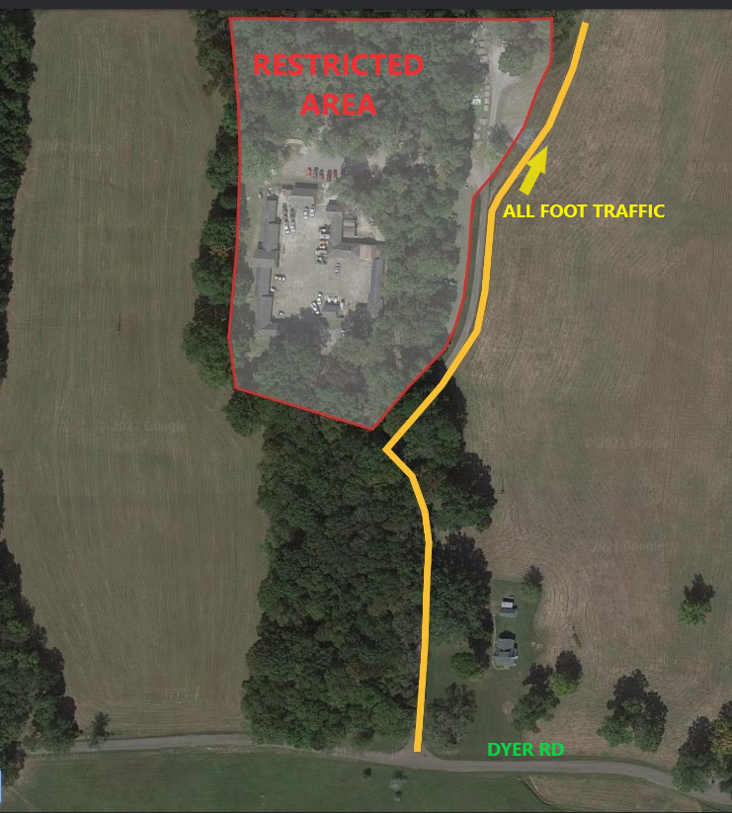

(This restriction is necessary to protect government property and enhance employee safety)

- Picnicking – Restricted Access: All units of the National Military Park are closed to picnicking except for the following designated areas:
Chickamauga Battlefield
    - Reeds Bridge Road Picnic Area
    - Brotherton Road Picnic Area
    - Recreation Field Picnic Area
    - US Highway 27 Picnic Area
Lookout Mountain
    - Picnic tables at Lookout Mountain Visitor Center

(This restriction is necessary in order to preserve the historic viewshed from intrusive uses)

- Recreation – Restricted: All units of the national military park are closed to the following recreational activities: kite flying, ball playing, sunbathing and other similar activities, except in the area designated as the Recreation Area located in Chickamauga Battlefield. The use of golf clubs, model airplanes, gliders, para gliders and model rockets are not permitted anywhere in the park.

GPS based recreational activities (geocaching) are prohibited. Due to the sensitivity of the park’s archeological and paleo resources, the only GPS recreational activity that the park allows is “Virtual Caching.”

(Recreational opportunities must be limited in order to protect the commemorative values of the historic landscape and ensure recreational visitors do not interfere with the interpretation of the historic resource. Limiting recreational activity advances the primary preservation values found within the park’s enabling legislation.)

Roads Closed to Motorized Use:
The following roads are designated as administrative roads and are closed to public motor vehicle use.
Chickamauga Battlefield:
      - Dalton Ford-Thedford Ford Road
      - Dyer Service Road
      - Mullis-Vittetoe Road
      - Mullis Road
      - Snodgrass Savannah Road
      - Snodgrass Road (unpaved section)
      - Vittetoe Road
      - Snodgrass Service Road
Lookout Mountain Battlefield:
  - Upper Truck Trail
  - Lower Truck Trail

(This closure is necessary for resource protection, as well as public and employee safety.)

- Rock Climbing – Restricted Access: Technical rock climbing on Lookout Mountain is permitted on the rock faces above and below the Bluff Trail extending between the areas known as the Towers to the climb known as Blonde Ambition and at Eagles Nest. All other areas on Lookout Mountain are closed to technical rock climbing. Sport rappelling is permitted at Eagles Nest only.

(This restriction is necessary to protect the park’s sensitive natural and cultural resources and to enhance public safety.)

- Unmanned Aircraft -- Prohibited: Launching, landing, or operating an unmanned aircraft from or on lands and waters administered by the National Park Service within the boundaries of Chickamauga and Chattanooga National Military Park is prohibited except as approved in writing from the Superintendent.

(This restriction is necessary to protect human health and safety, preserve visitor experience of unimpaired view sheds, safeguard park wildlife from potential displacement or harassment, avoid creation of public safety hazards per operation near roadways or large aggregations of visitors, and maintain safety for emergency operations that may include use of a helicopter.)

36 CFR § 1.6: Permits
(a) When authorized by regulations set forth in this chapter, the Superintendent may issue a permit to authorize an otherwise prohibited or restricted activity or impose a public use limit.
(f) The following is a compilation of those activities for which a permit from the Superintendent is required:

§2.1 Preservation of Natural and Cultural Resources
(a)(5) Entering any cave or rock shelter

§2.4 Weapons, traps and nets.
(e) Carry or possess a weapon, trap, or net that is otherwise not authorized.
§2.5 Research specimens.
(a) Taking plants, fish, wildlife, rocks or minerals for specimen collection.

§2.12 Audio Disturbances.
(a)(4) Operation of a public address system in connection with a public gathering or special event
for which a permit has been issued pursuant to §2.50 or §2.51.
§2.17 Aircraft & Air Delivery.
(a)(3) Delivery or retrieval of a person or object by parachute, helicopter or other airborne means.
§2.37 Soliciting or demanding gifts, money goods or services (pursuant to the terms and conditions of a
permit issued under §2.50, §2.51 or §2.52).
§2.38 Explosives.
(a) Using, possessing, storing, or transport explosives, blasting agents, or explosive materials.
(b) Using or possessing fireworks.
§2.50 Special events.
(a) Sports events, pageants, regattas, public spectator attractions, entertainments, ceremonies, and similar events.
§2.51 Public assemblies, meetings, gatherings, demonstrations, parades and other public expressions of views involving more than 25 people.

The areas listed below are designated for demonstrations and the sale or distribution of printed matter. These areas may be occupied by groups of 25 or fewer persons without a permit provided that all terms of 36 CFR 2.51 and 2.52 are met.

- Chickamauga Battlefield Visitor Center
- Located on the east side of LaFayette road directly across from the visitor center and contained within the fenced area. No demonstrations are permitted within 50 feet of LaFayette Road. This restriction is necessary for public safety.

- Lookout Mountain Battlefield Visitor Center
- Located in the picnic area west of the Visitor Center and east of West Brow Road. The access road to the parking lot must not be obstructed.

Detailed maps of designated areas are located at the end of this document.

Weddings are allowed in the following locations with a permit:

- Chickamauga Battlefield – Old Dyer House Site on Dyer Road
- Lookout Mountain - Southwest side of New York Peace Monument at Point Park
- Signal Point – In the grassy area immediately above the overlook

§2.52 Sale of printed matter and the distribution of printed matter and other message-bearing items.
(c) Sale and distribution of printed matter and other message-bearing items that is not solely commercial advertising for groups of 26 or more persons. The areas listed above in 2.51 a and b are designated for this activity.
§2.62 Memorialization.
(a) Erection of monuments (requires approval from the National Park Service Director)
(b) Scattering of ashes from human cremation
- Two locations have been designated for scattering of ashes inside the park boundary
- Chickamauga Battlefield – Brock Field at the southern tree line (See Yellow line marked “Woodline for Ashes” on map inset)
- Signal Point overlook – Ashes may be scattered over the overlook wall.
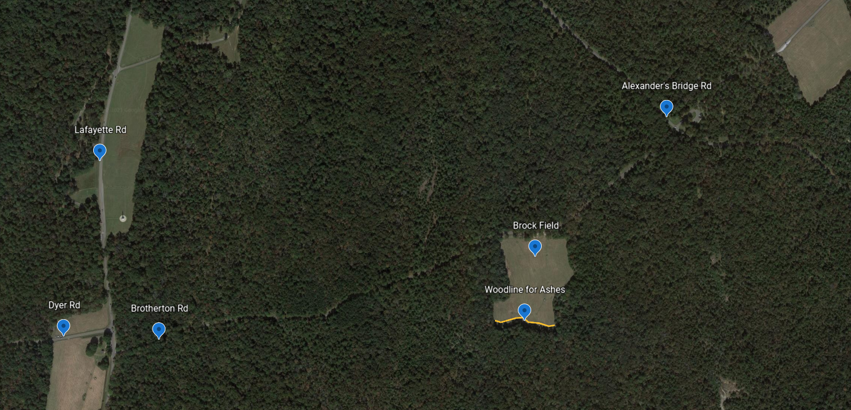
§5.1 Display, posting or distribution of commercial notices or advertisements.
§5.3 Engaging in or soliciting any business.
§5.5 Commercial Filming, Still Photography & Audio Recording
(a) Commercial filming of motion pictures or television involving the use of professional casts, settings, or crews, other than bona fide newsreel or news television (as defined by 43 CFR 5.12, per 43 CFR 5.2. See definitions on pages 3-4).
(b) Still photography does not require a permit unless:
      - It uses a model, set, or prop as defined in 43 CFR 5.12 or
      - The agency determines a permit is necessary because:
        - It takes place at a location where or when members of the public are not allowed; or
        - The agency would incur costs for providing on-site management and oversight to protect agency resources or minimize visitor use conflicts.
(c) Visitors do not require a permit for filming or still photography activities unless the filming is commercial filming as defined in § 5.12 or the still photography activity involves one of the criteria listed in § 5.2(b).
(d) Audio recording does not require a permit unless:
- It takes place at location(s) where or when members of the public are generally not allowed;
- It uses equipment that requires mechanical transport;
- It uses equipment that requires an external power source other than a battery pack; or
- The agency would incur additional administrative costs to provide management and oversight of the permitted activity to:
  - Avoid unacceptable impacts and impairment to resources or values; or
  - Minimize health or safety risks to the visiting public.

More information about permits can be found on the park website: Permits & Reservations - Chickamauga & Chattanooga National Military Park (U.S. National Park Service) (nps.gov)

36 CFR Part 2: Resource Protection, Public Use & Recreation

36 CFR § 2.1: Preservation of Natural, Cultural & Archeological Resources
(a)(1)(ii) Plants may not be removed or disturbed within the park. However;

(a)(4) Campers may gather wood within the park area to use as fuel for campfires within the designated
park area when wood is both dead and down.

(c)(1) The following fruits (including the fruiting bodies of certain mushrooms), berries, and nuts may be
gathered by hand for personal consumption or use:
• blackberries, blueberries, grapes, muscadines, persimmons, walnuts, hickory nuts, beech nuts, and
acorns.

(The Superintendent has determined that the gathering and/or consumption of the above in the quantities described below will not adversely affect park wildlife, the reproductive potential of individual plant species, or otherwise adversely affect
park resources.)

(c)(2)(i) The quantity of berries and nuts collected under the provisions of Section 2.1(c)(1) will not
exceed 1 gallon per family or group per day for each species.

(The unrestricted collection of fruits, berries, and nuts could have an adverse impact on plant propagation
and/or wildlife food sources.)

(c)(2)(ii) All such fruits, berries or nuts must be collected while standing on the ground. The gathering of
such fruits, berries or nuts is also prohibited within 200 feet of scientific research plots or areas.

(The use of collection methods such as ladders and tree climbing are prohibited in order to protect trees
and vegetation from damage and to allow sufficient food supplies for wildlife. Gathering such items in research areas is
prohibited in order to protect the integrity and reliability of research activities.)

(a)(5) The following rock climbing practices are prohibited at Chickamauga Chattanooga NMP:
- The operation of a power drill or motorized equipment used to support the placement of new climbing aides or otherwise to directly support a climb.
- The gluing or chipping of rock, or the gluing, affixing, or placement of artificial hand holds on rock, or other damaging practices such as forcibly prying off rock or destroying vegetation to enhance a route.
- Leaving fixed ropes unattended
- Installation of new bolts or fixed pitons
- Any tree used as an anchor to attach webbing, rope, or any type of sling used for climbing activity must be first wrapped with protective padding around its entire circumference. The padding must be of sufficient thickness to prevent abrasion of the tree.

(This restriction is necessary to protect the park’s natural resources)

  - Accessing the social trail that connects the Skyuka Trail to the Upper Truck Trail, commonly referred to as the Jura Trail, is prohibited and has been designated as closed.

(This restriction is necessary for erosion management and to reduce trail degradation.)

36 CFR § 2.2: Wildlife Protection
(e) The park is closed to viewing of wildlife with any artificial light, which includes and is not
limited to spotlights and vehicle headlights directed beyond those areas covered in normal highway driving.

(These prohibitions and restrictions are necessary for public safety and resource protection.)

36 CFR § 2.11: Picnicking

Certain areas have been designated for picnicking and have been listed in section 1.5(a)(2).

Conditions for Picnicking:

Cooking foods by means of open flame, controlled combustion or other cooking device is
not permitted.

(These restrictions and conditions are necessary in order to preserve the historic viewshed from intrusive uses, public safety, and resource protection)

36 CFR § 2.15: Pets

(a)(5) Pet excrement must be disposed of in accordance with the following conditions:

Owners or persons having custody or control of any animal(s), within all units of the Chickamauga and Chattanooga NMP will immediately remove and dispose of excrement voided by an animal(s) under their control.

(These prohibitions and restrictions are necessary for public safety and resource protection.)

36 CFR § 2.16: Horses & Pack Animals
(b) The use of horses is allowed on the following trails, routes or areas:
- The designated horse trails in Chickamauga Battlefield, (Red, White and Blue trails only).
- The Lower Truck Trail on Lookout Mountain Battlefield.

(These limitations are necessary to protect the resource and for public safety)
36 CFR § 2.20: Skating, Skateboards and Similar Devices
The use of roller skates, roller blades, skateboards, and foot powered scooters is prohibited in all areas of the park.

(These prohibitions are necessary for public safety)

36 CFR § 2.21: Smoking
        - Smoking is prohibited in all interior spaces and outdoor areas within 25 feet of air intake ducts, including doors and windows, of buildings owned by the federal government.

(The Superintendent has implemented this closure in accordance with Executive Order 13058 entitled “Protecting Federal Employees and the Public from Exposure to Tobacco Smoke in the Federal Workplace.” The intent of EO 13058 is to establish a smoke-free environment for Federal employees and members of the public visiting or using Federal facilities. The Superintendent has determined this closure to be necessary and the least restrictive means to ensure federal employees and the public have access to smoke-free environments.)

36 CFR § 2.23: Recreation Fees
(b) Recreation fees, in accordance with Title 36 CFR part 71, are established for the Point Park entrance fee areas, and/or for the use of the following specialized sites, facilities, equipment or services, or for participation in the following group activity, recreation events, or specialized recreation uses:

Entrance Fees

Daily Pass, Individual Person | $10.00, valid for 7 days
Point Park Annual Pass | $35.00, valid for 1 year

More information about fees can be found on the park website.

36 CFR § 2.35: Alcoholic Beverages & Controlled Substances
(a)(3)(i) The following public use areas, portions of public use areas, and/or public facilities within the park are closed to consumption of alcoholic beverages, and/or to the possession of a bottle, can or other receptacle containing an alcoholic beverage that is open, or has been opened, or whose seal has been broken or the contents of which have been partially removed:

- Lookout Mountain, Missionary Ridge, Signal Point, and Moccasin Bend National Archeological District.

(The proximity of these areas to bluffs, cliffs, steep slopes and other natural hazards make them unsuitable for consumption of alcohol due to the concern for visitor safety.)

- Chickamauga Battlefield, except in designated picnic areas.

(Consumption of alcohol would interfere with visitor’s appreciation of the historic scene and resources.)

36 CFR Part 3: Boating & Water Use Activities

Launching or recovery of a vessel is prohibited within all units of Chickamauga and Chattanooga National Military Park, as per 36 CFR 1.5(a)(2).

36 CFR § 3.16: Swimming and Bathing:

(a)(1) Swimming and bathing are prohibited in all areas.

(These prohibitions and restrictions are necessary for public safety and resource protection.)

36 CFR Part 4: Vehicles & Traffic Safety

36 CFR § 4.21: Speed Limits
(b) The following speed limits are established for the routes/roads indicated:
- LaFayette Road from the north boundary of Chickamauga Battlefield to Kelly Field 30 MPH
- LaFayette Road from Kelly Field to the south boundary of Chickamauga
- Battlefield 35 MPH
- McFarland Gap Road 30 MPH
- Reeds Bridge Road 30 MPH
- Sanders Road 20 MPH
- All other roads within the national military park boundaries 25 MPH.

(The Superintendent has determined that these restrictions are necessary to promote traffic and visitor safety, and to reduce wildlife mortalities caused by vehicular collisions.)

36 CFR § 4.30: Bicycles and 36 CFR § 4.30(i): E-bikes

(a), (i) Bicycle and e-bike use are permitted in the following areas:

- Park Roads and Parking Areas- Bicycles and Electric Bicycles will be permitted on all public roads and parking areas located within Chickamauga Battlefield and Lookout Mountain Battlefield. Bicyclist must adhere to Georgia and Tennessee State Laws regarding bicycles use on public roads.

- Administrative Roads - The following paved or unimproved roads have been authorized for bicycle and e-bike use:

Chickamauga Battlefield:
• Dalton Ford and Thedford Ford Roads
• Dyer Service Road
• Mullis Road
• Mullis-Vittetoe Road
• Snodgrass Road (unpaved section)
• Snodgrass-Savannah Road
• Snodgrass Service Road
• Vittetoe Road

Lookout Mountain Battlefield:
• Lower Truck Trail Road
• Upper Truck Trail Road

- Trails - The following trails have been authorized for bicycle and e-bike use:

Chickamauga Battlefield:
• Green Trail located between lower parking lot at Visitor Center to Glenn-Kelly Road

Lookout Mountain Battlefield:
• Jackson Gap Trail
• John Smartt Trail (upper section)

Reference linked trail maps of the Chickamauga and Lookout Mountain Battlefields for locations of specific trails and Administrative (Gravel) Roads mentioned above:
Chickamauga Battlefield Trail Map
Lookout Mountain Battlefield Trail Map

(The Superintendent has designated these routes for bicycle use based on written determination that such use is consistent with the protection of the park’s natural, scenic, and aesthetic values, safety considerations, and management objectives and will not disturb wildlife or park resources.)

36 CFR Part 5: Commercial Vehicles

All park roads are closed to use by commercial vehicles, with the following exceptions:

Commercial vehicles less than 5 tons (GVW) are permitted on Reeds Bridge Road and McFarland Gap Road

Motor Vehicle Towing/Recovery vehicles are permitted on park roads when necessary to access adjacent lands and as deemed necessary for responding to emergency calls.

Commercial vehicles/carriers delivering goods and services to the National Military Park.
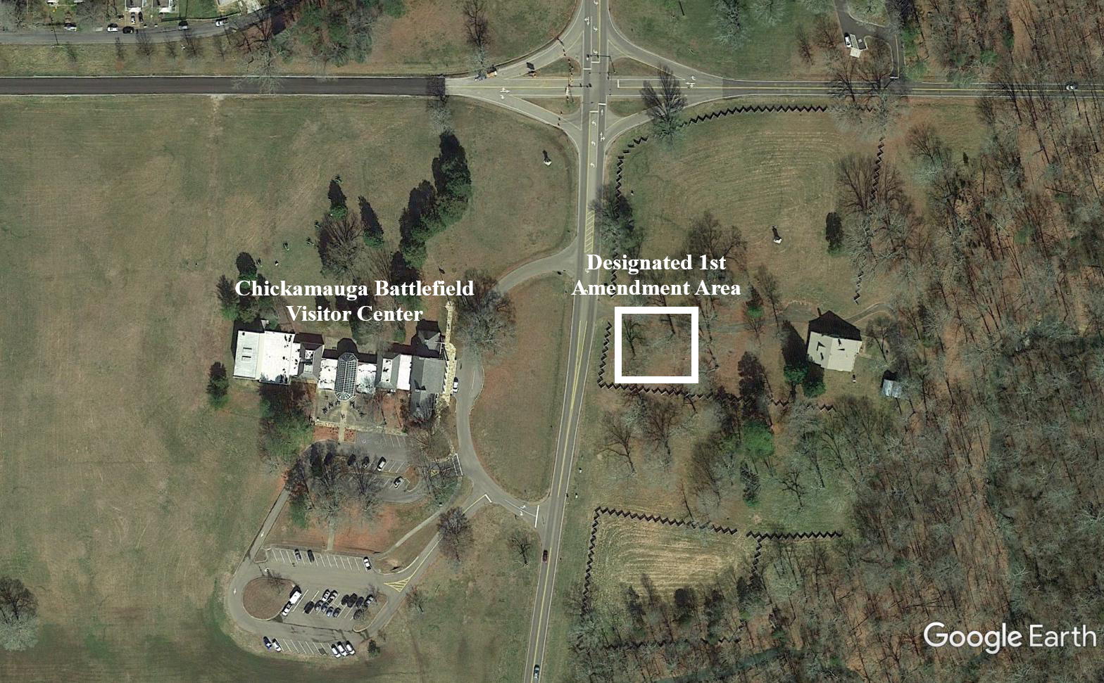
National Park Service
U.S. Department of the Interior
Chickamauga & Chattanooga National Military Park
Designated First Amendment Area
Chickamauga Battlefield
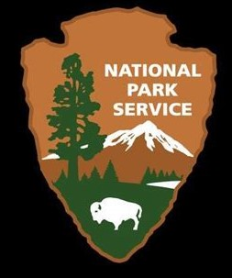

National Park Service
U.S. Department of the Interior
Chickamauga & Chattanooga National Military Park
Designated First Amendment Area
Lookout Mountain Battlefield

