MIDDLE AND HIGH SCHOOL LEARNING SERIES

Dr. Carter G. Woodson Home NPS
National Park Service Educational Project

By La Vonne I. Neal, Ph.D. and Sarah Militz-Frielink, Ph.D.

The same educational process which inspires and stimulates the oppressor with the thought that he is everything and has accomplished everything worth while, depresses and crushes at the same time the spark of genius in the Negro by making him feel that his race does not amount to much and never will measure up to the standards of other peoples. –CARTER G. WOODSON

Purpose of Learning Series
The purpose of this learning series is to give middle and high school students an opportunity to investigate the importance of collecting, preserving, and teaching the history of diverse people and cultures, especially African Americans.
The Carter G. Woodson Home National Historic Site
The Carter G. Woodson Home National Historic Site highlights the contributions of Dr. Carter Godwin Woodson, "the Father of Black History." Dr. Woodson worked to educate the public about the history of African Americans and their profound impact on American society.
Born on December 19, 1875 in New Canton, Virginia, Woodson had few educational or employment opportunities during his youth. He did not receive a formal education until age 20. Woodson's thirst for knowledge led him to complete a high school diploma, two bachelor's degrees, and a master's degree. In 1912, he became the second black American and the only person of enslaved parentage to earn a Ph.D. from Harvard University.

Woodson was the first professionally trained historian to devote his career to advancing black history. He believed that spreading knowledge about black history was an important part of the struggle for black equality. He spent many years as an educator at various institutions, including the prestigious Armstrong Manual Training School, M Street School, and Howard University.
On July 18, 1922, Woodson purchased his home at 1538 9th Street, N.W. for $8,000. This home served as the headquarters for the organizations that Woodson founded: the Association for the Study of Negro Life and History, Inc. and the Associated Publishers, Inc.
Dr. Carter G. Woodson: The Father of Black History
Dr. Carter G. Woodson, "the Father of Black History," was an educator and historian of African American life and culture. His book The Miseducation of the Negro (1933) challenged histories of the United States that did not recognize the role of Africans and their descendants. Dr. Woodson founded the Association for the Study of Negro Life and History (ASNLH) in 1915, now called the Association for the Study of African American Life and History (ASALH).
In 1916, Dr. Woodson launched The Journal of Negro History. It was the nation’s first major historical journal on the black American experience. By 1919, the Journal had reached 4,000 people. Woodson also established Associated Publishers to ensure that black history was more readily available. Woodson's ground-breaking work, The Negro in Our History, was published by the Associated Publishers in 1922. It would go on to serve as the foundational textbook for teaching black history.
Woodson also founded the federal celebration of Negro History Week in 1926, which was expanded to Black History Month in 1976. In 1937 Dr. Woodson, with the encouragement of the first female president of ASNALH—Mary McLeod Bethune—co-founded the The Negro History Bulletin to teach young people about their cultural heritage. The Negro History Bulletin, now called the Black History Bulletin, publishes and disseminates peer-reviewed information about African Americans in U.S. History, the African Diaspora, and the peoples of Africa to inform the practice of middle and high school teachers.
If These Walls Could Talk: 1538 Ninth Street, N.W. and The People who Assisted in the Creation of the Black History Movement

Dr. Carter G. Woodson’s home played a vital role in his mission to promote the study of black history. The first floor housed the Associated Publishers, The Journal of Negro History, The Negro History Bulletin, and the Association for the Study of Negro Life and History. Important figures of the early black history movement either worked for or visited this intellectual space. It also functioned as an important mentoring center. Woodson either employed or counseled budding historians like Rayford Logan, Charles Wesley, Lorenzo Johnston Greene, and John Hope Franklin here. During the 1920s, both Langston Hughes and Zora Neale Hurston worked at the home.
Vital to ASNLH's success was the work and support of African American women. Black women were important grassroots organizers, officeholders, and participants in ASNLH chapters throughout the country. Some of these women included Nannie Helen Burroughs, Mary Church Terrell, Lois Mailou Jones, and Dorothy Porter. Out of all of Woodson’s relationships, one of his closest friendships was with renowned educator Mary McLeod Bethune. In 1936, Bethune was elected the first female president of ASNLH. Bethune brought money and prestige to the association, and Woodson thought very highly of Bethune, calling her “one of the most distinguished personages of her time.”
While the second floor of Woodson's home housed his office and library, the basement served as a make-shift archive. Woodson preserved rare artifacts and collections that documented the experiences of people of African descent. He housed manuscripts from important individuals of African American history like Francis J. Grimke, Charles Young, Frederick Douglass, and Booker T. Washington. Woodson passed away of a heart attack in his home on April 3, 1950. His efforts continue to be an invaluable resource for scholars today.

Multi-Week Unit
Dr. Carter G. Woodson Home
National Historic Site
National Park Service Educational Project

Connections to Middle School and High School School
This learning series addresses the overall purposes and goals of the high quality embedded technology standards developed by the District of Columbia Office of the State Superintendent of Education. Additionally, adaptations for students who have disabilities are included. The series also incorporates the District of Columbia PreK through Grade12 Social Studies Standards, which examine complex themes and concepts such as:

- The evolution of the concepts of personal freedom, individual responsibility, and respect for human dignity over time.
- The struggles that men and women have faced in overcoming political oppression, economic exploitation, religious persecution, and racial injustice
- The growth and impact of centralized state power through time.
- The birth, growth, and decline of civilizations.
- The influence of economic, political, religious, and cultural ideas as human societies move beyond regional, national, or geographic boundaries.
- The historical patterns and relationships within and among world nations, continents, and regions — economic competition and interdependence; age-old ethnic, racial, and religious enmities; political and military alliances; peacemaking and war making — that serve as a backdrop to and explain contemporary policy alternatives with national and worldwide implications.
- The effects of geography on the history of civilizations and nations.
- The effects of the interactions between humans and the environment through the ages.
- The growth and spread of free markets and industrial economies.
- The development of scientific reasoning, technology, and formal education over time and their effect on people’s health, standards of living, economic growth, government, religious beliefs, communal life, and the environment.

This series incorporates the thematic structure of the National Curriculum Standards for Social Studies developed by the National Council for Social Studies (NCSS).

CULTURE
Social studies programs should include experiences that provide for the study of culture and cultural diversity.

Human beings create, learn, share, and adapt to culture. The study of culture examines the socially transmitted beliefs, values, institutions, behaviors, traditions and way of life of a group of people; it also encompasses other cultural attributes and products, such as language, literature, music, arts and artifacts, and foods. Students come to understand that human cultures exhibit both similarities and differences, and they learn to see themselves both as individuals and as members of a particular culture that shares similarities with other cultural groups, but is also distinctive. In a multicultural, democratic society and globally connected world, students need to understand the multiple perspectives that derive from different cultural vantage points.
Cultures are dynamic and change over time. The study of culture prepares students to ask and answer questions such as: What is culture? What roles does culture play in human and societal development? What are the common characteristics across cultures? How is unity developed within and among cultures? What is the role of diversity and how is it maintained within a culture? How do various aspects of culture such as belief systems, religious faith, or political ideals, influence other parts of a culture such as its institutions or literature, music, and art? How does culture change over time to accommodate different ideas, and beliefs? How does cultural diffusion occur within and across communities, regions, and nations?
Through experience, observation, and reflection, students will identify elements of culture as well as similarities and differences among cultural groups across time and place. They will acquire knowledge and understanding of culture through multiple modes, including fiction and non-fiction, data analysis, meeting and conversing with peoples of divergent backgrounds, and completing research into the complexity of various cultural systems.
In schools, this theme typically appears in units and courses dealing with geography, history, sociology, and anthropology, as well as multicultural topics across the curriculum. Young learners can explore concepts of likenesses and differences among cultural groups through school subjects such as language arts, mathematics, science, music, and art. In social studies, learners interact with class members and discover culturally-based likenesses and differences. They begin to identify the cultural basis for some celebrations and ways of life in their community and in examples from across the world. In the middle grades, students begin to explore and ask questions about the nature of various cultures, and the development of cultures across time and place. They learn to analyze specific aspects of culture, such as language and beliefs, and the influence of culture on human behavior. As students progress through high school, they can understand and use complex cultural concepts such as adaptation, assimilation, acculturation, diffusion, and dissonance that are drawn from anthropology, sociology, and other disciplines to explain how culture and cultural systems function.

Unit Objectives
At the end of this unit students will be able to investigate multiple perspectives across many content areas about African American history—connecting to museum collections, primary documents, and historical places related to Dr. Carter G. Woodson, the Association for the Study of African American Life and History, and his mentees. Students will be able to design, engage with, and present products that display an accurate portrayal of historical people, places, and collections. Students will be able to engage with several museum themes including preserving the past and planning for the future; rebuilding a legacy brick by brick; and the power of place. The museum themes will assist students in the development of advanced geometric, problem-solving, and algebraic skills.

MIDDLE SCHOOL
District of Columbia Social Studies
6-8 Historical and Social Sciences Analysis Skills

CHRONOLOGY AND HISTORICAL INTERPRETATION
1. Students explain how major events are related to one another in time.
2. Students construct various time lines of key events, people, and periods of the historical era they are studying.
3. Students explain the central issues and problems from the past, placing people and events in a matrix of time and place.
4. Students understand and distinguish cause, effect, sequence, and correlation in historical events, including the short-term causes or sparks from long-term causes. 5. Students explain the sources of historical continuity and how the combination of ideas and events explains the emergence of new patterns.
6. Students recognize the role of chance, oversight, and error in history.
7. Students recognize that interpretations of history are subject to change as new information is uncovered.
8. Students interpret basic indicators of economic performance, and they conduct cost-benefit analyses of economic and political issues.
9. Students frame questions that can be answered by historical study and research. 10. Students distinguish fact from opinion in historical narratives and stories. They know facts are true statements because they are supported by reliable evidence and can cease to be facts if new evidence renders previous evidence wrong or unreliable. 11. Students distinguish relevant from irrelevant information, essential from incidental information, and verifiable from unverifiable information in historical narratives and stories.
12. Students assess the credibility of primary and secondary sources, draw sound conclusions from them, and cite sources appropriately.
13. Students assess the credibility and reliability of Internet sources.
14. Students detect the different historical points of view on historical events and determine the context in which the historical statements were made (the questions asked, sources used, and author’s perspectives).
15. Students know the distinction between sound generalizations and misleading oversimplifications and stereotypes, such as the attribution of individual perspectives on historical events to entire demographic groups.

GEOGRAPHIC SKILLS
1. Students explain Earth’s grid system and are able to locate places using degrees of latitude and longitude.
2. Students use a variety of maps and documents to identify physical and cultural features of neighborhoods, cities, states, and countries. Students interpret historical maps and charts.
3. Students create maps that show the growth and decline of empires.
4. Students categorize characteristics of places in terms of whether they are physical (natural) or cultural (human). Know and apply the subcategories of physical and cultural characteristics when describing any given place.
5. Students explain the historical migration of people, expansion and disintegration of empires, and the growth of economic systems. Identify spatial patterns in the movement of people, goods, and ideas throughout history.
6. Students study current events to identify the characteristics, distribution, and complexity of earth’s cultural mosaics.
7. Students assess how people’s changing perceptions of geographic features have led to changes in human societies. They study current events to describe how people’s experiences of diverse cultures and places influences their perceptions and viewpoints.
8. Students identify and explain the process of conflict and cooperation (political, economic, religious, etc.) among people in the contemporary world at local, national, regional, and international scales.
9. Students explain the effects of interactions between humans and natural systems, including how humans depend on natural resources and adapt to and affect the natural environment.
10. Students apply the concept of region and their patterns of change to the study of the natural and human characteristics of places.
11. Students use geographic knowledge and skills to analyze historical and contemporary issues.

HIGH SCHOOL
District of Columbia Social Studies
9-12 Historical and Social Sciences Analysis Skills

HISTORY CHRONOLOGY AND INTERPRETATION
1. Students compare the present with the past, evaluating the consequences of past events and decisions and determining the lessons that were learned.
2. Students analyze how change happens at different rates at different times, understand that some aspects can change while others remain the same, and understand that change is complicated and affects not only technology and politics but also values and beliefs.
3. Students show the connections, causal and otherwise, between particular historical events and larger social, economic, and political trends and developments.
4. Students recognize the complexity of historical causes and effects, including the limitations on determining cause and effect.
5. Students distinguish intended from unintended consequences.
6. Students interpret past events and issues within the context in which an event unfolded rather than present-day norms and values.
7. Students understand the meaning, implication, and impact of historical events and recognize that events could have taken other directions.
8. Students conduct cost-benefit analyses and apply basic economic indicators to analyze the aggregate economic behavior of the U.S. economy.

GEOGRAPHIC SKILLS
1. Students understand the influence of physical and human geographic factors on the evolution of significant historic events and movements. They apply the geographic viewpoint to local, regional, and world policies and problems.
2. Students use a variety of maps and documents to interpret human movement, including major patterns of domestic and international migration, changing environmental preferences and settlement patterns, the frictions that develop between population groups, and the diffusion of ideas, technological innovations, and goods. Identify major patterns of human migration, both in the past and present.
3. Students relate current events to the physical and human characteristics of places and regions. They identify the characteristics, distribution, and complexity of Earth’s cultural mosaics.
4. Students evaluate ways in which technology has expanded the capability of humans to modify the physical environment and the ability of humans to mitigate the effect of natural disasters.
5. Students hypothesize about the impact of push-pull factors on human migration in selected regions and about the changes in these factors over time. Students develop maps of human migration and settlement patterns at different times in history and compare them to the present.
6. Students note significant changes in the territorial sovereignty that took place in the history units being studied.
7. Students study current events to explain how human actions modify the physical environment and how the physical environment affects human systems (e.g., natural disasters, climate, and resources). They explain the resulting environmental policy issues.
8. Students explain how different points of view influence policies relating to the use and management of Earth’s resources. 9. Students identify patterns and networks of economic interdependence in the contemporary world.

HISTORICAL RESEARCH, EVIDENCE, AND POINT OF VIEW
1. Students distinguish valid arguments from fallacious arguments in historical interpretations (e.g., appeal to false authority, unconfirmed citations, ad hominem argument, appeal to popular opinion).
2. Students identify bias and prejudice in historical interpretations.
3. Students evaluate major debates among historians concerning alternative interpretations of the past, including an analysis of authors’ use of evidence and the distinctions between sound generalizations and misleading oversimplifications.
4. Students construct and test hypotheses; collect, evaluate, and employ information from multiple primary and secondary sources; and apply it in oral and written presentations.

Embedded Technology Standards:
10.W‐E.4 – Writing Write content‐based research reports that organize and record information on charts, maps, and graphs for use as visuals, employing appropriate technology.

E.1.10 – Environmental Science Select and use appropriate tools and technology to perform tests, collect data, analyze relationships, and display data.

11.M.4 – Media create coherent media presentations that synthesize information from several sources

6.R.1 – Research Apply steps for obtaining and organizing information from a variety of sources, documenting, and presenting research in individual and group projects.

Common Core State Standards for English Language Arts Standards Reading Literature: Grades 9-10
The Common Core Reading anchor standards and high school grade-specific standards work in tandem to define college and career readiness expectations—the former providing broad standards, the latter providing additional specificity.

Key Ideas and Details:
CCSS.ELA-LITERACY.RL.9-10.1
Cite strong and thorough textual evidence to support analysis of what the text says explicitly as well as inferences drawn from the text.

CCSS.ELA-LITERACY.RL.9-10.2
Determine a theme or central idea of a text and analyze in detail its development over the course of the text, including how it emerges and is shaped and refined by specific details; provide an objective summary of the text.

CCSS.ELA-LITERACY.RL.9-10.3
Analyze how complex characters (e.g., those with multiple or conflicting motivations) develop over the course of a text, interact with other characters, and advance the plot or develop the theme.

Craft and Structure:
CCSS.ELA-LITERACY.RL.9-10.4
Determine the meaning of words and phrases as they are used in the text, including figurative and connotative meanings; analyze the cumulative impact of specific word choices on meaning and tone (e.g., how the language evokes a sense of time and place; how it sets a formal or informal tone).

CCSS.ELA-LITERACY.RL.9-10.5
Analyze how an author's choices concerning how to structure a text, order events within it (e.g., parallel plots), and manipulate time (e.g., pacing, flashbacks) create such effects as mystery, tension, or surprise.

CCSS.ELA-LITERACY.RL.9-10.6
Analyze a particular point of view or cultural experience reflected in a work of literature from outside the United States, drawing on a wide reading of world literature.

Integration of Knowledge and Ideas:
CCSS.ELA-LITERACY.RL.9-10.7
Analyze the representation of a subject or a key scene in two different artistic mediums, including what is emphasized or absent in each treatment.

Range of Reading and Level of Text Complexity:
CCSS.ELA-LITERACY.RL.9-10.10
By the end of grade 9, read and comprehend literature, including stories, dramas, and poems, in the grades 9-10 text complexity band proficiently, with scaffolding as needed at the high end of the range.
By the end of grade 10, read and comprehend literature, including stories, dramas, and poems, at the high end of the grades 9-10 text complexity band independently and proficiently.
Common Core Standards for Math
Reason quantitatively and use units to solve problems.
CCSS.MATH.CONTENT.HSN.Q.A.1
Use units as a way to understand problems and to guide the solution of multi-step problems; choose and interpret units consistently in formulas; choose and interpret the scale and the origin in graphs and data displays.

Understand and apply the Pythagorean Theorem.
CCSS.MATH.CONTENT.8.G.B.6
Explain a proof of the Pythagorean Theorem and its converse.
CCSS.MATH.CONTENT.8.G.B.7
Apply the Pythagorean Theorem to determine unknown side lengths in right triangles in real-world and mathematical problems in two and three dimensions.
CCSS.MATH.CONTENT.8.G.B.8
Apply the Pythagorean Theorem to find the distance between two points in a coordinate system.

Solve real-world and mathematical problems involving volume of cylinders, cones, and spheres.
CCSS.MATH.CONTENT.8.G.C.9
Know the formulas for the volumes of cones, cylinders, and spheres and use them to solve real-world and mathematical problems.

Learning Goals: Products

- Integrate the information presented from reading and listening to a recording of Frederick Douglass’ chapter 1 of the Narrative of the Life of Frederick Douglass (an excerpt from the true story of his life) Speak and write about the barriers Douglass overcame to accomplish great feats in his lifetime.

- Make parallels to the struggles Black athletes face today after analyzing a passage from Frederick Douglass’ autobiography, specifically: “It was necessary to keep our religious masters at St Michael’s unacquainted with the fact that, instead of spending the Sabbath in wrestling, boxing, and drinking whisky, we were trying to learn how to read the will of God; for they had much rather see us engaged in those degrading sports than to see us behaving like intellectual, moral, and accountable beings.”

- Listen to a recording about Carter G. Woodson’s life and learn about historical events related to Carter G. Woodson and Black History.

- Tweet sentences about Carter G. Woodson.

- Write original song lyrics on what it means to be miseducated based on Dr. Woodson’s text and Lauryn Hill’s song—The Miseducation of Lauryn Hill.

- Write an essay or give an oral presentation about what it means to be miseducated.

- Learn about Dr. Woodson’s education at Harvard, University of Chicago, and Berea College. Evaluate the social conditions of higher education for Blacks at each institution during that historical time period. Write or present about what it would be like to go to college during that time.

- Learn about becoming a forensic historian and find key archive documents in Dr. Woodson’s collection or online. Answer critical questions about the documents.

- Virtually engage with the location of Dr. Woodson’s home on a Google map as well as other pertinent locations in Washington DC, which are relevant to Woodson’s legacy.

- Complete mathematic activities related to the architecture of Dr. Woodson’s house.

- Learn about feminist figures in Black history who climbed the staircase in Woodson’s house. The same house that could no longer contain the Association for the Study of African American Life and History as it expanded over time. Make inferences about this complex concept. Zora Neale Hurston and Dr. Mary McLeod Bethune

Day 1
Activity 1: Learning about Carter G. Woodson
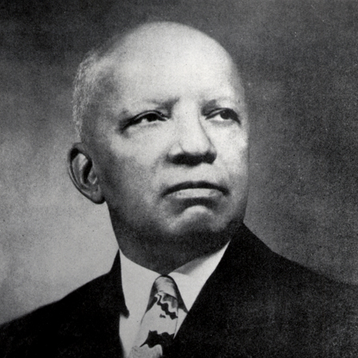

• Today we are going to learn some vocabulary words that are relevant to the life of Dr. Carter G. Woodson, his legacy, and the organization he started—the Association for the Study of African American Life and History. Then we are going to listen and read a short biography about Dr. Carter G. Woodson and tweet favorite facts about Woodson with the hash tags #Dr.CarterG.Woodson #NPS.

Adaptations for children who have disabilities (*not an exhaustive list for all disabilities, but a start): Create semantic maps for each vocabulary word. Create power cards for each vocabulary word. Pair appropriate words with a video that explains the meaning. Pair words with pictures that help visual learners. Enlarge the text for students with visual impairments or provide text in braille for students who use braille in the classroom. Provide all vocabulary words in audio format with accompanying definitions in audio format for students who need auditory supports.

Vocabulary word or phrase | Definition
Publisher | A person or company who produces books, journals, or software
Historian | A person who accurately writes about the facts, events, and social conditions of the past.
Forebears | An ancestor; someone who died a long time ago.
Accomplished | Having many talents and skills
Citizens | Someone who has the right to live in a country
Society | People who are bound together by similar institutions, communities, and structures.
Scholarly | Showing a great deal of knowledge
Negro History Week | Federally initiated by Carter G. Woodson in 1926 to celebrate the accomplishments of African Americans in the United States and across the world.
Heritage | Something someone is born into, the status or conditions established by one’s family or social class.
Compromise | To negotiate and reach a deal or agreement.
Principle | One’s ethical standard, values, or beliefs
Carpenter | A builder who works with wood
Fundamentals | The basics of something
Miner | Someone who works with coal in the mines
Diploma | A certificate that says one has graduated from an institution of learning (e.g. high school, college, graduate school).
Philosophy | A way of thinking and a way of life
social conditions | The circumstance in which one was born into or was subjected to may be beyond one’s control (e.g. access to income, education, etc.).
Period | A time in history
Association for the Study of Negro Life and History | Founded in 1915 by Dr. Carter G. Woodson to preserve, disseminate, and generate the study of Black History, the Association for the Study of Negro Life and History is called the Association for the Study of African American Life and History
journals | A magazine or periodical that is published by a professional body for its members (such as the Journal of African American History) for people who are interested in History
Journal of Negro History | Founded by Dr. Woodson in 1917, now called the Journal of African American History
The Negro History Bulletin | Co-founded by Dr. Woodson and Mary McLeod Bethune in 1937 to increase the knowledge of secondary education teachers who were teaching Black History. Now called the Black History Bulletin
Legitimate | Something that is valid
Integral | Vital to the survival of something
Research | Investigate or make an inquiry
Profound | sincere
Inquiry | Research or make an investigation

Adaptations for children who have disabilities (*not an exhaustive list for all disabilities, but a start):
Enlarge the text for students with visual impairments or provide text in braille for students who use braille in the classroom. Provide biography in audio format for students who need auditory supports. For museum settings: the audio format should be used in addition to any visual format as it is ideal for the lesson.

Short Biography: Carter G. Woodson
These are the words of Dr. Carter Godwin Woodson, distinguished Black author, editor, publisher, and historian (December 1875 – April 1950). Carter G. Woodson believed that Blacks should know their past in order to participate intelligently in the affairs in our country. He strongly believed that Black history – which others have tried so diligently to erase – is a firm foundation for young Black Americans to build on in order to become productive citizens of our society.
“Those who have no record of what their forebears have accomplished lose the inspiration which comes from the teaching of biography and history”
Known as the “Father of Black History,” Carter G. Woodson holds an outstanding position in early 20th century American history. Woodson authored numerous scholarly books on the positive contributions of Blacks to the development of America. He also published many magazine articles analyzing the contributions and role of Black Americans. He reached out to schools and the general public through the establishment of several key organizations and founded Negro History Week (precursor to Black History Month). His message was that Blacks should be proud of their heritage and that other Americans should also understand it.
Carter G. Woodson was born in New Canton, Buckingham County, Virginia, to former slaves Anne Eliza (Riddle) and James Henry Woodson. Although his parents could neither read nor write, Carter G. Woodson credits his father for influencing the course of his life. His father, he later wrote, insisted that “learning to accept insult, to compromise on principle, to mislead your fellow man, or to betray your people, is to lose your soul.”
His father supported the family on his earnings as a carpenter. As one of a large and poor family, young Carter G. Woodson was brought up without the “ordinary comforts of life.” He was not able to attend school during much of its five-month term because helping on the farm took priority over a formal education. Determined not to be defeated by this setback, Carter was able “largely by self-instruction to master the fundamentals of common school subjects by the time he was seventeen.” Ambitious for more education, Carter and his brother Robert Henry moved to Huntington, West Virginia, where they hoped to attend the Douglass High School. However, Carter was forced to earn his living as a miner in Fayette County coal fields and was able to devote only a few months each year to his schooling. In 1895, a twenty-year-old Carter entered Douglass High School, where he received his diploma in less than two years.
From 1897 to 1900, Carter G. Woodson began teaching in Winona, Fayette County. In 1900, he returned to Huntington to become the principal of Douglass H.S.; he finally received his Bachelor of Literature degree from Berea College, Kentucky. From 1903 to 1907, he was a school supervisor in the Philippines. Later he traveled throughout Europe and Asia and studied at the Sorbonne University in Paris. In 1908, he received his M.A. from the University of Chicago, and in 1912, he received his Ph.D. in history from Harvard University.
During his lifetime, Dr. Woodson developed an important philosophy of history. History, he insisted, was not the mere gathering of facts. The object of historical study is to arrive at a reasonable interpretation of the facts. History is more than political and military records of peoples and nations. It must include some description of the social conditions of the period being studied.
Woodson’s work endures in the institutions and activities he founded and promoted. In 1915, he and several friends in Chicago established the Association for the Study of Negro Life and History. The following year, the Journal of Negro History appeared, one of the oldest learned journals in the United States. In 1926, he developed Negro History Week and in 1937 published the first issue of the Negro History Bulletin.
Dr. Woodson often said that he hoped the time would come when Negro History Week would be unnecessary; when all Americans would willingly recognize the contributions of Black Americans as a legitimate and integral part of the history of this country. Dr. Woodson’s outstanding historical research influenced others to carry on his work. Among these have been such noted historians as John Hope Franklin, Charles Wesley, and Benjamin Quarles. Whether it’s called Black history, Negro history, Afro-American history, or African American history, his philosophy has made the study of Black history a legitimate and acceptable area of intellectual inquiry. Dr. Woodson’s concept has given a profound sense of dignity to all Black Americans.

Activity 2: Comprehension Activity Through Social Media

Adaptations for students who have disabilities (*not an exhaustive list for all disabilities, but a start): Depending on the student, a parent, paraprofessional or peer mentor may need to assist student with this activity.

Use the following hash tags. Fill in the sentence on your twitter feed.

#Dr.CarterGWoodson____________________________________
Go NPS#

You can use the following vocabulary words or phrases for ideas!

publisher
historian
author
Father of Black History
society
scholarly
Black History Bulletin
Journal of African American History
Berea College
University of Chicago
Harvard University Ph.D.
Washington DC
research
Association for the Study of African American Life and History (ASALH)

Activity 2.5
History, Maps, Places

Reason quantitatively and use units to solve problems.
CCSS.MATH.CONTENT.HSN.Q.A.1
Use units as a way to understand problems and to guide the solution of multi-step problems; choose and interpret units consistently in formulas; choose and interpret the scale and the origin in graphs and data displays.

Show students the following locations on a Google map: Dr. Carter G. Woodson’s home, the current location of the Association for the Study of African American Life and History, and Howard University.

- Dr. Carter G. Woodson’s Home National Historic Site: https://www.google.com/maps/place/Carter+G.+Woodson+Home+National+Historic+Site/@38.9108206,-77.0263962,17z/data=!3m1!4b1!4m5!3m4!1s0x89b7b7ee6584eae1:0xc17b04268f5fcc94!8m2!3d38.9108164!4d-77.0242075
- Howard University: https://www.google.com/maps/place/Howard+University/@38.9226885,-77.0216264,17z/data=!3m1!4b1!4m5!3m4!1s0x89b7b7fc56b4cef9:0x32dcc71fc8db77c2!8m2!3d38.9226843!4d-77.0194377
- Association for the Study of African American Life and History, located in the Howard Center: https://www.google.com/maps/place/Howard+Center,+2225+Georgia+Ave+NW+%23331,+Washington,+DC+20059/@38.9195061,-77.0237472,17z/data=!3m1!4b1!4m5!3m4!1s0x89b7b7fb54071ccb:0x3b0360f2f5551867!8m2!3d38.9195019!4d-77.0215585

- Go over each location again, delete (X out) the red pin which shows the students the spot for each exact location on the map of each designated location as you go through the maps.

- Have students locate the places on the map without the red pins first as a group, then individually or in pairs.

- See if students can identify two locations at once without the red pins (e.g. located ASALH and Howard University). Zoom the map out and see if students can located all three locations.

Inferential and critical thinking about maps:

- How do you think the map looked in the 19th century as compared to how it looks today?
- Can you provide some examples of how life would be different in 1922 when Dr. Carter G. Woodson bought this house and had ASNLH meetings here? How would the streets be different? How would the city of Washington DC be different? Why?

Activity 2.6
Mathematical Activity:
Using the Google map as a tool, figure out the miles it takes to drive to the following locations today in Washington DC:
- Drive from ASALH to Dr. Carter G. Woodson’s House, how many miles?
- Drive from Dr. Carter G. Woodson’s House to Howard University, where he taught college classes. How many miles?
- Round-trip, how many miles did Dr. Carter G. Woodson commute when he taught at Howard University?
- Tweet how many miles Dr. Carter G. Woodson commuted when he taught at Howard. Think about him walking the streets of Washington D.C. as an African American man during the historical times and the risks he took crossing the streets.

Activity 3 Materials needed:

• Frederick Douglass’ Autobiography
• Access to the Internet
• Paper or iPads (i.e., digital devices to write on)
• Copies of Frederick Douglass’ short biography
• Audio recordings of Douglass’ passages in lesson
• Audio recordings of Douglass’ short biography

Day 2

Adaptations for students who have disabilities (*not an exhaustive list for all disabilities, but a start):
Enlarge the text for students with visual impairments or provide text in braille for students who use braille in the classroom. Provide Douglass’ biography in audio format for students who need auditory supports. For museum settings: the audio format should be used in addition to any visual format as it is ideal for the lesson.
Learning about Frederick Douglass

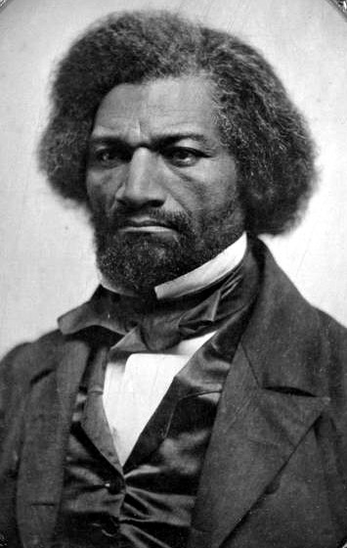

Warm up (Anticipatory Set):

• First let’s talk about Frederick Douglass. Can anyone tell me who he is and some of the great deeds he accomplished in history? Does anyone remember how Dr. Carter G. Woodson is connected to Frederick Douglass? Dr. Carter G. Woodson kept original manuscripts that Frederick Douglass wrote in this library.
Listen to a recording of Chapter 1 from one of Frederick Douglass’ books The Narrative of the Life of Frederick Douglass, written in 1845. Then we are going to watch a short biography of Douglass.

• This way we can start to understand the historical context and the insurmountable barriers that both Woodson and Douglass had to overcome as African American men who were born in the 18th and 19th centuries.

Activity 2
Pause for brief questions after the recording of Frederick Douglass’ Chapter 1 from The Narrative of the Life of Frederick Douglass

First, let’s learn a new word that you may not know. The correct word for slavery is enslavement. A person is not born a slave; they become enslaved by another human being who has chosen to misuse and abuse their power.

We have seen the words slave and slavery used a lot in books because those are the words that people used back then to describe the conditions of the times. However, today we choose to replace those derogatory terms with vocabulary words that more accurately reflect the true nature of what happened in history.

So when you read or hear certain historical words in our texts today, remember the context for how and when they were used.

- Compare: How does Frederick Douglass’ Chapter 1 compare to other books you have read about enslavement?
- Infer: Why do you think Frederick Douglass’ true story is so important?
- Infer: What would we think about enslavement if we only read certain history books and we did not read true accounts of what really happened, such as stories like Frederick Douglass’?

Activity 3

Listen: Now we are going to listen to the biography of Frederick Douglass’ life (what he accomplished after enslavement and recall the timeline of Douglass’ triumphant life).

Given what you learned about Frederick Douglass from his narrative, I want you to try to imagine the period of time during the late 1800s and what Frederick Douglass had to overcome to become one of the most successful self-educated people in history.

Short Biography: Frederick Douglass
Frederick Augustus Washington Bailey was born into slavery in Talbot County, Maryland, around 1818. The exact year and date of Douglass' birth are unknown, though later in life he chose to celebrate it on February 14.

Douglass initially lived with his maternal grandmother, Betty Bailey. At a young age, Douglass was selected to live in the home of the plantation owners, one of whom may have been his father. His mother, an intermittent presence in his life, died when he was around 10.

Learning to Reading and Write
Defying a ban on teaching slaves to read and write, Baltimore slaveholder Hugh Auld’s wife Sophia taught Frederick Douglass the alphabet when he was around 12. When Auld forbade his wife to offer more lessons, Douglass continued to learn from white children and others in the neighborhood.
It was through reading that Douglass’ ideological opposition to slavery began to take shape. He read newspapers avidly and sought out political writing and literature as much as possible. In later years, Douglass credited The Columbian Orator with clarifying and defining his views on human rights.
Douglass shared his newfound knowledge with other enslaved people. Hired out to William Freeland, he taught other slaves on the plantation to read the New Testament at a weekly church service. Interest was so great that in any week, more than 40 slaves would attend lessons. Although Freeland did not interfere with the lessons, other local slave owners were less understanding. Armed with clubs and stones, they dispersed the congregation permanently.
With Douglass moving between the Aulds, he was later made to work for Edward Covey, who had a reputation as a "slave-breaker.” Covey’s constant abuse nearly broke the 16-year-old Douglass psychologically. Eventually, however, Douglass fought back, in a scene rendered powerfully in his first autobiography. After losing a physical confrontation with Douglass, Covey never beat him again. Douglass tried to escape from slavery twice before he succeeded.

Abolitionist
After settling as a free man with his wife Anna in Bedford in 1838, Frederick Douglass was eventually asked to tell his story at abolitionist meetings, and he became a regular anti-slavery lecturer. Founder of The Liberator, William Lloyd Garrison, was impressed with Douglass’ strength and rhetorical skill, and wrote of him in his newspaper. Several days after the story ran, Douglass delivered his first speech at the Massachusetts Anti-Slavery Society's annual convention in Nantucket. Crowds were not always hospitable to Douglass. While participating in an 1843 lecture tour through the Midwest, Douglass was chased and beaten by an angry mob before being rescued by a local Quaker family.
Following the publication of his first autobiography in 1845, Douglass traveled overseas to evade recapture. He set sail for Liverpool on August 16, 1845, and eventually arrived in Ireland as the Potato Famine was beginning. He remained in Ireland and Britain for two years, speaking to large crowds on the evils of slavery. During this time, Douglass’ British supporters gathered funds to purchase his legal freedom. In 1847, the famed writer and orator returned to the United States a free man. Upon his return, Douglass produced some abolitionist newspapers: The North Star, Frederick Douglass Weekly, Frederick Douglass' Paper, Douglass' Monthly and New National Era. The motto of The North Star was "Right is of no Sex – Truth is of no Color – God is the Father of us all, and we are all brethren."

Women’s Rights
In addition to abolition, Douglass became an outspoken supporter of women’s rights. In 1848, he was the only African American to attend the first women's rights convention at Seneca Falls, New York. Elizabeth Cady Stanton asked the assembly to pass a resolution stating the goal of women's suffrage. Many attendees opposed the idea. Douglass stood and spoke eloquently in favor, arguing that he could not accept the right to vote as a black man if women could not also claim that right. The resolution passed.

Civil War and Reconstruction
By the time of the Civil War, Douglass was one of the most famous black men in the country. He used his status to influence the role of African Americans in the war and their status in the country. In 1863, Douglass conferred with President Abraham Lincoln regarding the treatment of black soldiers, and later with President Andrew Johnson on the subject of black suffrage.
President Lincoln's Emancipation Proclamation, which took effect on January 1, 1863, declared the freedom of all slaves in Confederate territory. Despite this victory, Douglass supported John C. Frémont over Lincoln in the 1864 election, citing his disappointment that Lincoln did not publicly endorse suffrage for black freedmen. Slavery everywhere in the United States was subsequently outlawed by the ratification of the Thirteenth Amendment to the Constitution.
Douglass was appointed to several political positions following the war. He served as president of the Freedman's Savings Bank and as chargé d'affaires for the Dominican Republic. After two years, he resigned from his ambassadorship over objections to the particulars of U.S. government policy. He was later appointed minister-resident and consul-general to the Republic of Haiti, a post he held between 1889 and 1891.
In 1877, Douglass visited one of his former owners, Thomas Auld. Douglass had met with Auld's daughter, Amanda Auld Sears, years before. The visit held personal significance for Douglass, although some criticized him for the reconciliation.

Vice Presidential Candidate
Douglass became the first African American nominated for vice president of the United States as Victoria Woodhull's running mate on the Equal Rights Party ticket in 1872. Nominated without his knowledge or consent, Douglass never campaigned. Nonetheless, his nomination marked the first time that an African American appeared on a presidential ballot.

When Did Frederick Douglass Die?
Frederick Douglass died on February 20, 1895 of a massive heart attack or stroke shortly after returning from a meeting of the National Council of Women in Washington, D.C. He was buried in Mount Hope Cemetery in Rochester, New York.

District of Columbia Social Studies Standard
4. Students construct and test hypotheses; collect, evaluate, and employ information from multiple primary and secondary sources; and apply it in oral and written presentations.

Activity 3, part 2:

Making Parallel Connections: Are sports still degrading for Black Athletes today? Do Black athletes have the freedom to make moral, intellectual, and political statements/stances in society without facing social consequences?

- Using your critical and creative thinking skills, I want you to study the following text and make a connection to what NFL football player Colin Kaepernick did when he took a moral stance and refused to stand for our national anthem. Kaepernick told reporters that:

There are a lot of things that are going on that are unjust [that] people aren’t being held accountable for. And that’s something that needs to change. That’s something that this country stands for — freedom, liberty, justice for all. And it’s not happening for all right now.
- Ironically taking this moral, intellectual stand as a public figure and as a Black professional athlete might have cost him his career, which leads one to believe that racism played a role. Kaepernick remains unsigned for the 2017-2018 season.

- What kinds of connections do you see from Kaepernick’s situation to what Douglass wrote in his autobiography in 1845? Are sports still degrading for Black Athletes today? Consider the various stereotypes, social expectations, and prejudice Black athletes deal with on and off the field. Are they allowed to take moral, political stands in society without facing hostility in general?
- Study this passage from Frederick Douglass’ Autobiography:

It was necessary to keep our religious masters at St Michael’s unacquainted with the fact that, instead of spending the Sabbath in wrestling, boxing, and drinking whisky, we were trying to learn how to read the will of God; for they had much rather see us engaged in those degrading sports than to see us behaving like intellectual, moral, and accountable beings.

- Read the following articles: Collect, evaluate and present information in an oral or written presentation about your opinion on Black athletes in today’s society arguing your stance on the following questions: Considering Kaepernick’s recent situation, have things changed much since Douglass’ passage in 1845? Do Black athletes have the freedom to make moral, intellectual, and political statements in society without facing social consequences?

https://www.washingtonpost.com/posteverything/wp/2016/08/30/insulting-colin-kaepernick-says-more-about-our-patriotism-than-his/?utm_term=.dee3ddc0b6cc

http://bleacherreport.com/articles/2730440-aaron-rodgers-says-colin-kaepernick-isnt-on-nfl-team-because-of-his-protests

OPTIONAL
Add vocabulary words for middle school students as necessary
Teachers, pre-teach the following vocabulary words to go with the above passage. The vocabulary definitions were written to match the context of Douglass’ autobiography.

Adaptations for students who have disabilities (*not an exhaustive list for all disabilities, but a start): Create semantic maps for each vocabulary word. Create power cards for each vocabulary word. Pair appropriate words with a video that explains the meaning. Pair words with pictures that help visual learners. Enlarge the text for students with visual impairments or provide text in braille for students who use braille in the classroom. Provide all vocabulary words in audio format with accompanying definitions in audio format for students who need auditory supports.

Activity 5
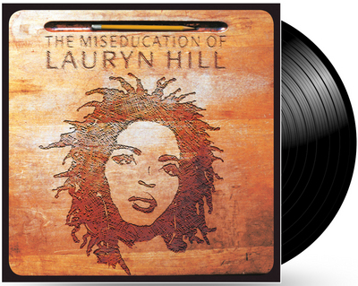 Lauryn Hill branched out and released her solo debut album after the Fugees disbanded in 1997. It was both a critical and commercial success, shooting to number one on the Billboard 200 upon its release. To this day, it remains a landmark record for both hip-hop and neo-soul. Hill later won five Grammys (including Album of the Year) for the LP.

Warm-up:
We are going to learn about an important song artist who was inspired by the work of Dr. Carter G. Woodson, specifically his book The MisEducation of the Negro written in 1933. The song artist we are going to learn about today is –Lauryn Hill who released an album in 1998 titled “The Miseducation of Lauryn Hill.”

Does anyone know what the prefix “mis” means? “Mis” means wrongly. So to be miseducated means to be educated wrongly. When Carter G. Woodson wrote his famous book The MisEducation of the Negro in 1933 in this very house, he wrote about the ways in which schools can lie to Black people and tell them that they are not equal to white people through the teachers, books, and treatment of African Americans in schools, and also that the ways in which students are taught can actually remove the passion and desire to learn. So this is part of the miseducation of African Americans. Here is a quote from Dr. Woodson’s book, the Miseducation of the Negro that explains his idea of what it means to be wrongly educated:

The same educational process which inspires and stimulates the oppressor with the thought that he is everything and has accomplished everything worth while, depresses and crushes at the same time the spark of genius in the Negro by making him feel that his race does not amount to much and never will measure up to the standards of other peoples. –CARTER G. WOODSON

Intro the MisEducation of Lauryn Hill
Teacher in the album taking attendance is Ras Baraka
Please respond when I call your name...
Alright, Kevin Charles... (here)
Jaris Boykins... (here)
Alicia Simmons... (here)
\
Phillip Valdez... (here)
Gabrielle Salado... (here)
Latoya Bradberry... (right here)
Antawn Mitchell... (here)
Shaquan Sutton... (here)
Cory Thomas... (here)
Tyron Lucas... (here)
Kennia Codwell...(here)
Tanika Marshall... (here)
Lauryn Hill...
Lauryn Hill...
Lauryn Hill...
Walton Spates... (here)
(music fades)

The MisEducation of Lauryn Hill—Lyrics
My world it moves so fast today
The past it seems so far away
And life squeezes so tight that I can't breathe
And every time I try to be, what someone else has thought of me
So caught up, I wasn't able to achieve
But deep in my heart, the answer it was in me
And I made up my mind to define my own destiny
I look at my environment
And wonder where the fire went
What happened to everything we used to be
I hear so many cry for help
Searching outside of themselves
Now I know his strength is within me
And deep in my heart, the answer it was in me
And I made up my mind to define my own destiny
And deep in my heart...
And deep in my heart, the answer it was in me
And I made up my mind to define my own destiny

Answer the following questions in complete sentences. (written or orally). You may complete this activity on a tablet or with a chaperone in a discussion circle.

Analyzing Order and Juxtaposition
Artists, film directors, and songwriters often choose to use events, voice-overs, and on-screen text to present their point of view.

- Analyze: How did Lauryn Hill accomplish this through the use of Ras Baraka at the beginning of her album taking attendance and then including the rest of the lyrics later in the album?
- Infer (or draw a conclusion): What did it mean when the teacher kept saying the artist’s name and she did not answer?

Analyze Lauryn Hill’s Point of View
Hi, this is Lauryn Hill, and I want to tell you guys a little bit about a song that means a great deal to me. The song is called, “The Miseducation of Lauryn Hill,” and it has a lot to do with how I figured out some things from my life. It doesn’t necessarily mean miseducation like I didn’t do well in school– as I did well in school– but it has a lot to do with finding out about your own aspirations and your own dreams, and not those dreams and those aspirations that some might have for you. It’s a song about movement and growth and inspiration.
- Identify: What is the main idea that Lauryn Hill is trying to express through her song (as stated in her own words)?
- Infer (or draw a conclusion): How does this contribute to Lauryn Hill’s idea of what it means to be miseducated?

Compare Lauryn Hill’s Lyrics to the selected passage from Woodson’s Miseducation of a Negro that we listened to earlier:
- Evaluate and Create: In history, we often reflect on the unintended consequences of specific times and events. Have you ever been miseducated or told you will never measure up to the standards of other people? What are some of the unintended consequences of being miseducated?
- Express: Write an essay on what you think it means to be miseducated and what some of the solutions to the problem of miseducation should be, citing Carter G. Woodson’s Miseducation of the Negro. (High School only)

Activity 6
4.M.2 – Reading/English Language Arts/Media Create presentations using audio recordings of poems and/or stories.

Create: Using your recorders on your smart phone and some of the words in the optional word bank, create your own lyrics about what it means to be miseducated to you.

• heart
• own
• dreams
• someone else
• my
• Miseducation
• destiny
• steal
• equality
• oppress

Tweet one line of your new song with the following hash tags: #NPS #CarterGWoodson

Activity 7
Learning about Carter G. Woodson’s Education
Have students pursue education charts to fill out about Woodson’s other educational experiences at Harvard University and University of Chicago. Then have them complete comparison charts.

Berea College
Divide the class into small groups of 3-4 students.

“We are going to watch a video from Berea College and learn about the important history surrounding the founding of that institution. Watch the video on Youtube here:
https://www.youtube.com/watch?v=5Xvl8ceFoR4

Originally founded in 1855 by abolitionist John Gregg Fee, Berea College was the first co-educational and racially integrated higher learning institute in the South. Dr. Carter G. Woodson obtained his bachelor’s degree in literature from Berea College in 1903.
Complete the chart about Woodson’s education.

Harvard University  (Fill out chart like this for University of Chicago) | What was happening historically when Dr. Woodson attended Harvard University? | What made Harvard University different from other colleges during that time? | What kind of environment do you think Harvard was for Dr. Woodson? (friendly, racially hostile, neutral, none of the above) as compared to Berea College? Why?
Find any information you can about Dr. Woodson’s educational experience at Harvard, document here: | What was the social experience at Harvard for Dr. Woodson? | What were the racial demographics at Harvard during the time Dr. Woodson attended? | Create a 15 minute multi-media presentation (your choice which kind) that documents Dr. Woodson’s educational experiences at all three institutions. Include how his experiences might have been different if he attended universities today.
 |  |  | Middle school only has to do a 7 minute presentation

Encourage students to consult other primary and secondary sources on the internet to make connections between the history of African Americans during the time Carter G. Woodson attended Berea College, University of Chicago, and Harvard University.

Reflective Activity (Whole Group): Written and Oral

- Document your main findings about the history of African Americans and their experience in college during the early 1900s.
- Imagine you were going to college as an African American during that time.
- What do you think it would be like?

Activity 8
Becoming an Forensic Historian in Dr. Carter G. Woodson’s Library
First pre-teach the following words, using visuals in Dr. Woodson’s library when/if possible. If not, use visuals in the classroom to go with the vocabulary definitions.

Pre-teaching vocabulary Words
Artifacts | Objects made by a human being that has cultural or historical interest
Archives | Collection of documents, letters, official papers, photographs, recorded material
Collections 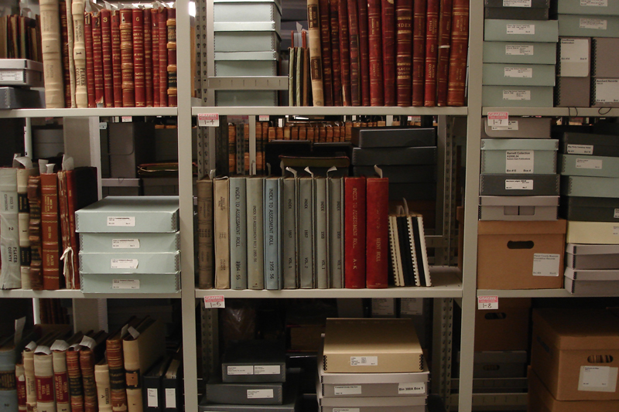 | Groups of writing, music, books, and other objects that are together

Activity 9 continued
Scavenger Hunt:
“Today we are going to locate some specific documents, important journals, and publications that Dr. Carter G. Woodson co-founded, created, or started during his life.”
Adaptions for the Classroom:
Find a partner and conduct a digital search on the internet for the following artifacts. It may help to click on images when you search and also check the ASALH website.

Adaptions for Woodson Home:
Find a partner and search the archives in Dr. Woodson’s house for the following artifacts:

Forensic historian artifact hand-outs
Directions: Make an X on the visual representation of the artifact when you locate it in Dr. Woodson’s house or on the internet.

- Table of Contents: The Journal of Negro History
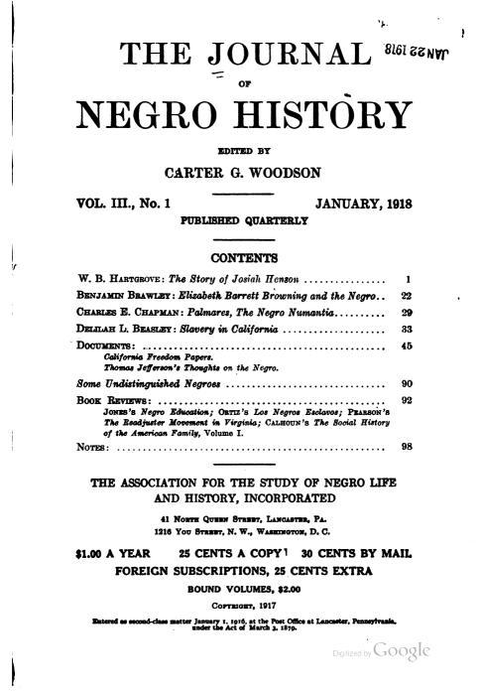

- Letter written to Mr. Thomas H. Barnes requesting the establishment of a Black Studies Department in New Orleans, N.Y. 1927:
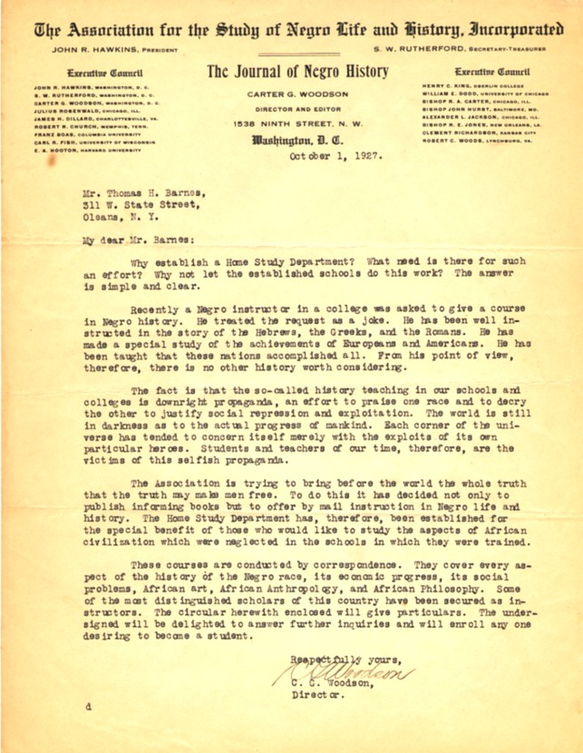

- Description: The Negro in Our History from ASNLH

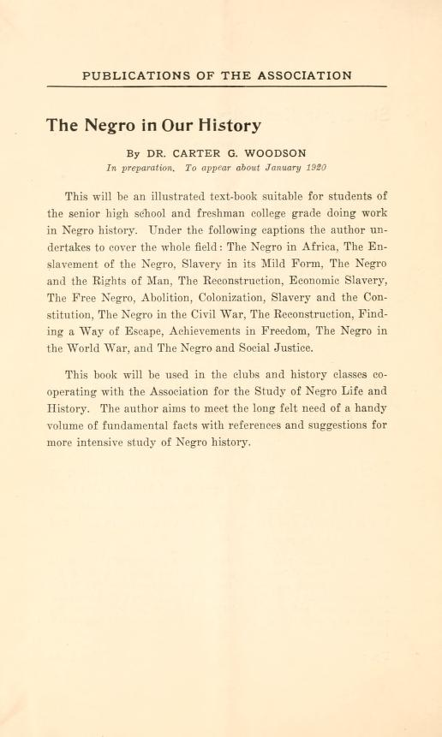

- What the public thinks about The Journal of Negro History:

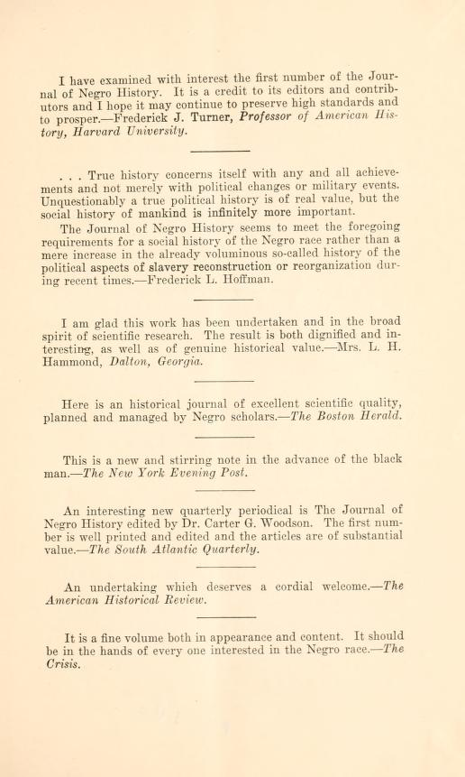

- Early Literature about The Associated Publishers, INC.

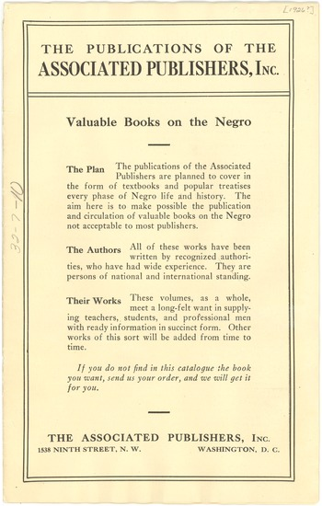

- Federally recognized celebration: Negro History Week, established in 1926
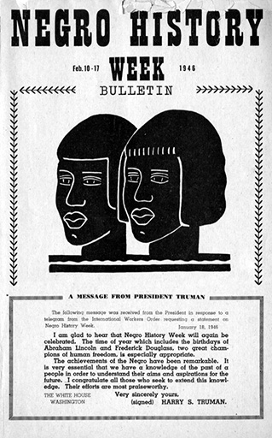

- Federally recognized celebration: Black History Month, established in 1976

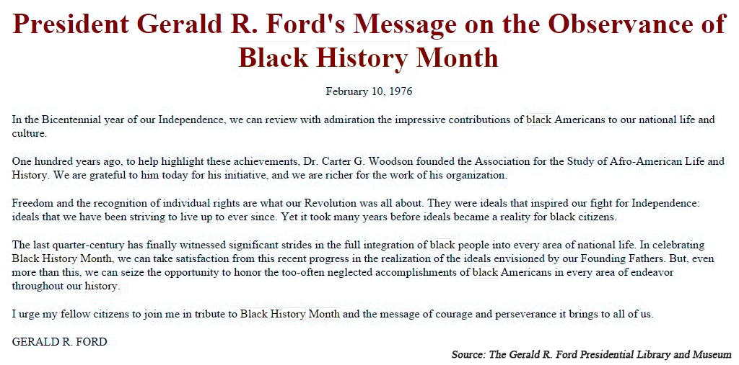

Activity 10: Historical Architecture

Becoming an restorative architect at Carter G. Woodson’s house

Study this fireplace, which was completely restored to the original one from 1922 using the bricks from the original house.

- Study the picture of the fireplace or the actual fireplace. Measure the width, and height of the fireplace. 2. Measure the width and height of the fireplace in feet if you are at the museum.
- Calculate the area.

For example, a 10 foot wide wall that is 8 feet high would be 80 feet squared or 80 ft² because 10 times 8 = 80

After you determine the area of the surface that you would hypothetically need to restore with bricks (if you were the restorative architect), you need to figure out the area that each brick will cover.

- To do that: You need to find the square footage of each brick and divide by 144 to convert square inches to square feet. For example, a modular brick is 7 ⁵⁄₈” wide x 2 ¹⁄₄” high. To get the square footage of a modular brick you would use the formula (7 ⁵⁄₈ x 2 ¹⁄₄)/144 = .12

- Estimate the number of bricks you would need as a restorative architect to cover the fireplace by dividing the square footage of the area (from the problem you solved above) by the square footage of the brick (wall square footage divided by block square footage). For example, to find the number of bricks to cover the 80 ft² from the example above we would follow the formula 80 / .12 = 667 bricks

Measure the width of the wall inside the fireplace in feet?  Measure the height of the wall in feet? | Calculate the area. | What is the area of the fireplace?  Height times Width=  H x W = | How many bricks do we need?  Take the area of the fireplace and divide by .12

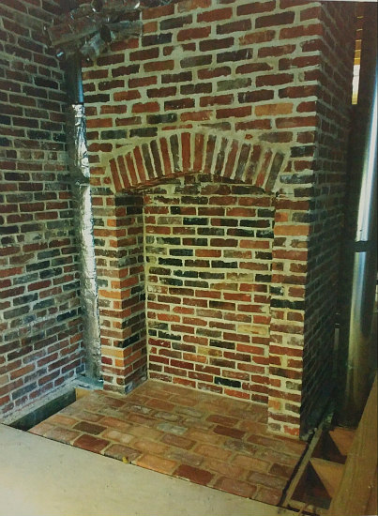

Activity 11

Influential Women who climbed the stairs in Woodson’s home.

Dr. Mary McLeod Bethune and Zora Neale Hurston

Connections to Middle School and High School:

- The struggles that men and women have faced in overcoming political oppression, economic exploitation, religious persecution, and racial injustice.

Common Core English
- CCSS.ELA-LITERACY.RL.9-10.1
Cite strong and thorough textual evidence to support analysis of what the text says explicitly as well as inferences drawn from the text.
- CCSS.ELA-LITERACY.RL.9-10.2
Determine a theme or central idea of a text and analyze in detail its development over the course of the text, including how it emerges and is shaped and refined by specific details; provide an objective summary of the text.
- CCSS.ELA-LITERACY.RL.9-10.3
Analyze how complex characters (e.g., those with multiple or conflicting motivations) develop over the course of a text, interact with other characters, and advance the plot or develop the theme.

Dr. Mary McLeod Bethune
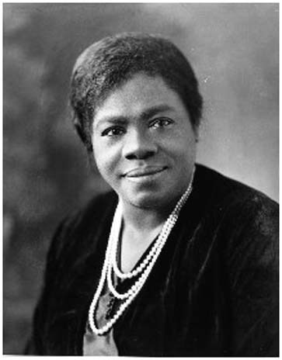
Dr. Mary McLeod Bethune had a vision for teachers across the United States that they could access the true history of African Americans in the United States; thus co-founding the Black History Bulletin with Dr. Carter G. Woodson in 1937, which celebrated its 80th year anniversary in 2017. Bethune’s work in the Association for the Study of African American Life and History was key in the movement for racial justice. She was the first female president of ASALH from 1936 to 1951 “and is one of the most outstanding women role models in our history,” (ASALH, 2018).

She also had the some of the following noteworthy contributions to humanity:

- Florida Chapter President of the National Association of Colored Women from 1917-1925

- President of the Southeastern Association of Colored Women’s Clubs

- Founder of the National Council of Negro Women (NCNW)

- First African American female division head of the NationalYouth Administration, federal agency created under Roosevelt’s Works Progress Administration

- In 1994, the National Park Service acquired Bethune's last residence, the NACW Council House at 1318 Vermont Avenue. The former headquarters was designated as the Mary McLeod Bethune Council House National Historic Site.

Research Activity

Pick one of Mary McLeod Bethune’s achievements or research another one of her contributions to humanity on your smart device write an investigative report about your favorite achievement.

Twitter Activity
Tweet 280 characters or less about Mary McLeod Bethune’s achievements with the hash tags: #NPS #McLeodBethune

Activity 11 continued

Influential Women who climbed the stairs in Woodson’s home.

Zora Neale Hurston
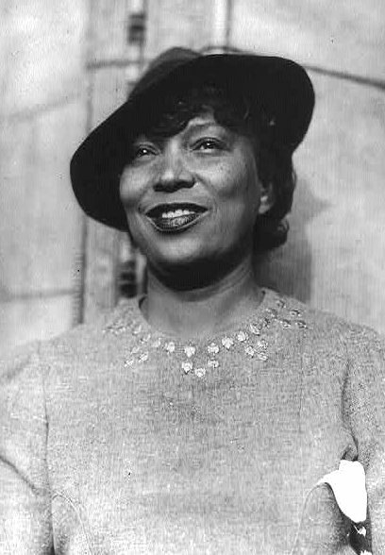
Zora Neale Hurston was born in Eastonville Florida, which is the home of the Zora Neale Hurston Museum of Fine Arts. She was one of the women who was influenced by Dr. Carter G. Woodson and climbed his stairs, was a feminist thinker who developed spiritual overtones in her books and essays. Gnostic, religious and existential spiritual themes have proliferated in Zora Neale Hurston’s writings. For example Janie, the main character in Their Eyes Were Watching God often describes divine aspects of the natural world.

Here are some of the novels she published in her lifetime. She also wrote a play called Mule Bone: A Comedy of Negro Life with Langston Hughes (1930).

• Jonah’s Gourd Vine (1934)

• Mules and Men (1935)

• Their Eyes were Watching God (1937)

• Moses, Man on the Mountain (1939)

• Dust Tracks on a Road (1942)

• Seraph on a Suwanee (1948)

• The Sanctified Church (1981)

Investigative Report
Read a chapter from your favorite novel by Zora Neale Hurston. Write a one to three page book report on her novel. Modification for students with learning disabilities: read a passage of one of her books and write one- three sentences or paragraphs about the best part of the book.

Twitter activity
Tweet about your favorite book by Zora Neale Hurston in 280 characters or less with the hash tags #NPS #NealeHurston

Books by Carter G. Woodson:

- The Education Of The Negro Prior To 1861: A History of the Education of the Colored People Of The United States From The Beginning of Slavery to the Civil War (New York: Putnam’s, 1915. Repr. Ayer Co., 1968 LC2741.W7).

- A Century Of Negro Migration. (Washington, D.C.: ASNLH., 1918) Repr. Russell, 1969. E185.9.W89).

- The History Of The Negro Church. (Washington, D.C.: Associated Publishers, 1921 BR563.N9W6).

- THE Negro In Our History. (Washington, D.C.: Associated Publishers, 1922. E185.9 .W89 1970).

- FREE Negro Owners Of Slaves In The United States In The United States In 1830: Together With Absentee Ownership Of Slaves In The United States In 1830, ed. (Washington: ASNLH., 1924; Repr. Negro Univ. Press. E185.W8873).

- FREE Negro Heads Of Families In The United States In 1830: Together With Brief Treatment Of The FREE Negro. (Washington: ASNLH., 1925. F185.W887125).

- Negro Orators And Their Orations, ed. (Washington: Associated Publishers, 1926. Repr. Russell, 1969. PS663.N4.W6).

- The Mind Of The Negro As Reflected In Letters Written During The Crisis, 1800-1860, ed. (Washington: ASNLH., 1926. Repr. E185.W8877 1969b).

- Negro Makers Of History. (Washington: Associated Publishers, 1928. E185.W85).

- African Myths Together With Proverbs: A Supplementary Reader Composed Of Folk Tales From Various Parts Of Africa. Adapted to use of children in the public schools. (Washington: Associated Publishers, 1928. PE1127.G4 W7).

- The Negro As A Businessman, joint author with John H. Harmon, Jr. and Arnett G. Lindsay. (Washington: Associated Publishers, 1929. E185.8.H251).

Books by Carter G. Woodson continued…

• The Negro Wage Earner, joint author with Lorenzo J. Greene. (Washington: ASNLH., 1930. Repr. AMS Press. E185.G79).

- The Rural Negro. (Washington: ASNLH., 1930. Repr. Russell, 1969. E185.86.W896).

- THE Mis-education Of The Negro. (Washington: Associated Publishers, 1933. Repr. AMS Press, 1972. LC2801.W6 1977).

- The Negro Professional Man And The Community: With Special Emphasis On The Physician And The Lawyer. (Washington: ASNLH.,1934 Repr. Negro University Press, 1969. Johnson Reprints E185.82.W88).

- THE Story of the Negro Retold. (Washington: Association Publishers, 1935. E185.W898).
- THE African Background Outlined. (Washington: ASNLH., 1936. DT351.W89.

- African Heroes And Heroines. (Washington: Associated Publishers, 1939. DT3525.W66).

Teacher Resources:
- Library of Congress’ Teacher’s Guide: Analyzing Photographs & Prints: http://www.loc.gov/teachers/usingprimarysources/resources/Analyzing_Photographs_and_Prints.pdf.
- Library of Congress’ Teacher’s Guide: Analyzing Primary Sources:
http://www.loc.gov/teachers/usingprimarysources/resources/Analyzing_Primary_Sources.pdf

- Guidebook to African American History in the National Parks http://www.eparks.com/store/product/92424/Guidebook-to-African-American-History-in-the-National-Parks/
- District of Columbia Social Studies Pre-K through Grade 12 Standards
https://osse.dc.gov/sites/default/files/dc/sites/osse/publication/attachments/DCPS-horiz-soc_studies.pdf

National Curriculum Standards for the Social Studies https://www.socialstudies.org/standards

District of Columbia Embedded Technology Standards https://osse.dc.gov/sites/default/files/dc/sites/osse/publication/attachments/Embedded_Technology_Standards_into_other_Content_Standards.pdf.

Common Core State Standards High School: Reading Literature: Grades 9-10 http://www.corestandards.org/ELA-Literacy/RL/9-10/
Common Core State Standards High School: Number and Quantity http://www.corestandards.org/Math/Content/HSN/Q/#CCSS.Math.Content.HSN.Q.A.1

Common Core State Standards Grade 8 Geometry
http://www.corestandards.org/Math/Content/8/G/.

Notes:

Brittany Omoleye-Hall, “Overview of Dr. Carter G. Woodson: The Carter G. Woodson Home National Historic Site,” Panel 1, National Park Service.
Brittany Omoleye-Hall, “The Journal of Negro History, Negro History Week, and The Negro History Bulletin,” Panel 2, National Park Service.
Brittany Omoleye-Hall, “If These Walls Could Talk: 1538 Ninth Street, N.W. and The People who Assisted in the Creation of the Black History Movement,” Panel 3, National Park Service.
District of Columbia, “Social Studies, PreK through Grade 12 Standards,” accessed August 15, 2017, https://osse.dc.gov/sites/default/files/dc/sites/osse/publication/attachments/DCPS-horiz-soc_studies.pdf, 4.
National Curriculum Standards for the Social Studies, accessed February 21, 2017, https://www.socialstudies.org/standards/strands.
" District of Columbia, Social Studies, PreK through Grade 12 Standards,” pages 48-49.
Ibid., pages 88-89.
District of Columbia, “Embedded Technology Standards,” DC Office of the Superintendent, accessed August 15, 2017, https://osse.dc.gov/sites/default/files/dc/sites/osse/publication/attachments/Embedded_Technology_Standards_into_other_Content_Standards.pdf, 5.
Ibid., p. 11.
Ibid., p. 8
Ibid., p. 5
Common Core State Standards, “English Language Arts Standards: Reading Literature: Grades 9-10,”accessed February 23. 2018. http://www.corestandards.org/ELA-Literacy/RL/9-10/.
Common Core State Standards, “Math Standards Grade 4 Overview,” accessed August 29, 2017, http://www.corestandards.org/wp-content/uploads/Math_Standards1.pdf, 27.
Common Core State Standards, “High School: Number and Quantity,” accessed November 1, 2017, http://www.corestandards.org/Math/Content/HSN/Q/#CCSS.Math.Content.HSN.Q.A.1
Common Core State Standards, “Grade 8 Geometry,” accessed November 1, 2017, http://www.corestandards.org/Math/Content/8/G/.
Definitions of vocabulary words were written with the assistance of the Encarta Dictionary: English (North America) available through Microsoft Word.
NAACP History: Carter G. Woodson, accessed August 17, 2017, http://www.naacp.org/oldest-and-boldest/naacp-history-carter-g-woodson/.
Biography, “Frederick Douglass,” accessed August 17, 2017 https://www.biography.com/people/frederick-douglass-9278324.
Ibid., pages 88-89.
Kareen Abul-Jabbar, “Let Athletes Love their Country in their Own Ways,” Washington Post, August 30, 2016, accessed August 31, 2017 https://www.washingtonpost.com/posteverything/wp/2016/08/30/insulting-colin-kaepernick-says-more-about-our-patriotism-than-his/?utm_term=.7b1e2f33f13d.
Frederick Douglass, Narrative of the Life of Frederick Douglass, an American Slave (New York: Barnes & Noble Books, 2003), 74-75. (Originally published in 1845 by the Anti-Slavery Office.)
Carter G. Woodson, The Miseducation of the Negro (Washington: Associated Publishers, Inc., 1933).
Lauren Hill, “The MisEducation of Lauren Hill,” Lyrics
Ibid.
District of Columbia, “Social Studies, PreK through Grade 12 Standards,” accessed August 15, 2017, https://osse.dc.gov/sites/default/files/dc/sites/osse/publication/attachments/DCPS-horiz-soc_studies.pdf.
Common Core State Standards, “English Language Arts Standards: Reading Literature: Grades 9-10,”accessed February 23. 2018. http://www.corestandards.org/ELA-Literacy/RL/9-10/.
ASALH, Mary McLeod Service Bethune Service Award, accessed February 19, 2018, https://asalh.org/awards/mary-mcleod-bethune-service-award/.
Wikipedia, Mary McLeod Bethune, accessed February 19, 2018, https://en.wikipedia.org/wiki/Mary_McLeod_Bethune.
Sarah Militz-Frielink, “Toward a Liberatory Pedagogy: A Genealogy of Black Feminist Pedagogy,” Black History Bulletin 77, no. 2 (Fall, 2014): 17.

