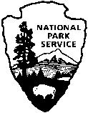National Park Service  U.S. Department of the Interior | Catoctin Mountain Park |  | 6602 Foxville Road  Thurmont, MD 21788  (301) 663-9388 phone  (301) 271-2764 fax

Catoctin Mountain Park News Release

April 22, 2014
For Immediate Release
Mel Poole, Superintendent

Catoctin Mountain Park Concludes Deer Management Actions for Winter 2013-2014 and Conducts Population Surveys

THURMONT, MD – Catoctin Mountain Park completed the fifth year of white-tailed deer population reduction as prescribed in the Catoctin White-tailed Deer Management Plan / Final Environmental Impact Statement. The plan addressed the inability of native forests to regenerate due to consumption of tree and shrub seedlings by an increasing deer population.

Park staff worked with United States Department of Agriculture Biologists to carry out the herd reduction as a safe and humane operation. This included using highly qualified and experienced personnel familiar with the park’s geography, establishing safety zones and conducting population reduction actions in closed areas of the Park, shooting from elevated positions with a safe backdrop, and utilizing non-lead ammunition. Reduction took place between November 2013 and March 2014, resulting in the removal of 156 deer from the park. A total of 6,046 pounds of venison was donated to the Thurmont Food Bank in Frederick County, Maryland during the winter of 2013-2014.

Deer Management will continue annually to reduce the deer population at Catoctin. Before the first season of deer management began in February 2010, there were approximately 123 deer per square mile in the Park. Before the fifth season reduction began the deer population was estimated by NPS Biologists to be 36 deer per square mile. This is still more than 2 times higher than the density of deer in healthy forest ecosystems (15 deer per square mile). The number of deer removed each year will be based on the results of annual vegetation monitoring and deer population monitoring conducted each fall.

Spring deer population monitoring spotlight surveys will be conducted April 24, 25, 28, 29, and 30. There will be no road closures during the spotlight survey, which will occur after dusk.

-more-

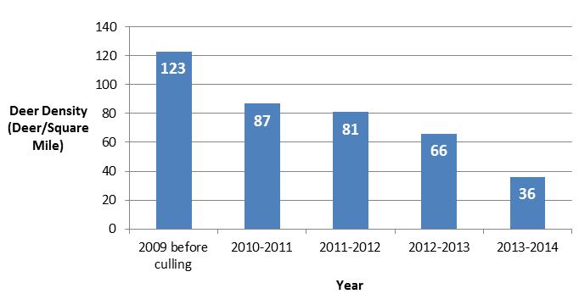

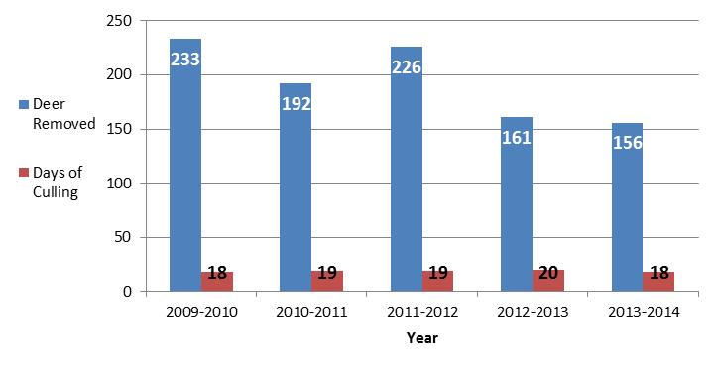

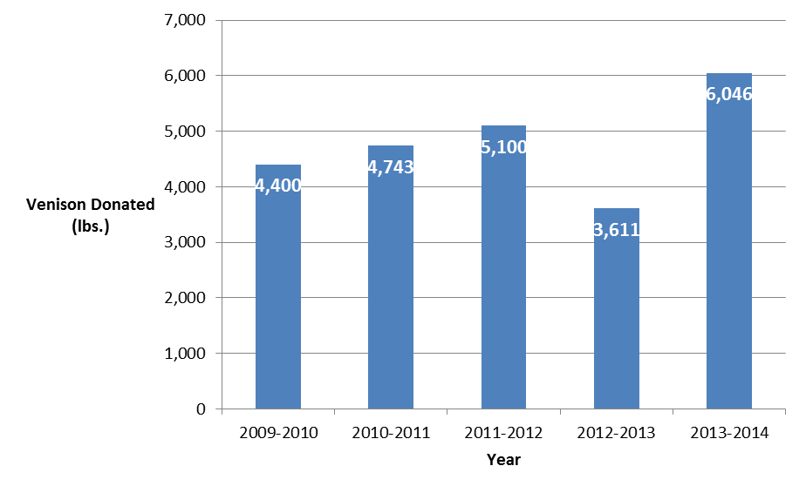

Catoctin Mountain Park is one of over 400 units administered by the National Park Service, U.S. Department of the Interior. Correspondence should be addressed to: Superintendent, Catoctin Mountain Park, 6602 Foxville Road, Thurmont, MD 21788. Please visit the Catoctin Mountain Park website at www.nps.gov/cato for more information. General information can be obtained by calling the Visitor Center at (3010 663-9388. The Park Visitor Center is open Sunday-Saturday from 9:30 a.m. until 5:00 p.m. daily. Emergency calls should be directed to the National Capital Region Communications Center at 1-866-677-6677.

-NPS-

EXPERIENCE YOUR AMERICA™
The National Park Service cares for special places saved by the American people so that all may experience our heritage.

