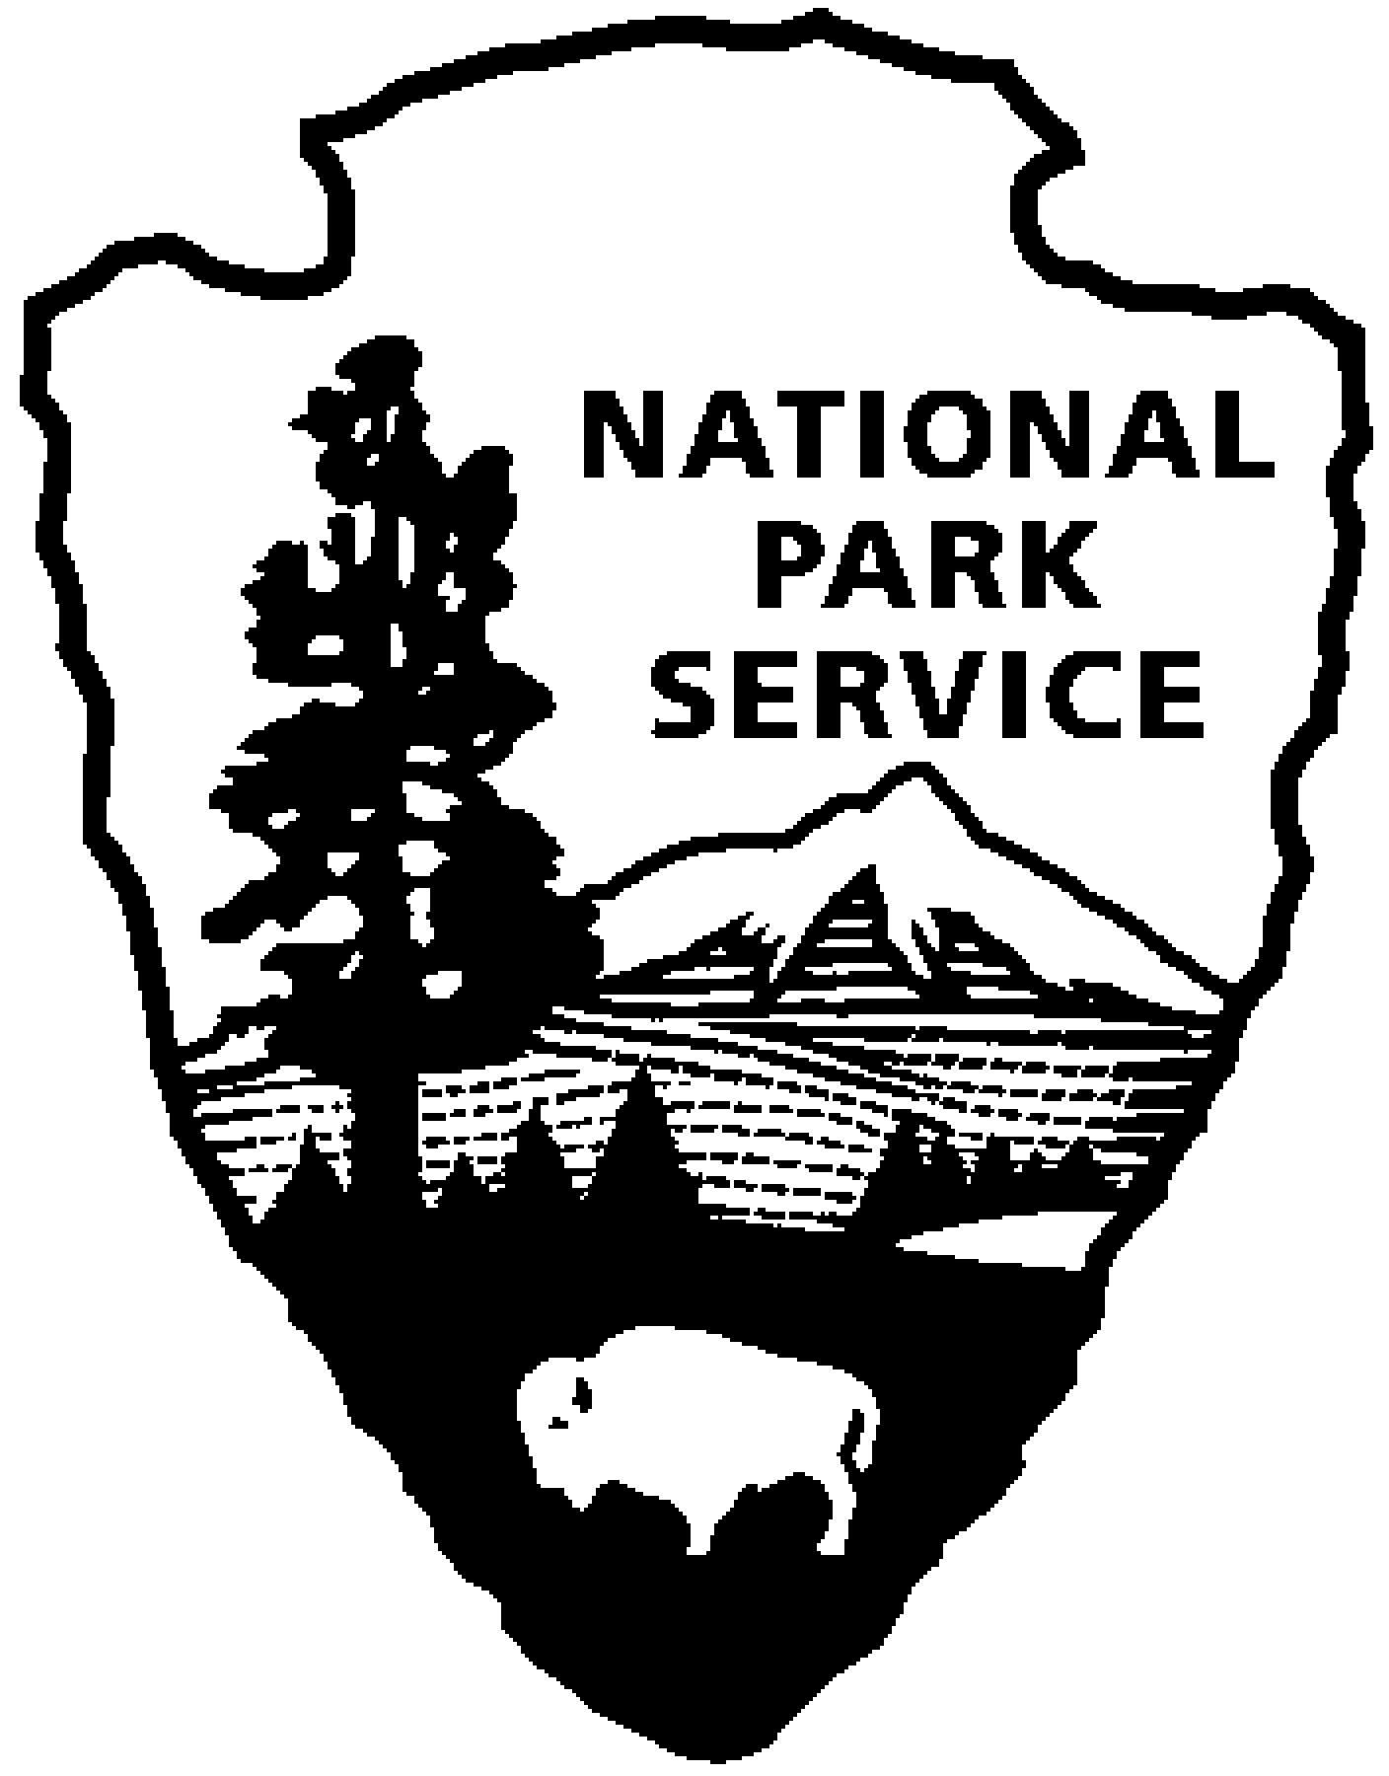National Park Service  U.S. Department of the Interior | Catoctin Mountain Park |  | 6602 Foxville Road  Thurmont, MD 21788  (301) 663-9388 phone  (301) 271-2764 fax

Catoctin Mountain Park News Release

August 1, 2014
For Immediate Release
Debra Mills

Catoctin Mountain Park Invites Individuals and Groups to Join the Barberry Brigade

It has been stated that the invasive of non-native, alien plants is the most irreversible human impact on earth’s ecosystem. Catoctin Mountain Park hopes to lessen the impact of Japanese Barberry through citizen involvement in the “Barberry Brigade.”

“Japanese Barberry was introduced for erosion control because it grows and spreads quickly,” states Superintendent Mel Poole, “these same traits have made it a forest monster, displacing native vegetation that provides food and shelter for forest wildlife. We hope to reverse this trend and encourage a balanced forest-ecosystem with volunteer help through the Barberry Brigade.”

The goal of the Barberry Brigade is to recruit 100 volunteer teams to contribute 100 hours or more with the objective of removing visual signs of Japanese Barberry within 100 feet of all roads, trails and developed areas in Catoctin Mountain Park by the 100th Anniversary of the National Park Service on August 25, 2016. Participating individuals volunteering 10 or more hours to this cause will receive a special patch. All members of the Barberry Brigade will be invited to a recognition picnic on National Public Lands Day in September, 2016.

The Barberry Brigade will require more enthusiasm than skill, as plants will be literally ripped from the soil. Interested individuals or groups may enlist by contacting Volunteer Coordinator Debra Mills at debbie_mills@nps.gov, or by calling 301-663-9399. Participation is possible year-round, but conditions for pulling are best in late Spring and early Fall.

Catoctin Mountain Park is one of over 400 units administered by the National Park Service, U.S. Department of the Interior. The park Visitor Center, located on State Route 77 three miles west of Thurmont, Maryland, is open daily from 9:30 a.m. until 5:00 p.m., and until 7:00 p.m. on Fridays and Saturdays. Correspondence should be addressed to: Superintendent, Catoctin Mountain Park, 6602 Foxville Road, Thurmont, MD 21788. Our website address is www.nps.gov/cato. General information can be obtained by calling the Visitor Center at (301) 663-9388.

-NPS-

EXPERIENCE YOUR AMERICA™
The National Park Service cares for special places saved by the American people so that all may experience our heritage.

