Birds Resource Brief

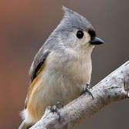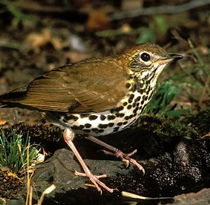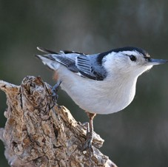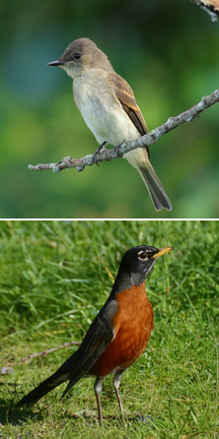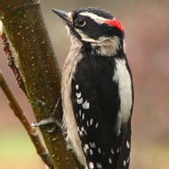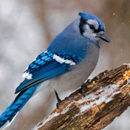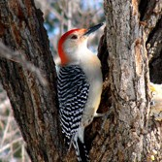Red-bellied Woodpecker
.36

Eastern Tufted Titmouse
.36

Blue Jay
.38

Downy Woodpecker
.41
All photographs are used with permission of the Cornell Lab of Ornithology. Individual photographers noted on reverse.

Eastern Wood-Pewee
.48

Regional Bird Monitoring
Since 2007, the National Capital Region Network (NCRN) Inventory & Monitoring program has monitored birds at approximately 385 forest plots throughout the region. Birds are monitored at each plot twice every summer for a total of 770 visits a year. Because this long-term monitoring program occurs within forest habitats, it only accounts for bird species found in forests.

Top 10 Most Common Birds at Catoctin Mountain Park
The pictures of birds stacked on the left side of the page represent the most commonly found birds in Catoctin’s forests. The largest picture in the stack, the Red-eyed Vireo, represents the species with the highest density of birds per hectare (ha) of forest. There are 1.36 Red-
eyed Vireos per hectare (although we don’t actually have fractions of birds).
The smaller the image, the lower the species density rate and the less likely you are to find that species of bird. That means you’re about twice as likely to find a Red-eyed Vireo (1.36 birds/ha) as the next bird in the list, the Scarlet Tanager (.73 birds/ha).
What’s impressive about this top ten list is that it includes a species of conservation con-

American Robin
.48

White-breasted Nuthatch
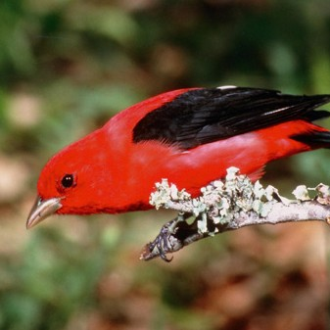
.49
cern. The Wood Thrush, framed in yellow, is designated as a “watchlist species” by the Partners in Flight program. The fact that it makes Catoctin’s top ten list means that this vulnerable species is finding valuable habitat at Catoctin. For a full list of birds found in Catoctin’s forests, see reverse.

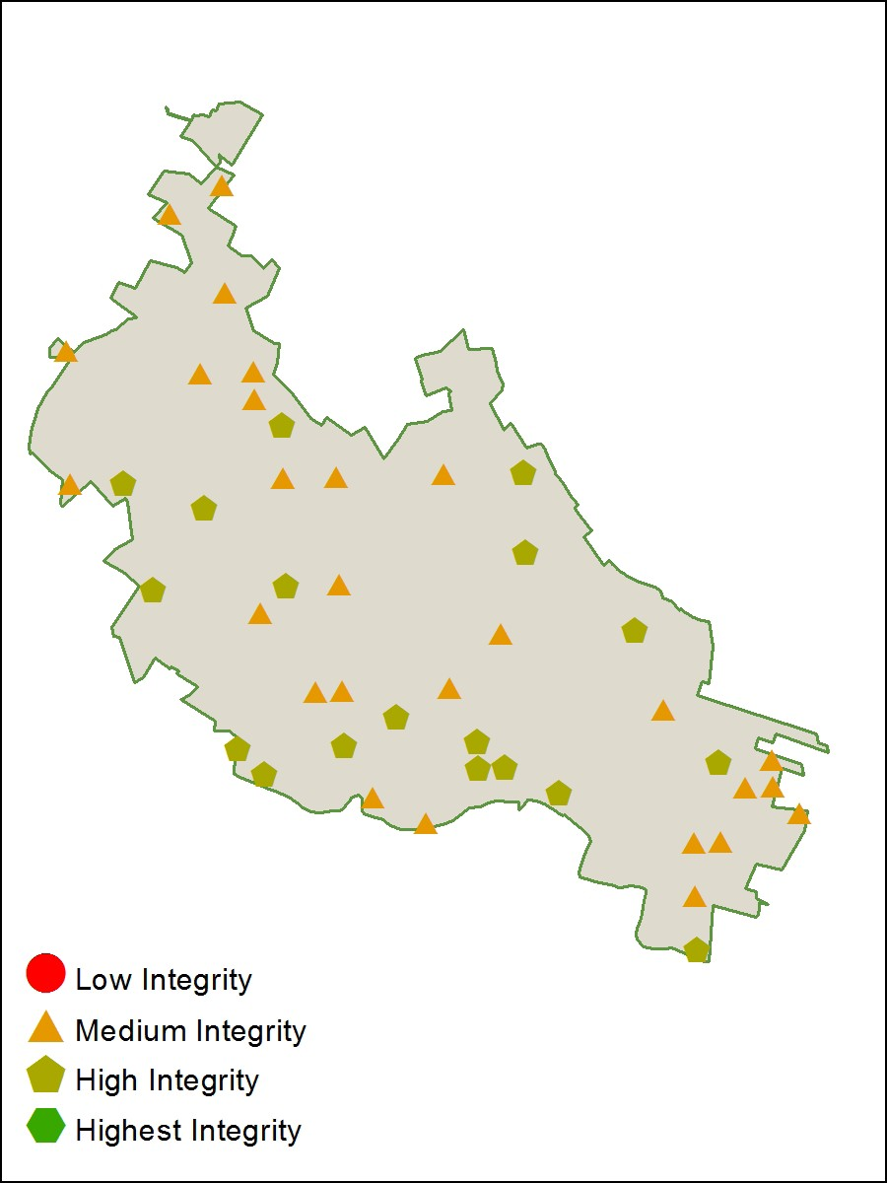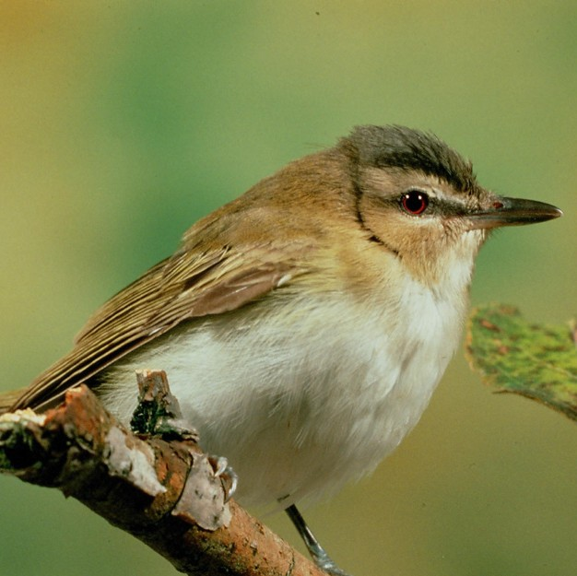
Wood Thrush
.65

Scarlet Tanager
.73
Bird Monitoring Plots & Habitat Quality
Birds are monitored at forty-five forest plots in Catoctin Moun- tain Park. Based on the types of birds detected, each plot is
rated for habitat quality.
Points with large numbers of generalist and habitat- insensitive species score poorly and those with high numbers of specialist or habitat-sensitive species
get higher scores.
Red-eyed
Vireo 1.36
In this map, orange tri- angles mark Medium integrity habitat and light green pentagons mark High integriyt habitat.
http://science.nature.nps.gov/im/units/ncrn/index.cfm
June 2011

Birds of Catoctin’s Forests
From 2007 to 2010, the number of different species detected each year at Catoctin ranged from 41 to 59. Catoctin is home to 13 species of conservation concern, marked below with asterisks.

Acadian Flycatcher** American Crow American Goldfinch American Redstart American Robin Baltimore Oriole
Black-and-white Warbler Black-billed Cuckoo Blackpoll Warbler
Black-throated Blue Warbler Blue Jay
Blue-gray Gnatcatcher Blue-headed Vireo Broad-winged Hawk Brown Creeper
Brown-headed Cowbird Carolina Wren*
Cedar Waxwing Cerulean Warbler* Chestnut-sided Warbler Chimney Swift Chipping Sparrow Common Grackle Common Raven

For further information
Common Yellowthroat Cooper’s Hawk Downy Woodpecker Eastern Kingbird Eastern Phoebe Eastern Towhee**
Eastern Tufted Titmouse Eastern Wood-Pewee European Starling
Gray Catbird
Gray-cheeked Thrush Great Crested Flycatcher Hairy Woodpecker Hermit Thrush
Hooded Warbler** House Wren Indigo Bunting** Kentucky Warbler*
Louisiana Waterthrush* Mourning Dove Northern Cardinal Northern Flicker Northern Parula Ovenbird
Pileated Woodpecker Pine Warbler*
Red-bellied Woodpecker** Red-eyed Vireo
Red-tailed Hawk
Ruby-throated Hummingbird Scarlet Tanager
Summer Tanager
Turkey Vulture Unidentified Chickadee+ Veery
White-breasted Nuthatch Wood Thrush*
Worm-eating Warbler* Yellow-billed Cuckoo Yellow-throated Vireo**

*Partners in Flight Watchlist species are vulnerable at a continental scale
**Stewardship Species have most of their global population within the re- gion.
+Detections of Carolina and Black- capped Chickadee are combined

Ladin, Z., S. E.Goodwin, and W. G. Shriver. In Press. Avian Monitoring in the National Capital Region Network: 2007 – 2011. Natural Resource Data Series Report NPS/NCRN/NRDS—2011/TBD. National Park Service, Fort Collins, Colorado.
Will be available online at: http://science.nature.nps.gov/im/units/ncrn/monitoring_birds.cfm

Sinclair, J., M. Koenen, S. Hood, M. Milton, and C. Wright. 2004. Avian Inventory at Six National Capital Region Parks Final Report (Revised). TIC#: NCRO D-48
Available online at: http://science.nature.nps.gov/im/units/ncrn/inventories_avian.cfm

NCRN Bird Monitoring webpage: http://science.nature.nps.gov/im/units/ncrn/monitoring_birds.cfm

