United States Department of the Interior
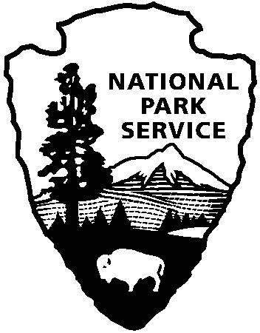
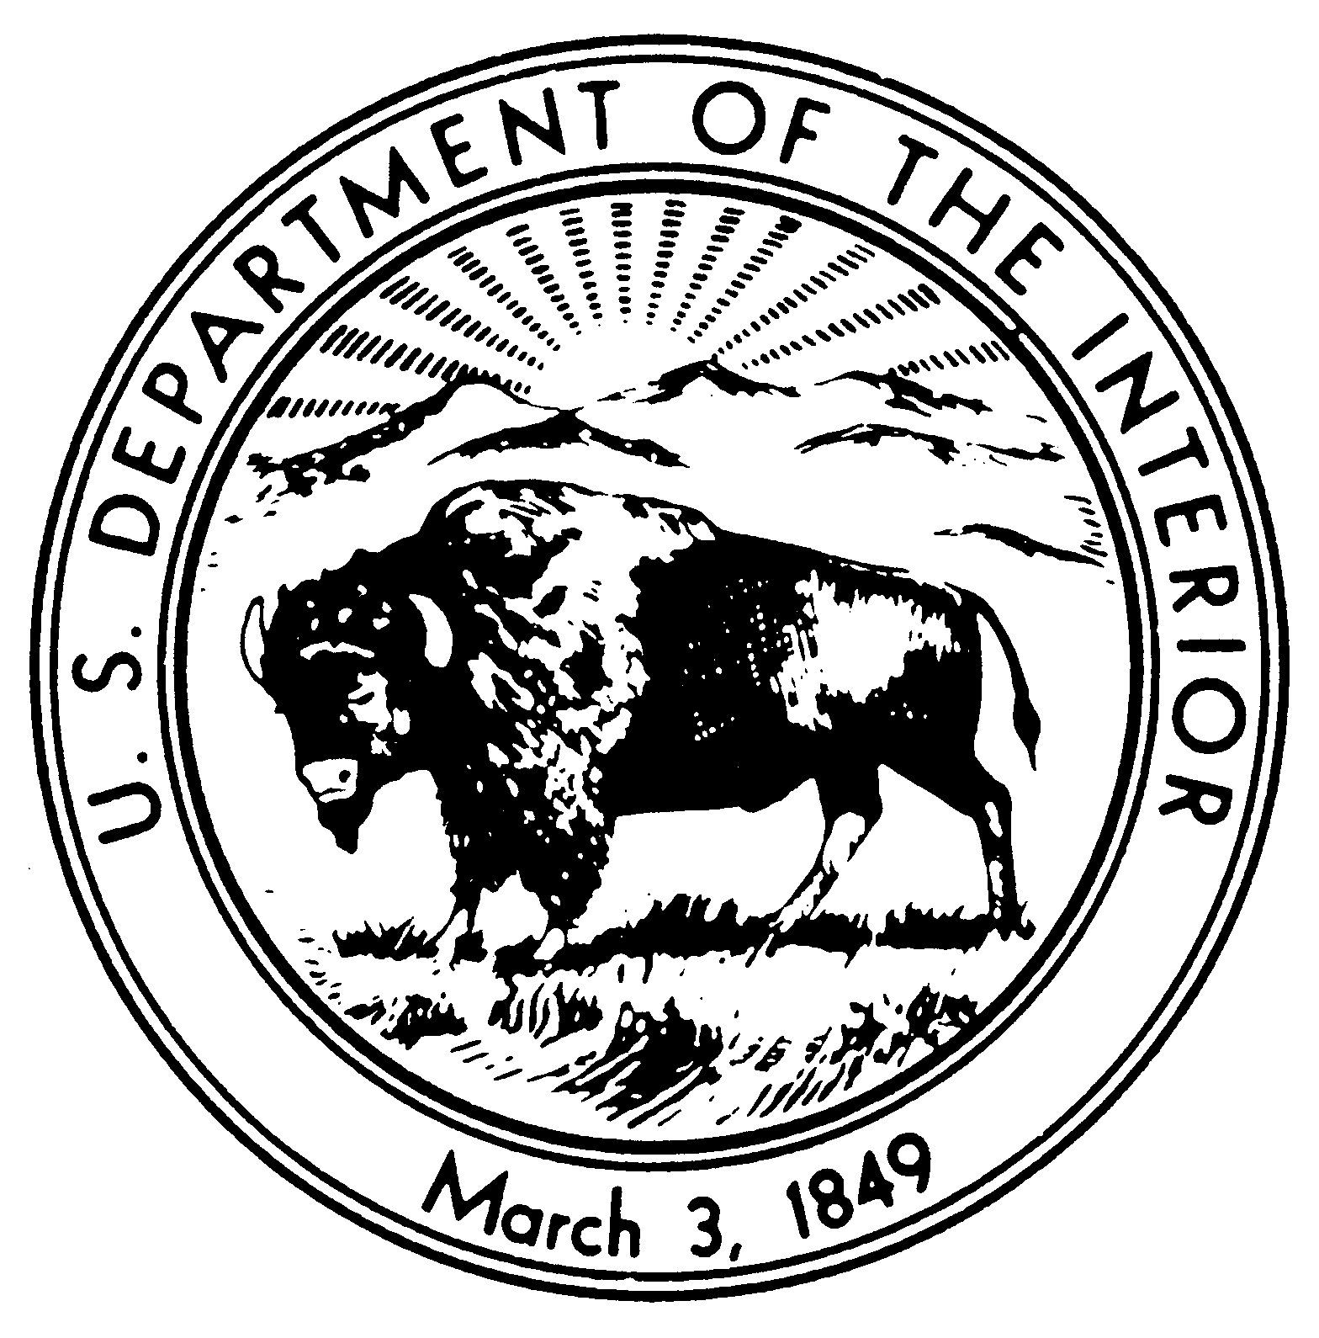

NATIONAL PARK SERVICE
Chesapeake Bay Office
Captain John Smith Chesapeake National Historic Trail
Chesapeake Bay Gateways and Watertrails Network
Star-Spangled Banner National Historic Trail
410 Severn Avenue, Suite 314
Annapolis, MD 21403

National Park Service News Release

FOR IMMEDIATE RELEASE – May 17, 2012
CONTACT: CINDY CHANCE (410.260.2492)
cindy_chance@nps.gov

America’s Great Outdoors: Secretary Salazar Designates
Captain John Smith Chesapeake National Historic Trail
Four Rivers in Five States to Make Up Connecting Water Trails

ANNAPOLIS, MD—Joined by Maryland Governor Martin O’Malley and other leaders in a ceremony at Sandy Point State Park, Secretary of the Interior Ken Salazar yesterday designated four water trails as new historic connecting components of the existing Captain John Smith Chesapeake National Historic Trail.

Yesterday’s Secretarial designation recognizes the significance of four connecting rivers– the Susquehanna, Chester, Upper Nanticoke and Upper James Rivers—to the history, cultural heritage, and natural resources of the 3,000-mile-long national historic trail in the Chesapeake Bay. The new river connecting trails are found in Delaware, Maryland, New York, Pennsylvania and Virginia.

“These river trails, totaling 841 miles in length, are closely associated with John Smith’s exploration of the Chesapeake Bay and its tributaries, including the American Indian towns and cultures of the 17th-century Chesapeake that he encountered,” said Secretary Salazar. “Incorporating these river segments into the national historic trail will increase public access, provide important recreation and tourism opportunities, and enrich exploration of the water routes in the entire Chesapeake watershed.”

The designation of trail components will enable the National Park Service to work closely with state and local agencies and other partners--notably conservation and tribal organizations--to provide technical and financial assistance, resource management, facility enhancement, interpretive trail route marking and promotion along the connecting trails.

Congress authorized the Captain John Smith Chesapeake National Historic Trail in 2006 as “a series of water routes extending approximately 3,000 miles along the Chesapeake Bay and the tributaries of the Chesapeake Bay.” Yesterday, Secretary Salazar used his authority under the National Trails System Act to designate the connecting rivers as part of the national trail with the support of the five states.

"Thanks to the leadership of President Obama and Secretary Salazar, we are blazing a new trail for America's great outdoors," said Governor O'Malley. "By linking our extraordinary landscapes and waterways to our country's history, the Captain John Smith Chesapeake National Historic Trail will support jobs and local economies across the region while providing unique opportunities for visitors to explore our cultural heritage while enjoying our natural resources."

Yesterday’s event also drew participation from a number of other public officials and conservation and tribal leaders. Speakers included Patrick Noonan, Chairman Emeritus of the Conservation Fund, who has led efforts over the past decade to establish and extend the national historic trail, and Joel Dunn, executive director of The Chesapeake Conservancy, which is the National Park Service’s principal nonprofit partner for developing the trail.

The numerous American Indian leaders joining the ceremony in person included: Tadodaho Sid Hill, spiritual leader of the Haudenosaunee nations (Six Nation/Iroquois Confederacy); Sid Jamieson, Chief of the Mohawk Nation; Stephen Adkins, Chief of the Chickahominy Tribe; Dennis Coker, Chief of the Lenape Tribe; Rico Newman, Piscataway member and chairman of the Maryland Indian Tourism Association; Deanna Beacham of the Virginia Council of Indians and member of the Captain John Smith Chesapeake National Historic Trail Advisory Council; and Virginia Busby of the Maryland Commission on Indian Affairs.

The Chesapeake Conservancy funded and managed a professional evaluation of Chesapeake Bay tributaries to determine their potential for designation as historic connecting components to the Captain John Smith trail. Research teams included historians, tribal representatives and regional universities.

Based on the study’s findings, the Chesapeake Conservancy worked with local watershed, tribal and water trail groups and state agencies to develop applications to the National Park Service to nominate the four rivers as connecting trail components.

Each of the nominations was supported by the governors of the five states through which the connecting trails pass, and by local groups, including American Indian tribes and descendant communities.

President Obama’s America’s Great Outdoors Initiative recognized the Captain John Smith trail and the nominated historic connecting components as important parts of the 21st Century conservation agenda of the United States—an agenda that includes increasing access to water-based outdoor recreation, encouraging community connections to cultural resources, and promoting tourism that fuels local economies.

“The Chesapeake Conservancy greatly appreciates the Secretary’s designations, which are the culmination of years of research and planning by private and public partners in the Chesapeake Bay region,” said executive director Joel Dunn. “The four historic connecting river components of the national historic trail extend the framework for collaborative conservation of our region’s history, wildlife and special places on a large landscape scale.”

“These designations do far more than create water trails and treasured lands that are a part of our history,” The Conservation Fund’s Noonan added. “They create opportunities for our children’s children to enjoy the natural beauty and bounty of the Chesapeake and her rivers and to experience their own Chesapeake journeys. Their gratitude will be thanks enough.”

Secretary Salazar designated the following historic connecting rivers:
- The Susquehanna River Component Connecting Trail is a 552-mile system of water trails along the main stem and West Branch of the Susquehanna River in Maryland, Pennsylvania, and New York. Sections of the trail are managed by a variety of organizations and agencies, all of which support the component connecting designation. Overall coordination of the component is provided by the Susquehanna Greenway Partnership. The southern end of this trail links directly with the Captain John Smith Chesapeake National Historic Trail at Conowingo, Maryland.
- The Chester River Component Connecting Trail is a 46-mile system of the Chester River and its major tributaries. The trail connects to the Captain John Smith Chesapeake National Historic Trail at its mouth just south of Rock Hall, Maryland. This connecting component is managed by Sultana Projects of Chestertown, Maryland, in close consultation with the State of Maryland.
- The Upper Nanticoke River Component Connecting Trail is an existing state water trail managed by the Delaware Department of Natural Resources and Environmental Control (DNREC) along approximately 23 miles of the Nanticoke River, Broad Creek and Deep Creek. The western end of this trail links directly with the Captain John Smith Chesapeake National Historic Trail.
- The Upper James River Component Connecting Trail is a 220-mile water trail that crosses nine counties and connects to the Captain John Smith Chesapeake National Historic Trail at the Falls of the James in Richmond, VA. It is managed by the James River Association.

###

For more information about the Captain John Smith Chesapeake National Historic Trail, contact John Maounis, Superintendent, at 410-260-2471 or john_maounis@nps.gov.

For more information on the Chesapeake Conservancy’s John Smith Trails Program, contact Michael Shultz at 410-972-2470 or mshultz@chesapeakeconservancy.org.

For more information about the Upper Nanticoke River Connecting Trail contact Michael Krumrine at 302-739-9243 or Michael.krumrine@state.de.us.

For more information about the Susquehanna River Connecting Trail contact Trish Carothers at 570-522-7259 or tcarothers@susquehannagreenway.org.

For more information about the Upper James River Connecting Trail contact Bill Street at 804-788-8811 X201 or bstreet@jrava.org.

For more information about the Chester River Connecting Trail contact John Mann at 410-778-5954 or jmann@sultanaprojects.org.

Additional Chesapeake Bay Leaders’ Comments on the New Historic Connecting Components of the Captain John Smith Chesapeake National Historic Trail:
MARYLAND:
Gov. Martin O'Malley: "Today, thanks to the leadership of President Obama and Secretary Salazar, we are blazing a new trail for America's great outdoors. By linking our extraordinary landscapes and waterways to our country's history, the Captain John Smith National Historic Trail will support jobs and local economies across the region while providing unique opportunities for visitors to explore our cultural heritage while enjoying our natural resources."
Sen. Barbara Mikulski: “The Chesapeake Bay is part of who we are as Marylanders – our heritage and our culture. Our Appropriations Subcommittee funds the Chesapeake Bay Interpretive Buoy System, which is part of the John Smith Chesapeake Trail. We have a responsibility to provide the tools and the resources our scientists need to protect the Bay and the livelihoods that depend on it. That’s why I have worked so hard to put money in the federal checkbook to support this invaluable buoy system that are used to better understand and restore the Bay’s health – and to tell the story of Captain John Smith. Plus, these buoys are now linked into U.S.’s Integrated Ocean Observing System, connecting the Bay and the John Smith Trail to the rest of the world.
Sen. Ben Cardin: “I was proud to advocate this expansion of the Captain John Smith Chesapeake National Historic Trail to Interior Secretary Salazar. The newly designated trails run along rivers that were particularly significant for Native American culture and commerce in the 17th Century, and they will attract tourists to our state who are interesting in learning more about the early American history of our region.”
Rep. John Sarbanes: "I am pleased that these beautiful and historic river trails have officially been included in the Captain John Smith Chesapeake National Historic Trail. More than four hundred years ago, John Smith set out on his exploration of the Chesapeake Bay. Today, students and visitors alike can replicate his journey, learn about the environment and appreciate the great treasure we have in the Bay."

VIRGINIA:
Gov. Bob McDonnell: “Virginia’s history is filled with tales of brave men and women who followed their vision of a great and fruitful land that would one day become our Commonwealth. Captain John Smith led the original colony that would become Virginia and our great nation, and significantly enhanced his contemporaries’ understanding of the promise that the new world held for them. His explorations and detailed scholarship inspired countless others to follow their own dreams and establish a new life in this new world. The National Park Service’s recognition of the Captain John Smith Chesapeake National Historic Trail and its addition of these new river connections to the trail’s historic places will help future generations discover the story of our country’s origins. The recognition for the Upper James River Connecting Trail will help new generations understand Virginia’s Native American cultures and the unique role Virginia played in the establishment of the United States we know today.”
Sen. Mark Warner: “Today’s designation recognizes the important role that the James River and the greater Chesapeake Bay region played in our nation’s history. I encourage both residents and tourists to take advantage of the wonderful educational and recreational opportunities that the Captain John Smith Chesapeake National Historic Trail has to offer.”
Rep. Jim Moran: “I applaud Secretary Salazar for designating the Susquehanna, Chester, Upper Nanticoke and Upper James Rivers as Connecting Component Trails of the John Smith Trail. This designation will provide an opportunity to share the stories of Indian cultures and trade routes and provide individuals firsthand knowledge of the significance of John Smith's exploration.”
DELAWARE:
Gov. Jack A. Markell: “The State of Delaware supports the establishment of the Upper Nanticoke River Connecting Trail. . . The connecting trail has great potential to integrate both recreational and economic development objectives in a way that protects our vital natural and cultural heritage…Recent research led by the Chesapeake Conservancy and conducted by Delaware scholars showed a strong connection between Smith’s voyages and the Upper Nanticoke River’s 17th century Native Americans. . . “(Letter of 4/27/2011)
Sen. Tom Carper: “The Captain John Smith Chesapeake National Historic Trail brings together the Mid-Atlantic region’s rich heritage and its environmental beauty. This natural resource gives Americans of all ages the opportunity to explore the expansive Chesapeake's treasured landscapes and ecosystems, while learning the story of our nation’s beginning. I am proud to support this important waterway, both for the health of these rivers – in Delaware and throughout the region – and for the preservation of our nation’s history. I thank Secretary Salazar and the Administration for including this important trail as part of President Obama’s America’s Great Outdoors initiative.”
Sen. Chris Coons: “Any time we can give folks a reason to connect with our nation’s history and to explore natural resources like the Chesapeake Bay and its tributaries, we’re also helping the local economy with a boost to tourism. Secretary Salazar's designation of the Upper Nanticoke River Connector Trail recognizes the historic significance of the river in Captain John Smith's exploration. With this designation, visitors will be able to experience sections of the Upper Nanticoke that remain largely intact and appear as they would have to Captain Smith in the 17th century. ”
PENNSYLVANIA
Gov. Tom Corbett: “By strengthening ties to our culture and history, and by increasing tourism, the Susquehanna River Connecting Trail has great potential to boost both the economic development and recreational opportunities for the towns along the Susquehanna River. We are pleased that this connecting trail is now designated and we will continue to support this initiative, which will benefit not only Pennsylvania, but our nation.”

Rep. Joseph Pitts: “The Susquehanna River is a natural treasure with a rich history pre-dating the arrival of the first colonists. I hope that the new river trails will encourage many more people to enjoy the beauty of the Chesapeake watershed and learn the stories of those who lived here and explored these waters.”
NEW YORK:
Gov. Andrew M. Cuomo: “New York strongly supports the designation of the Susquehanna River Connecting Trail as part of the Captain John Smith Chesapeake National Historic Trail. The creation of water trails offers new outdoor recreation and tourism opportunities for the public. The New York portion of the Susquehanna Connecting Trail includes hundreds of miles of navigable waters and numerous public access points, allowing boaters and anglers to enjoy this natural resource, facilitating future trail improvements, and expanding tourism opportunities.”
AMERICAN INDIAN NATIONS:
Karenne Wood, Monacan Nation and Virginia Heritage Program: “The Virginia tribes are pleased that the Upper James River connecting trail will join other waterways along the National trail. The Upper James has been home to the Monacan Nation for thousands of years. This waterway allowed our Siouan-speaking people to flourish in a powerful confederation of tribes. It was the backbone of our community and remains an important element of Monacan history and heritage.”
Steve Adkins, Chief of the Chickahominy Tribe in Virginia and Chesapeake Conservancy Board: “For the Chesapeake’s Indians, the arrival of the English began a terrible period of loss, which these trails help us better understand. But these trails also help us see the potential we have for building on that past, conserving our lands and water, and appreciating the beauty of the Bay and her great rivers.”
Sid Jamieson, Haudenosaunee Nations member and staff member at Bucknell University: “This is a wonderful day for the water that flows in the Susquehanna River. The water carries hundreds of years of history and culture of the Native peoples who lived along the banks of the river or those who traveled long distances for trade, or for the business of the Tree of Peace. It is the responsibility of the Haudenosaunee Nations to care for the well-being of all things, so today’s designation is very significant as it will continue to carry the story of the indigenous peoples of the past as well as all current communities along its banks. Most important, it will also continue to tell the story of all things living and non-living, current and past, associated with one of the most historic rivers in the very early development of this country.”

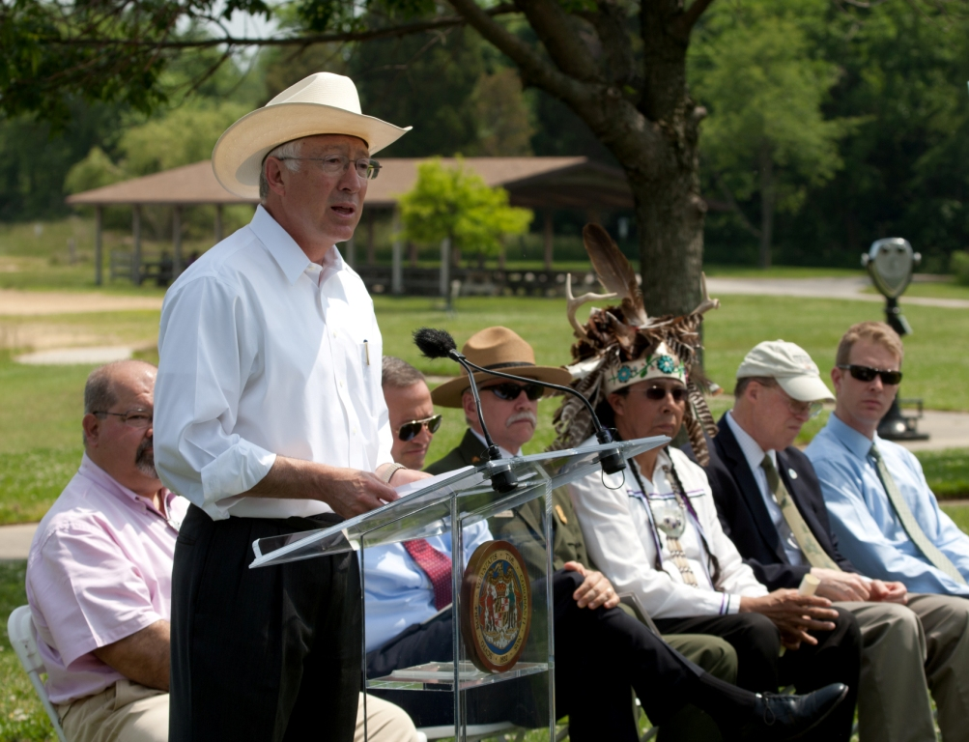
Secretary of the Interior Ken Salazar speaks at the designation of four connecting components to the Captain John Smith Chesapeake National Historic Trail. Other speakers, seated from left to right, include John Maounis, trail superintendent; Maryland Governor Martin O’Malley; National Park Service Director Jon Jarvis; Tadodaho Sid Hill, spiritual leader of the Haudenosaunee nations; Patrick Noonan, Chairman Emeritus of the Conservation Fund; and Joel Dunn, Executive Director of Chesapeake Conservancy.

