Citizen Science Phenology Monitoring Program
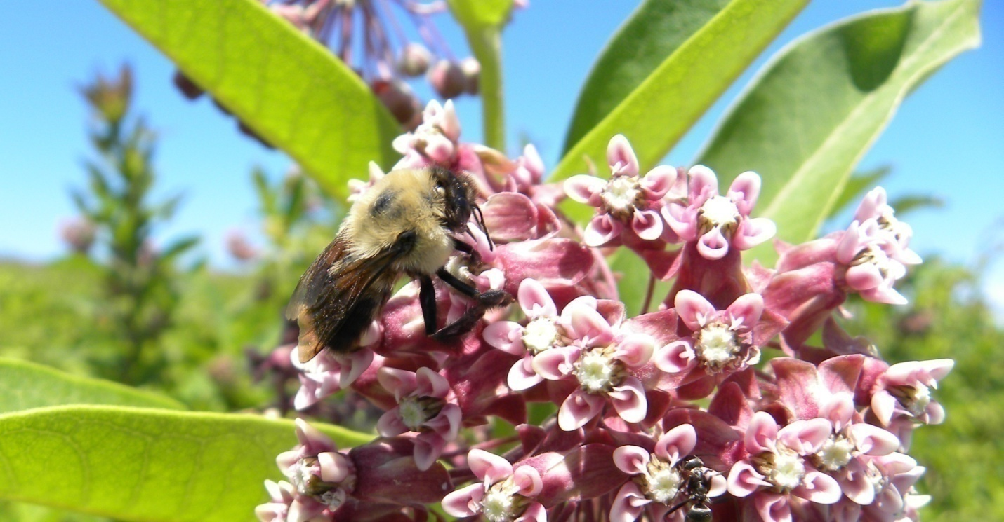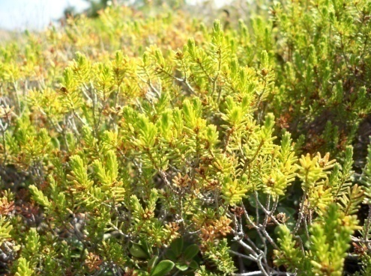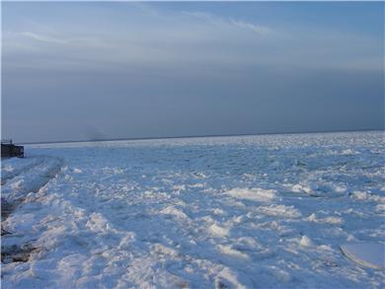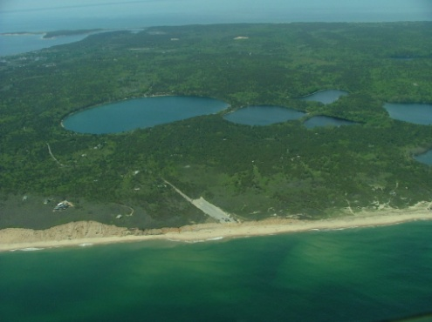
Cape Cod National Seashore

Citizen Science Phenology Monitoring Program
Cape Cod National Seashore
A protocol for long-term citizen science led ecological monitoring

Scott W. Buchanan
Science Communication Technician
North Atlantic Coastal Laboratory
Cape Cod National Seashore

Megan C. Tyrrell
Research Coordinator
North Atlantic Coastal Laboratory
Cape Cod National Seashore

September, 2011

Cape Cod Ecosystem Monitoring Program
Cape Cod National Seashore
Wellfleet, MA 02667
This report is on the Cape Cod National Seashore website:
http://www.nps.gov/caco/naturescience/phenology-monitoring-program.htm
Acknowledgements
A number of National Park Service personnel offered valuable insight during the design of these protocols. Mark Adams, Holly Bayley, Bob Cook, Sophia Fox, Krista Lee, Kelly Medeiros and Steve Smith are among those that shared local knowledge and in doing so helped to design these protocols. Sue Haley, Sue Moynihan, and Jenna Sammartino were all instrumental in making contact with potential volunteers for future monitoring. A conversation with Abe Miller-Rushing was helpful in steering the priorities of the program in the early stages of design. Michael Sousa aided in revisions and formatting for the final edition of this handbook.

Executive Summary
Phenology is among the simplest of ways in which to tie ecological change to environmental change, specifically changes in climate. By monitoring the timing of annual life cycle events in organisms, one can test the hypothesis that changes in the organism’s environment are altering the initiation and duration of these events. However, meaningful trends cannot be discerned in only a few years worth of data. In order to gauge the relationship between an organism’s life cycle events and something as broad as climate, data must be collected on the decadal scale. The following monitoring handbook was developed to accommodate the demands associated with such an effort. This document develops a protocol for monitoring phenology of a host of plant and animal species (and in one case a physical feature - ice) found at Cape Cod National Seashore (CCNS). In selecting what species to monitor, preference was given to those solicited by the USA National Phenology Network. Many of the protocols developed herein draw largely from the established protocols of this organization. Species were selected from a range of different community types at CCNS, the intent being to potentially demonstrate shifts in phenology across systems. The viability of the program depends entirely on the recruitment, adequate training, and retention of dedicated volunteers. With this and with the implementation of sound monitoring protocols, the program will be able to achieve the goals of resolving a better understanding of local ecological changes associated with a changing climate and further educating and engaging members of the public.

Table of Contents
Acknowledgements --------------------------------------------------------------------------------------------------------------- pg. 3
Executive Summary --------------------------------------------------------------------------------------------------------------- pg. 4
Table of Contents ------------------------------------------------------------------------------------------------------------------ pg. 5
List of Figures and Tables -------------------------------------------------------------------------------------------------------- pg. 7
Section 1 – Introduction --------------------------------------------------------------------------------------------------------- pg. 8
Section 2 – Consideration of Proposed Sites ------------------------------------------------------------------------------- pg. 10
Section 3 – Monitoring Sites ---------------------------------------------------------------------------------------------------- pg. 13
Section 4 – Data Management and Data Collection Protocols -------------------------------------------------------- pg. 37
Section 5 – Discussion ------------------------------------------------------------------------------------------------------------ pg. 43
Index A – Locations of All Monitoring Organisms and Sites ------------------------------------------------------------ pg. 45
Index B – Volunteer Data Collection Sheets -------------------------------------------------------------------------------- pg. 47
Glossary ------------------------------------------------------------------------------------------------------------------------------ pg. 56
Works Cited ------------------------------------------------------------------------------------------------------------------------- pg. 57

List of Figures and Tables
Figure 1. Program implementation and evaluation schematic -------------------------------------------------------------- Page 9.
Figure 2. Site map for Fort Hill tree phenology, Eastham --------------------------------------------------------------------- Page 14.
Figure 3. Marked trees at Fort Hill site -------------------------------------------------------------------------------------------- Page 15.
Figure 4. Site map for Salt Pond Visitor Center tree phenology, Eastham ----------------------------------------------- Page 16.
Figure 5. Marked trees at SPVC site ------------------------------------------------------------------------------------------------ Page 17.
Figure 6. Site map for White Cedar Swamp Trail, Wellfleet ------------------------------------------------------------------ Page 18.
Figure 7. Marked trees for White Cedar Swamp -------------------------------------------------------------------------------- Page 19.
Figure 8. Rosa rugosa and Prunus maritima growing in the same location at Herring Cove North ---------------- Page 20.
Figure 9. Map of Provincetown showing projected areas affected by 100-year storm event ----------------------- Page 21.
Figure 10. Site map for High Head ORV Road, Truro --------------------------------------------------------------------------- Page 22.
Figure 11. Marked shrubs at High Head ORV Road site ----------------------------------------------------------------------- Page 23.
Figure 12. Site map for Herring Cove North, Provincetown ------------------------------------------------------------------ Page 24.
Figure 13. Marked shrubs at Herring Cove North site ------------------------------------------------------------------------- Page 25.
Figure 14. Site map for Herring Cove South, Provincetown ------------------------------------------------------------------ Page 26.
Figure 15. Marked shrubs at Herring Cove South site ------------------------------------------------------------------------- Page 27.
Figure 16. Site map for Snow Pond, Truro ---------------------------------------------------------------------------------------- Page 29.
Figure 17. Site map for Great Pond, Wellfleet ----------------------------------------------------------------------------------- Page 30.
Figure 18. Site map for Long Pond, Wellfleet ------------------------------------------------------------------------------------ Page 31.
Figure 19. Site map for Fort Hill (Nauset Marsh) salt marsh vegetation phenology, Eastham ---------------------- Page 33.
Figure 20. Site map for Salt Pond salt marsh vegetation phenology, Eastham ------------------------------------------ Page 34.
Figure 21. Site map for West End Marsh salt marsh phenology, Provincetown ---------------------------------------- Page 35.
Figure 22. Site map for Hatches Harbor salt marsh vegetation phenology, Provincetown -------------------------- Page 36.
Figure 23. Red-winged black bird image ------------------------------------------------------------------------------------------ Page 40.
Figure 24. Images showing 2” PVC pipe inserted into marsh ---------------------------------------------------------------- Page 42.
Table 1. List and locations of all trees and shrubs that will undergo phenology monitoring ------------------------- Page 45.
Table 2. List and locations of all ice phenology monitoring locations ----------------------------------------------------- Page 46.
Table 3. List and locations of all salt marsh phenology monitoring plots ------------------------------------------------- Page 46.
Table 4. Eastham Route (Freshwater Wetlands) – Fort Hill Data Collection Sheet ------------------------------------- Page 47.
Table 5. Eastham Route (Freshwater Wetlands) – White Cedar Swamp Data Collection Sheet -------------------- Page 48.
Table 6. Eastham Route (Freshwater Wetlands) – Salt Pond Visitor Center Data Collection Sheet ---------------- Page 49.
Table 7. Provincetown Route (Marimtime Dunes) – High Head Data Collection Sheet ------------------------------- Page 50.
Table 8. Provincetown Route (Marimtime Dunes) – Herring Cove North Data Collection Sheet ------------------- Page 51.
Table 9. Provincetown Route (Marimtime Dunes) – Herring Cove South Data Collection Sheet ------------------- Page 52.
Table 10. Ice Phenology & Red-Winged Blackbirds – Pond & RWBB Data Collection Sheet ------------------------- Page 53.
Table 11. Salt Marsh Vegetation (Spartina alterniflora) – Smooth Cordgrass Data Collection Sheet -------------- Page 54.

Section 1 - Introduction
Phenology is the study of life cycle events in organisms and the timing at which these events occur. When a rose bush flowers, when a population of spring peepers begin to call, and when piping plovers migrate from their winter homes and arrive on Cape Cod beaches are all examples of phenological events. Phenological data is usually recorded as the day of the year that a particular event occurs. From year to year these types of events can be highly variable. This interannual variation is normal and is a function of many local, physical and ecological, factors. For example, when a beach plum flowers may be dependent on a number of variables tied to photoperiod, hydrology, soil chemistry, disturbance, extreme weather events, dietary preferences of herbivores, etc. Data that is collected over many years (10-100 years or more) may show patterns and trends that often reveal greater forces shaping the timing of these events. In many cases climate has a strong influence on when an organism undergoes a particular phenological event (Miller-Rushing and Inouye 2009).
Climate can be defined as the prevailing weather conditions of a region over the course of many years. Climate has been changing since the atmosphere was formed and it should be expected that climate will continue to change. But there is consensus among a strong majority of scientists that the earth’s climate is changing at an accelerated rate due to certain human activities (IPCC 2007). The body of evidence to suggest this is now well established and is increasing all the time. Our understanding of all of these changes can best be seen through phenology, which is perhaps the simplest method of study that can effectively demonstrate a relationship between ecological processes and change in climate (IPCC 2007). As citizens we should be aware of the many potential consequences of accelerated climate change, especially in the regions where we live. Climate models for the United State, specifically the Northeast, project a far-reaching and in some cases dramatic suite of changes to physical and biological processes (Frumhoff, et al. 2007). In addition to phenological shifts, ecological changes associated with climate change include range shifts (both in terms of latitude and elevation) and a strong effect on trophic interactions between species (Chen, et al. 2011, Edwards and Richardson 2004, Winder and Schindler 2004).
Cape Cod National Seashore (hereafter CCNS) has undertaken an ambitious approach to addressing climate change. With the understanding that the National Park Service should fulfill its role as a steward of natural resources, CCNS has taken significant steps to ensure that it is limiting its own carbon footprint through the climate friendly parks program. In addition, CCNS hopes to engage citizens and raise public awareness of these issues by instituting a citizen science led phenological monitoring program that will monitor a number of organisms and physical features throughout the Seashore. By incorporating a group of dedicated and well-trained volunteers into the program, the objective of the program is to collect phenological data over the course of many years. This data will serve to establish baselines and eventually trends in phenology for the array of species and events observed by volunteer scientists.
However, in order to yield meaningful results, it is necessary that such an effort be carried out over long periods of time (e.g. on the decadal scale). The protocols contained in this document are made with this fact in mind. All sites were selected with the hopes that they will remain suitable for phonological data collection for at least thirty years. That is to say, before succession, geomorphic change, or human use will significantly impact any one site. It is to be expected that observations made by volunteers may change as the normal physical and ecological factors are disturbed over time. Therefore, it is especially important to manage data collection somewhat adaptively, especially in the early phases of the program. This will hold especially true of the efforts to study phenology in CCNS salt marshes; the development and implementation of this protocol is at this time unique to the Seashore.

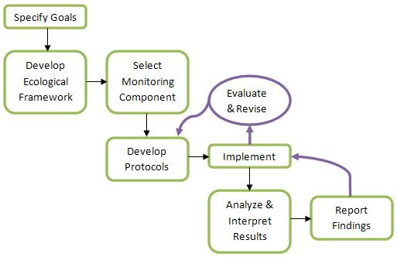
Figure 1. Diagram showing the step-by-step rationale by which the phenology monitoring program has been designed and is to be implemented. This diagram was taken from a presentation made to describe the long-term ecosystem monitoring efforts taking place at Cape Cod National Seashore (Phillips 2002).
Fortunately, precedent exists for developing long-term ecological studies at CCNS and it is the intent of this program to draw upon past efforts wherever possible. The above schematic (Figure 1) represents the progression of design for previous long-term studies. A similar, if not identical, strategy has been employed for the phenology program and should continue to be utilized as the program develops. As the phenology program develops, special attention should be given to the evaluation and revision feedback loops illustrated above. As there is limited precedent for citizen science data collection of this magnitude at CCNS, special care should be made to ensure adaptive flexibility in the protocols. Furthermore, by virtue of their design, the established Cape Cod Ecosystem Monitoring (CCEM) efforts, in many cases, collect phenological data. At some point, existing data sets (e.g. amphibian calling surveys, plover arrival dates) should be analyzed for phenological trends and used to supplement data collected from citizen scientists and described in this guidebook.
A citizen science led phenology monitoring program has great potential to yield meaningful data and sharpen the understanding of the timing of ecological events in response to a changing environment. With results of this project placed alongside results from the Cape Cod Ecosystem Monitoring program, the opportunity exists to significantly advance understanding of certain ecological processes. In addition, the opportunity to engage a substantial number of citizens within the realm of science is another major motivation behind the program. The amount of effort required on behalf of CCNS staff to implement the project is likely to be skewed heavily towards the first few years as necessary changes and improvements are made. Once the means of implementation are developed and streamlined the program is likely to function efficiently with the majority of the work being performed by volunteers.

Section 2 - Consideration of Proposed Species & Sites
In the hopes that this section will provide volunteers with a better understanding of the work they are carrying out, the paragraphs below (a series of expected questions) detail the thought process behind selecting what species to monitor and where to monitor them.
With respect to the species to be monitored:
- Does the species (or physical feature) under study demonstrate an annual characteristic that is easily observable and likely to be affected by temperature?
A volunteer collecting data should be able to reliably identify phenophases for all species in question. These phenophases should be conspicuous and not likely to be confused with other characteristics. Each of the phenophases under study should have an expected causal relationship with temperature or a closely related environmental variable.
- Will phenological trends associated with the data collected shed light on changes related to climate and be used as insight into other relationships when viewed in a broader ecological context?
The primary relationship explored via data analysis from observations collected will be timing (the Julian date) of each particular phenotype over time (years). This data will be placed in the context of local and regional changes to climate. If these types of trends have potential to reveal more about certain ecological relationships for particular species, emphasis should be placed on studying them. For example, by studying the phenology of a native species and an invasive species in the same area, potential divergences in their timing of flowering and fruiting may lead to a shift in competitive advantage for one species with respect to the other. Differential success between native and non-native vegetation as a result of climate change has been demonstrated in Massachusetts (Willis et al. 2010). Similarly, a shift in the timing and duration of certain life cycle events in plants as a result of warming temperatures and an extended growing season could influence the community composition of pollinators (Miller-Rushing and Inouye 2009).
- How does the intended characteristic of study fit into the greater framework of the USA NPN and NE-RPN? Does the intended characteristic of study contribute to regional datasets?
Much effort has been put into establishing national and regional phenology networks. The phenology program at CCNS should strive to draw from and complement these efforts. The species monitored at CCNS will likely be species that the larger networks already have protocols for and the protocols developed for CCNS should draw heavily from them. Data should be shared with regional and national networks whenever possible. The National Park Service’s (NPS) Northeast Temperate Network (NETN) has worked closely with the Northeast Regional Phenology Network (NE-RPN) (a subsidiary of the USA National Phenology Network) to develop and implement a phenology program in its parks that relies heavily on volunteers for data collection and management. CCNS should seek to leverage the existing relationship between NPS and the NE-RPN wherever possible.

- Has the Cape Cod Ecosystem Monitoring (CCEM) program been considered when selecting particular characteristics for study?
A large part of the CCNS Division of Natural Resource Management (NRM) is charged with long-term monitoring of natural resources, both physical and biological. Certain components of these efforts result in what is, in part, phenological data. For example anuran calling surveys reveal timing of amphibian breeding every year. Consideration should be made as to how citizen science monitoring efforts can complement existing data sets. Furthermore, ecological data is inherently complex and phenological data is no exception. The timing of a particular phenological event is likely to be influenced by a number of different factors. These covariates (i.e. other than temperature) are very likely to confound future analysis of phenological data. Data that is to be collected by existing long-term monitoring protocols that may serve to minimize these confounding effects should be considered when selecting species for phenological monitoring.
- How will the data collected be managed?
Ideally data management will be managed primarily by citizen volunteers. This will entail collection, entry, and quality assurance/quality control (QAQC). Procedures for data management can be found in the ‘Monitoring Sites’ section.
With respect to the sites to be monitored:
- Are the sites easily accessible?
Sites should be near vehicle access points and should require only normal walking to reach. Emphasis should be placed on sites that are near established walking trails. Care should be taken not to establish sites in places where they will result in new social trails.
- Have succession and expected sea-level rise (and the associated coastal flooding) been taken into account?
Plant community succession has the potential to change the physical and biological dynamic of any particular site. Differences over time in community composition may affect shading and soil chemistry and have the potential to confound the interpretation of changes in phenology. The possibility also exists that individual plants intended for long-term study may be replaced by other individuals. Such cases could severely limit the ability of those charged with interpreting results from data collected. Care should be taken to choose sites that are believed to be limited in their potential to undergo succession during the timeframe of interest (30 years) and beyond. Many other factors need to be considered as well. Taking in to account a conservative average of erosion rate per year of four feet of the Atlantic coastal bluff, sites should be chosen no less than 120 feet away from the bluff. Herring Cove is also eroding, albeit at a slower rate. Sites at Herring Cove should be placed no less than 30 meters away from the primary dune (Mark Adams, CCNS GIS Specialist, pers. Comm.). Sites (other than those where salt marsh vegetation is being monitored) should take into account the potential for effects from disturbance from strong storms. FEMA flood maps have been consulted to avoid selecting areas where storm surge has the potential to disrupt or remove vegetation (Figure 9). Sea-level rise projection models should also be taken into account to avoid selecting areas that hold a potential for disturbance. Finally, human disturbance needs to be taken into account. Areas that may be managed in any way other than as a natural area should be avoided. The most common human disturbances to affect individual plants would be mowing and pruning of branches which obstruct passage on an established trail.
- What are the potential risks to volunteers carrying out field work at these sites?
There are a number of unavoidable risks associated with performing field work on Cape Cod. The most significant of these is driving. Volunteers will be utilizing their own vehicles for this study and should be familiar with the areas in which they are asked to collect data. Consulting maps and having good driving directions prior to driving to a particular site is critical. Other risks include poison ivy, ticks, sunburn, and dehydration. Limiting risk is possible, eliminating it is not. As such, volunteers should expect exposure to all of these risks and take steps to avoid them whenever possible. Long pants and shirts are the best way to avoid poison ivy. Tucking one’s pants into their socks is an effective means of limiting the chance of tick embedment. A full body sweep for ticks after returning from the field is strongly encouraged and should be performed on every single occasion where volunteers enter brush or understory. Volunteers should not proceed into the field without proper UV-protection sun-block and ample amounts of water. It is important that volunteers observe trail conditions while walking and be aware of tree roots, stumps, and other naturally-occurring hazards. The possibility also exists for unanticipated emergencies such as those associated with an allergic reaction. It is advised that volunteers keep a cell phone on them at all times and notify another party of their whereabouts before visiting a site.

Section 3 – Monitoring Sites
Four different community types (freshwater wetland/adjacent woodland, maritime dunes, kettle ponds, and salt marshes) have been selected to undergo phenological monitoring. Multiple sites have been selected for each community type (total number of sites = 13). They have been categorized according to community type and listed below. The individual sites are listed in order of ascending tree tag numbers which run roughly north to south.
‘A’ Sites – Freshwater Wetland and Adjacent Woodland
Species of Study: Red Maple (Acer rubrum), Eastern Redcedar (Juniperus virginiana), White Oak (Quercus alba), Red-Winged Blackbird (Agelaius phoeniceus).
Range of Sampling Dates: March 1 – June 30 Frequency of Sampling: 1-2 times/week
The kame and kettle topography of the Outer Cape plays host to a plethora of freshwater wetlands ranging in size, hydro period, and species composition. A common type of freshwater wetland in the northeast United States is the red maple swamp. These types of wetlands are created in low-lying areas of forests, usually with temporary standing water, where red maple dominates the canopy. They serve as important habitat for invertebrates, amphibians, reptiles, birds and mammals. They also provide an ideal setting in which to monitor phenophases of a number of species.
Red maple and eastern redcedar are USA NPN “calibration species.” Calibration species are species of particular interest that the USA NPN wishes to emphasize because they have broad distributions and are ecologically or economically important (http://www.usanpn.org). Both species are found at the three sites. Red maple (Acer rubrum) is abundant and is found in the interior and edges of the actual wetland. Eastern redcedar (Juniperus virginiana) is found in the areas immediately adjacent to the wetlands. Being an early-successional species, the presence of eastern redcedar is very likely a product of land use disturbance at specific sites (e.g. Fort Hill in Eastham) and has raised concerns when selecting individual trees to monitor in order to avoid selecting trees that are actively disturbed in some way (e.g. mowing and trimming alongside trails). Eastern redcedars are dioecious, meaning that male and female cones occur on different individuals. Only male trees were selected in order to minimize the variability between tress in our sample. Also, care was taken to select individual trees that provide low hanging branches for easier monitoring. A tree that has branches only in the canopy (as many eastern redcedars do) will not make for an observable individual. White oak (quercus alba) was selected as an additional species for monitoring being solicited by the USA NPN. The USA NPN lists white oak as a “regional plant species.” This is another designation that signifies ecological and economic importance throughout its range. White oak, a late-successional species, also occurs in the adjacent uplands.
Red-winged blackbirds (Agelaius pheoniceus) are ideally suited for monitoring in freshwater wetland sites. Conspicuous in appearance and song, they are among the first species of migratory bird to return to northern temperate zones. Males establish territories at the edge of wetlands in the early spring. For these reasons, this species makes a good candidate for phenological monitoring, especially for volunteers who may be inexperienced in identifying birds. In accordance with USA NPN protocols, volunteers will be asked to make observations on presence/absence and abundance during each visit. They will be monitored at two freshwater wetland sites and at three kettle pond sites. The following sites have been selected to undergo monitoring.

A1 – Fort Hill/Red Maple Swamp Trail, Eastham
Figure 2.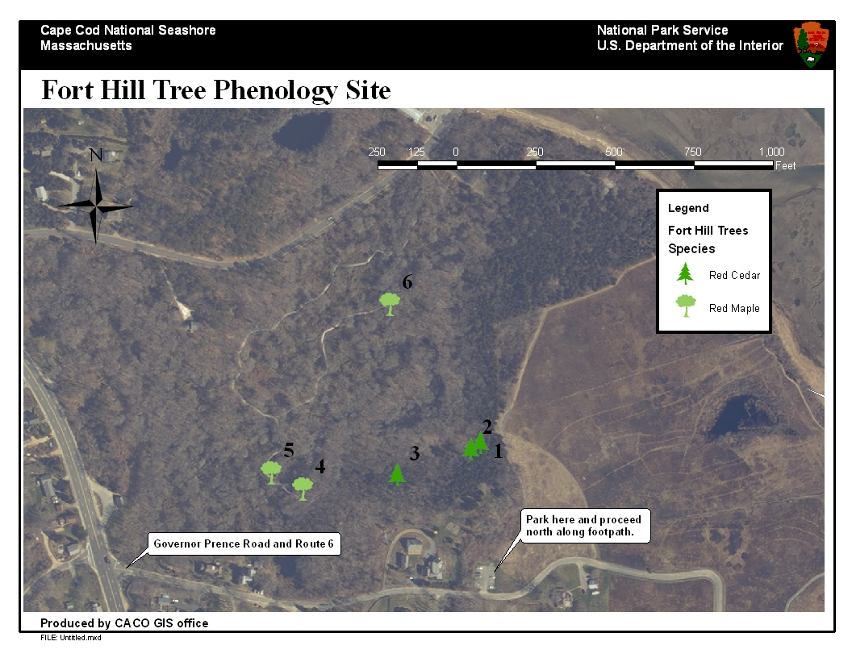
Turn east onto Governor Prence Road and bear left at the fork. Park in the lower Fort Hill parking lot. Proceed north along footpath for about 1/10 of a mile and turn left onto the Red Maple Swamp Trail. Some trees are on the trail, some are a short walk off the trail (~25-50 feet). The eastern redcedars will likely prove more difficult to find as appropriate individuals were more difficult to locate. The three red maples are all immediately adjacent to the boardwalk portion of the trail.

Figure 3. Marked trees at the Fort Hill/Red Maple Swamp site.
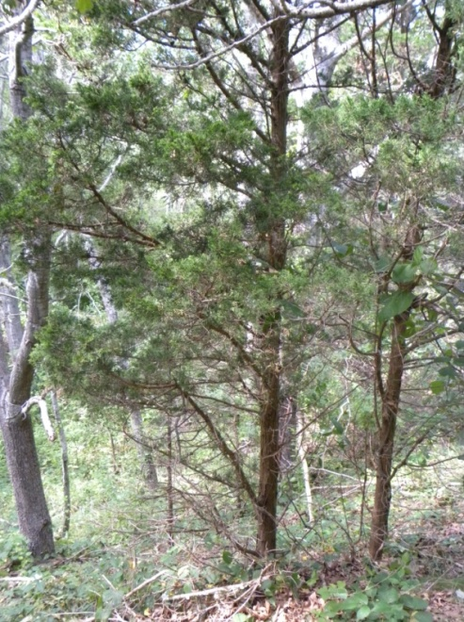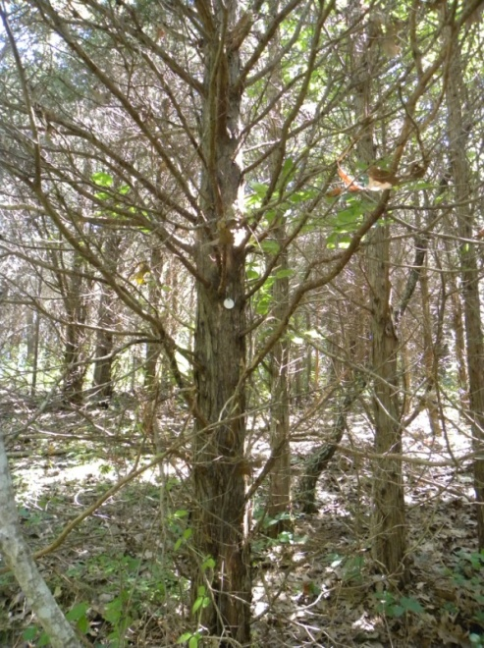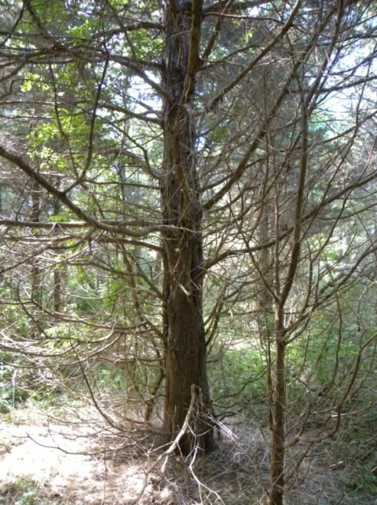
Tree #3 – Also down an existing social trail (south of main trail). Largest individual eastern redcedar selected for monitoring.
Tree #2 – May be the most difficult to find. Would be useful to flag at the beginning of every season.
Tree #1 – Down an existing social trail (north of main trail) just after turning onto the main trail. Watch out for the eroded ledge.

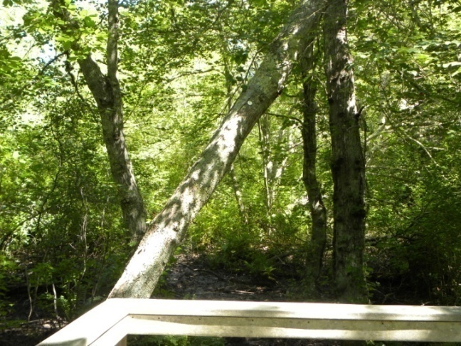
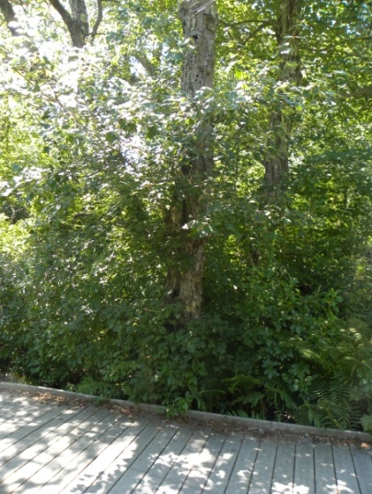
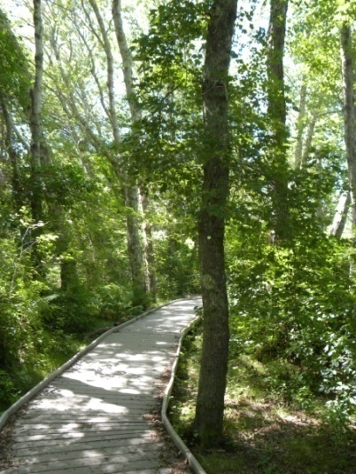
Tree #6 – Located at terminus of eastern spur of boardwalk. Red-winged blackbird sampling will take place from this location as well.
Tree #5 – Located across from wooden bench on boardwalk.
Tree #4 – Located at beginning of boardwalk (on right).

A2 – Salt Pond Visitor Center Buttonbush Trail
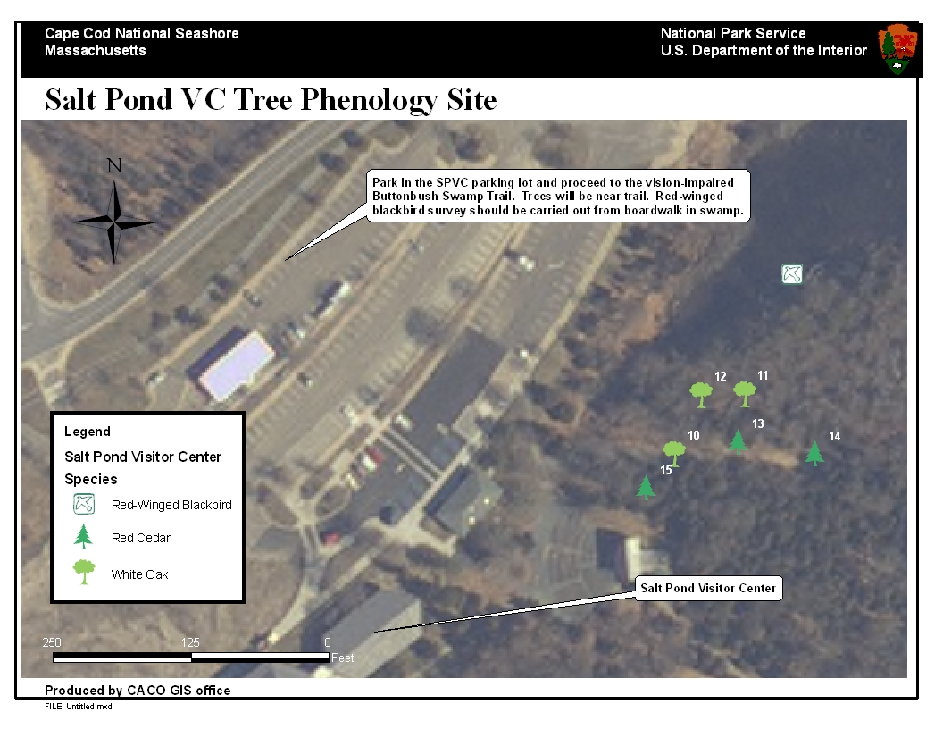
Figure 4.
Park at Salt Pond Visitors Center and proceed to the Buttonbush Trail. Trees 11 and 12 are set back off the trail along an existing social trail (north of main trail). The other trees are located near the trail and can probably be observed from it. Red-winged blackbird observations should be made from the middle of the boardwalk overlooking the buttonbush-dominated wetland.

Figure 5 . Marked trees at the Salt Pond Visitor Center Buttonbush Trail site.
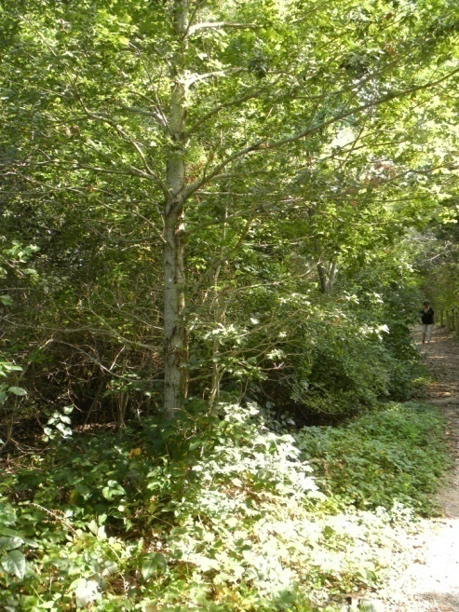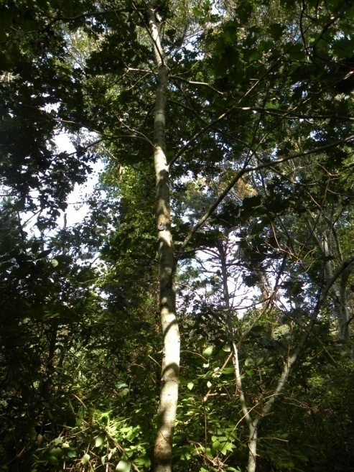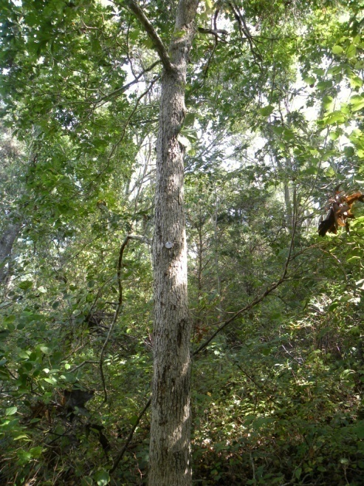
Tree #12 – White oak. Located off trail along existing social trail to north of main trail.
Tree #11 – White oak. Located off trail down existing social trail to north of main trail.
Tree #10 – White oak located along vision-impaired trail.

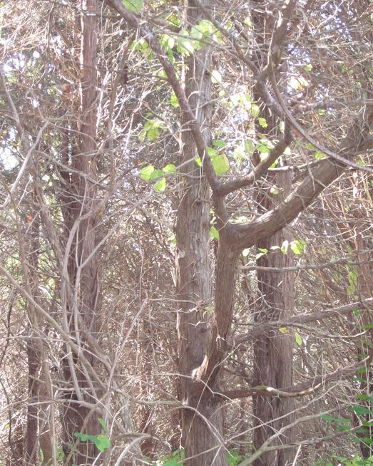
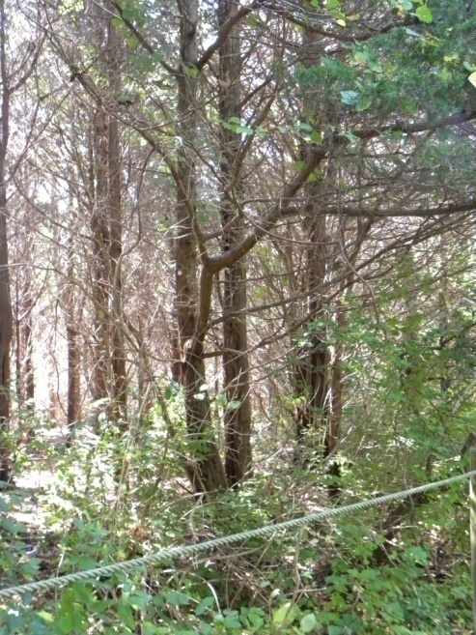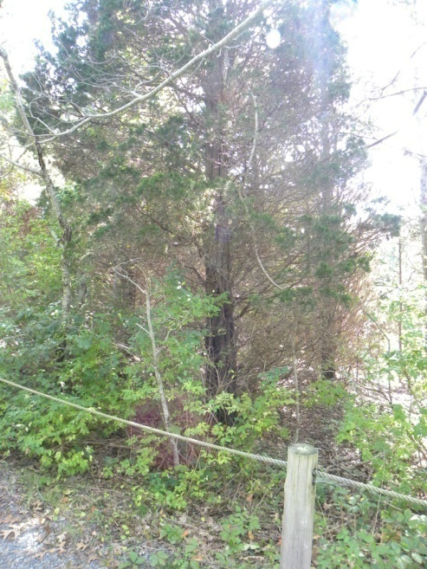
Tree #14 – Eastern redcedar. Located along vision-impaired trail.
Tree #15 – Eastern redcedar. Located along vision-impaired trail.
Tree #13 – Eastern redcedar. Located along vision-impaired trail.

A3 – Edge of Atlantic White Cedar Swamp, Wellfleet
Figure 6.
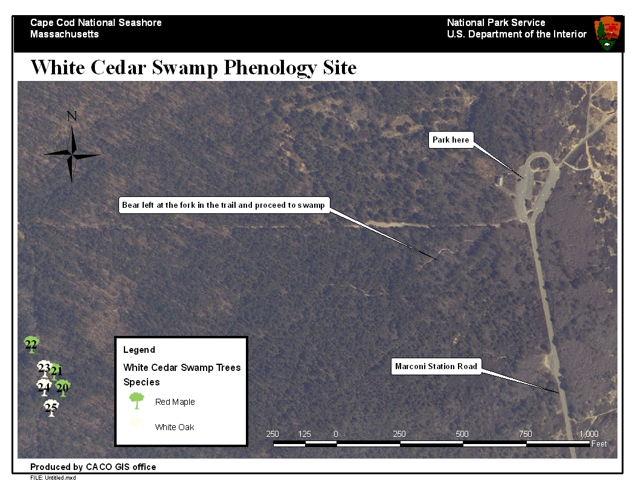
Proceed past Seashore headquarters on Marconi Station Road and park at the parking lot at the end of the road. Proceed west down marked footpath that leads to the white cedar swamp. Take the left fork at the beginning of the trail and proceed to swamp. All red maples are located very close to the marked trail. The white oak trees are located along Wireless Road, the dirt road that runs perpendicular to the footpath at the edge of the white cedar swamp. The walk from parking lot to trees is approximately one-half of a mile.

Figure 7. Marked trees at White Cedar Swamp phenology site.
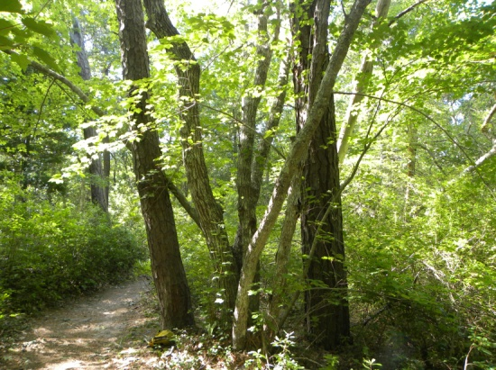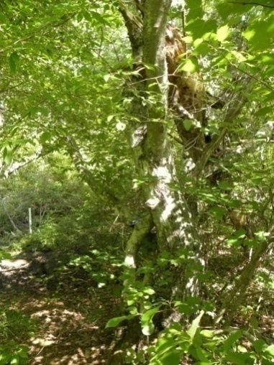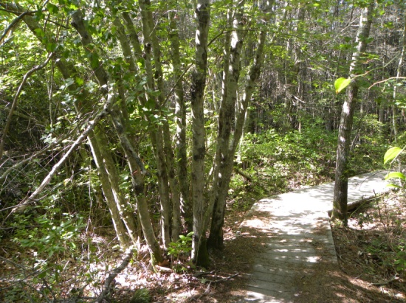
Tree #20 – Red maple. Located along WCS Trail (north side). Multi-truncated; treat all trunks as the same individual.
Tree #22 – Red maple. Located at beginning of boardwalk on WCS Trail (south side). Also multi-truncated; treat all trunks as the same individual.
Tree #21 – Red maple. Located a few meters off WCS Trail (north side) at an existing social trail.

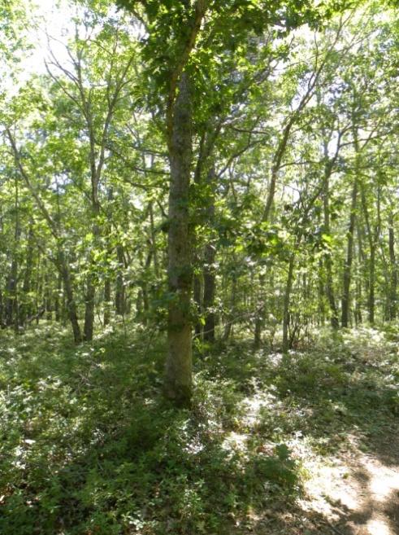
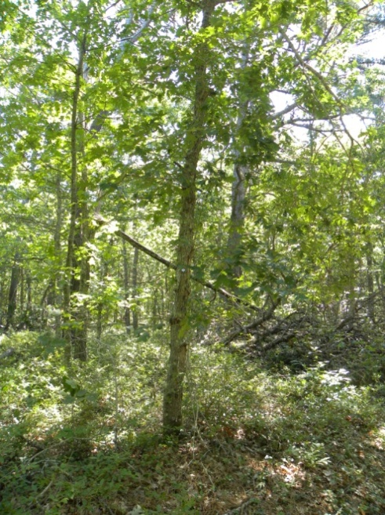
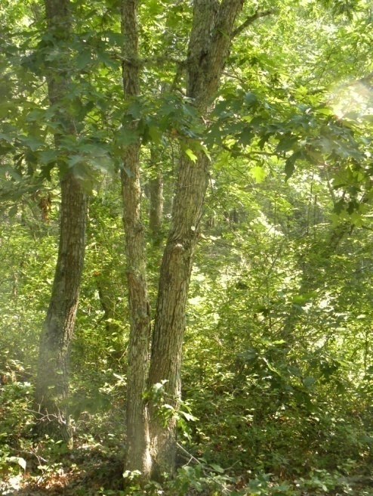

Tree #25 – White oak. Located south of trail on east side of Wireless Road (beyond tree 24).
Tree #24 – White oak. Located south of trail on east side of Wireless Road.
Tree #23 – White oak. Located at the intersection of WCS Trail (northeast side) and Wireless Road. Multi-truncated; treat both trunks as same individual.

‘B’ Sites – Maritime Dune Shrub Communities:
Species of Study: Beach Plum (Prunus maritima), Black Cherry (Prunus serotina), and Rugosa Rose (Rosa rugosa).
Range of Sampling Dates: March 1 – July 31 Frequency of Sampling: 1-2 times/week
The shrub associations of interest occur most readily on the post-glacial deposits of the Province Lands. In the Province Lands, a long history of human use has shaped the landscape and resulted in a varied mosaic of early successional communities. These early successional dune shrub communities are found on well-drained, sandy soils. Wind and salt spray inhibit the growth of certain species, leaving open the opportunity for others to thrive. These communities consist of many native and introduced species. By observing multiple species at each designated site, we may obtain a better understanding of not only whether shifts in phenology are occurring, but how shifting phenology may alter the interactions between species and ultimately the composition of these communities. For example, beach rose, an invasive species, is often found competing for space with the native beach plum (Figure 8). A question of interest is: Will phenological shifts associated with climate change differentially favor one species over the other?
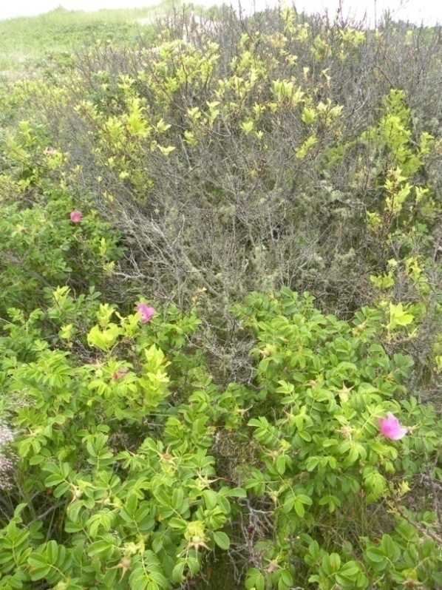
Figure 8. Rugosa rose (Rosa rugosa) and beach plum (Prunus maritima) growing in the same location at Herring Cove North Site (Photo: Buchanan). To what degree are they competing with one another for resources and what effect might a shift in phenology in either species have on their respective distribution and abundance?
These sites will be monitored for a total of three species, all deciduous shrubs which make for excellent phenological species of study. Conspicuous features such as budburst, flowering, and fruit ripening can be easily identified and monitored. Also, individuals can be easily identified and marked for repeated monitoring. Species of monitoring interest will include beach plum (Prunus maritima), rugosa rose (Rosa rugosa), and black cherry (Prunus serotina). It is recommended by USA-NPN that at each site multiple individuals for each species be monitored. Individuals have been permanently marked for repeated monitoring using ½” PVC pipe that has been hammered down into the sand.
Sites have been selected based on the criteria stated in section two. Nonetheless, as is the nature of such a study, each site will have risks associated with it as far as its abilities to reliably produce 20-30 years worth of data. Perhaps the greatest risks are those from storms and anticipated sea-level rise. These risks are greatest at the sites situated closest to the coast, especially Herring Cove North and South. These sites were selected a minimum of 30 meters away from the primary dune to account for no less than 30 years of shoreline erosion (Mark Adams, CCNS GIS Specialist pers. Comm..) and to place the sites outside of the range of direct impact from a 100 year storm (Figure 9). Duck Harbor, Wellfleet, was also considered as a site, but was excluded due to the fact that it would significantly increase the travel time associated with data collection. The sites listed below are those that have been selected for future monitoring.
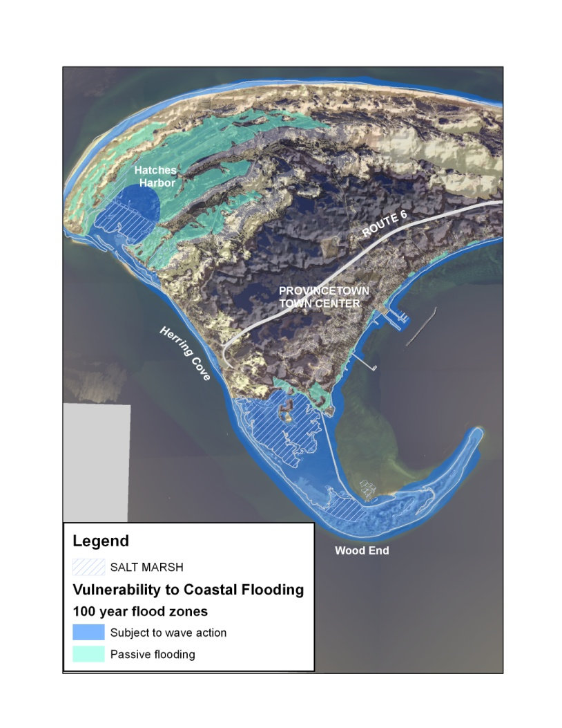

Figure 9. Map produced by CACO GIS office showing projected areas affected by a 100 year storm event. While portions of Herring Cove are likely to be affected by such an event, care was taken to select sites beyond the range of areas subject to wave action (CACO GIS Office 2009).

B1 - High Head ORV Road, Truro
Figure 10. 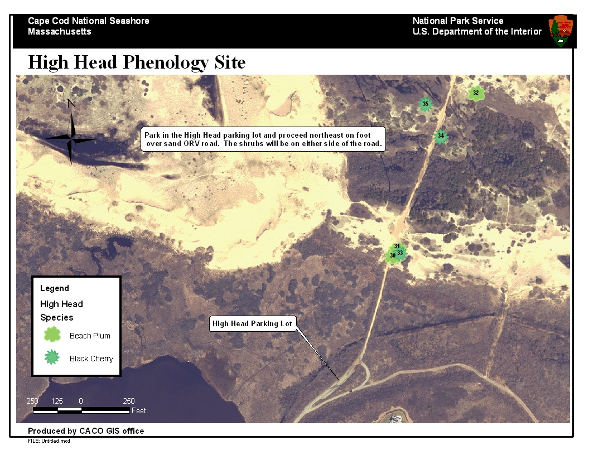
Turn off of Route 6 onto High Head Road. Bear left at the fork and proceed down the dirt road to the parking lot. Proceed on foot northeast along the sand ORV road. Shrubs will be near the road.

Figure 11. Marked shrubs at High Head ORV Road site. Individual shrubs have been marked with ½” PVC pipe. Attached to the top of each pipe is a numbered metal tree tag. Also, the PVC pipe has been marked with the corresponding number to ensure positive Shrubs are located near the road, though some over-sand walking will be required.
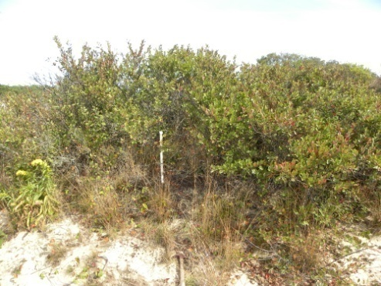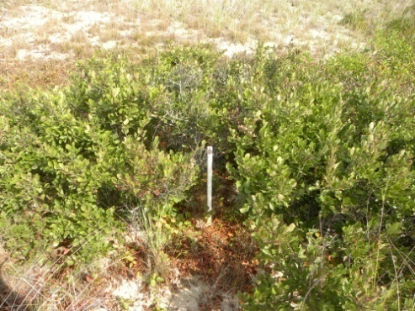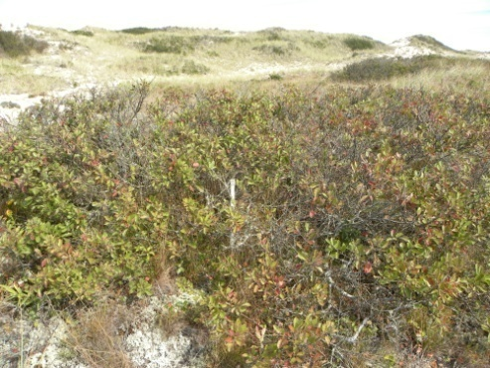
Shrub #32 – Beach plum near northern end of ORV road.
Shrub #31 – Beach plum. Near shrub 30.
Shrub #30 – Beach plum near southern end of ORV road.

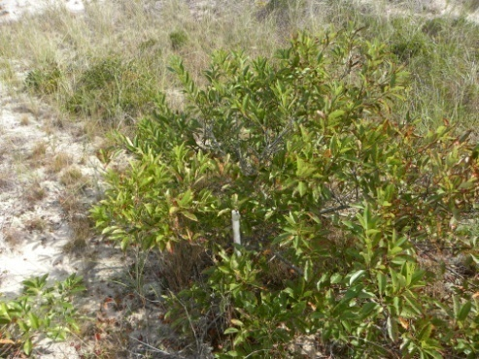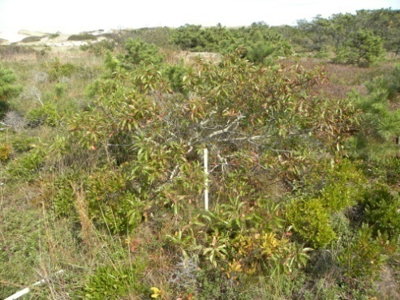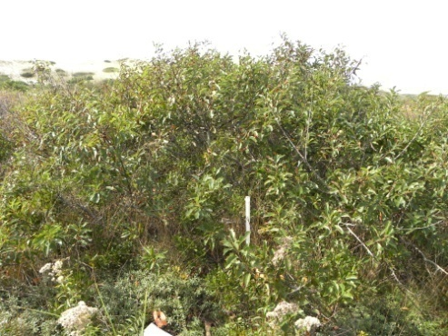
Shrub #33 – Black cherry. Near shrubs 30 and 31. Close to another black cherry - consider this one only.
Shrub #34 – Black Cherry. Near northern end of ORV road.
Shrub #35 – Black Cherry. Near northern end of ORV road.

B2 - Herring Cove North, Provincetown
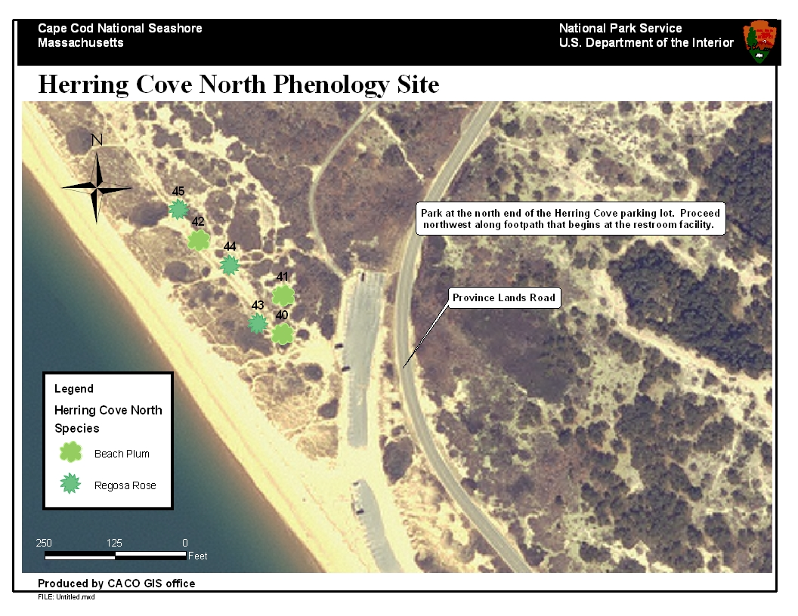
Figure 12.
Park at the north end of the Herring Cove parking lot and proceed northwest along sand footpath that begins at the restroom facility. All shrubs are adjacent to or just off the existing footpath. They are marked with ½” PVC pipes that have been hammered down into the sand and marked with tree tags. Shrubs have been grouped according to species, not the order in which they will be encountered along the trail.

Figure 13. Marked shrubs at Herring Cove North Site. Shrubs are located along sand footpath beyond bathroom facilities. Shrubs are for the most part clearly delineated individuals. The exception is shrub #43 which consists of sprawling Rugosa rose. As with the shrubs from Herring Cove South, a three meters radius from the pipe should be acknowledged and observed.
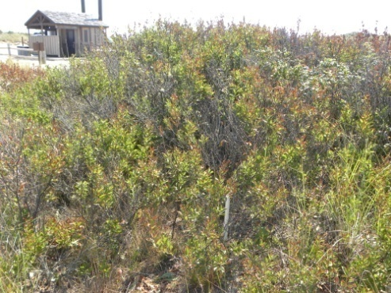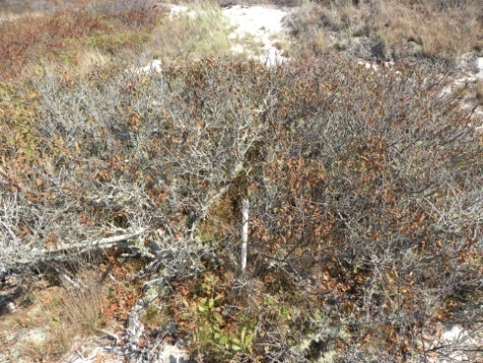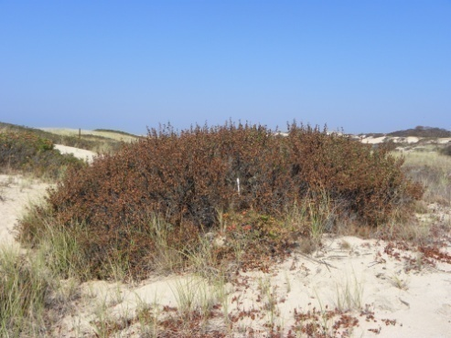
Shrub #42 – Beach plum.
Shrub #41 – Beach plum. Located on east side of sand trail.
Shrub #40 – Beach plum. Plant located nearest to bathroom facilities along footpath.

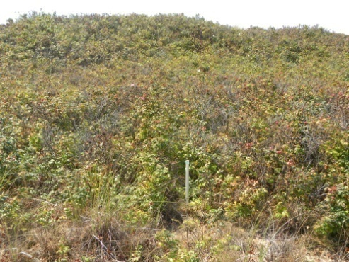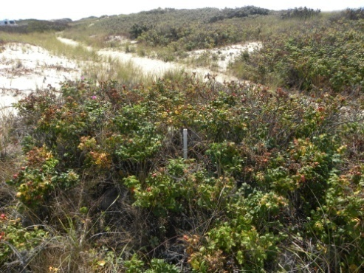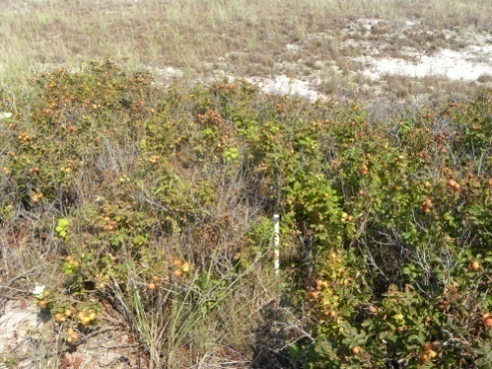
Shrub #45 – Rugosa rose. Located at northwest extent of site.
Shrub #44 – Rugosa rose.
Shrub #43 – Rugosa rose. Consists of a mat of sprawling Rugosa rose vegetation. Sample only within a 3 meter radius of the PVC stake.

B3 - Herring Cove South, Provincetown
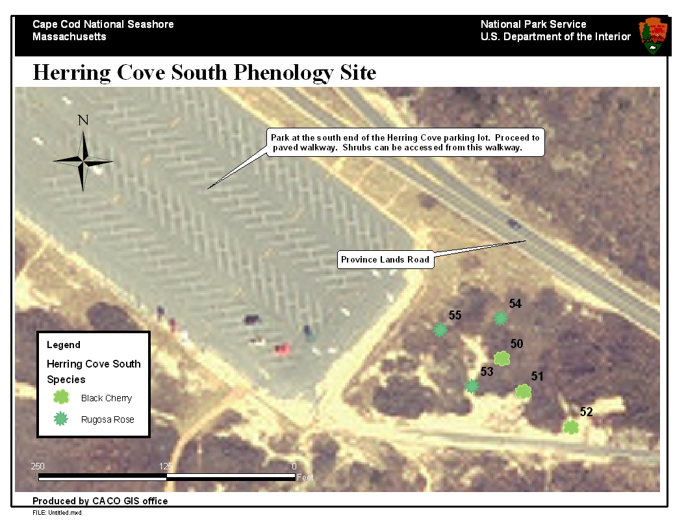
Figure 14.
Park at the sound end of Herring Cove parking lot. A paved walking just south of the shrubs under study can be utilized to access all flagged species. All shrubs are adjacent to or just off the existing footpath. They are marked with ½” PVC pipes that have been hammered down into the sand and marked with tree tags. Shrubs have been grouped according to species, not the order in which they will be encountered along the trail.

Figure 15. Marked shrubs at Herring Cove South site. Individual shrubs have been marked with ½” PVC pipe. Attached to the top of each pipe is a numbered metal tree tag. Shrubs are located near paved walkway leading southeast towards Province Lands Road. Individual shrubs are not easily delineated in all cases which may lead to some ambiguity between what vegetation should be considered. For the rugosa rose data collectors should consider all vegetation of that species within a three meter radius of the PVC stakes.
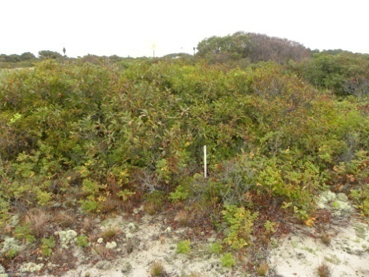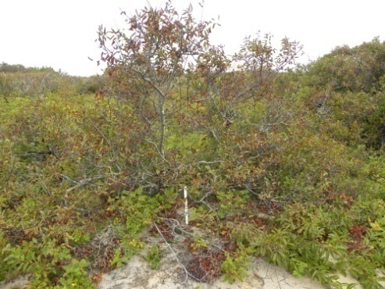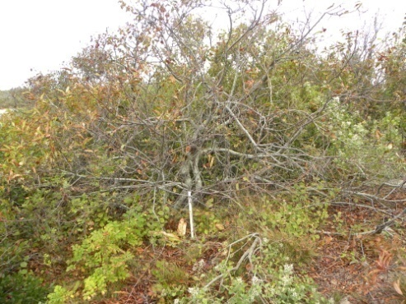
Shrub #52 – Black cherry. Located near (north side) the paved walkway.
Shrub #51 – Black cherry. Considerably less crowded by other native species. Easily identifiable.
Shrub #50 – Black cherry. There are other species of shrub/vine competing for space with all black cherry at this site. Be sure to consider only black cherry.

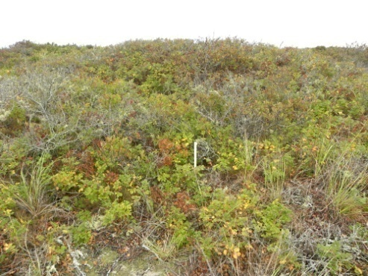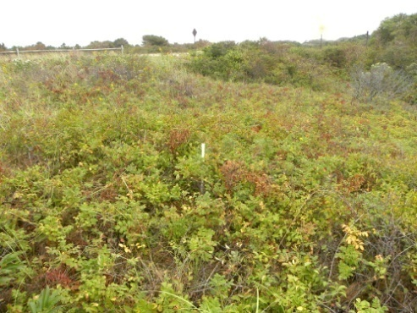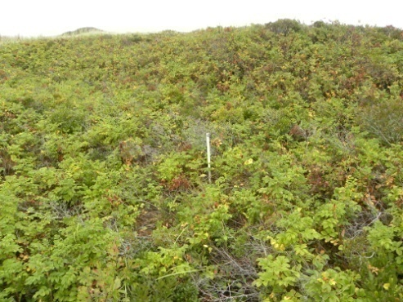
Shrub #55 – Rugosa rose. Be sure to only include observations of Rugosa rose. Crowding by other species may make this difficult.
Shrub #54 – Rugosa rose. Ensure to monitoring within three meters from the PVC pipe.
Shrub #53 – Rugosa rose. The Rugosa rose at this site is sprawling and somewhat intertwined with other species. Use caution to be sure that only Rugosa rose is being considered.

‘C’ Sites – Freshwater Ponds:
Species/Characteristics of Study: Ice Dynamics, Red-Winged Blackbird (Agelaius phoeniceus)
Range of Sampling Dates: December 1 – April 15 Frequency of Sampling: 1-2 times/week
Kettle ponds are among the most recognizable landscape features of the Outer Cape. Formed by retreating glaciers, these ponds are recharged exclusively by precipitation and groundwater. They make for unique and delicate ecosystems and offer an excellent opportunity to monitor not only biological characteristics, but physical characteristics as well - specifically ice. Because of the direct physical relationship between temperature and ice formation, monitoring the frequency and duration at which these ponds contain ice is an excellent phenological parameter (Magnusson et al. 2000).
Three kettle ponds will be monitored for ice coverage. The kettle ponds will be sampled at least once per week from the same vantage point along the shore. At each monitoring event, the observer will record presence/absence of any ice on the surface of the water (or just below the surface), and make a broad-range estimate of percent cover of ice on the water. An index has been established to incorporate these ranges. The index values are as follows: 0=No Ice, 1=1-25%, 2=26-50%, 3=51-75%, 4=76-100% -- Each index number designates a percent of ice coverage for the pond under study.
Monitoring will begin in late fall and continue into mid-April. The possibility exists that the kettle ponds may contain ice at an earlier date than December 1. April 15 should serve as a safe date after which no ice will be present on the ponds. So long as the range of dates that monitoring is taking place is approximately the same every year and this range of dates safely incorporates the ice terminus, the data collected will be valid with respect to making statements about duration of ice coverage (within that range of dates) and ice-out dates. However, the possibility does exist that we will have to constrain our observations to ice-out date only due to difficulty in judging dates of complete ice cover and the variable nature of ice cover throughout the winter. Ice out date will be determined when “0” is recorded as the value and no subsequent observations for that season result in a value greater than “0.” Certain biological characteristics can be monitored at kettle ponds as well. In the same fashion described for the freshwater wetland sites, red-winged blackbird presence/absence and abundance will be monitored at all three kettle ponds.
The kettle ponds to be monitored are listed below. They were selected based primarily on accessibility and to obtain a variety of sizes while excluding the largest ponds (based on the assumption that the larger the pond, the more difficult to estimate ice percent cover). All three ponds selected are also CCEM primary ponds – ponds selected for more intensive management by CCNS scientists (Portnoy et al. 2003). We are optimistic that, in addition to index data, from the range of dates where data is collected, those performing analysis can extract both “freeze dates” and “break-up date.” Freeze dates will be defined as the first day of the year where the ponds are observed to be completely ice covered. Break-up dates will be defined as the last date of any ice observed on the ponds (Magnusson et al. 2000). The estimates of percent cover should provide another dimension of data that will allow for a greater understanding of the dynamic of interannual ice coverage for these systems. The multitude of variables between ponds that could affect ice cover (e.g. elevation, aspect, surrounding vegetation, prevailing microclimate, etc.) may confound future analysis. When statistical analysis is carried out (many years down the road) freeze and break-up dates can be graphed individually for each pond and/or be grouped and averaged using a 5- or 10-year sliding average smoothing factor.

C1 - Snow Pond, Truro
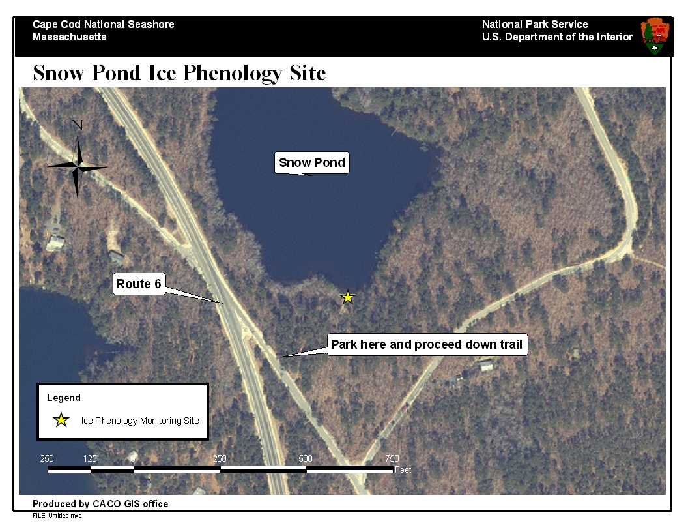
Figure 16.
Snow Pond is situated alongside Route 6 in Truro. There is easy parking and an established public access pathway that leads to a vantage point at the edge of the pond. The pond will serve as a site for ice phenology and red-winged blackbird monitoring.

C2 – Great Pond, Wellfleet
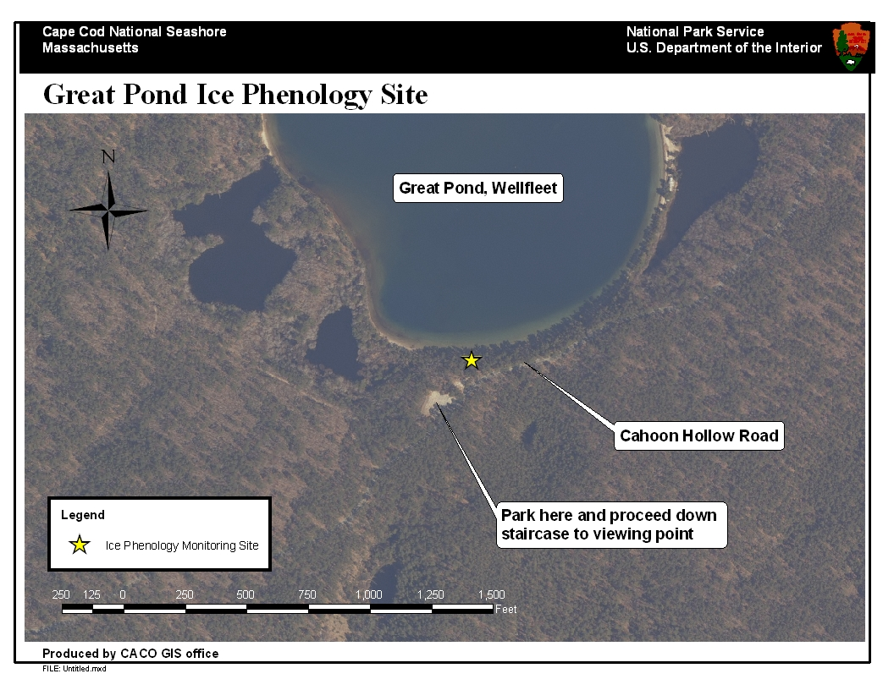
Figure 17.
Great Pond is another ideally situated pond next to a paved road. Also advantageous is the steep ascent of the public access way which will make for a well suited vantage point from which to gauge ice coverage. This pond represents the largest of the ponds we intend to monitor for ice.

C3– Long Pond, Wellfleet
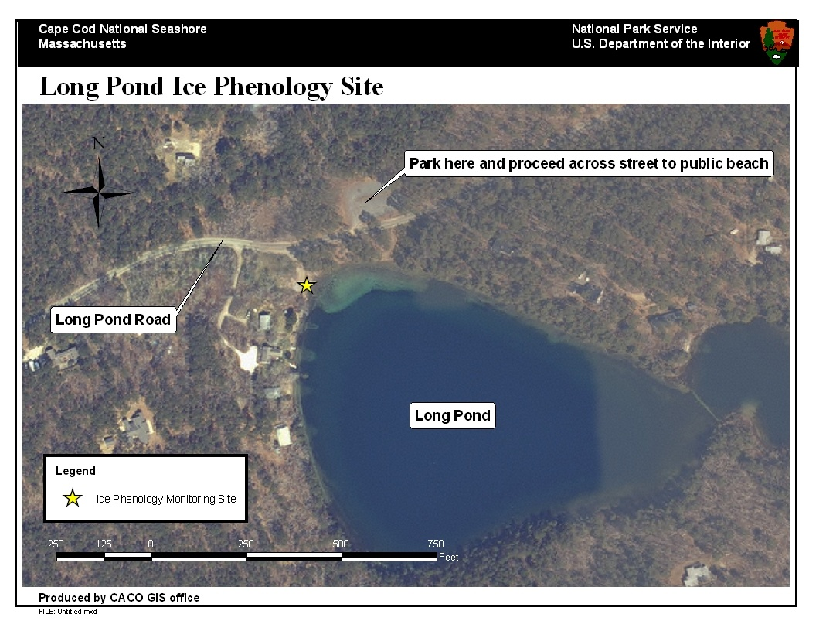
Figure 18.
Long Pond is also situated next to a paved road – Long Pond Road in Wellfleet. The public beach across the street from the parking lot will serve as the viewing point. Volunteers should stand in the center of the public beach. Red-winged blackbird monitoring will take place here as well.

‘D’ Sites – Salt Marsh Vegetation
Species of Study: Smooth Cordgrass (Spartina alterniflora). Sampling Dates: June 21 (Summer Solstice) every year.
Salt marsh ecosystems are among the most biologically productive systems on the planet. The ecological and economic importance of these systems is difficult to overstate. Cape Cod is rich with salt marshes; these are the dominant saltwater wetlands found along our coasts. These systems serve as habitat for a wide variety of marine and wildlife species and play a critical role in maintaining water quality. Historically though, many of Cape Cod’s salt marshes have become subject to some type of tidal restriction by way of human modifications (e.g. culverts, dikes, roads, etc.). When built across a salt marsh these structures can greatly limit the amount of tidal flushing which takes place on a daily basis. The resulting changes to sedimentation, hydrology, and salinity greatly alter upstream ecosystems often resulting in vegetation shifts that favor non-native species and in turn, alter the marine and wildlife communities that utilize those systems. Cape Cod National Seashore has made salt marsh restoration a management priority. A greater understanding of how our salt marshes function is an important part of their effective management.
The phenology monitoring envisioned for salt marsh systems is an idea unique to CCNS. Once a year under staff supervision, a group of volunteers will gather at the designated salt marsh sites. In established one meter-square plots, volunteers will measure maximum stem height for all smooth cordgrass (Spartina alterniflora) stems occurring in the plots. By performing this task on the same date every year, over time we will generate a long-term dataset that includes metrics for growth in exactly the same locations in the marsh. The monitoring effort effectively establishes a static reference point at which we can establish metrics for growth rate, density and biomass on an annual basis. In a warming climate scenario, one would expect a longer growing season and increased growth earlier in the season. The data collected will allow us to test this hypothesis.

D1 – Nauset Marsh (at Fort Hill), Eastham
Figure 19.
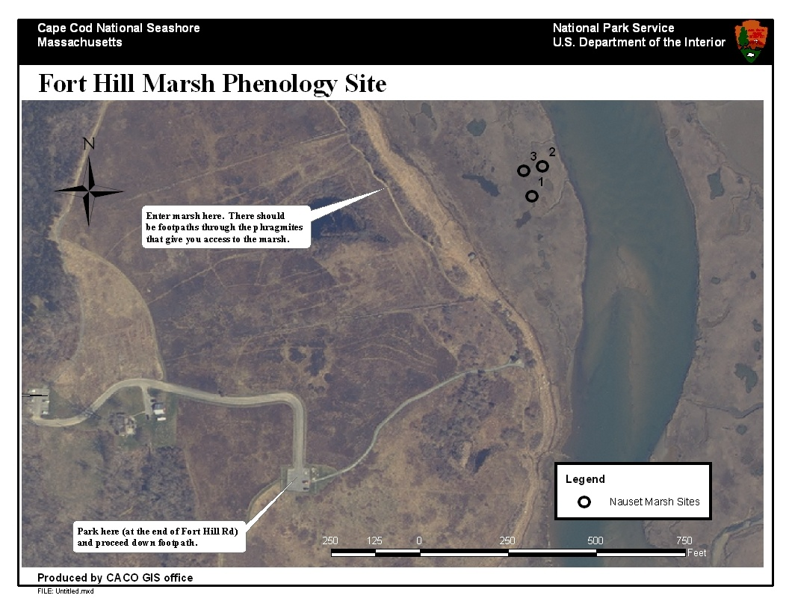
Volunteers can park in the upper Fort Hill parking lot and proceed down the footpath towards the marsh. There is an unmarked social trail leading into a Phragmites patch that will lead out into the Spartina marsh.

D2 – Salt Pond, Eastham
Figure 20.
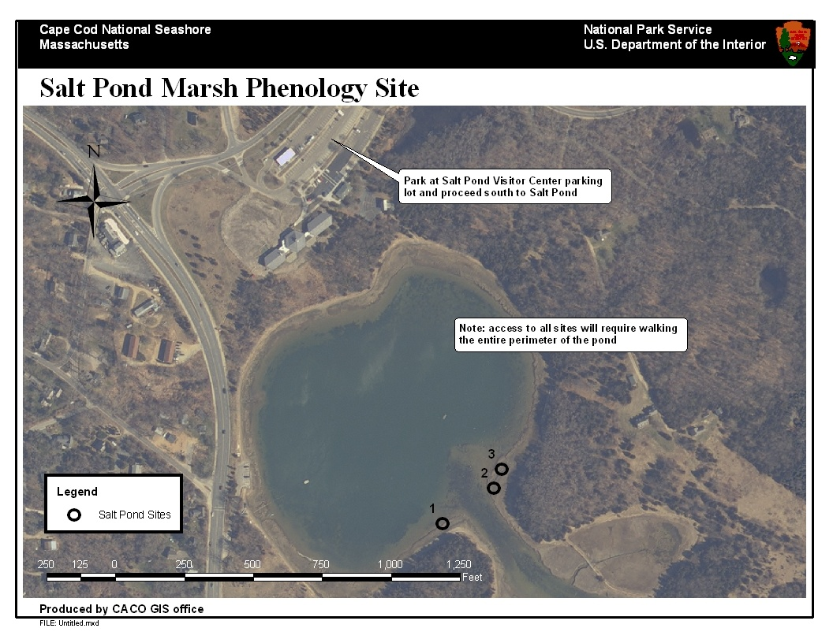
Volunteers can park at the Visitor Center parking lot and proceed down towards Salt Pond. Pipes have been placed on either side of the inlet requiring a walk along the entire perimeter of the site in order to access all plots. Care should be taken at pipes 2 and 3 as the terrain surrounding them is somewhat uneven.

D3 – West End Marsh, Provincetown
Figure 21.
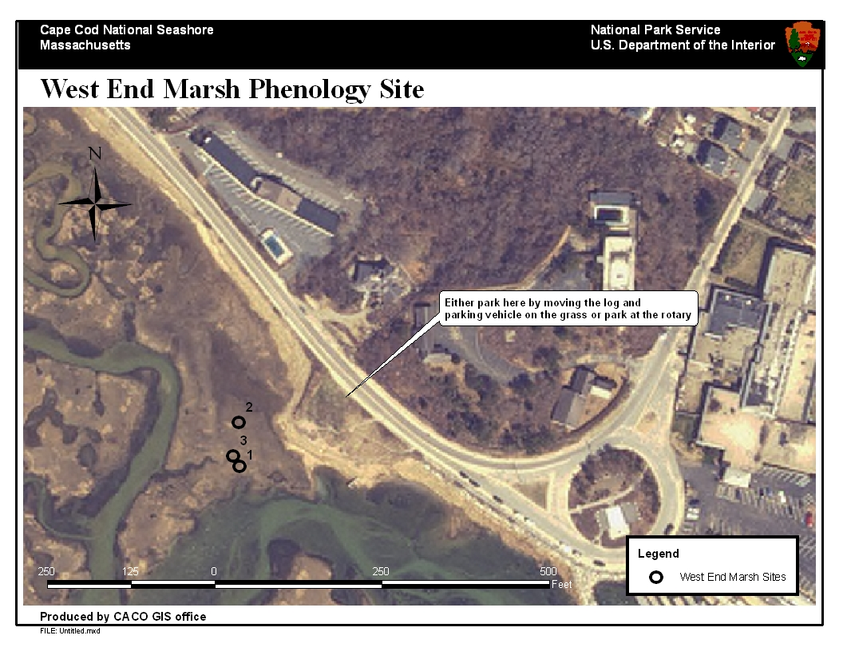
Volunteers can park either on the rotary or in the dirt lot designated for park staff and volunteers just northwest of the rotary. There is a log that serves as a removable barricade to the dirt lot which can be moved to allow vehicle access. A CCNS Volunteer certificate should be placed in the windshield of vehicles using the dirt lot. The pipes marking the plots are located not far from the road.

D4 – Hatches Harbor, Provincetown
Figure 22.
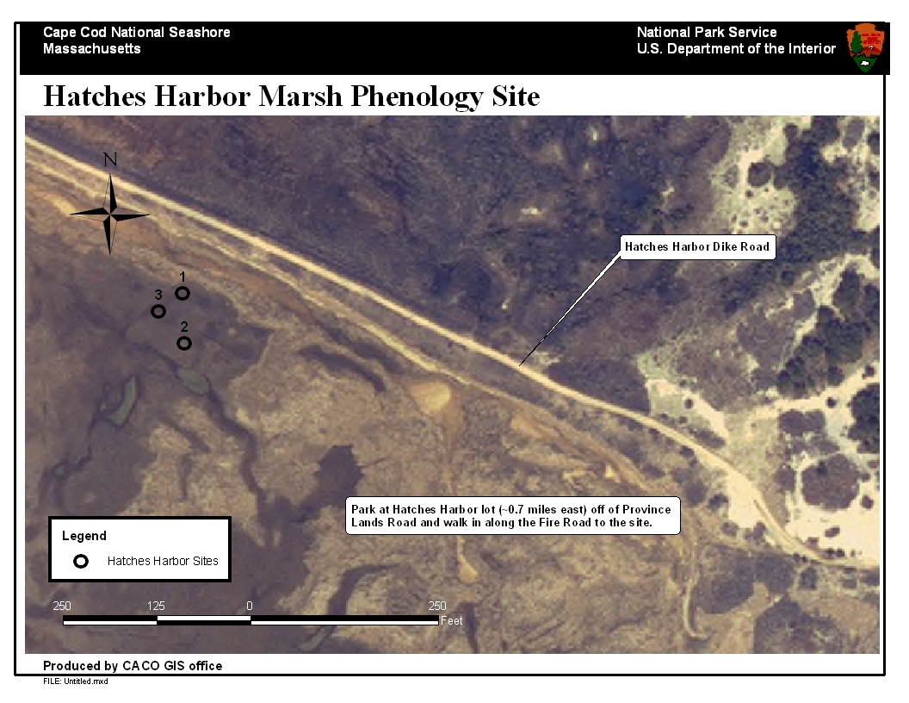
Parking is available at the Hatches Harbor Lot off of Province Lands Road. An approximate 0.7 mile walk from the lot to the plots will be required.

Section 4 – Data Collection & Data Management Protocols
Data management is a time consuming but critical part of most research projects. In research projects where data collection spans many years, the importance of ensuring sound data management is amplified by the fact that it is often handled by many different individuals. Continuity in stringent methods over time is critical. The systems for data collection and data management that will be put in place at CCNS have been largely adopted from protocols designed by the USA NPN. Most of the species selected for CCNS monitoring have been selected in accordance with the USA NPN species list so that data entry into the online database will be straight forward. Data entry into the USA NPN database will proceed under a multi-user format known as a “group site.” Developing a group site for the CCNS phenology monitoring program will allow for multiple users (i.e. volunteers) to independently create their own usernames and passwords and enter data for sites and species specifically designated by one or multiple administrators (i.e. Seashore employees managing the program). This data entered into the USA NPN database is stored with data from around the country, but can be extracted and viewed independently at any time. In other words, our data can live among all the other data, but we will always have the option of accessing only our data. Use of this online database is designed for non-experts and should be approachable for any computer and internet literate volunteer. However, the USA NPN database does not maintain entry options for all parameters we wish to monitor, specifically smooth cordgrass and ice. As such, a CCNS internal database will have to be developed to accommodate these phenophases. Also, it is possible that the USA NPN online database will languish over time and that it may become necessary to expand the CCNS database to encompass all species and phenophases. Development of a sound database that efficiently and reliably stores data may be the most important aspect of data management.
In addition to utilizing the USA NPN database, the CCNS program will rely on modified versions of their datasheets. The USA NPN datasheets have been designed by experts to include information relating to the most important phenophases. While CCNS monitoring may or may not retrieve information for all of the phenophases listed on any particular species’ datasheet, the existing USA NPN template will help steer efforts in the most meaningful direction. Modified versions of these datasheets have been created for use on specific CCNS site routes and are completely compatible with the USA NPN database. The USA NPN website contains a wealth of information pertaining to the description of specific phenophases and how to gauge whether or not they have come to pass. It is strongly recommended that all volunteers utilize the USA NPN website (http://www.usanpn.org) as a reference for specific questions. Specifically, the FAQ page will prove helpful in answering many data collection questions.
Protocols for data collection have been broken down by into groups pertaining to a specific or group of organisms. A total of four protocols have been developed to encompass the range of species (and the physical feature of ice) that will undergo monitoring. They include the following: Trees/Shrubs (both deciduous and coniferous), Red-winged Blackbirds, Ice, and Salt Marsh Vegetation.

Trees/Shrubs
Protocols for monitoring phenophases of both coniferous and deciduous trees and shrubs have been developed by the USA NPN. These phenophases will serve as the basis for monitoring at CCNS. Furthermore, while CCNS route-specific data sheets have been developed, these too have been largely adapted from USA NPN datasheets. This will allow for efficient integration with the USA NPN online database.
Deciduous Trees/Shrubs
Deciduous tree and shrub species that will undergo monitoring at CCNS include the following: red maple, white oak, beach plum, black cherry, and rugosa rosa (sometimes called salt spray rose). All four of these species are monoecious, meaning that male and female reproductive structures occur on the same individual plants. As such, all phenophases can be considered for all individuals. The phenophases listed below are those that will be considered for deciduous shrubs during each sampling event. For each phenophase being considered there is both a presence/absence criteria and a component of quantity to be recorded at each sampling event. Each phenophase listed below is followed by a short description. Please note that the USA NPN website may have additional phenophase categories. The phenophases listed below are those deemed most appropriate given certain constraints of the CCNS monitoring program. The descriptions have been transcribed verbatim from the USA NPN website.
Breaking leaf buds - One or more breaking leaf buds are visible on the plant. A leaf bud is considered breaking once a green leaf tip is visible at the end of the bud, but before the first leaf from the bud has unfolded to expose the leaf stalk (petiole) or leaf base. How many buds are breaking? Less than 3 (<3); 3 to 10 (3-10); More than 10 (>10)
Leaves - One or more live unfolded leaves are visible on the plant. A leaf is considered unfolded once the leaf stalk (petiole) or leaf base is visible. New small leaves may need to be bent backwards to see whether the leaf stalk or leaf base is visible. Do not include dried or dead leaves. What proportion of the canopy is full with leaves? Less than 5% (<5); 5-24%; 25-49%; 50-74%; 75-94%; 95% or more (95+)
Increasing leaf size - A majority of leaves on the plant have not yet reached their full size and are still growing larger. Do not include new leaves that continue to emerge at the ends of elongating stems throughout the growing season. What proportion of full size are most leaves? Less than 25% (<25); 25-49%; 50-74%; 75-94%; 95% or more (95+)
Flowers - One or more fresh flowers or flower heads (inflorescences) are visible on the plant. Flower heads include many small flowers that usually do not open all at once. Do not include wilted or dried flowers that remain on the plant, or heads whose flowers have all wilted or dried. How many fresh flowers or flower heads are present? Less than 3 (<3); 3 to 10 (3-10); More than 10 (>10)
Open flowers - One or more open fresh flowers are visible on the plant. Flowers are considered open when the reproductive parts (male stamens or female pistils) are visible between unfolded or open flower parts. Do not include wilted or dried flowers that remain on the plant. How many fresh flowers are open? Less than 3 (<3); 3 to 10 (3-10); More than 10 (>10); Peak flower (P): The plant has a large number of flowers and one half (50%) or more are open and still fresh.
Pollen release - One or more flowers on the plant release pollen when gently shaken or blown. How many flowers release pollen? Less than 3 (<3); 3 to 10 (3-10); More than 10 (>10); Peak pollen (P): The plant has a large number of flowers and one half (50%) or more release pollen.
Fruits - One or more fresh fruits are visible on the plant. How many fresh fruits are present? Less than 3 (<3); 3 to 10 (3-10); More than 10 (>10)
Ripe fruits - One or more ripe fruits are visible on the plant. How many fruits are ripe? Less than 3 (<3); 3 to 10 (3-10); More than 10 (>10)
Recent fruit drop - One or more fresh mature fruits or seeds have dropped or been removed from the plant since your last visit. Do not include obviously immature fruits that have dropped before ripening, such as in a heavy rain or wind. How many mature fruits have dropped? Less than 3 (<3); 3 to 10 (3-10); More than 10 (>10)
Coniferous Trees
The only coniferous tree species to be monitored is the eastern redcedar. Eastern redcedar is a coniferous (evergreen) tree growing 15-65 feet high. The bark is reddish-brown and mature leaves are scale-like, green in color, and grow in a spreading fashion. Eastern redcedar is a dioecious species meaning that male and female reproductive structures occur on different individual trees. We have selected only male trees; male trees contain pollen cones. Volunteer data collectors will need to determine this and record data for only the appropriate phenophases. The phenophases for monitoring are listed below, each with a short description. Please note that the USA NPN website may have additional phenophase categories. The phenophases listed below are those deemed most appropriate given certain constraints of the CCNS monitoring program. The descriptions have been transcribed verbatim from the USA NPN website.
Pollen cones - One or more fresh male pollen cones (strobili) are visible on the plant. Cones have overlapping scales that are initially tightly closed, then spread apart to open the cone and release pollen. Do not include wilted or dried cones that have released all of their pollen but remain on the plant. How many fresh pollen cones are present? Less than 3 (<3); 3 to 10 (3-10); More than 10 (>10)
Open pollen cones - One or more open fresh male pollen cones (strobili) are visible on the plant. Cones are considered "open" when the scales have spread apart to release pollen. Do not include wilted or dried cones that have released all of their pollen but remain on the plant. How many fresh pollen cones are open? Less than 3 (<3); 3 to 10 (3-10); More than 10 (>10); Peak opening (P): One half (50%) or more of the pollen cones on the plant are open and still fresh.
Pollen release - One or more male cones (strobili) on the plant release pollen when gently shaken or blown. How many pollen cones release pollen? Less than 3 (<3); 3 to 10 (3-10); More than 10 (>10); Peak pollen (P): One half (50%) or more of the pollen cones on the plant release pollen.

Red-Winged Blackbirds
Red-winged blackbirds are among the first migratory bird species to arrive in the spring and begin breeding on Cape Cod. They are common and have a continent-wide breeding distribution. Adult males are black with a red (and sometimes yellow) wing patch (Figure 23). Their conspicuous breeding behaviors and distinct call make them an excellent candidate for phenology monitoring. Upon arrival, males establish breeding territories usually along the periphery of wetland sites. Volunteers will monitor for red-winged blackbirds at predetermined wetland sites. There will be a total of six sites: Tree #6 (Fort Hill/Red Maple Swamp), Tree #21 (White Cedar Swamp), the Buttonbush Trail boardwalk, Long Pond, Great Pond, and Snow Pond. At each sampling event volunteers will spend exactly three minutes looking and listening for individual birds and will be asked to record (sometimes estimate) the number of active individuals observed. Any visual observation will suffice as an instance of “active individuals.” An auditory observation of either singing males (territory proclamation and breeding) and/or various other songs should be categorized into one of the other two phenophase descriptions (“Singing males” or “Calls or song”). Volunteers are encouraged to carry binoculars for visual confirmation whenever possible. The various calls and songs of the red-winged blackbird can be accessed using the Cornell Lab of Ornithology “All About Birds” website. Volunteers should learn all the different vocalizations for the species prior to monitoring. The phenophases listed below are those that will be considered for red-winged blackbirds. Each is followed by a short description. Please note that the USA NPN website may have additional phenophase categories. The phenophases listed below are those deemed most appropriate given certain constraints of the CCNS monitoring program. The descriptions have been transcribed verbatim from the USA NPN website.
Active individuals - One or more individuals are seen moving about or at rest. For abundance, enter the number of individual animals observed in this phenophase.
Calls or song - One or more individuals are heard calling or singing. For abundance, enter the number of individual animals observed in this phenophase.
Singing males - One or more singing males are heard. Singing refers to stereotypical, simple or elaborate vocalizations used as a part of territorial proclamation or defense or mate attraction. It does not include relatively simple calls used for other forms of communication. For abundance, enter the number of individual animals observed in this phenophase.
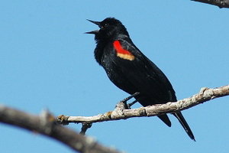
Figure 23. Photo courtesy USA NPN. A male red-winged blackbird calls in early spring. Volunteers should use the Cornell Lab of Ornithology “All About Birds” (http://www.allaboutbirds.org/Page.aspx?pid=1189) website to learn the songs and calls of this species.
Ice Coverage
Due to its direct tie to temperature, the formation of ice on ponds makes for an excellent phenophase by which to tie climate change to local physical processes. The timing of these physical processes, in turn, can have a significant effect on the timing of ecological processes. As the USA NPN deals only with the phenology of living organisms, no known national protocol exists for ice coverage. As such, a protocol has been developed at CCNS specifically for the kettle ponds. The protocol is simple and straightforward. Volunteers will make observations a minimum of 1-2 times per week from the same location along the shore of the selected kettle ponds. At each visit, volunteers will make estimates for the percentage of ice coverage visible on the surface of the ponds. This should include ice that remains below a thin layer of standing water at the surface of the ponds. It is important to make observations for the entire range of dates specified (December 1 – April 15) in an effort to demonstrate as complete as possible a picture of the annual dynamic of ice coverage. Percentage estimates will be grouped into one of five categorical index values. These values are listed below:
0 - No ice visible on the surface of the pond.
1 - 1-25% of the surface of the pond covered in ice.
2 - 26-50% of the surface of the pond covered in ice.
3 - 51-75% of the surface of the pond covered in ice.
4 - 76-100% of the surface of the pond covered in ice.

Salt Marsh Vegetation (Smooth Cordgrass - Spartina alterniflora)
The protocol for salt marsh vegetation is another that is unique to CCNS. This protocol is unique not only because it encompasses an often overlooked ecosystem (in terms of phenology), but because it incorporates not just observations but actual measurements. This protocol is also different because it will consist of data collected on one day a year only. Each year, on as close as possible to the summer solstice (usually June 20 or 21) volunteers will assemble at the appropriate salt marshes and measure maximum stem height of all smooth cordgrass in pre-established one meter-square plots. Sites for monitoring have been marked with 2” PVC pipe hammered into the marsh (Figure 24). Plots will be established using a one meter-square PVC quadrat. The 2” PVC pipe will serve as the southwest corner of the plot. In some instances (excluding Salt Pond Visitor Center) there are also smaller PVC pipes indicating the northeast corner of the plots. The quadrats should align with both pipes so that each pipe fits just inside the opposite corners of the quadrat forming a square where each side is oriented perpendicular to a cardinal direction. Each 2” PVC pipe has a notch in the top that has been oriented in a north-south direction (Figure 24). This notch should serve as a reference to assure that the plot is aligned correctly. This is important because it ensures that from year to year we are observing the same exact patch of salt marsh. Care should be taken when approaching and measuring the plots so to minimize disturbance to the vegetation.
The current Cape Cod Ecosystem Monitoring (CCEM) protocol for salt marshes is implemented once every five years and has no component that measures biomass. By obtaining data on stem height and stem density inside each plot (three per marsh) we can begin to approach the question as to whether or not expected increased temperatures and flooding (associated with sea-level rise) are leading to shifts in the timing of production (biomass accumulation) for smooth cordgrass.
At each plot volunteers will measure the maximum stem height (MSH) of all individual plants inside the quadrat. When measuring it will be important to keep track of which individuals have already been measured and which remain to be measured. Volunteers will use a standard metric measuring tape to obtain this information. These measurements should be recorded in centimeters. Each plot will require at least one person measuring plants and at least one person recording data. As salt marshes are tidally influenced systems, this data must be collected during low tide. And as this is an annual event, it is probably worthwhile for a CCNS scientist to supervise on-site to ensure data is collected properly. This will also ensure the timely return of any borrowed equipment.

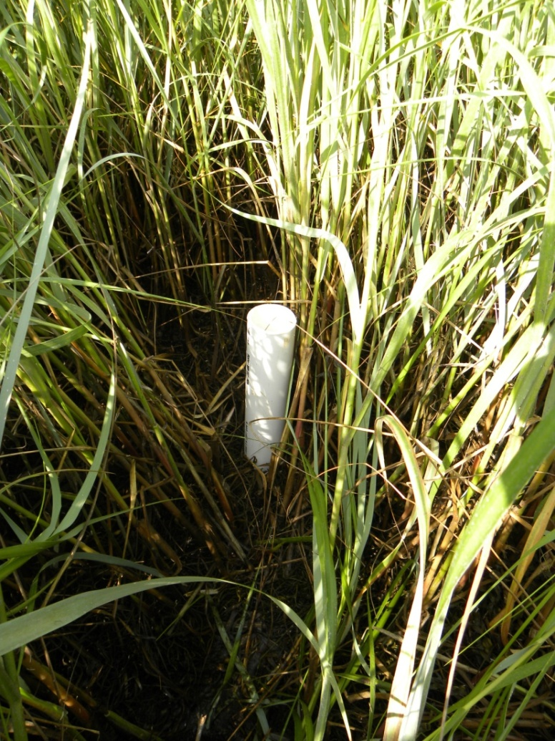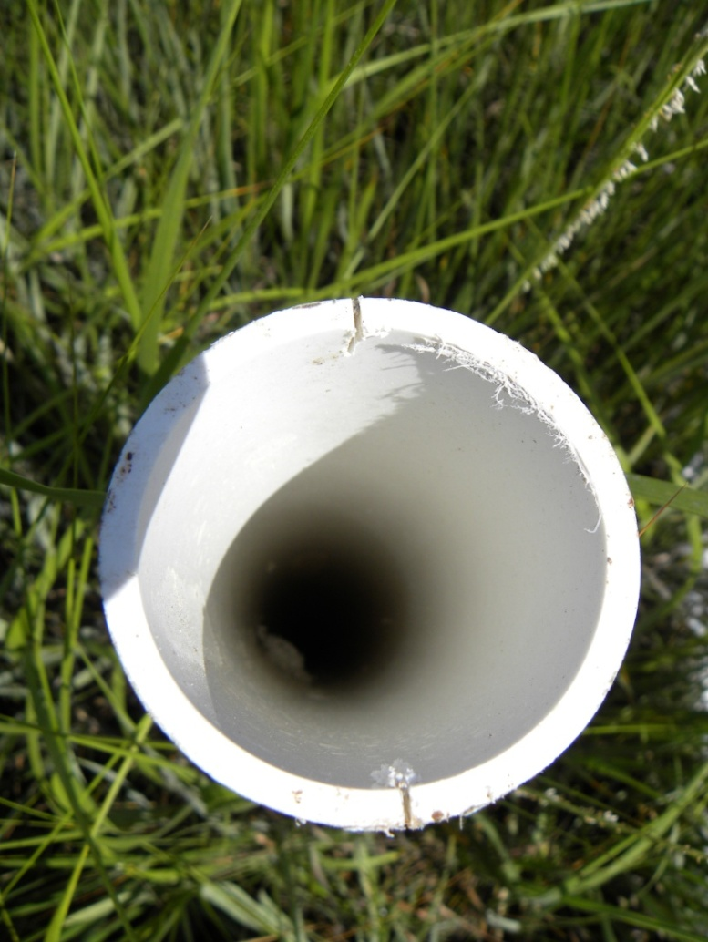

Figure 24. Photos showing 2” PVC pipe inserted into marsh. Each designated marsh plot will be established with the 2” PVC pipes as the southwest corner of the one meter-square. A pipe inserted into the marsh amidst smooth cordgrass (left). The top of a PVC pipe showing notches that are oriented in a north-south direction (right).

Section 5 - Discussion
The benefits of this program will be two-fold. Most importantly the program will provide monitoring data that will increase our understanding of the ecological effects of climate change. Secondly, the program will give members of the public the opportunity to engage in meaningful scientific data collection and in doing so learn more about the natural world in which they live. The project will serve as a way for the public to be actively involved in the process of preserving and protecting CCNS natural resources as they relate to climate change.
One of the biggest challenges, especially in the initial stages of implementation, will be to manage all facets of the project adaptively. There are certain to be unforeseen challenges in implementing the many different aspects of data collection and data management. CCNS staff responsible for managing the program should be prepared for issues voiced by volunteers and be able to direct those concerns to references that will answer the question at hand. Aside from this document, one particularly useful resource will be the USA NPN website (http://www.usanpn.org). The frequently asked questions section (FAQ) should be considered a primary resource in helping to clarify issues raised. In the event that an issue cannot be rectified it may be appropriate to change the methodology of one or more of the protocols. This is in line with the process of revision illustrated in Figure 1.
It is important to realize that in its present form this is a descriptive study. As it is likely that many climate variables will co-vary, by simply detecting a correlation between some climate variable (e.g. temperature) and a phenological trait, one does not necessarily demonstrate that climate variable as the cue regulating phenology. Only by tightly controlling for all the potential variables can one make concrete statements about what exactly is driving the timing of certain life cycle events. Depending on the organism in question these potential variables are numerous. For example, in the case of a tree, accumulated temperature (degree days), photoperiod, genes, and precipitation are among the factors that can drive phenology (Forrest and Miller-Rushing 2010). Many of the same cues drive animal phenology (Faust and Weston 2009). In a study such as this one, where measurements are made in situ (in the field), controlling for all the potential variables is, for all practical purposes, impossible.
This is not to say though, that this study represents only an exercise in public engagement or that it does not hold scientific merit. By adopting USA NPN protocols for data collection (and by entering our data into their online database) this study will contribute to building a national database of phenological observations. Such a database is very useful for discerning large-scale (i.e. regional and global) trends over time. This type of large-scale data set can test different predictors of phenological response with advanced statistical modeling techniques (Dunne et al. 2006, Hulber et al. 2010). It is in this way that individual data sets contribute to a defensible understanding of global change with respect to climate change (Parmesan and Yohe 2003). In addition, by developing our own CCNS database we will, at minimum, demonstrate and perhaps gain a greater understanding into what is driving local phenological changes in different community types on the Outer Cape. Results from this study will provide greater insight to resource managers charged with making sound stewardship decisions and will likely lead to the development of more complex ecological questions that could trigger future research.
Worth considering for future modifications to the CCNS program is whether or not we want to collect data on covariates (for any protocol) that are not options to enter into the USA NPN online database. If we choose to do so this may sharpen the understanding as to what is driving local changes in phenology. This will need to be weighed as the specific protocols are implemented for each species.
The potential for phenology monitoring at CCNS is enormous. Climate change is expected to have a strong bearing on the timing of many biological processes (Gibbs and Breisch 2001, Walther et al. 2002, Bertin 2008). Because phenology is an integral part of virtually all ecological and evolutionary processes, pursuing a greater understanding of what is driving the timing of physical and biological events is certainly a worthwhile endeavor for the Park Service to engage in (Forrest and Miller-Rushing 2010). Of interest to park administrators and natural resource managers is the fact that a greater understanding of local phenology will provide an additional dimension of insight when making local management decisions. And because phenology is one of the simplest ways in which to track ecological change, it is well-suited for implementing citizen science initiatives.
Much of the potential for future monitoring exists in the realm of expanding the program to encompass additional species. Of particular ecological interest may be other non-native. Currently no non-native tree species have been selected to undergo monitoring (the lone non-native species slated to undergo monitoring is rugosa rose). Black locust is a nitrogen-fixing tree native to the Central Appalachian and Ozark Mountains. Stands of black locust are common at CCNS and have been shown to be negatively correlated with native biodiversity (Von Holle et al. 2006). Because they are common, easy to identify, and often occur in areas of human use/disturbance, they make for an excellent phenology monitoring candidate. Other potential plant species of interest include rare species such as broom crowberry (Corema conradii).
An additional plant monitoring protocol for beach grass (Ammophila breviligulata) was discussed, but was not included in this document due to constraints in time and doubt about its efficacy. It was envisioned that beach grass monitoring would take place in a fashion similar to smooth cordgrass, being monitored in predetermined plots on an annual basis. However, few suitable sites were found that contained an appropriate assemblage and density of the species. Most beach grass sites scouted were particularly vulnerable to succession. The exception to this was the uplands adjacent to the extreme west end of East Harbor near the Dune Parking Lot. This was the only site that contained a homogenous and dense enough array of beach grass to warrant monitoring on the one meter-square scale. Should a future effort be made to go forward with beach grass monitoring it is recommended that scouting for sites begin here.
Only one animal species has been selected for phenological monitoring. This was due in part to the more complex nature of animal data collection. This does not mean that the program should shy away from additional animal monitoring in the future. Of particular interest would be to study the phenology of well known pollinators of plant species already slated for monitoring. A major concern of scientists is that the timing of these relationships will be subject to disruption as a result of climate change and the subsequent shifts in phenology for either species (Memmott et al. 2007, Hegland et al. 2009). If these disruptions sever completely the overlap in time between pollinator and flower, the likelihood of local extinction increases.
Shifts in phenology as they relate to climate change are complex and do not always follow expected trends (Von Holle et al. 2010). Regardless of what patterns and trends are revealed, this project will add to the comprehensive understanding of phenological shifts (or lack thereof) taking place on the Outer Cape. In combination with data collected from the CCEM program including anuran calling peaks and shorebird nesting data, the CCNS phenology program will begin to paint an easily understood picture of local change associated with a changing climate. Such efforts are increasingly important in improving public understanding in a rapidly changing world.

Index A. Locations of All Phenology Monitoring Organisms and Sites
Table 1. List and locations of all trees and shrubs that will undergo phenology monitoring.
Tree ID # | Species | Site | Easting | Northing
1 | Eastern Redcedar | Fort Hill | 419876 | 4630240
2 | Eastern Redcedar | Fort Hill | 419866 | 4630234
3 | Eastern Redcedar | Fort Hill | 419795 | 4630211
4 | Red Maple | Fort Hill | 419703 | 4630200
5 | Red Maple | Fort Hill | 419673 | 4630216
6 | Red Maple | Fort Hill | 419792 | 4630375
10 | White Oak | SPVC | 419349 | 4632231
11 | White Oak | SPVC | 419369 | 4632247
12 | White Oak | SPVC | 419357 | 4632247
13 | Eastern Redcedar | SPVC | 419367 | 4632234
14 | Eastern Redcedar | SPVC | 419388 | 4632230
15 | Eastern Redcedar | SPVC | 419341 | 4632222
20 | Red Maple | White Cedar Swamp | 418762 | 4640370
21 | Red Maple | White Cedar Swamp | 418752 | 4640390
22 | Red Maple | White Cedar Swamp | 418726 | 4640423
23 | White Oak | White Cedar Swamp | 418741 | 4640394
24 | White Oak | White Cedar Swamp | 418740 | 4640371
25 | White Oak | White Cedar Swamp | 418748 | 4640346
30 | Beach Plum | High Head | 407880 | 4657128
31 | Beach Plum | High Head | 407888 | 4657138
32 | Beach Plum | High Head | 408019 | 4657382
33 | Black Cherry | High Head | 407892 | 4657132
34 | Black Cherry | High Head | 407962 | 4657315
35 | Black Cherry | High Head | 407939 | 4657366
40 | Beach Plum | Herring Cove North | 398824 | 4656116
41 | Beach Plum | Herring Cove North | 398825 | 4656137
42 | Beach Plum | Herring Cove North | 398780 | 4656168
43 | Rugosa Rose | Herring Cove North | 398811 | 4656122
44 | Rugosa Rose | Herring Cove North | 398797 | 4656154
45 | Rugosa Rose | Herring Cove North | 398770 | 4656185
50 | Black Cherry | Herring Cove South | 399556 | 4655214
51 | Black Cherry | Herring Cove South | 399562 | 4655204
52 | Black Cherry | Herring Cove South | 399576 | 4655193
53 | Rugosa Rose | Herring Cove South | 399547 | 4655206
54 | Rugosa Rose | Herring Cove South | 399556 | 4655226
55 | Rugosa Rose | Herring Cove South | 399538 | 4655223

Table 2. List and locations of all ice phenology monitoring locations.
Pond | Easting | Northing
Long Pond, Wellfleet | 416180 | 4644175
Great Pond, Wellfleet | 417052 | 4643386
Snow Pond, Truro | 414885 | 4646814
Long Pond, Wellfleet Vantage Point | 416189 | 4644183
Great Pond, Wellfleet Vantage Point | 417153 | 4643389
Snow Pong, Truro Vantage Point | 414887 | 4646814

Table 3. List and locations of all salt marsh phenology monitoring plots.
Marsh Site | Pipe Number | Easting | Northing
Nauset (Fort Hill) | 1 | 420306 | 4630274
Nauset (Fort Hill) | 2 | 420316 | 4630299
Nauset (Fort Hill) | 3 | 420300 | 4630296
Salt Pond | 1 | 419390 | 4631849
Salt Pond | 2 | 419448 | 4631886
Salt Pond | 3 | 419457 | 4631907
Hatches Harbor | 1 | 398196 | 4657504
Hatches Harbor | 2 | 398196 | 4657484
Hatches Harbor | 3 | 398186 | 4657497
West End | 1 | 400790 | 4654612
West End | 2 | 400790 | 4654632
West End | 3 | 400787 | 4654617

Index B. Volunteer Data Collection Sheets
Table 4. Eastham Route (Freshwater Wetlands) – Fort Hill Data Collection Sheets
CCNS Phenology Monitoring - Eastham Route (Freshwater Wetlands) |  |  |  |  | Date:
Site | Fort Hill | Fort Hill | Fort Hill | Fort Hill | Fort Hill | Fort Hill
Tree # | 1 | 2 | 3 | 4 | 5 | 6
Time | _____:______ | _____:______ | _____:______ | _____:______ | _____:______ | _____:______
Species | Red Cedar | Red Cedar | Red Cedar | Red Maple | Red Maple | Red Maple
Do You See…?
Breaking leaf buds | Y N ? _____ | Y N ? _____ | Y N ? _____ | Y N ? _____ | Y N ? _____ | Y N ? _____
Leaves | Y N ? _____ | Y N ? _____ | Y N ? _____ | Y N ? _____ | Y N ? _____ | Y N ? _____
Increasing leaf size | Y N ? _____ | Y N ? _____ | Y N ? _____ | Y N ? _____ | Y N ? _____ | Y N ? _____
Flowers | Y N ? _____ | Y N ? _____ | Y N ? _____ | Y N ? _____ | Y N ? _____ | Y N ? _____
Open flowers | Y N ? _____ | Y N ? _____ | Y N ? _____ | Y N ? _____ | Y N ? _____ | Y N ? _____
Pollen release |  |  |  | Y N ? _____ | Y N ? _____ | Y N ? _____
Fruits | Y N ? _____ | Y N ? _____ | Y N ? _____ | Y N ? _____ | Y N ? _____ | Y N ? _____
Ripe fruits | Y N ? _____ | Y N ? _____ | Y N ? _____ | Y N ? _____ | Y N ? _____ | Y N ? _____
Recent fruit drop |  |  |  | Y N ? _____ | Y N ? _____ | Y N ? _____
Pollen cones | Y N ? _____ | Y N ? _____ | Y N ? _____ | Y N ? _____ | Y N ? _____ | Y N ? _____
Open pollen cones | Y N ? _____ | Y N ? _____ | Y N ? _____ | Y N ? _____ | Y N ? _____ | Y N ? _____
Pollen release | Y N ? _____ | Y N ? _____ | Y N ? _____ | Y N ? _____ | Y N ? _____ | Y N ? _____
Unripe seed cones | Y N ? _____ | Y N ? _____ | Y N ? _____ | Y N ? _____ | Y N ? _____ | Y N ? _____
Ripe seed cones | Y N ? _____ | Y N ? _____ | Y N ? _____ | Y N ? _____ | Y N ? _____ | Y N ? _____
Red-winged blackbirds
Non-calling active individuals |  |  |  |  |  | Y N ? _____
Calls or song |  |  |  |  |  | Y N ? _____
Singing males |  |  |  |  |  | Y N ? _____
Observer(s):
Check when data entered:
Date:
Initials:

Table 5. Eastham Route (Freshwater Wetlands) – White Cedar Swamp Data Collection Sheets
CCNS Phenology Monitoring - Eastham Route (Freshwater Wetlands) |  |  |  |  | Date:
Site | Cedar Swamp | Cedar Swamp | Cedar Swamp | Cedar Swamp | Cedar Swamp | Cedar Swamp
Tree # | 20 | 21 | 22 | 23 | 24 | 25
Time | _____:______ | _____:______ | _____:______ | _____:______ | _____:______ | _____:______
Species | Red Maple | Red Maple | Red Maple | White Oak | White Oak | White Oak
Do You See…?
Breaking leaf buds | Y N ? _____ | Y N ? _____ | Y N ? _____ | Y N ? _____ | Y N ? _____ | Y N ? _____
Leaves | Y N ? _____ | Y N ? _____ | Y N ? _____ | Y N ? _____ | Y N ? _____ | Y N ? _____
Increasing leaf size | Y N ? _____ | Y N ? _____ | Y N ? _____ | Y N ? _____ | Y N ? _____ | Y N ? _____
Flowers | Y N ? _____ | Y N ? _____ | Y N ? _____ | Y N ? _____ | Y N ? _____ | Y N ? _____
Open flowers | Y N ? _____ | Y N ? _____ | Y N ? _____ | Y N ? _____ | Y N ? _____ | Y N ? _____
Pollen release |  |  |  | Y N ? _____ | Y N ? _____ | Y N ? _____
Fruits | Y N ? _____ | Y N ? _____ | Y N ? _____ | Y N ? _____ | Y N ? _____ | Y N ? _____
Ripe fruits | Y N ? _____ | Y N ? _____ | Y N ? _____ | Y N ? _____ | Y N ? _____ | Y N ? _____
Recent fruit drop |  |  |  | Y N ? _____ | Y N ? _____ | Y N ? _____
Pollen cones | Y N ? _____ | Y N ? _____ | Y N ? _____ | Y N ? _____ | Y N ? _____ | Y N ? _____
Open pollen cones | Y N ? _____ | Y N ? _____ | Y N ? _____ | Y N ? _____ | Y N ? _____ | Y N ? _____
Pollen release | Y N ? _____ | Y N ? _____ | Y N ? _____ | Y N ? _____ | Y N ? _____ | Y N ? _____
Unripe seed cones | Y N ? _____ | Y N ? _____ | Y N ? _____ | Y N ? _____ | Y N ? _____ | Y N ? _____
Ripe seed cones | Y N ? _____ | Y N ? _____ | Y N ? _____ | Y N ? _____ | Y N ? _____ | Y N ? _____
Red-winged blackbirds
Non-calling active individuals |  | Y N ? _____
Calls or song |  | Y N ? _____
Singing males |  | Y N ? _____
Observer(s):
Check when data entered:
Date:
Initials:

Table 6. Eastham Route (Freshwater Wetlands) – Salt Pond Visitor Center Data Collection Sheets
CCNS Phenology Monitoring - Eastham Route (Freshwater Wetlands) |  |  |  |  | Date:
Site | SPVC | SPVC | SPVC | SPVC | SPVC | SPVC | SPVC
Tree # | 10 | 11 | 12 | 13 | 14 | 15 | NA
Time | _____:______ | _____:______ | _____:______ | _____:______ | _____:______ | _____:______ | _____:______
Species | White Oak | White Oak | White Oak | Red Cedar | Red Cedar | Red Cedar | RWBB Site
Do You See…? |  |  |  |  |  |  | Y N ? _____
Breaking leaf buds | Y N ? _____ | Y N ? _____ | Y N ? _____ | Y N ? _____ | Y N ? _____ | Y N ? _____ | Y N ? _____
Leaves | Y N ? _____ | Y N ? _____ | Y N ? _____ | Y N ? _____ | Y N ? _____ | Y N ? _____ | Y N ? _____
Increasing leaf size | Y N ? _____ | Y N ? _____ | Y N ? _____ | Y N ? _____ | Y N ? _____ | Y N ? _____ | Y N ? _____
Flowers | Y N ? _____ | Y N ? _____ | Y N ? _____ | Y N ? _____ | Y N ? _____ | Y N ? _____ | Y N ? _____
Open flowers | Y N ? _____ | Y N ? _____ | Y N ? _____ | Y N ? _____ | Y N ? _____ | Y N ? _____
Pollen release |  |  |  | Y N ? _____ | Y N ? _____ | Y N ? _____
Fruits | Y N ? _____ | Y N ? _____ | Y N ? _____ | Y N ? _____ | Y N ? _____ | Y N ? _____
Ripe fruits | Y N ? _____ | Y N ? _____ | Y N ? _____ | Y N ? _____ | Y N ? _____ | Y N ? _____
Recent fruit drop |  |  |  | Y N ? _____ | Y N ? _____ | Y N ? _____ | Y N ? _____
Pollen cones | Y N ? _____ | Y N ? _____ | Y N ? _____ | Y N ? _____ | Y N ? _____ | Y N ? _____ | Y N ? _____
Open pollen cones | Y N ? _____ | Y N ? _____ | Y N ? _____ | Y N ? _____ | Y N ? _____ | Y N ? _____ | Y N ? _____
Pollen release | Y N ? _____ | Y N ? _____ | Y N ? _____ | Y N ? _____ | Y N ? _____ | Y N ? _____ | Y N ? _____
Unripe seed cones | Y N ? _____ | Y N ? _____ | Y N ? _____ | Y N ? _____ | Y N ? _____ | Y N ? _____ | Y N ? _____
Ripe seed cones | Y N ? _____ | Y N ? _____ | Y N ? _____ | Y N ? _____ | Y N ? _____ | Y N ? _____
Red-winged blackbirds
Non-calling active individuals |  |  |  |  |  |  | Y N ? _____
Calls or song |  |  |  |  |  |  | Y N ? _____
Singing males |  |  |  |  |  |  | Y N ? _____
Observer(s):
Check when data entered:
Date:
Initials:

Table 7. Provincetown Route (Marimtime Dunes) – High Head Data Collection Sheets
CCNS Phenology Monitoring - Provincetown Route (Marimtime Dunes) |  |  |  |  | Date:
Site | High Head | High Head | High Head | High Head | High Head | High Head
Tree # | 30 | 31 | 32 | 33 | 34 | 35
Time | _____:______ | _____:______ | _____:______ | _____:______ | _____:______ | _____:______
Species | Beach Plum | Beach Plum | Beach Plum | Black Cherry | Black Cherry | Black Cherry
Do You See…?
Breaking leaf buds | Y N ? _____ | Y N ? _____ | Y N ? _____ | Y N ? _____ | Y N ? _____ | Y N ? _____
Leaves | Y N ? _____ | Y N ? _____ | Y N ? _____ | Y N ? _____ | Y N ? _____ | Y N ? _____
Increasing leaf size | Y N ? _____ | Y N ? _____ | Y N ? _____ | Y N ? _____ | Y N ? _____ | Y N ? _____
Flowers | Y N ? _____ | Y N ? _____ | Y N ? _____ | Y N ? _____ | Y N ? _____ | Y N ? _____
Open flowers | Y N ? _____ | Y N ? _____ | Y N ? _____ | Y N ? _____ | Y N ? _____ | Y N ? _____
Fruits | Y N ? _____ | Y N ? _____ | Y N ? _____ | Y N ? _____ | Y N ? _____ | Y N ? _____
Ripe fruits | Y N ? _____ | Y N ? _____ | Y N ? _____ | Y N ? _____ | Y N ? _____ | Y N ? _____
Pollen release | Y N ? _____ | Y N ? _____ | Y N ? _____ | Y N ? _____ | Y N ? _____ | Y N ? _____
Recent fruit drop | Y N ? _____ | Y N ? _____ | Y N ? _____ | Y N ? _____ | Y N ? _____ | Y N ? _____
Observer(s):

Table 8. Provincetown Route (Marimtime Dunes) – Herring Cove North Data Collection Sheets
CCNS Phenology Monitoring - Provincetown Route (Marimtime Dunes) |  |  |  |  | Date:
Site | Herr. Cove N. | Herr. Cove N. | Herr. Cove N. | Herr. Cove N. | Herr. Cove N. | Herr. Cove N.
Tree # | 40 | 41 | 42 | 43 | 44 | 45
Time | _____:______ | _____:______ | _____:______ | _____:______ | _____:______ | _____:______
Species | Beach Plum | Beach Plum | Beach Plum | Regosa Rose | Regosa Rose | Regosa Rose
Do You See…?
Breaking leaf buds | Y N ? _____ | Y N ? _____ | Y N ? _____ | Y N ? _____ | Y N ? _____ | Y N ? _____
Leaves | Y N ? _____ | Y N ? _____ | Y N ? _____ | Y N ? _____ | Y N ? _____ | Y N ? _____
Increasing leaf size | Y N ? _____ | Y N ? _____ | Y N ? _____ | Y N ? _____ | Y N ? _____ | Y N ? _____
Flowers | Y N ? _____ | Y N ? _____ | Y N ? _____ | Y N ? _____ | Y N ? _____ | Y N ? _____
Open flowers | Y N ? _____ | Y N ? _____ | Y N ? _____ | Y N ? _____ | Y N ? _____ | Y N ? _____
Fruits | Y N ? _____ | Y N ? _____ | Y N ? _____ | Y N ? _____ | Y N ? _____ | Y N ? _____
Ripe fruits | Y N ? _____ | Y N ? _____ | Y N ? _____ | Y N ? _____ | Y N ? _____ | Y N ? _____
Pollen release | Y N ? _____ | Y N ? _____ | Y N ? _____ | Y N ? _____ | Y N ? _____ | Y N ? _____
Recent fruit drop | Y N ? _____ | Y N ? _____ | Y N ? _____ | Y N ? _____ | Y N ? _____ | Y N ? _____
Observer(s):

Table 9. Provincetown Route (Marimtime Dunes) – Herring Cove South Data Collection Sheets
CCNS Phenology Monitoring - Provincetown Route (Marimtime Dunes) |  |  |  |  | Date:
Site | Herr. Cove S. | Herr. Cove S. | Herr. Cove S. | Herr. Cove S. | Herr. Cove S. | Herr. Cove S.
Tree # | 50 | 51 | 52 | 53 | 54 | 55
Time | _____:______ | _____:______ | _____:______ | _____:______ | _____:______ | _____:______
Species | Black Cherry | Black Cherry | Black Cherry | Rugosa Rose | Rugosa Rose | Rugosa Rose
Do You See…?
Breaking leaf buds | Y N ? _____ | Y N ? _____ | Y N ? _____ | Y N ? _____ | Y N ? _____ | Y N ? _____
Leaves | Y N ? _____ | Y N ? _____ | Y N ? _____ | Y N ? _____ | Y N ? _____ | Y N ? _____
Increasing leaf size | Y N ? _____ | Y N ? _____ | Y N ? _____ | Y N ? _____ | Y N ? _____ | Y N ? _____
Flowers | Y N ? _____ | Y N ? _____ | Y N ? _____ | Y N ? _____ | Y N ? _____ | Y N ? _____
Open flowers | Y N ? _____ | Y N ? _____ | Y N ? _____ | Y N ? _____ | Y N ? _____ | Y N ? _____
Fruits | Y N ? _____ | Y N ? _____ | Y N ? _____ | Y N ? _____ | Y N ? _____ | Y N ? _____
Ripe fruits | Y N ? _____ | Y N ? _____ | Y N ? _____ | Y N ? _____ | Y N ? _____ | Y N ? _____
Pollen release | Y N ? _____ | Y N ? _____ | Y N ? _____ | Y N ? _____ | Y N ? _____ | Y N ? _____
Recent fruit drop | Y N ? _____ | Y N ? _____ | Y N ? _____ | Y N ? _____ | Y N ? _____ | Y N ? _____
Observer(s):

CCNS Phenology Monitoring Program - Ice Phenology |  |  | Date:
Observer(s):
Pond: | Long Pond | Great Pond (W) | Snow Pond
Ice Index Value: | ____ | ____ | ____
Red-Winged Blackbirds
Non-calling active individuals | Y N ? _____ | Y N ? _____ | Y N ? _____
Calls or song | Y N ? _____ | Y N ? _____ | Y N ? _____
Singing males | Y N ? _____ | Y N ? _____ | Y N ? _____
Ice Index Values
0 - No ice visible on the surface of the pond.
1 - 1-25% of the surface of the pond covered in ice.
2 - 26-50% of the surface of the pond covered in ice.
3 - 51-75% of the surface of the pond covered in ice.
4 - 76-100% of the surface of the pond covered in ice.
Red-winged Blackbird Phenophase Descriptions
Active individuals
• One or more individuals are seen moving about or at rest
• For abundance, enter the number of individual animals observed in this phenophase.
Calls or song
• One or more individuals are heard calling or singing.
• For abundance, enter the number of individual animals observed in this phenophase.
Singing males
• One or more singing males are heard. Singing refers to stereotypical, simple or elaborate vocalizations
as part of a territorial proclamation or defense or mate atrraction. It does not include relatively simple
calls used for other forms of communication.
• For abundance, enter the number of individual animals observed in this phenophase.
Table 10. Ice Phenology & Red-Winged Blackbirds – Pond & RWBB Data Collection Sheets

CCNS Phenology Monitoring Program - Salt Marsh Vegetation (Spartina alt.) |  |  |  |  | Date:
Observers:
Site | Nauset | Nauset | Nauset | SPVC | SPVC | SPVC
Plot | 1 | 2 | 3 | 1 | 2 | 3
Height (cm)
Height (cm)
Height (cm)
Height (cm)
Height (cm)
Height (cm)
Height (cm)
Height (cm)
Height (cm)
Height (cm)
Height (cm)
Height (cm)
Height (cm)
Height (cm)
Height (cm)
Height (cm)
Height (cm)
Height (cm)
Height (cm)
Height (cm)
Height (cm)
Height (cm)
Height (cm)
Height (cm)
Height (cm)
Height (cm)
Height (cm)
Height (cm)
Height (cm)
Height (cm)
Height (cm)
Height (cm)
Height (cm)
Height (cm)
Table 11. Salt Marsh Vegetation (Spartina alterniflora) – Smooth Cordgrass Data Collection Sheets

Site | Nauset | Nauset | Nauset | SPVC | SPVC | SPVC
Plot | 1 | 2 | 3 | 1 | 2 | 3
Height (cm)
Height (cm)
Height (cm)
Height (cm)
Height (cm)
Height (cm)
Height (cm)
Height (cm)
Height (cm)
Height (cm)
Height (cm)
Height (cm)
Height (cm)
Height (cm)
Height (cm)
Height (cm)
Height (cm)
Height (cm)
Height (cm)
Height (cm)
Height (cm)
Height (cm)
Height (cm)
Height (cm)
Height (cm)
Height (cm)
Height (cm)
Height (cm)
Height (cm)
Height (cm)
Height (cm)
Height (cm)
Height (cm)
Height (cm)
Height (cm)
Height (cm)
Height (cm)
Total Number of Stems:

Glossary of Terms
Biomass - The mass of living organisms within a particular environment.
Coniferous - Any of various needle-leaved or scale-leaved, cone-bearing trees or shrubs such as pines, spruces, and firs.
Deciduous - Any of various broad-leaved trees that shed their leaves at some time during the year, usually in the fall.
Dioecious - Characterized by species in which the male and female reproductive organs occur on different individuals.
Ecology - The study of organisms and their interactions with their environment and other organisms.
Monoecious - Characterized by species in which the male and female reproductive organs occur on the same individual.
Native - Plants endemic (indigenous) or naturalized to a given area.
Non-native - Plants originating in a different region but acclimated to a new environment.
Phenology - The study of the timing of annual life cycle events in organisms.
Phenophase - An observable stage or phase in the annual life cycle of a plant or animal that can be defined by a start and end point.
Quadrat - A one-meter square PVC apparatus used to demarcate a small area for study.

Bertin, R.I. 2008. Plant phenology and distribution in relation to recent climate change. The Journal of the Torrey Botanical Society. 135: 126-146.

CACO GIS Office Map. Vulnerability to coastal flooding. Using Federal Emergency Management Agency data: Flood Map for Town of Provincetown, Massachusetts, Barnstable County. Revised July 15, 1992. And using MassGIS data. 2009.
Chen, I., Hill, J.K., Ohlemuller, R., Roy, D.B., and Thomas, C.D. 2011. Rapid range shifts of species associated with high levels of climate warming. Science 333: 1024-1026.
Dunne, J.A., Harte, J., and Taylor, K.J. 2003. Subalpine meadow flowering phenology responses to climate change: integrating experimental and gradient methods. Ecological Monographs. 73: 69-86.
Edwards, M. and A. J. Richardson. 2004. Impact of climate change on marine pelagic phenology and trophic mismatch. Nature. 430: 881-884.
Faust, L.F. and P.A. Weston. 2009. Degree-day prediction of adult emergence of Photinus carolinus (Coleoptera: Lampyridae). Environmental Entomology. 38: 1505-1512.
Forrest, J. and A.J. Miller-Rushing. 2010. Toward a synthetic understanding of the role of phenology in ecology and evolution. Philosophical Translations of the Royal Society B. 365: 3101-3112.
Frumhoff, P.C., J.J. McCarthy, J.M. Melillo, S.C. Moser, and D.J. Wuebbles. 2007. Confronting Climate Change in the U.S. Northeast: Science, Impacts, and Solutions. Synthesis report of the Northeast Climate Impacts Assessment (NECIA). Cambridge, MA: Union of Concerned Scientists (UCS).

Gibbs, J.P., and A.R. Breisch. 2001. Climate warming and calling phenology of frogs near Ithaca, New York, 1900-1999. Conservation Biology. 15: 1175-1178.

Hegland, S.J., Nielsen, A., Bjerknes, L.A., and O. Totland. 2009. How does climate warming affect plant-pollinator
interactions? Ecology Letters 12: 184-195.

Hulber, K., Winkler, M. and Grabherr, G. 2010. Intraseasonal climate and habitat-specific variability controls the flowering phenology of high-alpine plant species. Functional Ecology. 24: 245-252.

IPCC. 2007: Climate Change 2007: Synthesis Report. Contribution of Working Groups I, II and III to the Fourth Assessment Report of the Intergovernmental Panel on Climate Change [Core Writing Team, Pachauri, R.K and Reisinger, A. (eds.)]. IPCC, Geneva, Switzerland, 104 pp.
Magnuson, J.J., Robertson, D.M., Benson, B.J., Wynne, R.H., Livingstone, D. M. , Arai, T., Assel, R.A. , Barry, R.G. , Card, V., Kuusisto, E., Granin, N.G., Prowse, T.D., Stewart, K.M. & Vuglinski, V.S. 2000. Historical trends in lake and river ice cover in the Northern Hemisphere. Science 289: 1743-1746.

Memmott, J., Craze, P.G., Waser, N.M., and Price, M.V. 2007. Global warming and the disruption of
plant–pollinator interactions. Ecology Letters 10: 710-717.

Miller-Rushing, A.J. and D.W. Inouye. 2009. Variation in the impact of climate change on flowering phenology and abundance: An examination of two pairs of closely related wildflower species. American Journal of Botany 96: 1821-1829.

Parmesan, C. and G. Yohe. 2003. A globally coherent fingerprint of climate change impacts across natural systems. Nature. 421: 37-42.

Phillips, C. 2002. Long-Term Ecosystem Monitoring at Cape Cod National Seashore. Division of Natural Resource Management Symposium, North Truro, Massachusetts.

Portnoy, J., Lee, K., Oset, J., Gwilliam, E., and J. Budreski. 2003. Water quality monitoring protocol for kettle ponds of Cape Cod National Seashore. Wellfleet, MA. 52 pp.

USA National Phenology Network website. Accessed September 2011. http://www.usanpn.org/

Von Holle, B., Joseph, K.A., Largay, E.F., and Lohnes, R.G. 2006. Facilitations between the introduced nitrogen-fixing tree, Robinia pseudoacacia, and nonnative plant species in the glacial outwash upland ecosystem of Cape Cod, MA. Biodiversity and Conservation 15: 2197-2215.

Von Holle, B., Wei, Y. and D. Nickerson. 2010. Climatic variability leads to later seasonal flowering of Floridian plants. PlosONE 5: e11500.

Walther,G., Post, E., Convey, P., Menzel, A., Parmesan, C., Beebee, T., Fromentin, J., Hoegh-Guldberg, O., and Bairlein, F. 2002. Ecological responses to recent climate change. Nature. 46: 389-395.

Willis C.G., Ruhfel B.R., Primack R.B., Miller-Rushing A.J., Losos J.B., et al. 2010. Favorable climate change response explains non-native species’ success in Thoreau’s woods. PLoS ONE 5: e8878.

Winder, M and D.E. Schindler. 2004. Climate change uncouples trophic interactions in an aquatic ecosystem. Ecology 85: 2100-2106.

