IN THEIR EYES | Conservation  +  Comics
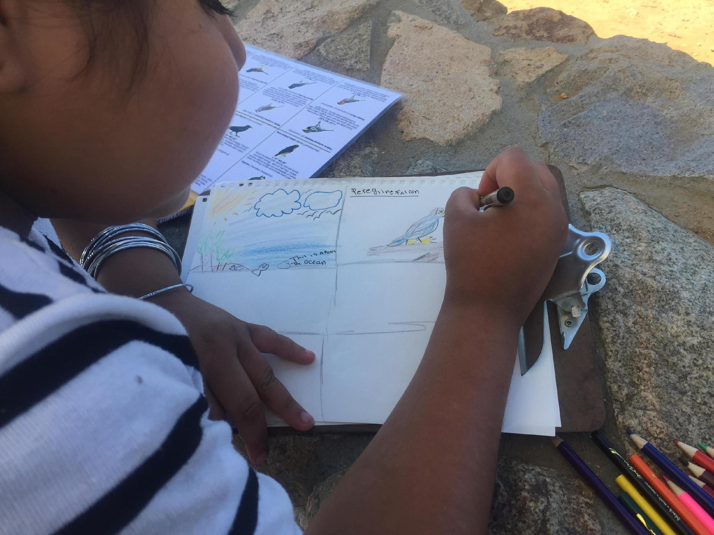 | 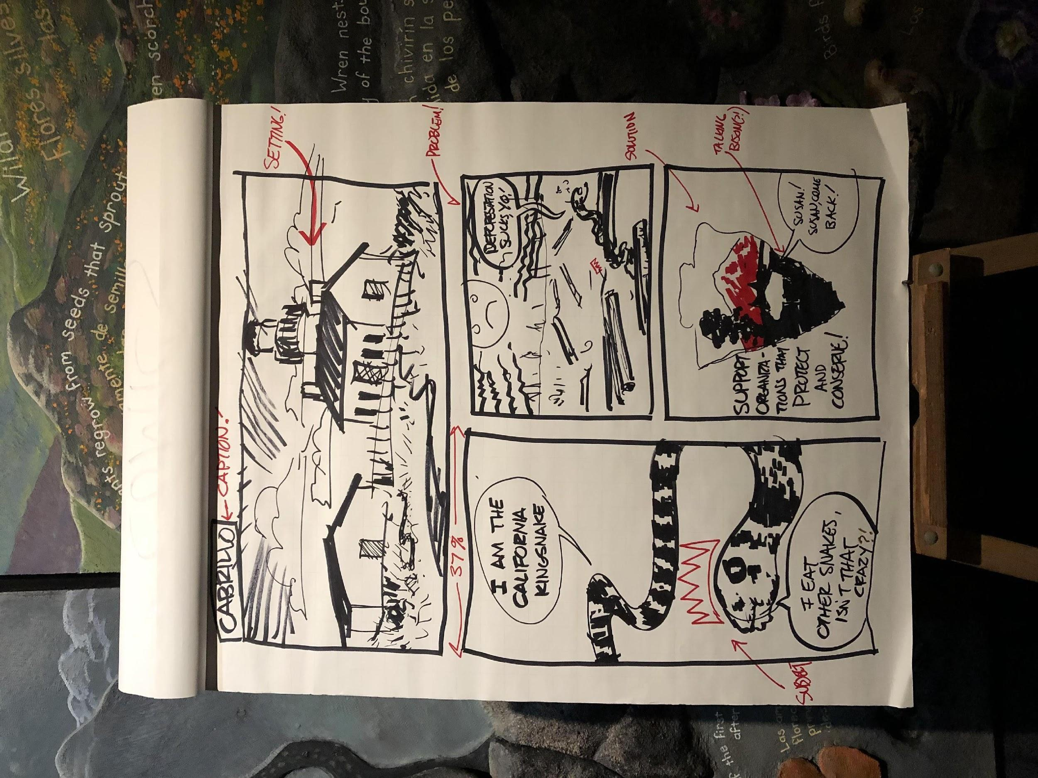
Table of Contents
Contents
Welcome to the “In Their Eyes: Conservation + Comics” Project! 3
Program Overview 4
Paperwork 5
National Park Service Photo Release 6
National Park Service Photo Release – Formulario de Permiso para Publicar Fotografia 8
9
In-class (touch #1; Virtual or In-person): Trading Card Instructions – Teacher 10
Virtual (touch #1): Comic Book & Quick Draw Activity - Teacher 10
In-class (touch #1; In-person): Comic Book & Quick Draw Activity - Teacher 12
Quick Draw Vocabulary Cards 14
Belding’s Orange-throated Whiptail Comic 14
Quick Draw Vocabulary Cards 15
Shaw’s Agave Comic 15
Virtual (touch #1): Field Trip Preparation – Teacher 16
Homework 16
Know Before You Go and Group Expectations 16
Administrative Items 17
Homework Answers 18
Virtual Field Trip Preparation – Student 21
Homework 21
Know Before You Go and Group Expectations 21
In-class (touch #1; In-person): Field Trip Preparation – Teacher 22
Homework 22
Know Before You Go and Group Expectations 22
Administrative Items 23
Homework Answers 23
On Site (touch #2; In-person): Field Trip Instructions – Teacher 26
Field Trip Preparation – Student 28
Homework 28
Know Before You Go and Group Expectations 28
In-class (touch #3; Virtual and In-person): Scientific Poster Instructions – Teacher 30
“Dos & Don’ts” for Scientific Posters 32
Do: 32
Don’t: 33
Scientific Poster Instructions – Student 34
Virtual (touch #3): Poster Exhibition Instructions – Teacher 37
Virtual Poster Exhibition Instructions – Student 38
In-class (touch #3; In-person): Poster Exhibition Instructions – Teacher 39
Poster Exhibition Instructions – Student 40
Resources 41

Welcome to the “In Their Eyes: Conservation + Comics” Project!

Dear Educator,
Thank you for participating in Conservation + Comics! This project was conceptualized after the team leads recognized a need for representation in STEM fields as well as positive nature experiences for youth. Research shows that almost all environmental education programs have positive results regarding conservation behaviors and that science identity is a strong predictor of students’ future scientific pursuits. This project’s goals are to create a program that positively impacts students’ attitudes and behaviors regarding conservation and their identity as scientists.
The Conservation + Comics STEAM (Science, Technology, Engineering, Art, Math) program follows a three-touch model with 1) interactive lessons in the classroom, 2) a science education field trip to Cabrillo National Monument (CNM), and 3) a scientific poster showing for friends, family, and the public. By using innovative tools such as art, games, and comics the programmatic leads hope to connect students to conservation science in a manner that will make a lasting impact with robust learning outcomes.
We hope you and your students enjoy the program!
Meet the team:
- Samantha Wynns is a conservation biologist and science educator with the Great Basin Institute and National Park Service. Sam both does science and communicates science at Cabrillo National Monument.
- Dr. Claire Meaders is a biologist and assistant teaching-professor at UCSD. She studies how students learn to contribute to more effective science education techniques.
- Dr. Jaye Gardiner is a biologist at the Fox Chase Cancer Center. She is an artist and illustrator, and is heavily involved in science communication and STEAM education.

Program Overview

This three-touch STEAM program will require two in-class periods of curriculum, as well as two field trips to Cabrillo National Monument (virtually or in-person) for a total of four class periods. In addition, there will be one homework assignment as well as a capstone project (scientific poster) that will require further time investment; whether these assignments are accomplished during in-class periods or outside of class is at the teacher’s discretion.
Each phase of the project is organized by “touch”: activities to be completed in-class before the first field trip (touch #1), activities accomplished during the first field trip (touch #2), and activities completed in-class after the first field trip coupled with a poster presentation during the second field trip as a capstone project (touch #3). Instructions and materials for these activities are provided in this packet in order of occurrence (see index). Please do not hesitate to reach out with any questions you might have!

Paperwork

If intending on participating in the field trip and in-person poster-showing at Cabrillo National Monument portion, there are two documents that require dissemination, review, and signatures before the start of the program (see attached):
- National Park Service photo release form (provided by CNM)
- Field trip permission form (provided by school and only necessary for in-person field trips)

National Park Service Photo Release
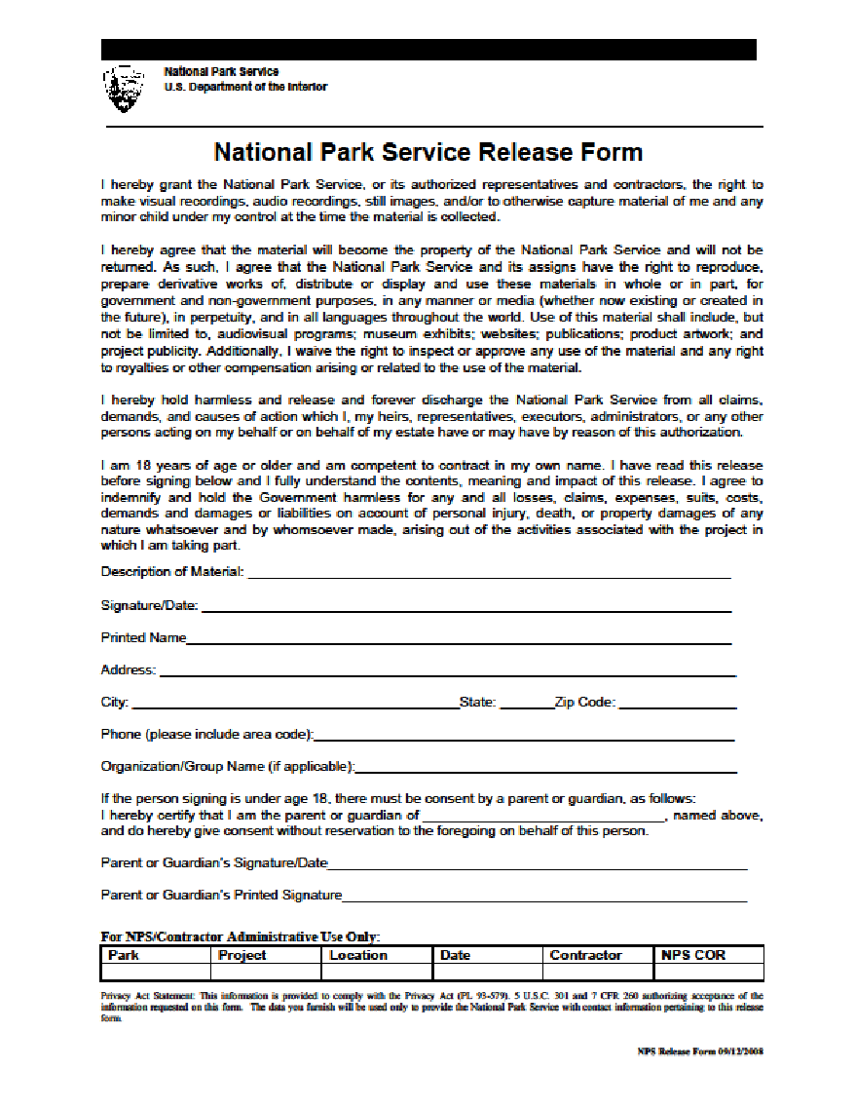

National Park Service Photo Release – Formulario de Permiso para Publicar Fotografia

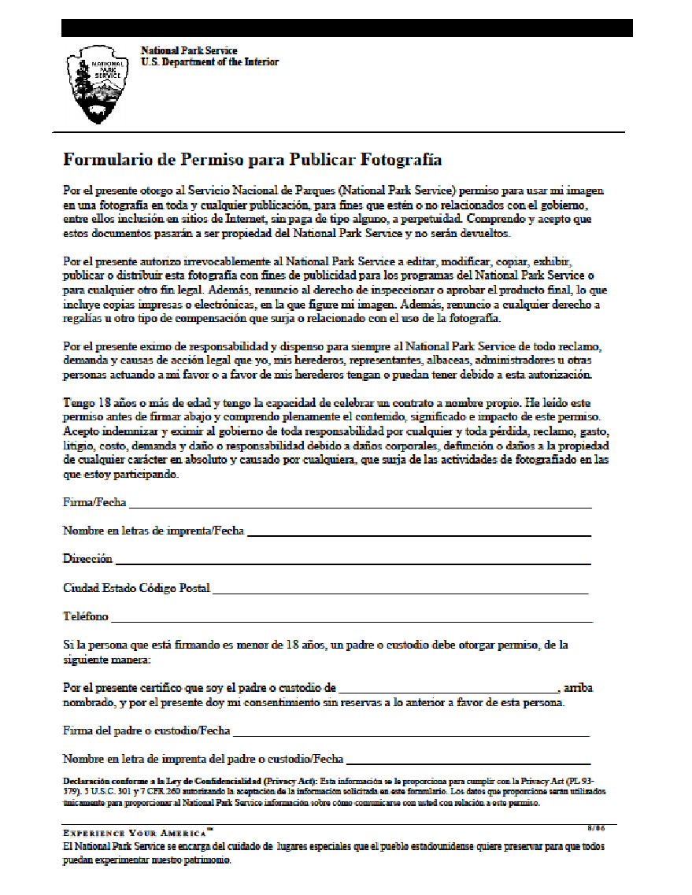

In-class (touch #1; Virtual or In-person): Trading Card Instructions – Teacher

These scientist trading cards are meant to highlight diverse scientists to promote science identity in students. Every student should receive 6 trading cards, with extra trading cards allotted as a prize for the in-class activity (see “Quick Draw”) and at the teacher’s discretion.
- After the “Draw a Scientist” activity, pass 1 of each of these 6 scientist trading cards to each student:
  - Jaye Gardiner
  - Samantha Wynns
  - Claire Meaders
  - Earyn McGee
  - Kristen Lear
  - <randomized scientist> - each student gets a different scientist to encourage trading
- Explain to the students that the first three scientists (Jaye Gardiner, Samantha Wynns, and Claire Meaders) developed the Conservation + Comics program that they will be participating in, while the latter two scientists (Earyn McGee and Kristen Lear) do research they will soon learn about. Please mention that the students will have the opportunity to earn more of these trading cards with different real, living scientists on them and are encouraged to trade to create their own unique collection.
- Immediately follow these materials with the Comic Book & Quick Draw Activity.

Virtual (touch #1): Comic Book & Quick Draw Activity - Teacher

Today your students are going to learn about conservation science in an innovative way – through art! This programmatic comic book will introduce students to their field trip location, Cabrillo National Monument, and the local animals and plants that they might see there. In addition, students will learn about different scientific concepts and the scientists that research these species to discover more about the ecosystems they inhabit.
- Explain to students that the comic is an introduction to the field trip. Emphasize that students should pay careful attention to the vocabulary words in bold as they will be used in an activity after the comic books have been read.
- Ask students to take out their comic books and instruct them to read quietly for 10 – 15 minutes.
- After the students have finished reading the comic books, begin the Quick Draw Activity:
  - Materials:
    - Whiteboard function (Note: change permissions so that students can draw on the digital whiteboard)
    - Vocabulary word cards (provided)
    - Timer
    - STEM trading cards (provided)
    - Comic books (provided)
  - Split the class into 3-5 groups, at your discretion depending on class size. We recommend having them change their names to include their group number at the end for clarity.
  - Run the game: The directions for this game are much like the board game “Pictionary” in which 1 individual from each group receives a word from you via private chat that they must draw while their teammates guess what they are trying to depict; each word is taken directly from the comic book and is either defined or inferred through context. The illustrator will have a total of 2 minutes – if their team guesses the vocabulary word in that time, they receive a collective point. We recommend allowing team members to unmute their mics during this guessing period. After team 1 has a turn, the activity rotates to team 2, then team 3, etc. At the end of the game, the team with the most points wins 1 extra trading card each (Note: feel free to distribute a different trading card to each student, there are intentionally not enough for every student to receive every scientist (to encourage trading), only for every student in the winning group to have the same total number of cards).
    - The students may:
      - reference the comic book at any time
      - optional: Provide the meaning of the word in a private chat, if they’re stumped. This will count towards their 2-minute drawing time.
      - “steal” a point from the playing group i f they are unable to identify what the drawer is illustrating in time
        - After the timer goes off, the group that raises its hand first is allowed 30 seconds to confer, then offer up their final answer.
        - If the second group fails, then the game continues as normal with the next group in the rotation.
    - The students may not:
      - write words in their illustration
      - guess when it is not their turn
  - Distribute the trading cards to the winning group. You may show them the image(s) of the trading cards that they won and distribute the cards at a later date, if necessary.

In-class (touch #1; In-person): Comic Book & Quick Draw Activity - Teacher

Today your students are going to learn about conservation science in an innovative way – through art! This programmatic comic book will introduce students to their field trip location, Cabrillo National Monument, and the local animals and plants that they might see there. In addition, students will learn about different scientific concepts and the scientists that research these species to discover more about the ecosystems they inhabit.
- Explain to students that the comic is an introduction to the field trip. Emphasize that students should pay careful attention to the vocabulary words in bold as they will be used in an activity after the comic books have been read.
- Pass out a comic book to each student and instruct them to read quietly for 10 – 15 minutes.
- After the students have finished reading the comic books, begin the Quick Draw Activity:
  - Materials:
    - White or chalkboard and whiteboard marker or chalk
    - Vocabulary word cards (provided)
    - Timer
    - STEM trading cards (provided)
    - Comic books (provided)
  - Split the class into 3-5 groups, at your discretion depending on class size. Make sure the individuals in each group are seated together.
  - Run the game: The directions for this game are much like the board game “Pictionary” in which 1 individual from each group receives a word they must draw while their teammates guess what they are trying to depict; each word is taken directly from the comic book and is either defined or inferred through context. The illustrator will have a total of 2 minutes – if their team guesses the vocabulary word in that time, they receive a collective point. After team 1 has a turn, the activity rotates to team 2, then team 3, etc. At the end of the game, the team with the most points wins 1 extra trading card each (Note: feel free to distribute a different trading card to each student, there are intentionally not enough for every student to receive every scientist (to encourage trading), only for every student in the winning group to have the same total number of cards).
    - The students may:
      - reference the comic book at any time
      - optional: Use a classroom device to look up the meaning of their vocabulary word, if they’re stumped. This will count towards their 2 minute drawing time. We recommend having a device available at the front of class.
      - “steal” a point from the playing group if they are unable to identify what the drawer is illustrating in time
        - After the timer goes off, the group that raises its hand first is allowed 30 seconds to confer, then offer up their final answer.
        - If the second group fails, then the game continues as normal with the next group in the rotation.
    - The students may not:
      - write words in their illustration
      - guess when it is not their turn
  - Distribute the trading cards to the winning group

Quick Draw Vocabulary Cards

Belding’s Orange-throated Whiptail Comic
Cut along the lines to isolate each word. Place the words in a hat or other opaque container for the drawer to pull from. Note: if you are playing this game online, we recommend assigning a number to each vocabulary word and using a random number generator to select a word.

Dorsum
Parthenogenetic
Genetically Identical
DNA
Biologist
Herpetologist
Ecosystem
Conservation
National Park Service
Clone

Quick Draw Vocabulary Cards

Shaw’s Agave Comic
Cut along the lines to isolate each word. Place the words in a hat or other opaque container for the drawer to pull from. Note: if you are playing this game online, we recommend assigning a number to each vocabulary word and using a random number generator to select a word.

Pollination
Inflorescence
Genetically Identical
DNA
Endemic
Conservationist
Ecosystems
Nectarivorous
National Park Service Cloning

Virtual (touch #1): Field Trip Preparation – Teacher

To continue learning about the subject matter, your students will be assigned homework or will be given more time in class to complete the virtual site-visit vocabulary crossword at the back of the comic book. These vocabulary words will prepare them for their virtual field trip to Cabrillo National Monument. Furthermore, the students should be prepared for their online excursion to Cabrillo and should be informed of the group expectations and the “know before you go” items at this time.

Homework
- Have the students review the Field Trip Preparation sheet (which includes the homework instructions and “know before you go” information).
- Explain that they will be responsible for completing the vocabulary crossword at the back of the comic book. Hint: we recommend that students re-read the comic book to help them understand the vocabulary in context.
- Collect the comic books to check student work at your discretion (see “Homework Answers” for reference). This can be done at a later date. Note: you may opt to have students take a picture of their crosswords to send to you.

Know Before You Go and Group Expectations
- Go over the “know before you go” and group expectations information as follows:
  - You will be hosting a guest-speaker in your virtual classroom:
    - MICROPHONES – Please keep your mic on mute unless and/or until otherwise instructed.

    - CAMERAS – If comfortable, please turn your cameras on. An appropriate virtual background is fine to use.
    - MANNERS - Please respect the speaker, your teacher, and your classmates by raising your hand and avoiding interruptions. Stay on task and do not chat about topics not related to the lesson.

Administrative Items
Teachers should follow the same guidelines as students (know before you go and group expectations), as well as some additional items:
WHAT TO PREPARE: Students should assemble these items before the virtual field trip begins
- Sketchbooks – 1 per student
- Colored pencils – 1 pack per student

Homework Answers
Name:
Read the definitions, then use the hints to complete the crossword puzzle below.

Biodiversity - the variety of life in the world or in a particular habitat or ecosystem.
Mass extinction - The extinction of a large number of species within a relatively short period of geological time.
Ecological island - an area of land which is isolated from the surrounding land.
Urbanization - the process by which large numbers of people become permanently concentrated in relatively small areas, forming cities.
Population bottleneck - an event that drastically reduces the size of a population. The bottleneck may be caused by various events, such as an environmental disaster, the hunting of a species to the point of extinction, or habitat destruction that results in the deaths of organisms.
Genetic diversity - is the diversity or variability of genes within species, community or group.
Habitat fragment - when a large expanse of habitat is transformed into a number of smaller patches. These patches are “fragmented”, or isolated from each other.
Invasive species - is an organism that causes harm in a new environment where it is not native.
Ecosystem services - the contributions of ecosystems to human well-being. They support our survival and quality of life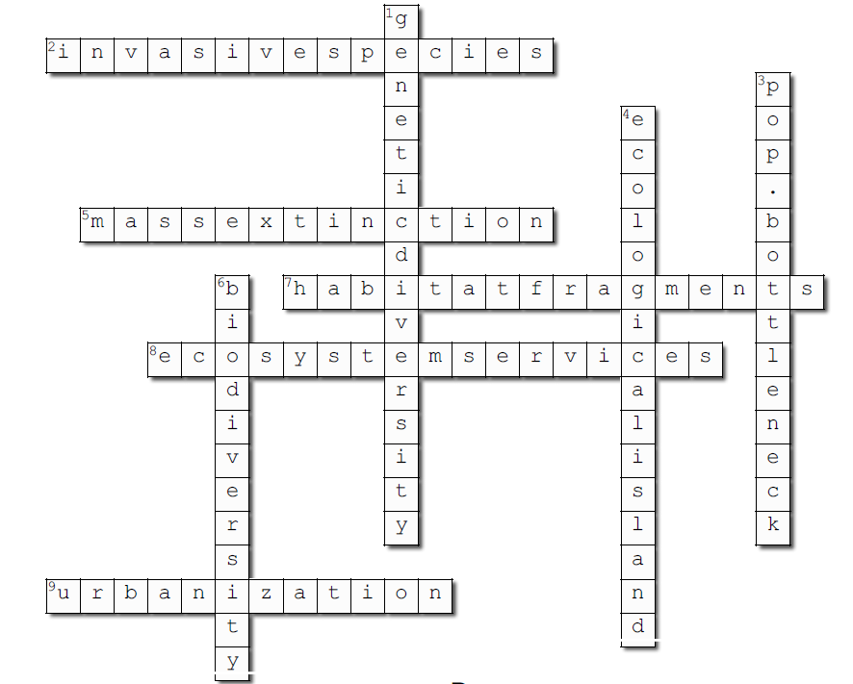

Across
2. intruder alert! (invasivespecies)
5. what happened to the dinosaurs?
(massextinction)
7. cut into pieces.
(habitatfragments)
8. helpful to humans.
(ecosystemservices)
9. the opposite of becoming rural.
(urbanization)
Down
1. an assortment of jeans. (geneticdiversity)
3. find a message in one of these.
(pop.bottleneck)
4. not quite where Gilligan landed.
(ecologicalisland)
6. variety is the spice of life! (biodiversity)

Virtual Field Trip Preparation – Student

Homework
Get ready for your virtual field trip to Cabrillo National Monument by learning more about it! At the back of your comic book is a field trip vocabulary crossword puzzle:
- Fill out the crossword puzzle before your virtual field trip to Cabrillo National Monument. Hint: re-read the comic book to get clues about these vocabulary words.

Know Before You Go and Group Expectations
On your virtual field trip, you’ll be digitally visiting one of our nation’s most culturally, historically, and naturally valuable places! Cabrillo National Monument is part of the National Park System, which means it is preserved and protected land. To make your virtual field trip enjoyable please follow these guidelines:
- Be prepared – make sure you have read the comic book and finished your crossword puzzle.
- Be polite – raise your hand when you wish to speak and do not interrupt each other:
  - Please keep mic muted unless you are instructed otherwise
  - If comfortable, please turn on your camera. The use of an appropriate background is fine
  - All voices are welcome! This is a discussion where curiosity, questions, and respectful dialogue is encouraged
- Be present – come awake, alert, and ready to learn
- Have fun – enjoy digitally exploring San Diego’s only National Park!

In-class (touch #1; In-person): Field Trip Preparation – Teacher

To continue learning about the subject matter, your students will be taking their comic books home or will be given more time in class to complete the site-visit vocabulary crossword at the back of the comic book. These vocabulary words will prepare them for their field trip to Cabrillo National Monument. Furthermore, the students should be prepared for their excursion to Cabrillo and should be informed of the group expectations and the “know before you go” items at this time.

Homework
- Pass out the Field Trip Preparation sheet (which includes the homework instructions and “know before you go” information) to each student.
- Explain that they will be responsible for completing the vocabulary crossword at the back of the comic book. Hint: we recommend that students re-read the comic book to help them understand the vocabulary in context.
- Collect the comic books to check student work at your discretion (see “Homework Answers” for reference).

Know Before You Go and Group Expectations
- Go over the “know before you go” and group expectations information as follows:
  - You will be outside on a field trip, so make sure you are prepared:
    - CLOTHING - Wear comfortable clothing and closed-toed, comfortable shoes. Bring jackets and sweaters, as the waterfront tends to be cooler than the rest of San Diego. Bring close-fitting masks for COVID-19 mitigation. Sunscreen is recommended.
    - SAFETY - Groups should remain 6 ft. apart for COVID-19 mitigation and must stay on designated walkways and trails. Cabrillo National Monument is a protected area. Please do not harass the wildlife or protected landscape in any way (subject to federal regulations). Stay away from cliff edges as they tend to be unstable. Students must not run in any area of the park and be spatially aware of other visitors to the park.
    - MANNERS - Please remember that many groups of people visit the park. Respect other visitors by keeping the noise level down, walking instead of running, and staying on the correct side of the path. Any collections of plants or animals is prohibited by Federal Law. Groups that disrespect the grounds of the National Park in any way will be asked to leave.
    - Water – Stay hydrated – bring water! Just remember that all trash must go with you as this is a pack-it-in, pack-it-out, leave no trace park.

Administrative Items
Teachers should follow the same guidelines as students (know before you go and group expectations), as well as some additional items:
WHAT TO BRING
- Sketchbooks – 1 per student
- Colored pencils – 1 pack per student
- Fee waiver(s) – for free entrance into the park; every field-trip affiliated vehicle must have one
- Trash bag – if bringing lunch/snacks/disposable water bottles

Homework Answers
Name:
Read the definitions, then use the hints to complete the crossword puzzle below.

Biodiversity - the variety of life in the world or in a particular habitat or ecosystem.
Mass extinction - The extinction of a large number of species within a relatively short period of geological time.
Ecological island - an area of land which is isolated from the surrounding land.
Urbanization - the process by which large numbers of people become permanently concentrated in relatively small areas, forming cities.
Population bottleneck - an event that drastically reduces the size of a population. The bottleneck may be caused by various events, such as an environmental disaster, the hunting of a species to the point of extinction, or habitat destruction that results in the deaths of organisms.
Genetic diversity - is the diversity or variability of genes within species, community or group.
Habitat fragment - when a large expanse of habitat is transformed into a number of smaller patches. These patches are “fragmented”, or isolated from each other.
Invasive species - is an organism that causes harm in a new environment where it is not native.
Ecosystem services - the contributions of ecosystems to human well-being. They support our survival and quality of life, such as clean water or air

Across
2. intruder alert! (invasivespecies)
5. what happened to the dinosaurs?
(massextinction)
7. cut into pieces.
(habitatfragments)
8. helpful to humans.
(ecosystemservices)
9. the opposite of becoming rural.
(urbanization)
Down
1. an assortment of jeans. (geneticdiversity)
3. find a message in one of these.
(pop.bottleneck)
4. not quite where Gilligan landed.
(ecologicalisland)
6. variety is the spice of life! (biodiversity)

On Site (touch #2; In-person): Field Trip Instructions – Teacher

GETTING TO CABRILLO
When you reach Cabrillo National Monument, you will be greeted by the ranger on duty at our entrance station. Please show them the fee waiver that was emailed to you by the science education team at Cabrillo National Monument and tell them that you are here for a ranger-led science education program.
PARKING
For safety and convenience, buses should unload and pick up your group in the traffic circle near the flagpole. Bus parking is available in designated spaces in the middle bay of the main parking lot. Buses must turn off engines while unloading or loading passengers.
WHERE TO MEET
Unless otherwise stated, teachers should check-in at the Visitor Center upon arrival. A ranger or volunteer will direct you where to go from there.
LUNCH
A lunch bin to store your lunches is located between the vending machines. Cabrillo is a trash-free park which requires that all trash that your group generates during your visit must be taken out of the park by your group. Please plan accordingly and bring a trash bag with you. Review our 'Zero-Waste' practices prior to your visit.
CELL PHONES
Due to our location, many cell phones do not work within the boundaries of the park. Alternatively, signals might redirect into Mexican cell towers and can result in international charges. Please plan ahead should this be the case. Emergency phone calls may be made from the Visitor Center landline.

Field Trip Preparation – Student

Homework
Get ready for your field trip to Cabrillo National Monument by learning more about it! At the back of your comic book is a field trip vocabulary crossword puzzle:
- Fill out the crossword puzzle before your field trip to Cabrillo National Monument. Hint: re-read the comic book to get clues about these vocabulary words.

Know Before You Go and Group Expectations
On your field trip, you’ll be going to one of our nation’s most culturally, historically, and naturally valuable places! Cabrillo National Monument is part of the National Park System, which means it is preserved and protected land. To make your trip comfortable, fun, and safe please follow these guidelines:
- Wear closed-toed, comfortable shoes and bring a light jacket – we’ll be walking around outside where it can get chilly.
- We recommend wearing sunscreen, too, so that you don’t get sunburned.
- Wear a mask and stay socially-distant anytime you are around people (even outside) to protect yourself and others from catching COVID-19.
- Bring water – stay hydrated! Just remember that all trash must go with you as this is a pack-it-in, pack-it-out, leave no trace park.
- Be respectful – this is sacred land, so treat it with respect:
  - Don’t harass wildlife
  - No picking or taking of any kind (cool rocks and pretty flowers included) – just photographs and memories allowed
  - Stay on the trail
  - No running
  - Respect other visitors to the park by moving aside to let them pass and keeping your voices down
- Have fun – enjoy spending the day outside at the beautiful Cabrillo National Monument!

In-class (touch #3; Virtual and In-person): Scientific Poster Instructions – Teacher
Your students will now synthesize and build upon the information they have been introduced to in the pre-visit and field trip through a scientific poster.
Objectives
- Reinforce the material covered for a robust learning outcome about science, conservation, and science identity
- Refine critical thinking skills as students pursue steps in the scientific process
- Develop creative design and science communication skills
- Promote teamwork and collaboration
- Foster science education and environmental stewardship
Instructions
Students will work in teams of two to create a scientific poster that communicates local conservation science. Teams are created at your discretion.
- Split the students into groups of two.
- Explain to students that they will be creating and presenting a scientific poster like scientists do at scientific conferences. These posters are a way to showcase the scientist’s work. Optional:
  - Review the “dos” and “don’ts” of scientific posters (see attached)
  - Show students provided examples of scientific posters (see attached)
- Explain that these posters will be based on the conservation science that they have learned so far in this program:
  - Have students pick a local, native species to create a poster about. Note: it might be useful to access Cabrillo’s native species guides for inspiration at: www.nps.gov/cabr/learn/nature/field-guides.htm
    - At your discretion, students may choose a species they learned about in any of the Conservation + Comics material, fieldtrip, or that they drew in their nature comic.
  - Each group will:
    - Research their native species – specifically what it is, where it lives, what it needs to survive, what human-induced threats it faces, and what action people can take to reduce said threat. Other information is also welcome. Note: ensure the students are using credible sources for their information – you might need to explain what that is to them.
    - Create a storyboard:
      - Write (and/or draw) the story they are trying to tell with an introduction, characters (their species), threats, and practical solutions to these threats. For example: Owl Limpets (marine snails) face the threat of shell-loss due to acidifying oceans, which is caused by climate change. One solution is to slow climate change by reducing carbon emissions.
    - Decide upon layout – how will the story flow in a logical and interesting manner? Note: it might be useful to show the students the provided poster examples to spark their imagination at this time. At your discretion, they may use one of these formats (attached) or create their own.
    - Create the poster – 36” x 48” to print; 9” X 12” for virtual poster exhibition
      - Gather/create images
      - Write script
      - Select a software to use – there are scientific poster templates available in different applications they can use. Just do a search for “scientific poster template + <whatever software they want to use>”. Some options include Adobe products, Google Slides, and Microsoft PowerPoint. Note: at your discretion, students may also create a poster by hand.
      - Optional: Have a group of fellow students edit their poster draft.
- Collect the final drafts of all posters and send them to the Cabrillo National Monument science education team for printing. Note: this task should be completed ≥2 weeks before the exhibition.

“Dos & Don’ts” for Scientific Posters
The purpose of a scientific poster is to communicate science in a clear and interesting manner while generating viewer interest for a discussion. Here are some guidelines of what to do (and what not to do) in order to accomplish this goal. Take them to heart - don’t be the person with a messy, boring, or confusing poster!

Do:
- Know your audience - will you be showing this poster to kindergartners, or adult scientists? What you create must be able to reach your audience. For example, you wouldn’t make a poster with a bunch of complicated scientific jargon for kindergartners. Think about who your audience primarily is!
- Organize the sections clearly - like any good story, there will be a beginning (introduction), middle (body), and end (conclusion). Ways to organize could include using bullet points or numbers and/or placing each section in its own column.
- Use a larger font - your audience will be standing a few feet away and should be able to read it clearly. Font size should be at least 24 pt.
- Choose a readable font - some fonts, like brush script, are hard to read. Instead use legible fonts like Times New Roman or Century Gothic.
- Use plenty of images/figures - Images are eye-catching and interesting to look at!
- Use colors with sharp contrast to increase readability and to make it look interesting.
- Have a title, add your name(s), and use subheadings/headlines for each category/chapter - these aspects help put the poster in context and tell a better story.
- Make sure each figure has a caption - a “figure” is any image, photograph, chart/graph, drawing, or any other visual in the poster. A caption explains what the image represents to the viewer. For example, say you include a photograph of a woman holding a lizard. The caption might be something like “Fig. 1: A herpetologist takes data on a Western Fence Lizard (Sceloperus occidentalis).”

Don’t:
- Use tiny font
- Pick a font color with a poor contrast to the background - Color selection is important to make sure your text is legible. For example, this color combination is hard to read!
- Use too much text - this is a poster, not a paper! You want to catch the eye of the viewer and get them interested, and a wall of text does the opposite. General guidelines are 300 - 800 words total.
- Choose a busy background - again, this makes your poster hard to read.
- Forget any of the important elements - like title, name, headings, and captions! You might also consider using references for research and adding acknowledgements at the end.

Scientific Poster Instructions – Student

Scientists routinely showcase their work at professional events, like conferences, to other scientists and the public with a scientific poster. You will be creating a scientific poster of your own, and showing it to your classmates, families, and visitors at Cabrillo National Monument! Note: you might also show your posters in a virtual poster showing.
WHO
You and 1 other student – you will be working in pairs.
WHAT
A poster that uses both words and images (drawings, graphics, photographs, charts, etc.) to communicate a scientific concept. For this poster, your topic will be what you have learned in the Conservation + Comics program.
- Virtual poster size = 9 inch X 12 inch
- Printed poster size = 36 inch x 48 inch
WHERE
Creation of the poster will occur in the classroom and at home (homework). The poster showing will occur at Cabrillo National Monument or in a virtual setting (like over Zoom).
INSTRUCTIONS
- Listen to your teacher’s explanation of the project. You might want to take notes.
- Break into pairs and brainstorm with your partner:
  - Select a local, native species as your subject – which plant or animal do you want to choose? Consult the Cabrillo National Monument Field Guides if you need ideas at nps.gov/cabr/learn/nature/field-guides
- Research your subject/species. You may use books, scientific articles and papers, and the internet – just be sure the information is from a reputable source (for example, a textbook or government website – not a personal blog)! Address these specific questions:
  - What is it (your subject/species)?
  - Where does it live?
  - What does it need to survive?
  - What are some threats caused by humans that it faces? Hint: think of the 5 biggest threats to biodiversity that you learned about during the field trip.
  - What is an action(s) people can take to reduce the threat?
  - Include other interesting and relevant facts
- Create a storyboard – this is where you start to put your ideas together for how to tell your scientific story. Remember that this is a poster and not a book – people will be standing 3+ ft. away and looking at it, so it should be readable from a distance and interesting to look at. Note: for more information about how to craft a scientific poster, review the “Do’s and Don’ts of Scientific Posters”.
  - Begin by writing out the narrative that you will use to tell your story. Your narrative should have an introduction, your character(s) (species), the threats to your character, and practical solutions to these threats. For example: Owl Limpets (marine snails) face the threat of shell-loss due to acidifying oceans, which is caused by climate change. One solution is to slow climate change by reducing carbon emissions. People can reduce carbon emissions by driving less and walking/biking/skateboarding to where they need to go.
  - You might want to include some visuals in your storyboard like drawings, pictures, charts, etc. This will help you figure out what your poster will look like when it’s finished.
- Decide the layout of the poster – how will the story flow in a logical and interesting way? Where should the text go, and where should the images go in order to tell a successful story? How you put the poster together will either communicate your science well, or it will confuse the viewer. Hint: take a look at the examples provided by your teacher for ideas about what makes a good poster layout.
- Create the poster – now that you have researched your topic and figured out what and how you want to communicate, it’s time to put the poster together!
  - Write a script – you will pull from your storyboard here. Your script will be the final version of the text you want to include, exactly how you want to say it. Think of it as a final draft of an essay, story, or paper.
  - Gather/create images (also known as figures) – remember, you are using more than words to tell your scientific story. Find or create images – photographs, art (drawings, paintings, etc.), graphs/charts, infographics, etc. – that help you tell a clear story. Note: extra credit if you create your images yourself!
- Select a software to create your poster with - there are many different types of software that can help you create a scientific poster such as Google Slides, Adobe In-Design, and Microsoft PowerPoint. Find one that works for you and is available for use. At your teacher’s discretion, you may also create your poster by hand. Note: you might want to ask your teacher for assistance with the selection process.
  - There are also scientific poster templates available in different applications. Just do a search for “scientific poster template + the name of the software you want to use”. Many poster templates are free, but not all of them, so double check before downloading.
- Build your poster in the program you have selected or by hand, if applicable.
- Edit your poster – nobody creates the perfect document in their first try and this is why there are “drafts”. Make sure you leave time to go over your poster to correct any mistakes or to make any changes. Hint: have someone else take a look for a fresh pair of eyes – they might pick up on something you missed!
- When your poster is finished (great job!), turn your .pdf file in to your teacher for printing.

Virtual (touch #3): Poster Exhibition Instructions – Teacher

It’s time for another virtual field trip to Cabrillo National Monument, this time to show off your students’ work! Prepare for this virtual exhibition in the same manner as before (see “Field Trip Preparation). In addition:
- re-familiarize yourself with the virtual field trip protocol
- remind students of “know before you go” and group expectations
- go over student poster exhibition instructions with class. Have students reference it at your discretion
WHAT TO BRING
- e-posters for digital display

DIGITAL DISPLAY
Each class will be given a 1-hour time block for their virtual poster-showing and student-pairs will be sorted into their own breakout rooms with 1 adult chaperone (chaperones provided by Cabrillo National Monument). Guests will rotate between breakout rooms to hear about each successive poster.
VISITOR CENTER EXHIBITION
After the virtual poster-showing, a few select posters will be printed and displayed in the Visitor Center at Cabrillo National Monument. Please select 2 posters from each class for this exhibit.

Virtual Poster Exhibition Instructions – Student

It is time to show your poster! You will be in a Zoom room with your poster-partner and one chaperone. Friends, family, and other guests will be entering your Zoom room to view your poster: It is customary to describe your poster to viewers. Be prepared to:
- explain what your poster is about
- offer why you decided to choose this topic
- talk about what you learned in the Conservation + Comics program
- discuss any actions you might take to preserve and protect biodiversity
- give advice about actions others can take to preserve and protect biodiversity – how can they help?
- encourage people to visit the Conservation + Comics exhibit at Cabrillo National Monument in the Visitor Center
And congratulations, young scientists, on creating your scientific poster – this is quite an achievement!

In-class (touch #3; In-person): Poster Exhibition Instructions – Teacher

It’s time for another field trip to Cabrillo National Monument, this time to show off your students’ work! Prepare for this field trip in the same manner as before with parking pass, etc. (see “Field Trip Preparation). In addition:
- re-familiarize yourself with the field trip protocol
- remind students of “know before you go” and group expectations
- go over student poster exhibition instructions with class. Pass out to students at your discretion
WHAT TO BRING
- Fee waiver
- Trash bag
- Posters (unless previously delivered to Cabrillo National Monument)

Poster Exhibition Instructions – Student

It is time to show your poster! It is customary to stand next to your poster and chat about it with people who view it. Be prepared to:
- explain what your poster is about
- offer why you decided to choose this topic
- talk about what you learned in the Conservation + Comics program
- discuss any actions you might take to preserve and protect biodiversity
- give advice about actions others can take to preserve and protect biodiversity – how can they help?
- encourage people to take a picture of the “Pledge to Protect” and post it on social media @CabrilloNPS or #CabrilloNPS
And congratulations, young scientists, on creating your scientific poster – this is quite an achievement!

Resources

Poster: Species Research
- Species conservation status – IUCN Red List: https://www.iucnredlist.org/
Poster: How to Create an Effective Scientific Poster
- Dos and Don'ts: https://guides.nyu.edu/posters
Poster: Free Images
- https://www.flaticon.com

