PROGRAMMATIC OVERVIEW
CONSERVATION + COMICS

ESSENTIAL QUESTION(S)
What living organisms are located in a given habitat and why? What is biodiversity, and how does it relate to conservation? What are the roles of a scientist?

OBJECTIVES

- Students will understand the importance of studying and preserving biodiversity
- Students will understand what a biodiversity hotspot looks like in our Mediterranean climate
- Students will understand the threats to biodiversity
- Students will understand their impact on biodiversity and actions they can take to help protect it

LESSON GRADE LEVEL
K- 12th Grade

DESCRIPTION
Conservation is the prevention of wasteful use of a resource. These resources include ecosystem services, habitats, and biodiversity. Each organism in an ecosystem or habitat plays an important role, thus ecosystems are most productive and healthy when species diversity is high. Unfortunately, species numbers are declining faster than ever before due to many human driven stressors. The role of a conservationist is to preserve and protect these dwindling resources, which is accomplished with three tasks: 1) to observe and examine a threat(s) to the resource, 2) to find a way to mitigate the threat, and 3) to communicate what was learned with others. During the Conservation + Comics Program students will accomplish all three tasks: they will explore a threat such as the loss of biodiversity or climate change and are then encouraged to critically think in an inquiry-based format as they brainstorm solutions, finishing the workshop by communicating the science they just learned through the innovative platform of nature comics.

VOCABULARY

- Conservation is the prevention of wasteful use of a resource.
- An ecosystem is a system, or a group of interconnected elements, formed by the interaction of a community of organisms with their environment.
- Ecosystem Services are the many benefits that humans gain from healthy, functioning ecosystems. These benefits include clean water and pest control, among others.
- Habitat(s) is where an organism lives and grows.
- Biodiversity refers to different forms of life that inhabit a given area. Bio meaning life, diversity meaning all the differing kinds of life that are living and growing there.
- Mass extinction is a wide spread and rapid decrease of biodiversity on Earth on a massive scale.
- An organism is an individual animal, plant, or single-celled life form.
- A survey means to look at or examine carefully and appraise something.
- An invasive species is an invading organism that causes harm to an ecosystem where it is not native.

NGSS STANDARDS MET

K-5 PRIMARY: K-LS1-1. K-ESS3-1. K-ESS3-3. 1-LS1-1. 1-LS3-1. 2-LS2-1. 2-LS4-1. 3-LS3-1. 3-LS3-2. 3-LS4-3. 3-LS4-4. 4-LS1-1. 4-ESS2-1. 5-LS2-1. 5-ESS3-1.
MIDDLE SCHOOL: MS-LS1-4. MS-LS1-5. MS-LS2-1. MS-LS2-2. MS-LS2-4.
HIGH SCHOOL: HS-LS2-1. HS-LS2-2. HS-LS2-6. HS-LS2-7.

VAPA STANDARDS MET

K-5 PRIMARY: K-AP1. K-AV4. 1-AP1.1. 1-AP1.3. 1-AP2.8. 1-AV4.3. 1-AV4.4. 2-AP1.1. 2-AP1.3. 2-AV4. 3-CE2.1. 3-CE2.3. 3-AV4.2. 5-AV4.3. 5-AV4.4.
MIDDLE SCHOOL: 6-CV2.3. 6-CV2.5. 6-AV4.3. 6-AV4.4. 7-AV4.2. 7-AV4.5. 8-AP1.2.
HIGH SCHOOL: 9-CE2.4. 9-AV4.4.

VISIT PREPARATION

GUIDED QUESTIONS

- What are the three tasks of a scientist?
- What is biodiversity and why does it matter?
- How do humans affect biodiversity?
- What is conservation and why is it important?

ACTIVITY
What is a resource? As a class, look up the definition, then have the students break into small groups to brainstorm resources they use every day. Each group will write down their combined resources. These resources can include items in the classroom, such as the paper they are writing on (trees) or the water in their bottle.

Next, create a bar chart on the white/blackboard with resources on the x-axis and amount on the y-axis. Have one representative from each group enter their data in the chart – writing their resource and adding the amount of group members that use each resource. The end result should be a clear visual representation of class resource use. Note: this activity can also be done verbally if the class is too young to write. Examine the data: are a lot of resources used? Is there a wide variety of resources used by the class? How do you think this compares to the rest of the world? Where do all of these resources come from? Are they harvested/used sustainably?

Now, use some real-life worldwide examples of resource use and human activity from a credible source, such as the UN’s International Resource Panel (resourcepanel.org). Focus in on biodiversity, ecosystems, and ecosystem services. This will give students context and prepare them for the program.

VIDEOS AND ONLINE RESOURCES

- “Why is Biodiversity so Important?” [Video]: https://www.youtube.com/watch?v=GK_vRtHJZu4
- Human Resource Use: https://www.resourcepanel.org/
- Nature and Science: https://www.nps.gov/cabr/learn/nature/index.htm
- Example Species Guides: www.nps.gov/CABR Go to: Learn About the Park>Publications>Field Guides
- Inspire students to do their part: http://www.biol.wwu.edu/hooper/10thingsforbiodiversity.pdf

SAFETY AND GETTING TO CABRILLO
Safety during your visit is our number one priority. Please review the Group Expectations and safety stipulations below. Prior to your visit, please thoroughly review our website for any questions you might have (FAQs – https://www.nps.gov/cabr/learn/education/frequently-asked-questions.htm) and further instructions on Traveling To Cabrillo and what to bring with you (https://www.nps.gov/cabr/learn/education/traveling-to-cabrillo-national-monument.htm).

YOUR VISIT TO CABRILLO NATIONAL MONUMENT

ARRIVAL INSTRUCTIONS

- Present your permit(s) to the Entrance Station and park in the designated bus/car parking spots.
- Check-in with a staff member at the Visitor Center upon your arrival.
- Arrive at least 15 minutes prior to the start of your program and allow plenty of time for your students to visit the restroom and have snack.
- Place your lunches in the designated receptacle.
- Meet staff for your program at the: Visitor Center Complex

ESTIMATED TIME
This Ranger-led program is one hour and thirty minutes in duration and is offered through arrangement with a ranger only due to the complicated nature (two instructors – science and art) of the program. Each program can accommodate 35 students. If you have more than 35 students, you will need to reserve TWO time slots for a day, at 1.5 hours each. If you have more than 70 students, you will need to request multiple days.

MATERIALS
(provided by Cabrillo NM)

- Sketchbooks
- Colored Pencils
- Field Guides for reference (https://www.nps.gov/cabr/learn/nature/field-guides.htm)
- For younger grade levels (K-2): A template is provided in the sketchbook

INTRODUCTION (10-15 minutes – Cabrillo staff)

- Welcome and Introduction to Cabrillo National Monument, the National Park Service, and Staff
- Topic Overview
  - What are the three tasks of a scientist?
  - What is biodiversity and why is it important?
  - Why is biodiversity at risk?
- Activity Review
  - In order to conserve biodiversity, we must first know more about it. Students will join Cabrillo scientists to observe the biodiversity of the park.
  - What makes a good observation? Explain senses.
  - How is the biodiversity of the park connected? What are the roles that different species play?
- Safety Protocols
  - No running in the park
  - Please stay on designated paths and be aware of other visitors
  - All of the plants and animals at Cabrillo National Monument are protected
  - Please respect the tools we are using

ACTIVITY (30-40 minutes – Cabrillo staff)

- Guided exploration of select trail with students.
- Pass out materials – sketchbooks and pencils.
- Group brainstorming session of conservation solutions.
- Create a nature comic that communicates the problem and solution.

CLOSING THOUGHTS (10 minutes – Cabrillo staff)

- Reflective Questions (Think-Pair-Share)
  - What types of biodiversity did students see?
  - Did they find anything unique or surprising during their exploration?
  - How are humans affecting earth’s resources?
  - What might happen if some of these species were missing?
- Activity Review: What are the three tasks of a scientist? What methods did they choose to conserve biodiversity with?
- Conservation Message: Review the mission of the National Park Service and how environmental awareness adds to our understanding of biodiversity and how to protect it.
- Conservation Commitment: What commitment will students make to help the earth and maintain high biodiversity?
- Address Final Questions
- Encourage student gratitude to teachers and chaperones
- Provide next steps for group
  - Where to have lunch and leave no trace principles
  - Thank group for participation and visiting

AFTER YOUR PROGRAM
You are welcome to stay at the park until closing (5 p.m.) just remember that you are responsible for your group through this duration – See Group Expectations. Visit our website for additional educational materials to supplement your group’s learning (http://cabrilloeducation.com/suggested-activities).

HANDOUT(S) TO ENHANCE THE LESSON WHILE YOU EXPLORE AFTER/BEFORE THE LESSON
See below

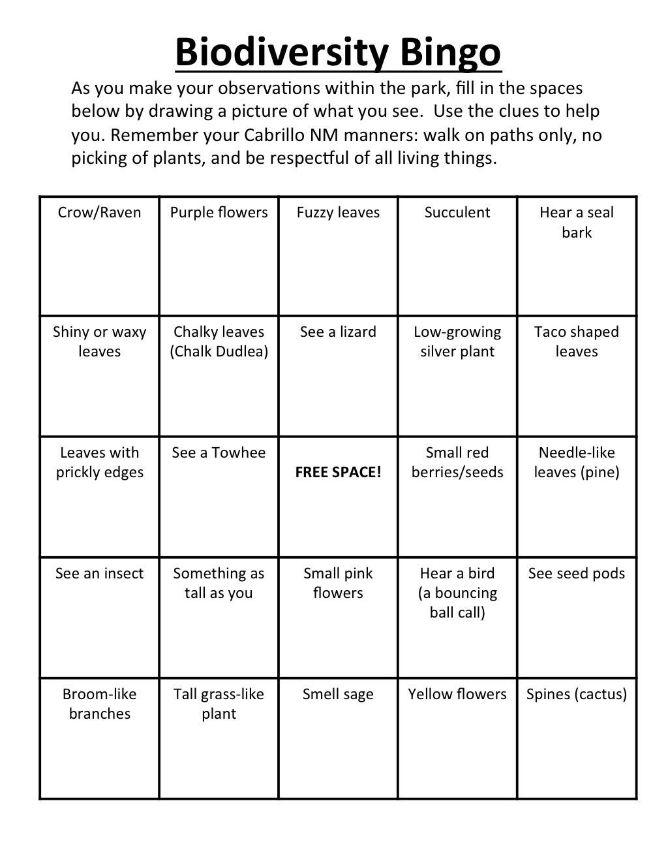
AFTER YOUR VISIT

GUIDED REFLECTION

- What is one resource that we can do a better job protecting?
- Make a classroom commitment to help the environment and track it over a given time period.

ACTIVITY
Review collected biodiversity data from the free app iNaturalist by visiting www.iNaturalist.org and searching Cabrillo National Monument. iNaturalist offers many interactive ways to look at data within projects. Encourage students to graph the number of species found and the different types of species found. Then separate this data by years by going into the “filters” tab and setting the “date observed – range”. Now, compare and contrast this data over time to see how biodiversity at Cabrillo might be changing. What is the same and what is different? Why are they different? What other questions might arise? Encourage students to interpret their findings and make connections.

VIDEOS AND ONLINE RESOURCES

- How to Help Biodiversity Tracker: https://www.amnh.org/ology/features/stufftodo_bio/howtohelp.php
- “Conservation and the Race to Save Biodiversity” [Video]: https://www.khanacademy.org/science/high-school-biology/hs-ecology/hs-human-impact-on-ecosystems/v/conservation-and-the-race-to-save-biodiversity
- 11 Things You Can Do to Protect Biodiversity: http://theunfoldingearth.com/10-things-you-can-do-to-protect-biodiversity/

ADDITONAL RESOURCES

- Cabrillo Field Notes: https://www.nps.gov/cabr/blogs/cabrillofieldnotes.htm
- Cabrillo YouTube: https://www.youtube.com/channel/UCFgWF77neF6I6bLt-Z7LL-w
- San Diego Natural History Museum: http://www.sdnhm.org
- San Diego Zoo, Institute for Conservation Research: http://institute.sandiegozoo.org

GROUP EXPECTATIONS

Please thoroughly review the following with your students and chaperones prior to your visit to Cabrillo National Monument. For the safety of the public and resources, we reserve the right to ask groups to leave the park if these expectations are not adhered to.

VEHICLE PASS
Your vehicle pass will be attached to your confirmation email. Upon arriving at the park EACH VEHICLE in your group must present the vehicle pass that is attached to this email to the ranger at the entrance station. Please print and make copies of your vehicle pass ahead of time and distribute them before arriving at the park. Vehicles without a pass will be charged the entrance fee.

WHERE TO MEET
Unless otherwise stated, the teacher should check-in at the Visitor Center upon arrival. A ranger or volunteer will direct you where to go from there. If you are participating in a tidepool focused program, a ranger will meet you at the tidepool kiosk 15 minutes prior to the start of your program and you do not need to check in at the Visitor Center.

LUNCH
A lunch bin to store your lunches is located between the vending machines. If you are participating in a tidepool program, we recommend either bringing class lunches in tubs or student backpacks. Cabrillo is a trash-free park which requires that all trash that your group generates during your visit must be taken out of the park by your group. Please plan accordingly and bring a trash bag with you. Review our 'Zero-Waste' practices prior to your visit.

PARKING
For safety and convenience, buses should unload and pick up your group in the traffic circle near the flagpole. Bus parking is available in designated spaces in the middle bay of the main parking lot. Buses must turn off engines while unloading or loading passengers. For groups visiting the tidepools, please remember that access to the coastal area is only by vehicle via Cabrillo Road. Travel by any other means is dangerous and not permitted. There is no pedestrian access. Parking is limited, so we encourage carpools or bus transportation. Buses can drop off students at the tidepools and park up the hill in the main parking lot. However, buses must be promptly available to pick-up students from tidepools at culmination of program.

MANNERS
Please remember that many groups of people visit the park. Respect other visitors by keeping the noise level down, walking instead of running, and staying on the correct side of the path. Any collections of plants or animals is prohibited by Federal Law. Groups that disrespect the grounds of the National Park in any way will be asked to leave.

SAFETY
Groups should remain together and stay on designated walkways and trails. Cabrillo National Monument is a protected area. Please do not harass the wildlife or protected landscape in any way (subject to federal regulations). Stay away from cliff edges as they tend to be unstable. Students must not run in any area of the park and be spatially aware of other visitors to the park.

CLOTHING
Wear comfortable clothing and closed-toed shoes. Bring jackets and sweaters, as the waterfront tends to be cooler than the rest of San Diego. Sunscreen is recommended.

CELL PHONES
Due to our location, many cell phones do not work within the boundaries of the park. Alternatively, signals might re-direct into Mexican cell towers and can result in international charges. Please plan ahead should this be the case. Emergency phone calls may be made from the Visitor Center landline.

TIDEPOOLS
If your class is visiting the tidepools, there is an almost certain likelihood they will get wet. Additionally, there is only one restroom facility in the tidepool area. Please plan accordingly. Make sure that you have your tidepool permit on hand, you may be asked to show it. Please be aware that tidepool access requires walking down steep sandstone cliffs. Safety is our number one concern in the tidepools, please 1) remind students to wear closed-toed or water shoes (no flip flops), 2) walk slowly and with caution, 3) be mindful of large waves and loose cliffs, 4) do not pick up or throw rocks, and 5) be gentle with all of the critters that call Cabrillo home.

CHAPERONES
We kindly request that chaperones remain attentive and engaged throughout your stay at Cabrillo. Please help us with the safety and well-being of your students by adhering to the following guidelines:

- Assist in facilitating student learning and engagement by asking them questions about what they are observing or experiencing.
- Know who is in your group at all times and be responsible for your group’s whereabouts during their visit.
- Know your group’s plan for the day: how long will they be in certain locations, what time will they eat lunch, what time will you be leaving and where will you meet, etc.
- Stay with your group at all times and make sure that they adhere to the park rules and are respectful of other visitors.
- Consider establishing a meeting place just in case anyone gets separated from the group. We suggest the Visitor Center.

Thank-you for your participation in our program. Hope to see you back soon!

Connect with us on social media @CabrilloNPS

