# Pictures: Velcro Task Board

## Instructions:

Feel free to use these pictures to make your own task board at home. These pictures are cut out and laminated for your use on site. We also have a task board with six velcro spaces to attach the appropriate pictures for your day’s schedule. However, we know it can be important to prepare you or your loved ones before you arrive on site. It is also important to use pictures that match reality, not cartoons. Therefore, we’ve provided these pictures for you to use as you see fit.

### Wooden sign with NPS arrowhead logo reads Pitcher Plant Trail.Hiking Trails

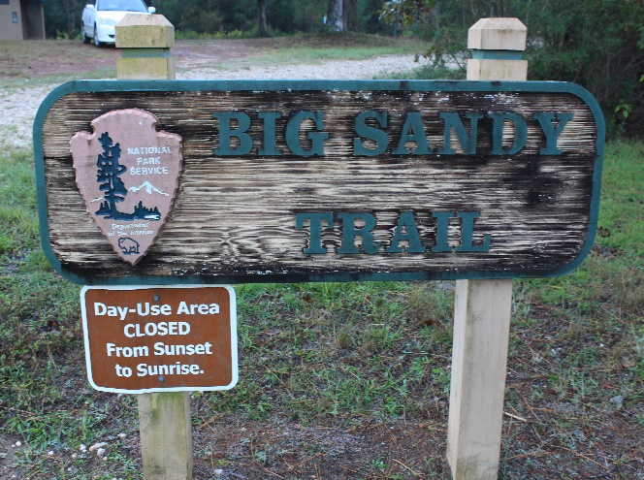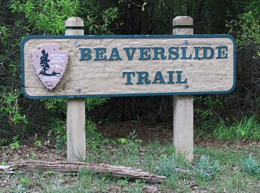

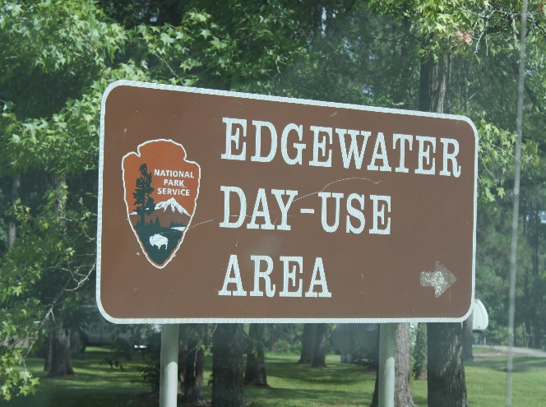

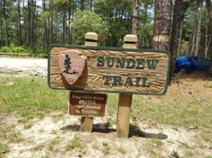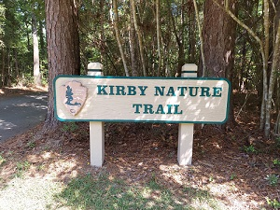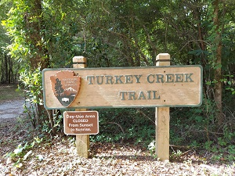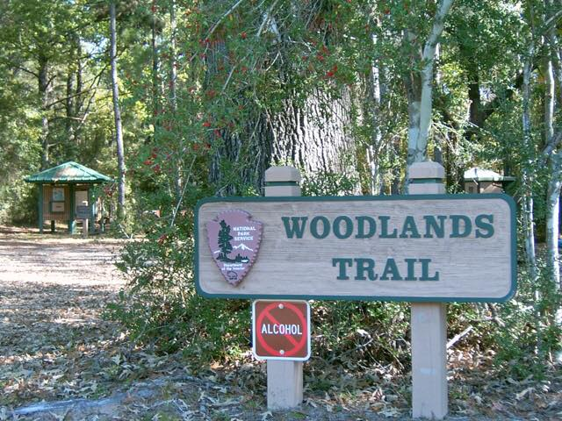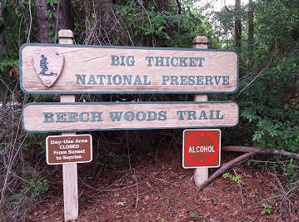

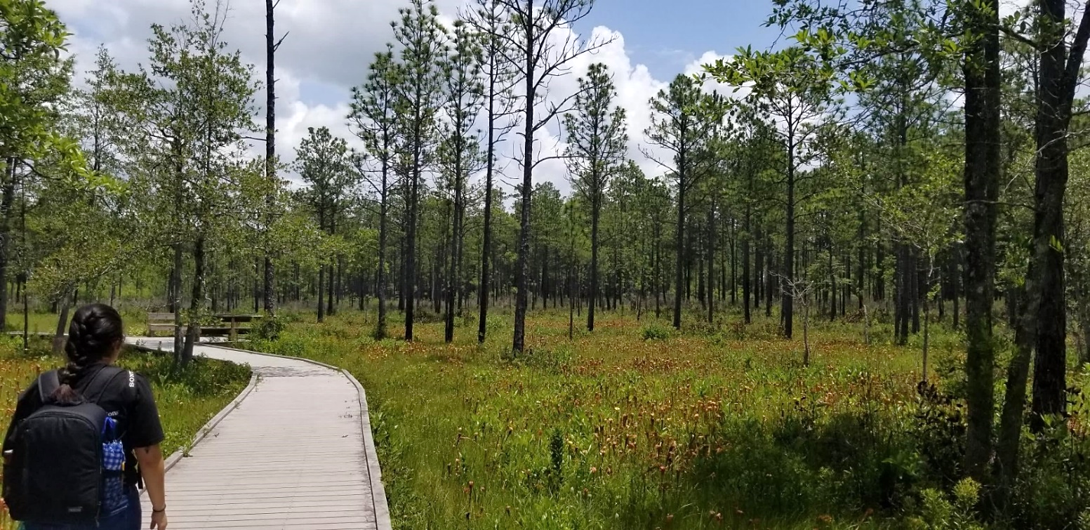

### Wooden sign with NPS arrowhead logo reads Big Thicket National Preserve: Lance Rosier Unit.Exploration Areas

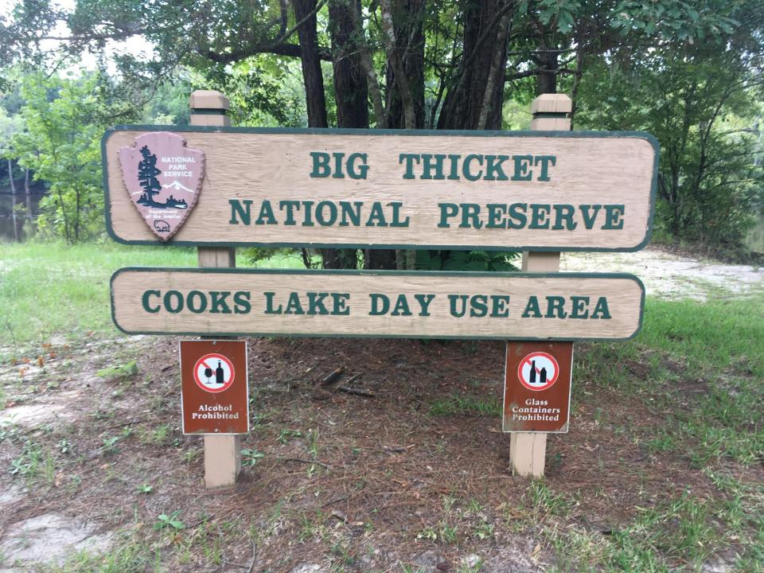

### A red and silver mountain bike stands on a wide dirt trail.3 people canoe on a wide, murky river lined by tall trees covered in leaves. 2 people are in 1 boat and the third person rides alone.Big Thicket junior ranger book, plastic badge, and metal pin rest on a brown background.A person stands at a river's edge holding a fishing pole towards the water. Another person wears a life jacket and kneels at the river's edge with a fishing pole. They both wear brimmed hats.Other Activities

### Visitor Center

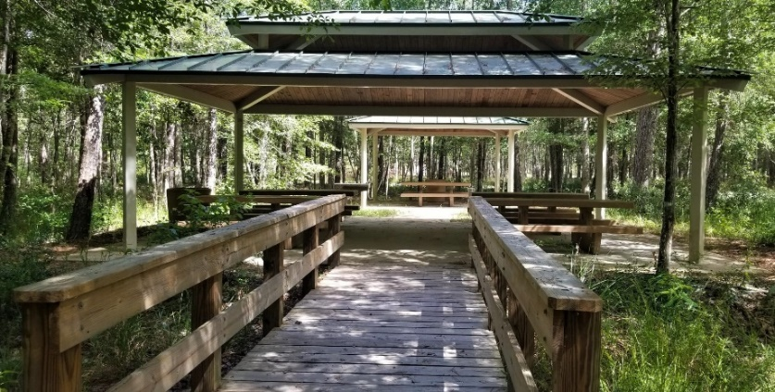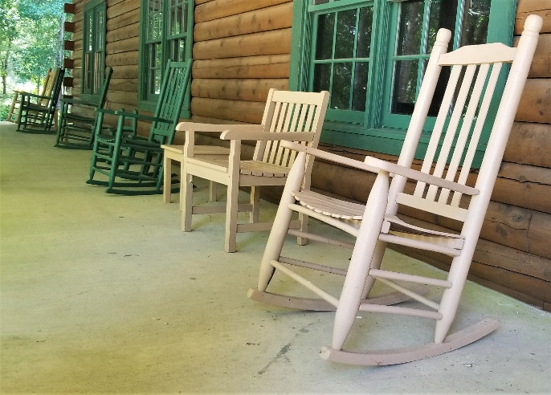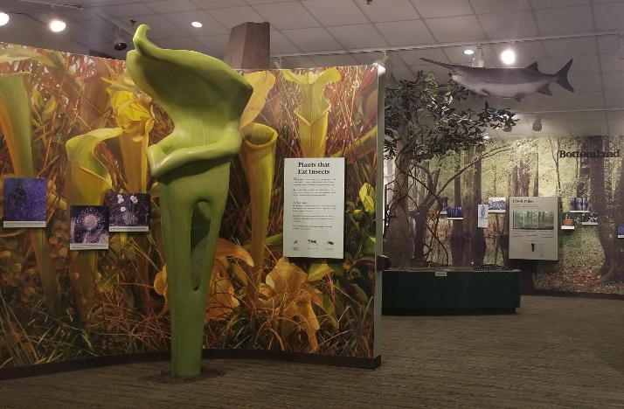

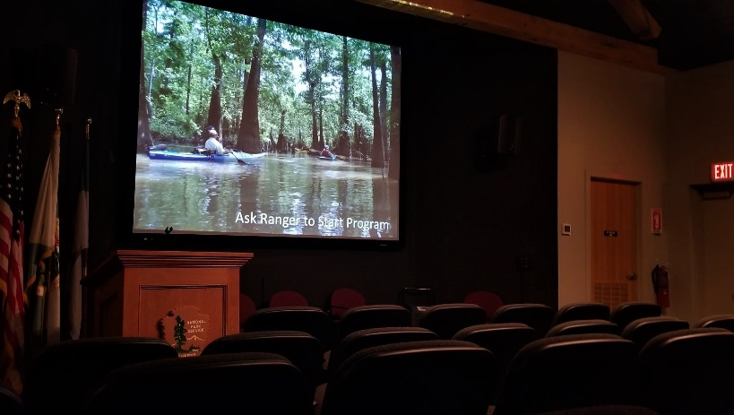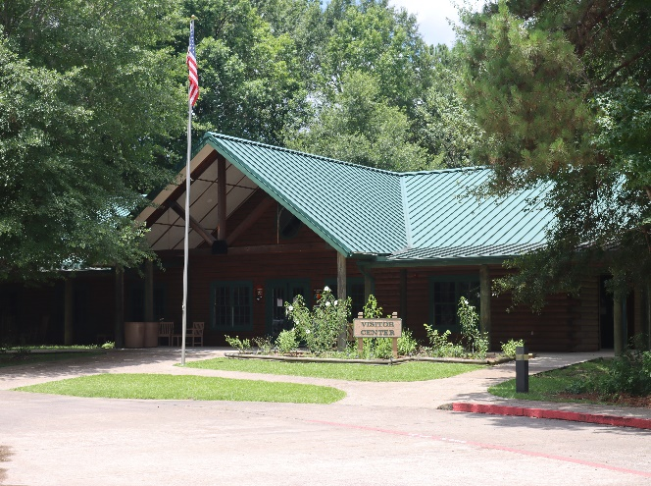

### A small 4-door, silver car parks in a parking lot with a background of tall trees.A blue plastic water bottle and a plastic container of trail mix sit on a desk indoors.Other Logistics

Please note there are no trails at the Visitor Center. You must drive to each trail. So, you may need more than one of these car pictures.

