K-2nd Grade
Nature Walk Unit
Bandy Creek
Fall/Spring

NPS Significance Statement:
The Big South Fork National River and Recreation Area (NRRA) is significant for protecting and preserving outdoor learning resources.

NPS Critical Issue:
Water Quality, Pollution, and Preservation of the Big South Fork National River and Recreation Area

Unit Rationale:
Elementary students are required to use their senses to explore the basic needs of organisms and discover the environment in which they are found. A visit to Bandy Creek Visitor Center offers students the opportunity to explore animals and plants found in both water and land environments. While recognizing the need to help protect these areas from pollution, they will be able to examine the examples of pollutants in the various environments as well as enjoy the aesthetic value the park offers.

Example Logistics (modify to meet your school’s needs):

~ 8:30 a.m. Leave School
10:00 a.m. Arrive at Visitor Center (allow time for restrooms and water)
10:00 a.m. – 10:30 a.m. Show and Tell inside visitor center (optional – Amphitheater)
10:30 a.m. – 12:00 p.m. Nature Walk
12:00 p.m. – 1:00 p.m. Lunch

Pre-site

Safety/Behavior lesson (Lost but Found Video (May borrow from Bandy Creek Visitor Center), Teacher Discussion Sheet)
Animal Group worksheets
Plant worksheets
Pollution worksheet

On-site

Show and Tell in Visitor Center or Amphitheater
Nature Walk

Post-site

Overview: Plants and animals have specific needs and characteristics that allow us to categorize and order living things. Living things require a healthy ecosystem in which to live.

Student Task: Each student will draw a picture of an on-site experience using construction paper. Pictures will then be taped together to make a long scroll and shown as a filmstrip by using two scrolling sticks and a cardboard box to represent a television show.

Language Arts: Find library books that have stories about animals in the Big South Fork NRRA. Draw pictures of BISO animals or plants and cut them out. Glue these pictures on craft sticks and have a puppet show.

Math: Make up word problems about animals in the Park. Ask students to answer them. Cut construction paper into post card size rectangles. Ask students to draw five pictures of the same animal on each card or use animal stickers or stamps. Use the cards to count by fives. Repeat this activity to count by tens.

Social Studies: Make a map to show Bandy Creek Visitor Center area. Use symbols and a compass rose.

Physical Education: Have a relay race by using different animal locomotions.

Art: Fold a piece of construction paper in half. Put a generous amount of paint in three puddles on the fold. Fold the paper again and then unfold to reveal a symmetrically shaped insect. Add legs or other features with markers.

Music: Sing the following song to the tune of I’m a Little Teapot. Sections that are underlined may be changed to fit the other animal groups:

I’m a little mammal with fur or hair.
Here is my tail and here is my nose.
When I’m in the mountains, then I shout,
Learn what I do and what I’m all about.

Health: Discuss how litter affects plant and animals. Clean up trash on the playground.

Big South Fork
National River and Recreation Area

Outdoor Learning and Assessment Lab

Bandy Creek
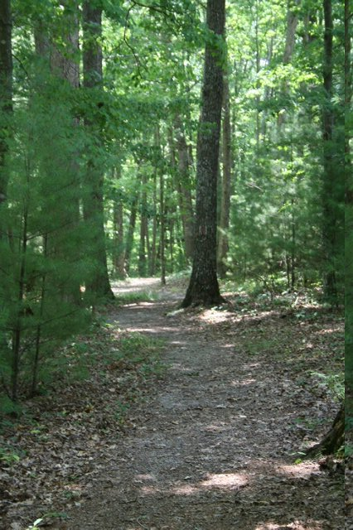

Classroom

A thematic unit on patterns
Featuring:

characteristics of plants and animals
land and water environments
nature walk

Geared toward a K-2nd Grade Setting




Bandy Creek Classroom

TO THE TEACHER

Thank you for participating in the Big South Fork Parks as Classrooms. The program provides an interdisciplinary learning experience for students integrating the natural and cultural resources of the Park with Tennessee curriculum.

On this trip, students will learn about different groups of animals and their habitats and what they have in common. The pre-site activities included in this packet are specific to the theme of your program and should be presented prior to your scheduled visit. The on-site instruction is conducted by the teacher with chaperone assistance in discussion and discipline. The post-site activities are designed to reinforce and build upon the Park experience. Please feel free to contact the Park at (423) 286-7275 if you have further questions.

Target class size: 20-25 students

Curriculum areas: Language Arts, Science, Social Studies

Site: Bandy Creek Visitor Center

Learning Strategies: Sensory experiences with animal skins and skulls; a hike contrasting various animals and insect habitats; a show and tell which will help the students distinguish between the characteristics of different groups of wildlife.

Pre-site: Pre-site activities included in packet

On-site: 10:00 a.m. to 1:00 p.m.
Introduction and welcome by Park Ranger. Teacher will lead both show and tell activity with puppets and animal furs and nature walk. Lunch at Picnic Area.

Post-site: Post-site activities. Teacher evaluation.

Bandy Creek Classroom

LOGISTICAL INFORMATION
Important Reminders for a Successful Program

Map: A map of Big South Fork National Park and surrounding area is included in this guide. If you need specific directions to the outdoor classroom, please contact the Park at (423) 286-7275

Where to meet: All students, teachers and chaperons will meet the Park Ranger at the Bandy Creek Visitor Center. The Visitor Center is located approximately 15 miles west of Oneida on TN Route 297. The Park Ranger will introduce himself/herself, state the theme of the program and how the program will be conducted.

Weather concerns: Please remind your students, the day before your park visit, to wear appropriate footwear and clothing for an extended outdoor program. Short pants, flip flops, or sandals aren’t recommended. Temperatures in the mountains can be 10-15 degrees colder than at your school. Portions of the program will be conducted regardless of inclement weather.

Restrooms: Restrooms and a drinking fountain are available at the Visitor Center. Please allow enough time for your class to use the restrooms prior to the start of your program.

Lunch: Lunches may be eaten at the Picnic area in front of the Visitor Center. Lunches should be packed in a box to be stored in the park Visitor Center until needed. Lunches, snacks, and drinks should be provided by the students.

Discipline: The teacher is responsible for discipline during the program. Please let you chaperones know they will be expected to assist with this duty during the program.

Chaperons: The program is designed for one class of approximately 20 – 25 students. We require an adult or teacher for every eight students to create a positive and rewarding learning experience. Please share appropriate materials with chaperones prior to the park visit so they may prepare for the program and have the opportunity to interact with the students.

Safety: Please review and be aware of the safety and behavior concerns addressed in the pre-site safety/behavior lesson. Notify the Park Ranger of any special concerns or medical conditions.

Cancellations: Should anything unforeseen occur preventing you from keeping your appointment, please contact the Park at (423) 286-7275.

Bandy Creek Classroom

BACKGROUND INFORMATION
Park and Site Description

Nat’l Park Service: The National Park Service is charged with the management and preservation of the nation’s most precious natural and cultural resources. These resources are woven into our heritage, and they provide opportunities for recreation, appreciation of beauty, historical reflection, cultural enrichment, and environmental education.

The future vision of the Service includes protection of Park resource; access and enjoyment for all people; education and interpretation to convey contributions of each Park unit and the Park system to the nation’s values, character, and experience; continuing science, research and resource management to manage and protect Park resources.

Big South Fork: The Big South Fork National River and Recreation Area of the Cumberland River drains an area of 1,382 square miles in Tennessee's Scott, Fentress, Pickett, and Morgan Counties and in Kentucky's Wayne and McCreary Counties. It threads through 106,000 acres of federally protected recreation area, established by Congress in 1974, giving the river traveler a true sense of wilderness.
This is an ancient river, cutting through gorges more than 250 million years old and is one of only three rivers in the United States designated by Congress as a "national river," that is, distinguished by its historical significance as well as its wild and scenic beauty. The Big South Fork is also one of the few rivers in the eastern United States that has not been dammed for power generation or flood control. The U.S. Corps of Engineers first proposed to dam the river in 1933, and construction was authorized several times in the 1950s and 1960s by the U.S. Senate, but the House of Representatives never agreed.
Canoers, kayakers, and rafters of every skill level--from novice to expert--can find a stretch of the Big South Fork that offers them relaxation or challenge. The river's rapids range in difficulty from Class I to Class IV. The best period to be on the river falls between March and the first part of June, before the water supply becomes problematic.
The Big South Fork National River and Recreation Area features spectacular scenery. Looking down from the Cumberland cliffs into the Big South Fork gorge hundreds of feet below, visitors have the feeling of standing on top of the world, and there is nothing quite like it. No visitor to the Cumberland wilderness can miss the extraordinary stone formations sculpted by the violent collision of continents and by the patient insistence of water flowing over--and after millions of years--through solid rock. Thousands of rock shelters and scores of natural arches are in the area, but the most spectacular are the Twin Arches, one of the largest natural bridges in the world. Within the Tennessee section of the park, the larger South Arch has a clearance of seventy feet and a span of more than 135 feet. The North Arch has a clearance of fifty-one feet and a span of ninety-three feet.
The area boasts massive sandstone bluffs carved in semicircles, and white and scarlet oaks, tulip poplars, sugar maples, umbrella and cucumber magnolias, white ash, willows, sycamores, sweet gums, and river birch and hickory trees populate the forests. The spreading branches of hemlocks and the smooth bark of the gray beech stand out amid a profusion of rhododendron, dogwood, holly, sassafras, mountain laurel, and azalea.
Animals are plentiful and include white-tailed deer, black bear, wild hogs, southern flying squirrels, gray squirrels, red and gray foxes, chipmunks, beaver, muskrat, mink, otter, bobcats, coyotes, long-tailed weasels, cottontail rabbits, and eastern spotted skunks. Birds--132 catalogued varieties--are seen and heard everywhere, including the ruffed grouse, the bobwhite, the hairy and the pileated woodpecker, the screech owl, the red-tailed hawk, an occasional osprey, the scarlet tanager, the crow, the whippoorwill, the cardinal, the mockingbird, the turkey, and the turkey vulture.
Human history in the Big South Fork area began about twelve thousand years ago with the nomadic tribes of hunters who followed the elk, bison, deer, bear, and other large game animals to what is now Tennessee and Kentucky. The rock shelters that nature created were used as homesteads by these hunters, and about four thousand such shelters can be found within the Big South Fork National River and Recreation Area. The National Park Service lists eight thousand archaeological sites in the area. (The Park Service also estimates that at one time there was one moonshine still for every 116 acres of the Big South Fork.)
There is evidence at these ancient sites of tremendous activity between twelve thousand and seven thousand years ago. There is evidence of mussel gathering and of intentional burning of forests to clear land for primitive planting. Evidence also indicates that beginning about seven thousand years ago, and for the next twenty centuries, human life in the Big South Fork area virtually vanished.
When they returned after two millennia, the people of the Big South Fork were hunting smaller game, collecting plants, living in primitive campsites, and moving with the seasons. Between A.D. 900 and 1000, these people left the plateau for good and founded agricultural communities along the Tennessee and Cumberland Rivers. Occasional hunting forays into the mountains were all that linked people with the Big South Fork for the next thousand years.
Long hunters changed all that when they first came to the area in the late 1700s. By 1800 several permanent homesteads had been established, but the fact that life was as hard for these settlers as their prehistoric predecessors is obvious from their choice of place names such as Difficulty, Troublesome, and No Business. Identified historic farm sites include the Clara Sue Blevins Farm and Oscar Blevins Farm near the park's Bandy Creek Visitor Center.
The nature of hardscrabble agriculture helped to make local settlers more Blue than Gray during the Civil War. Unlike planters further south, farmers in the Big South Fork region could not grow cotton and did not rely heavily on slaves. Most residents were fiercely loyal to the Union, sending more troops to serve in the Grand Army of the Republic than with the Confederacy. Indeed, when Tennessee finally seceded from the Union, Scott County seceded from Tennessee and briefly became the Independent State of Scott. The world little noted, nor long remembered, these passionate politics. On most maps of the era, this part of the country was referred to as simply "wilderness."
A portion of that "wilderness" now makes up the Big South Fork National River and Recreation Area. The Park Service is determined to manage this area in a manner that is responsive to the varying needs and desires of a wide constituency of users while protecting and preserving the diversity of its natural and cultural resources.
The Big South Fork is a wilderness area from the bluff lines down, which means in the parlance of the Park Service, "no vehicles, comforts, or conveniences." On the plateau, however, the Park Service must foster peaceful coexistence among four-wheel drive vehicles, bikers, horses, hikers, hunters, fishermen, and even trappers. Mountain biking and horseback riding continue to be the major draw to the area, which makes for an interesting mix, as horses do not much care for bicycles, nor cyclists for horses. Those coming to view fall colors must remember that they share the area with those in pursuit of deer--we are all learning to share this very special place.
Howard Baker Jr., Knoxville
http://tennesseeencyclopedia.net/imagegallery.php?EntryID=B044

Bandy Creek Classroom

Possible Standards and Objectives

Science
(Life Science): Interactions Between Living Things and Their Environment
Use the senses to explore the environment
Collect information about organisms that occupy specific environments.
Provide examples of pollutants in a specific environment

Food Production and Energy for Life
Recognize the basic needs of living things (e.g., food water, sunlight, and air).

Diversity and Adaptation Among Living Things
Observe and note differences among plants and animals of the same kind.
Recognize the environment in which an organism is typically found.

Earth Features
Distinguish between land and water environments.

Bandy Creek Classroom: K-2nd Grade Plants & Animals

PROGRAM EVALUATION

We are glad that you and your students participated in this Outdoor Learning and Assessment Lab at Big South Fork. Please help us continue to improve and develop this program by taking a few minutes to complete this evaluation. We want to ensure that our programs are serving your needs.

Name of Teacher(s):

Name of School:

School Address:

Program/Location in Park:

Grade Level: __________________ Date of Visit: ________________________

Name of Ranger(s):

How did you learn about this opportunity?

Did the information provided help you prepare for this trip?

Was the pre-site material effective?

Please comment on any strengths:

Please comment on any weaknesses:

What was the best part of this educational experience?

Please circle your response to the following questions:
1 (high/agree) 2 (medium/OK) 3 (low/disagree)

Overall evaluation:
Relevant to the curriculum: 1 2 3
Interest level of students: 1 2 3
Age appropriateness: 1 2 3
Effectiveness of pre-site lessons: 1 2 3

On-site program:
Suitable for class size: 1 2 3
Content appropriate for age level: 1 2 3
Ranger effectiveness: 1 2 3

Do you plan to participate in this program next year? Yes No

Please return this form to:

Big South Fork Headquarters
4564 Leatherwood Road
Oneida, TN 37841

Bandy Creek Classroom

VOCABULARY AND DEFINITONS

Environment: All of your surroundings. This includes living things (plants, animals, and people) and non-living things (air, water, rocks, and buildings).

Habitat: The environment in which a plant or animal lives.

Pollution: Things that are unnatural and unclean to the environment.

Vertebrates: Creatures with backbones.

Invertebrates: Creatures without backbones.

Insects: Invertebrates with 6 legs, 3 body parts that are segmented, usually have 2 pair of wings.

Birds: Warm blooded, feathered vertebrates. All birds have wing though some con not fly. They have bills or beaks and reproduce by laying eggs.

Reptiles: Cold blooded – this means they do not generate enough heat internally to keep them warm and must seek external heat sources. Reptiles are vertebrates. They have scaly skin. Most reproduce by laying hard shelled eggs.

Amphibians: Soft and slippery skin. Spend much of their time in and around the water in order to keep their skin most. Amphibians lay soft jelly eggs in and around the water.

Mammals: Warm blooded with fur or hair. They are vertebrates, and their young are born alive.

Fish: Vertebrates with gills instead of lungs. This allows them to breathe in water. They are cold blooded and reproduce by laying eggs.

SUGGESTED REFERENCES

Salamander Room
The Shrinking Mouse
The Bear Snores On

Bandy Creek Classroom

PRE-SITE LESSON Safety

Duration: 20 - 30 minutes

Location: School classroom

Materials: Teacher discussion sheet on safety/behavior (included in packet), Lost but Found Video (May borrow from Bandy Creek Visitor Center)

Thematic Unit: Awareness

Curriculum areas: Science, Health

INSTRUCTIONAL STRATEGIES

Learner objectives: The learner will be able to: 1) list at least three items to carry with them when they hike with their families in the wood; 2) discuss three methods to keep from getting lost; 3) identify the most important thing to do when lost; 4) discuss and identify three dangers in the woods and know how to avoid them; 5) Recognize how to behave in the park and respect the park.

Teacher task (set): Discuss the safety/behavior sheet and potential dangers students might encounter in the park.

Teacher task (overview): Identify items the students might carry with them when they visit the park with their families.

Teacher task (instruction): Discuss methods to keep from getting lost and identify the most important thing to do if lost. Show 12 minute video: Lost but Found, Safe and Sound.

Student task: Participate in discussion, view video.

Teacher task (closure): Summarize safety/behavior issues discussed during the lesson.

Student assessment: Participation in discussion.

Challenge activities: Create a list of items that would be necessary to safely day hike in the mountains.

Plans for re-teaching: Post-visit summary and discussion.

Bandy Creek Classroom

PRE-SITE LESSON Safety Lesson-Teacher Discussion Sheet

Park dangers: include rock, uneven trails; stinging insects; poison ivy and other irritating plants; snakes; changing weather conditions.

Avoid dangers by: staying together as a group.
not running or playing rough.
watching where you put your hands and feet.
knowing how to identify poison ivy.
knowing any allergies or conditions that may cause concern on the trail.

Avoid getting lost by: hiking with a group at all times.
staying on established, marked trails at all times.
reading and understanding all trail signs.
taking along a good map and knowing how to read it.
letting others know where you are and when you will return.

If you get lost: Stop, wait, and blow your whistle.

Words to the wise: If you can carry it in full, you can carry it out empty. Pack out all trash. The park is a living museum where all living and nonliving things are protected by law. Boil or treat all of your drinking water. Never drink from a stream even if it looks pristine. Use caution when walking near streams. Wet and moss-covered rocks can be slippery. Pair off into a “buddy system” and keep track of your buddy.

Items for hiking: Necessary Optional

Day pack compass
Water extra clothes
Lunch or snack map
Whistle guide books
Rain gear hat
First-aid kit, any personal medication pencil and paper

Bandy Creek Classroom

PRE-SITE LESSON Animal Groups

Duration: 45 minutes

Location: School classroom

Material: color sheets (use your own), response cards

Thematic Unit: Awareness

Curriculum areas: language arts, social studies, science, art, music

INSTURCIONAL STRATEGIES

Learner objectives: The learner will be able to: 1) list the basic survival needs of animals; 2) define the word “habitat.”

Teacher task (set): Read an animal book to the students. Suggested: The Very Hungry Caterpillar or The Mixed-up Chameleon by Eric Carle. The Salamander Room by Anne Mazer.

Teacher task (overview): Soon we will be going to the Big South Fork National Park. Many animals live in the Park. The forest is their home. We are going to learn about the basic needs of animals. We are also going to learn how to group animals by the way they look (physical appearance), the way they act (behavior), and where they live (habitats).

Teacher task (instruction): Use color sheets to introduce six animal groups. Introduce each animal group by reading the name of the group, and let the students write the group name. Then read the description of the group below the picture. Discuss skin covering, locomotion, and habitat. Discuss needs that are common to all animals (water, food, oxygen, shelter).

Student task: Participate in discussion of groupings and responding to questions and statements in the assessment activity.

Teacher task (closure): Song or discussion.

Bandy Creek Classroom

PRE-SITE LESSON Plants

Duration: 60 minute session wit additional optional activities

Location: School classroom

Material: poster or worksheets depicting parts of plants (use your own); bedding plants (optional)

Thematic Unit: Awareness

Curriculum areas: language arts, science, health

INSTURCITONAL STRATEGIES

Learner objectives: The learner will be able to: 1) label at least one physical characteristic of a plant; 2) list basic survival needs of a plant

Teacher task (set): Read a story about plants to the students. Suggested: Jack and the Beanstalk.

Teacher task (overview): Soon we will be going to Big South Fork National Park. The forest is made up of many plants. In order to stay alive, we have special needs and so do plants. Plants also have unique parts that we can identify. Each part of the plant has a special job.

Teacher task (instruction): Read narrative on each plant type and discuss. Introduce parts of the plant and the function of each part. Explain that roots absorb materials form the ground, stems carry water to the plant and provide support, leaves produce food, the flower produces seeds, and the seed produces a new plant. Explain that trees have trunks and branches. If possible use bedding plants such as a marigold to dissect. Plants can be shared among two or three students. View each part with a magnifying glass. Lead a discussion on basic needs of plants. Use marigold seeds to grow new plants in a cup of soil. Remind students that plants in the Park are not to be disturbed because they are protected for everyone to enjoy.

Student task: Discussion of color sheet. Dissection flowers and planting seeds (optional).

Teacher task (closure): Teacher reviews each part of the plant and its function. Teacher reviews the needs of plants.

Student assessment: Ask students to hold up a specific part that has a specific function. Example: Which part makes the food? How does it take up water?

Bandy Creek Classroom

ON-SITE LESSON Show and Tell

Duration: 30 minutes

Location: Bandy Creek Outdoor Classroom

Material: furs, puppets, skulls, trash (provided at Bandy Creek Visitor Center)

Thematic Unit: Awareness

Curriculum areas: language arts, science, health

INSTURCITONAL STRATEGIES

Learner objectives: The learner will be able to: 1) identify that animals belong to different groups: 2) realize that animals have different physical characteristics; 3) understand how animals behave; 4) Identify pollution found in the park.

Teacher task (set): Explain to students that they will be identifying different animals and their characteristics to discuss and act out how they behave.

Teacher task (overview): Discuss the differences between various animal groups. Show examples of pollution.

Teacher task (instruction): Have students listen and answer questions during the show and tell discussion.

Student task: Participate in show and tell and discussion.

Teacher task (closure): Summarize what students have learned about life in the Big South Fork.

Student assessment: Participation in discussion.

Challenge activities: Have students list what they remember from each animal that was shown and how they behave in the wild.

Plans for re-teacher: View live animals, encourage discussion of characteristics.

Bandy Creek Classroom

ON-SITE LESSON Nature Walk

Duration: One hour

Location: Bandy Creek nature trail

Material: replicas of salamanders, frogs, rubber snake and snake eggs, plastic insects, plastic birds, plastic fish, deer antler and/or small mammal skins, and trash bag (may borrow from BCVC)

Thematic Unit: Awareness

Curriculum areas: language arts, science, health

Note: Replicas of organisms need to be placed along trail before hike. Teacher or chaperone need to carry trash bag to pick up any pollution.

INSTURCITONAL STRATEGIES

Learner objectives: The learner will be able to: 1) explain why different types of life may be found in different types of habitats; 2) name one physical trait of a specific species; 3) explain why all animals require a healthy, non-polluted, ecosystem in which to live.

Teacher task (set): Explain to students that they will be taking a nature walk and examining some of the many different types of life that inhabit the Big South Fork

Teacher task (overview): Discuss the diversity of life here and how we group living things by their physical characteristics.

Teacher task (instruction): Have students participate in the nature walk.

Student task: Participate in nature walk and discussion.

Teacher task (closure): Summarize what students have learned about life in the Big South Fork.

Student assessment: Participation in discussion.

Challenge activities: Take a walk around the school yard. Group the animals/plants you see there and compare that with what you found in the Big South Fork.

Plans for re-teacher: Post-site test and discussion.

Bandy Creek Classroom

POST-SITE LESSON Student Activities

Overview: Plants and animals have specific needs and characteristics that allow us to categorize and order living things. Living things require a healthy ecosystem in which to live.

Student Task: Each student will draw a picture of an on-site experience using construction paper. Pictures will then be taped together to make a long scroll and shown as a filmstrip by using two scrolling sticks and a cardboard box to represent a television show.

Language Arts: Find library books that have stories about animals in the Big South Fork N.P. Draw pictures of BISO animals or plants and cut them out. Glue these pictures on craft sticks and have a puppet show.

Math: Make up word problems about animals in the Park. Ask students to answer them. Cut construction paper into post card size rectangles. Ask students to draw five pictures of the same animal on each card or use animal stickers or stamps. Use the cards to count by fives. Repeat this activity to count by tens.

Social Studies: Make a map to show Bandy Creek Visitor Center area. Use symbols and a compass rose.

Physical Education: Have a relay race by using different animal locomotions.

Art: Fold a piece of construction paper in half. Put a generous amount of paint in three puddles on the fold. Fold the paper again and then unfold to reveal a symmetrically shaped insect. Add legs or other features with markers.

Music: Sing the following song to the tune of I’m a little Teapot. Sections that are underlined may be changed to fit the other animal groups:

I’m a little mammal with fur or hair.
Here is my tail and here is my nose.
When I’m in the mountains, then I shout,
Learn what I do and what I’m all about.

Health: Discuss how litter affects plant and animals. Clean up trash on the playground.

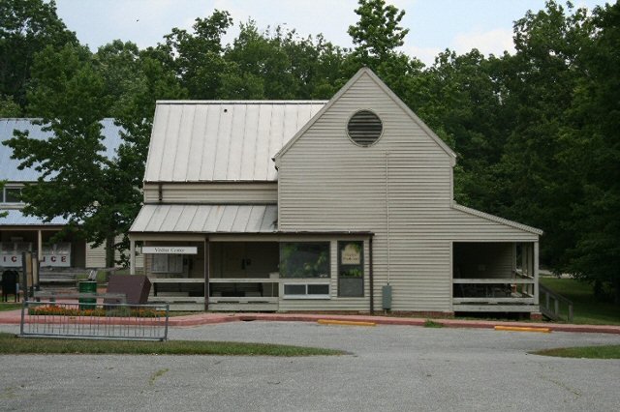
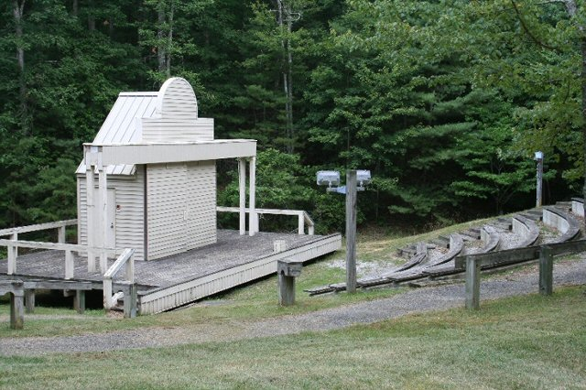

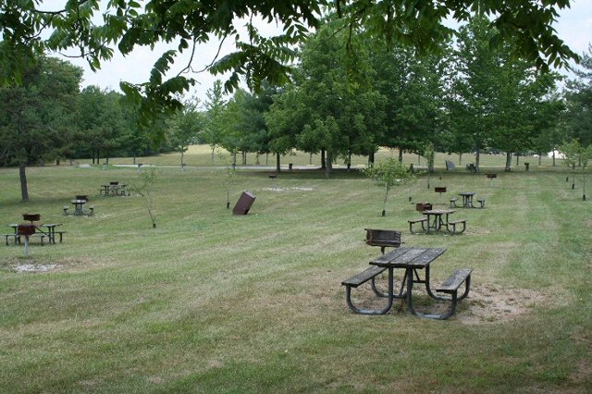
Visitor Center at Bandy Creek Amphitheater at Bandy Creek
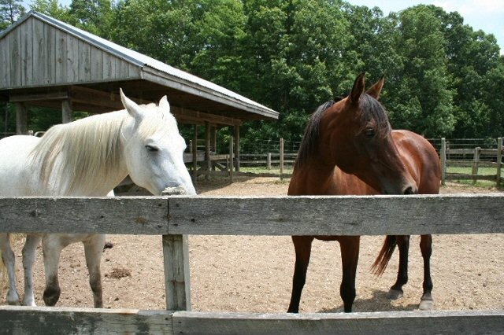

Picnic Area Horse Stables

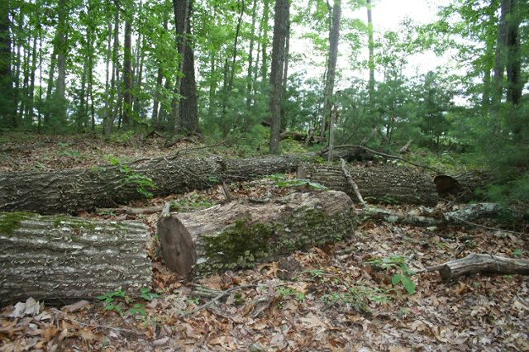

Places to put replicas along trail
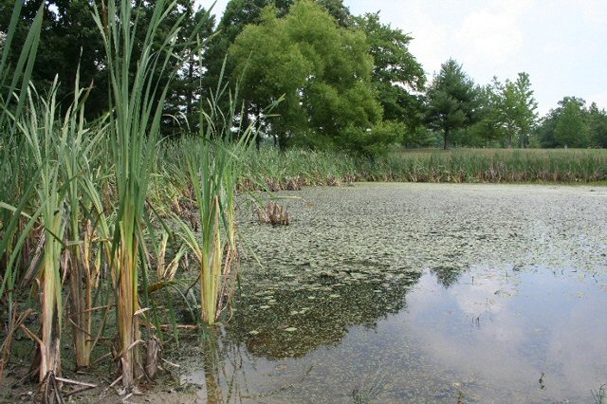

Nature trail

Pond

