The Civil War in the Upper Cumberland Plateau and its Effects on the Local Population: A Guide of the major events and themes, for teachers and interested citizens of the
Upper Cumberland Plateau of Tennessee and Kentucky

By
W. Stephen McBride, Ph.D.
Kentucky Archaeological Survey

Kentucky Archaeological Survey Report 236

Submitted to
Big South Fork National River and Recreation Area
4564 Leatherwood Road
Oneida, Tennessee 37841
Contact: Tom Des Jean
(423) 569-9778

Submitted by
Kentucky Archaeological Survey
1020A Export Street
University of Kentucky
Lexington, Kentucky 40506-9854
(859) 257-1944

October 2012

_________________________________
David Pollack,
Principal Investigator

Introduction

This document provides teachers and other interested parties information describing the actions and effects of the American Civil War in the Upper Cumberland Plateau. The guide is organized into nine major themes, 1. Secession Crisis, 2. Military Occupation, 3. Military Enlistment, 4. Major Battle/Campaigns, 5. Small Skirmishes, 6. Guerrilla Warfare, 7. Other Effects on and Responses by Civilians, 8. The End of Slavery, and 9. Post-War, Long Term Effects. Information is presented in concise bullets, with some statistical data from voting patterns, enlistment data, and federal census data.

While this area was not the scene of major strategic battles that shaped the outcome of the Civil War, the reader can see from the data presented that the Civil War entailed a host of encampments, minor skirmishes, two major campaigns, and especially a significant amount of guerrilla activity in the Upper Cumberland Plateau. The Civil War is a topic of considerable interest to scholars of and residents in the area, as evidenced by the substantial number of published sources cited at the end of the guide. The focus in the Resources section is on published works, but given the growing reliance on internet sources, several useful web sites are also listed.

The guide is being distributed to libraries and schools in Fentress, Pickett, Morgan, and Scott Counties, Tennessee, and McCreary County, Kentucky, and can be made available to other interested parties by request to the Big South Fork National River and Recreation Area. A Microsoft Powerpoint presentation containing most of the information in the nine themes, with select illustrations, is also available from the Big South Fork National River and Recreation Area.

Theme 1. Secession Crisis

Following election of Abraham Lincoln, Republican (Abolitionist Platform), seven states seceded between Dec. 1860 and Feb 1861 (SC, GA, FL, AL, MS, LA, TX). All of these states explicitly state that protection of slavery is the reason for secession. Following South Carolina’s April 1861 attack on Fort Sumter and President Lincoln’s Call to Arms to put down the rebellion, four more states secede (TN, ARK, VA, NC).

Kentucky
Never secedes.

Gov. Beriah Magoffin declares the state neutral after Lincoln’s call to arms, but Pro-Union Legislature, elected in July, 1861 and Sept. 1861, overturns this policy and Magoffin resigns.

Kentucky is one of four slave states to remain in the Union (with Maryland, Missouri, and Delaware). Some Kentuckians join the Confederate Army, but more join the Union Army.

Tennessee
Defeated the referendum supported by pro-secession Gov. Isham Harris on whether to call a secession convention in Feb 1861.

After Fort Sumter, the legislature approval an ordinance calling for secession in May 1861.

June 1861 – voters approved it (with No Convention).

Most Tennessee Upper Cumberland Plateau counties voted against the secession convention in February 1861 and against secession in June 1861 (see Table 1).

Scott County sends petition to secede from Tennessee; it is ignored.

Special Election on Secession Convention,  Feb 9, 1861 |  |  | Special Election on  Secession, June 8, 1861
 | For | Against | For | Against
Fentress | 334 (51%) | 325 (49%) | 128 (16%) | 651 (84%)
Morgan | 13 (2.6%) | 488 (97.4) | 50 (7%) | 630 (93%)
Scott | 29 (7%) | 385 (93%) | 19 (3.5%) | 521 (96.5%)
Overton | 563 (39.5%) | 863 (60.5) | 1471 (80%) | 364 (20%)
Table 1. Results of Special Elections (from Campbell 1961 and Fisher 1997).
Theme 2. Military Occupation

Kentucky
Intermittent Union Army Occupation by small forces in Upper Cumberland Plateau. Pro-Union Home Guard organized to protect border and watch for Confederate invasion.

Some recruitment camps set up nearby. Camp Clio, Pulaski County.

Harassment of Pro-Confederate citizens and curtailment of trade with Tennessee.

Brief Confederate military occupation (3,565 troops) in Wayne and Pulaski Counties, late 1861, early 1862, prior to Battle of Mill Springs (Jan. 19, 1862).

After Knoxville Campaign of August-Sept. 1863, less Union occupation and area seen as backwater. Still some effects as soldiers take livestock and goods.

Tennessee
Confederate Occupation July 1861 (District of East Tennessee, Generals Zollicoffer, Kirby Smith, Buchner in command with HQ at Knoxville) until Aug-Sept 1863.

Small Confederate force guarding border, suppressing Pro-Union activities, arresting Pro-Union leaders, and raiding Pro-Union farms. They suppressed local government and services, since these were controlled by Pro-Unionists.

Most Upper Cumberland Plateau population Pro-Union.

November 1861. Pro-Union men under William Carter burn seven of nine railroad bridges. This leads to martial law and crackdown on Pro-Union citizens. Supposed to be pre-cursor to Union invasion under Gen. George Thomas, but it was called off by Gen. William T. Sherman in Kentucky.

Lincoln wanted to capture Pro-Union E. Tennessee since the beginning of the war.

Mid Nov. 1861 – 3565 Confederate under Zollicoffer camped at Wartburg, Nov. 22-24, left for Kentucky, Battle of Mill Springs January 19, 1862.

March 1862 – Andrew Johnson appointed U.S. Military Governor of Tennessee. Pro-Confederate Governor had to flee Nashville after Battle of Fort Donelson. All of Tennessee except East Tennessee under Union control.

After April 1862, Confederates begin the draft. In East Tennessee this leads many men to flee, hide, or join Pro-Union guerrillas.

U.S. Army Occupation after Sept. 1863. Local government gradually reestablished.

U.S. Army sends various Cavalry units to fight Confederate guerrillas. Mostly unsuccessful until Summer 1864, when they begin a harsher policy against Pro-Confederate citizens.

Encampments. These often entailed some destruction of property, such as for firewood, and troops foraging for food (Figures 1, 2, and 3).

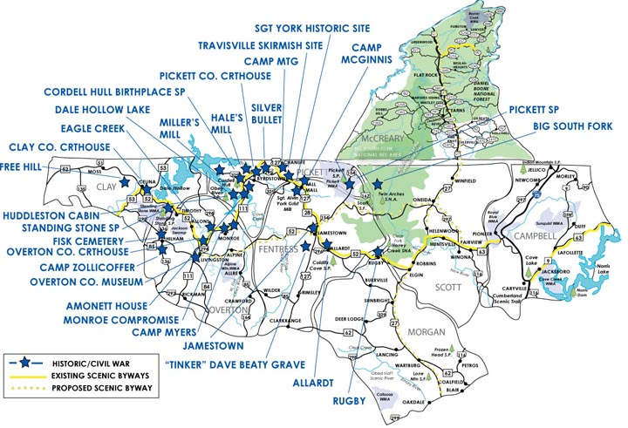
Figure 1. Map showing many Civil War sites in the Big South Fork (from Big South Fork Country.com)

Summer 1861 – Travisville, Pickett County, Confederate recruitment camp.

Summer 1861 – Overton County, Camp Zollicoffer and Camp Myers, Confederate camps.

Feb 1862 – Morgan County, (4 miles east of Wartburg), Confederate Camp Schuyler (or Schooler), 1st and 2nd Tennessee Cav. (C.S.).

May 1862 – August 1862 – Hill near Huntsville. Camp of 7th Tennessee Inf. (U.S.), 250 to 400 men.

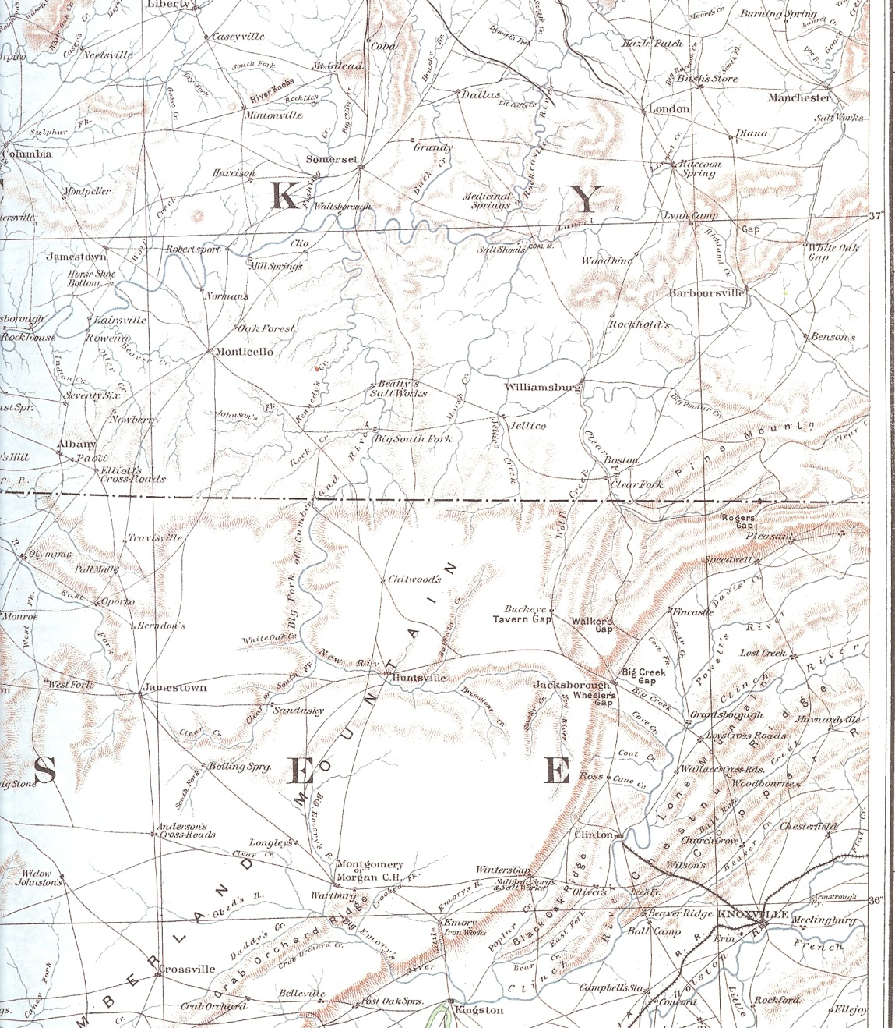
Figure 2. Map of the region from the Official Records of the Civil War Atlas (Davis 1983).

November 15-25, 1862 – Wartburg, Morgan County. 3500 Confederates under Gen. Felix Zollicoffer encamp before Battle of Mill Springs (Jan 19, 1862).

1862+ - Southern Pulaski County, Union Camp Clio.

March 1863 – Pt. Isabel (Burnside), Pulaski County. U.S. Army Depot established, Camp Burnside for Gen. Burnside’s Knoxville Campaign.

Summer 1863 – McCreary County, at golf course near Stearns, Union camp.

August 26-28, 1863 – Flat Gap, near Winfield, Scott County, U.S. Camp Chitwood. Large force of Maj. Gen. Ambrose Burnside’s Army of the Ohio.

August 30-31, 1863 – White Oak Creek (1 mile east of Sunbright). U.S. Camp Ragweed. Large force of Burnside’s army.

February 1864 – Wartburg, Morgan County. U.S. camp under Lt. William Estrada, 2nd E. Tennessee Cav.

n.d. – Three Forks of Wolf River, Pickett County. Camp McGinns Confederate guerrilla base of Champ Ferguson’s men.

n.d. East Fork of Obey River, Fentress County. Mountain Cove, base of Tinker Dave Beaty.

Theme 3. Military Enlistment

One of largest impacts of the Civil War was the enlistment of men into both armies. Many men left the area, some never to return. The loss of these men had a major economic, political and social impact on the region. Loss of labor and management and farms and businesses declined, many had to be run by family members – wives, children, elderly parents. Numerous men also joined local Home Guard Militia and guerrilla bands.

Summer 1861 – Travisville, Pickett County and Camps Zollicoffer and Myers, Overton County, C.S. enlistment camps established (Figures 2 and 3).

Aug-Sept 1861 – Camp Dick Robinson (Garrard County, Kentucky) founded as U.S. army enlistment center.

Sept 1861 – approximately 1000 East Tennessee men enlisted at Camp Dick Robinson.

March 1862 - approximately 4000 East Tennessee men enlisted at Camp Dick Robinson.

A total of 20- 30,000 East Tennessee men joined the U.S. Army.

Most Upper Cumberland area Kentucky and Tennessee men joined the Union Army, but some did join the Confederate Army (see Table 2). These Units were mostly in action in the Western Theatre. Some Units, such as the 7th Tennessee Infantry (U.S.) and 5th Tennessee Cav. (U.S.), performed local anti-guerrilla activity.

Table 2. Enlistment figures, compiled from Roy 2001, Smith 1985.
Men enlisted | U.S. | C.S.
Scott | 541 | 19
Wayne | 448 (July 1863) | ?
Whitley | 501 (July 1863) | ?
Pulaski | 1032 (July 1863) | ?

Regiments joined by local men include 12th, 13th, 18th, 26th, 30th, 32nd, 49th Kentucky Inf. (U.S.), 1st, 6th, 7th, Kentucky Cav. (U.S.), 1st, 2nd, 4th, 7th, 8th, and 11th Tennessee Inf.(U.S.), 1st and 4th Tennessee Cav. (U.S.), 1st Tennessee Light Artillery (U.S.), 10th Kentucky Cav. (C.S.), 8th, 25th and 28th Tennessee Inf. (C.S.), 4th and 13th Tennessee Cav. (C.S.).

African-American enlistment includes at least 47 men from Wayne County. The numbers from other Upper Cumberland Plateau counties are unknown. Most would have been mustered in at Camp Nelson, Kentucky after Spring 1864 or at larger Union encampments in Tennessee.
Theme 4. Major Battle/Campaigns

Only one large battle occurred near this region; the Jan. 19, 1862 Battle of Mill Springs/Logan’s Crossroads in Pulaski County, Kentucky. A large Confederate force under Gen. Felix Zollicoffer moved through Big South Fork area to Wayne County and southern Pulaski County in December 1861. They were attacked by a U.S. Force under Gen. George Thomas at Nancy, KY. The Confederates were defeated and retreated and Gen. Zollicoffer was killed. Thomas wanted to invade Tennessee but was ordered back and the Union army moved to north of Cumberland River following orders of Maj. Gen. Don Carlos Buell. Tension now increases in Big South Fork area and more people forced to choose sides.

Knoxville Campaign – June/August-Sept. 1863. This campaign under U.S. Gen. Ambrose Burnside’s Army of the Ohio was the largest to move through the study area. Col. William Sanders with 1500 U.S. cavalry rode through Big South Fork area in June 1863 as precursor to Knoxville campaign and burnt bridges and captured some Confederates. Almost two thirds of Burnside’s 16,000 men march through Big South Fork area August 20 – Sept 3 on way to Knoxville. They move through Jamestown, Pine Knot, Chitwoods, Huntsville, Montgomery, Warburg, Emory Iron Works and encamp at numerous places (Figure 4).

Prior to the march, Burnside commissions Union guerrillas in Tennessee counties and orders them to spy and harass (bushwhack) Confederate forces.

Local citizens help U.S. forces over bad roads in Big South Fork area. Stories of this from local informant France Miller, via Will Miller reflect importance and drama of this event to local citizens.

Knoxville abandoned by Conf. Gen. Simon B. Buckner, Sept 1863. Union victory in Battle of Knoxville, Nov. 1863, and Battle of Chattanooga Nov. 1863, lead to Confederate abandonment of Big South Fork area and most of East Tennessee.

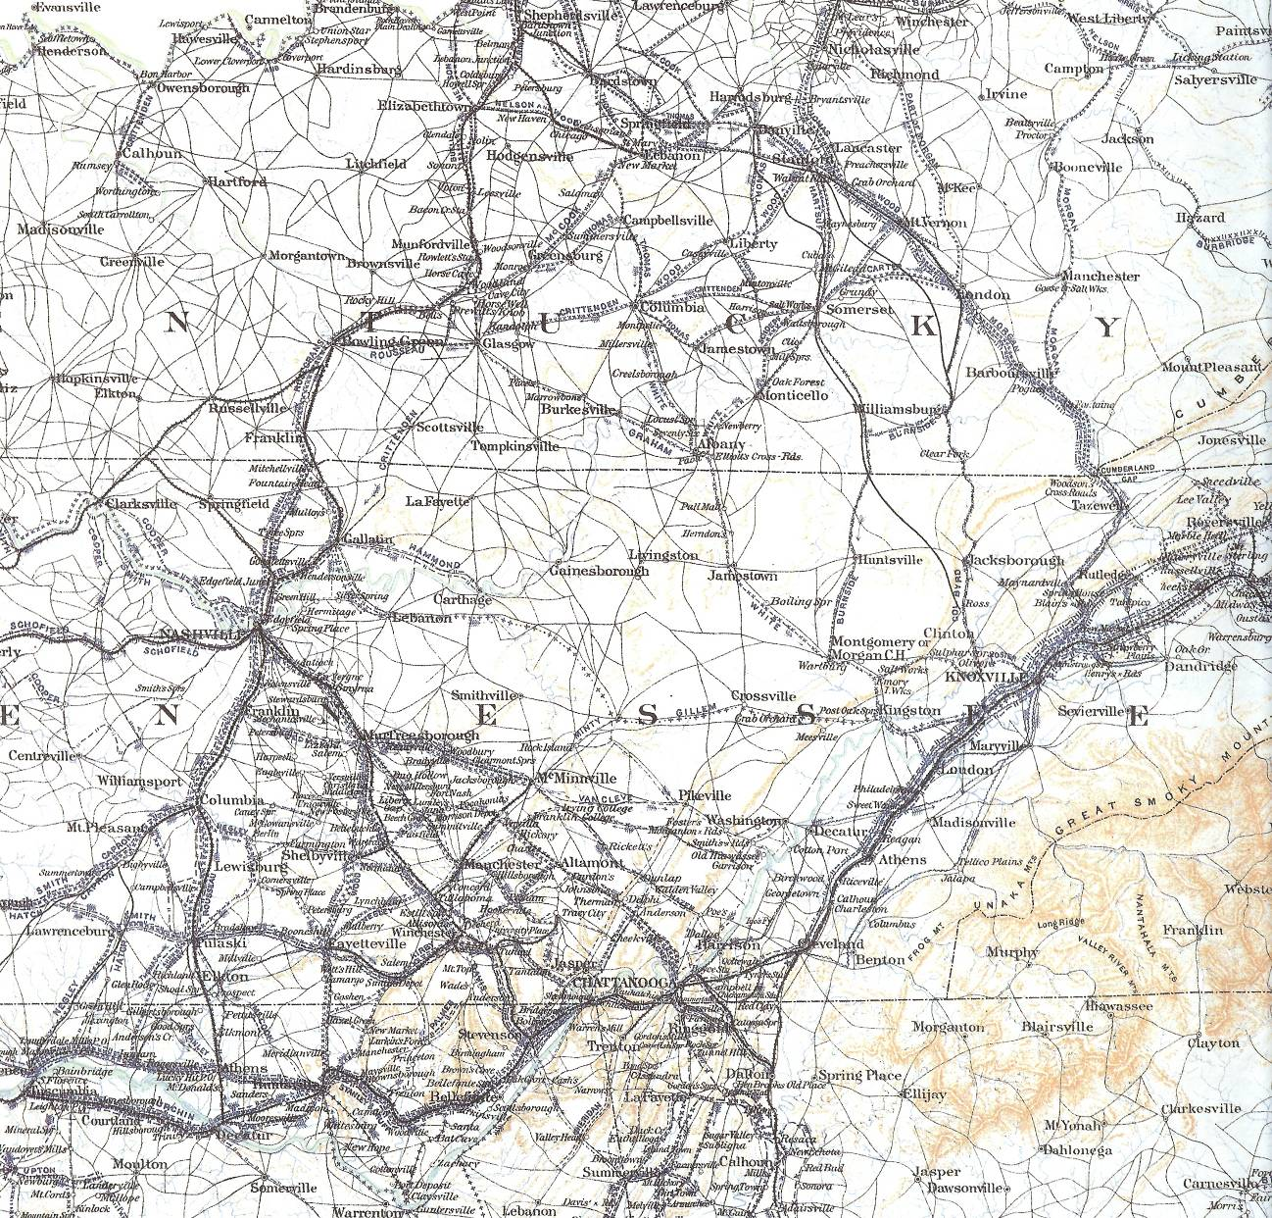
Figure 4. Map of General Burnside’s Campaign (routes outline in red by W. Stephen McBride) (Davis 1983)
Theme 5. Small Skirmishes

A few skirmishes involving regular troops occurred in the Upper Cumberland area. Most involved regular C.S. or U.S. troops against local partisans/guerrillas, but some had regular troops on both sides.

Sept. 29, 1861 – Travisville, Pickett County – 1st Kentucky Cav. (U.S.) and Kentucky Home Guard surprised and dispersed about 100 Confederates encamped at Travisville (often called the first battle in Tennessee).

February 2, 1862 – Morgan County, NW or Wartburg. 1st Tennessee Cav. (C.S) under Lt. Col. J. W. White skirmished with U.S. forces and killed 5 U.S. who retreated.

March 28, 1862 – Morgan County, near Montgomery. Confederates clash with local Union Home Guard forces who retreated. Confederates had five killed, 12 wounded. Union, 15 killed, 7 prisoners.

April 1-2, 1862 - Brimstone Creek, Scott County. Capt. John C. Vaughn (C.S.) surrounded house of Capt. W. H.H. Robbins, 7th Tennessee Inf. (U.S.), but Robbins on ridge above and attacked Vaughn’s men. U.S. held ground on ridge, Confederates withdrew.

April 13, 1862 – Battle of Huntsville, Scott County. Col. William Clift and 250 men of 7th Tennessee Inf. (U.S) had fortified a hill southwest of Huntsville. They were attacked by Confederates (600 Infantry, and 300 Cavalry) under Capt. T. M. Nelson. U.S. forces defeated and retreat.

January 15, 1863 – “Battle for the Bacon,” New River, Scott County, January 15, 1863. Confederate Capt. Thomas Butler and 30 men attacked U.S. detachment under Capt. Noah Doherty. Six U.S. soldiers killed or wounded, rest escaped. Butler captured 2000 pounds of bacon.

June 1863 – Scott and Morgan Counties. Col. William P. Sanders (U.S.) and 1500 men raided into East Tennessee as a precursor to the Knoxville campaign. Passed through Huntsville, Wartburg, and Montgomery. They captured a Confederate garrison of 100 soldiers in Wartburg.

January 1864 – Col. William B. Stokes’ 5th Tennessee Cav. (U.S) sent to defeat Confederate guerrillas. Engaged them near Sparta and kill 17 guerrillas.

February 22, 1864 – A company of 5th Tennessee Cav. (U.S.) ambushed on Calfkiller River in White County by Champ Ferguson’s men. 30 U.S. soldiers killed, many after surrendering.

Theme 6. Guerrilla Warfare

From the beginning of the war, irregular warfare between Pro-Confederate and Pro-Union partisans or guerrillas (sometimes called Home Guard, Independent Scouts, etc) took place. This activity actually increased from 1861 to 1864 as the area had less regular military presence. Sometimes these guerrillas fought regular troops (C.S. and U.S.), but often they fought each other or raided/terrorized the farm families of on opposite sides. While a few of these raids may have had military objectives, most were related to maintaining local power and control, acquiring supplies, horses, or money, spreading fear and terror, or settling personal vendettas (some dating to pre-War times).

This quote, from historian James A. Baggett’s “Homegrown Yankees” is instructive.

“More than anywhere else in Tennessee and the adjacent areas of Kentucky, the Cumberlands possessed the conditions to foster guerrilla warfare. The section’s isolated territory, much of it “rough and inaccessible,” made it suitable terrain for irregular warfare. Moreover its population clung to those traditions that encouraged the growth of guerrilla bands: retribution in kind, family feuds, class conflicts, vigilantism, and backwoods wars against authority.”

Guerrilla activity lead to numerous deaths (many have been called murder); property destruction – buildings, livestock, crops; and depopulation. Also, the danger was so great that the men involved could not live on or work their farms.

Leaders – Some had official military affiliation, others did not. Those that did were often on “detached” duty, and fought as irregulars/partisans/guerrillas.

Confederate- Col. John M. Hughs (25th Tennessee Inf.), Champ Ferguson (Figure 5), Capt. Willis Scott Bledsoe (Co. F, 4th Tennessee Cav.), Capt. James W. McHenry (Co D. 4th Tennessee Cav.), James Rule, Lt. Col. Oliver P. Hamilton (Hamilton’s Cavalry Battalion), Captain James Gatewood.

Union – Col. William Clift (7th Tennessee Inf.), Tinker Dave Beaty (Independent Scouts) (Figure 6), Capt. Rufus Dowdy (Co. D, 1st Tennessee Mounted Infantry), Elam Huddleston.

Initially Confederate guerrillas would mostly raid into Kentucky and Union would raid Confederates in Tennessee. But later, with less military occupation, they raided each other within Tennessee, and Kentucky.

Numerous attempts by regular U.S. Army to defeat Confederate guerrillas after the Knoxville campaign, but most were unsuccessful until very late in the war. It was very hard to catch small mobile bands in rugged terrain.

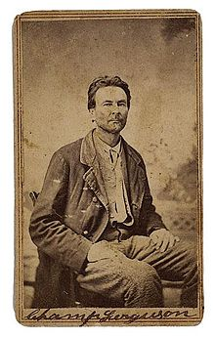
Figure 5. Champ Ferguson (from en.wikipedia.org)

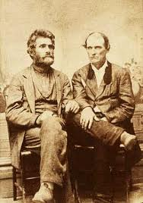
Figure 6. Jonathan Hale and Tinker Dave Beaty (photo provided by the Big South Fork National River and Recreation Area).

Mid-1864-65- U.S. Army began harsh policy of occupation and punished Pro-Confederate supporters of guerrillas by confiscating property, arrests, and burning property. This policy led to less support for guerrillas and much hardship. Also, no-quarter policy for guerrillas was established. U.S. forces, used the loyalty oath to identify Pro-Confederate citizens.

End of War – Some guerrilla activity continued, especially by Champ Ferguson. U.S. offered amnesty to any (except Ferguson) who would surrender. If not, the army would declare them outlaws. Most did surrender, or left the area (to Texas). Ferguson arrested, tried, hanged.

Guerillas Skirmishes and Major Events:

Summer 1861 – Pickett County. Pro-Union citizen (later guerrilla) Elam Huddleston and others recover his confiscated goods from his house. Pursued by cousin Col. Stokely Huddleston, C.S., Tennessee Militia. Col. Huddleston shot and killed and Elam escapes to Kentucky.

November-December 1861 – Champ Ferguson murders William Frogge while sick in bed in Clinton County, Kentucky. Reuben Woods also killed by Ferguson’s men.

January 1862 – Fentress County. Tinker Dave Beaty’s Union Independent Scouts formed.

March 1862 – Overton County. Monroe Compromise to stop guerrilla warfare agreed upon, but soon broken, some say by Champ Ferguson.

March 1862 – Fentress County, Tennessee and Clinton County, Kentucky. Champ Ferguson and gang kill Alexander Huff in Fentress and others in Clinton. John Duncan and John Rick also killed by Confederate guerrillas.

June 1862 – Fentress County. Champ Ferguson and band kill James Zackary.

Summer 1862 – Scott County. Confederate guerrilla raid on homes of Jimmy Slavin, Esquire Blevins, and Hiram Marcum; the latter on Buffalo Creek. Here Julia Marcum fought and killed a guerrilla with an ax. She lost an eye and a finger.

September 1862 – W. Lafayette Allen killed by Union guerrillas at Hale’s Mill, Pickett County. In retaliation, Ferguson’s men burn the mill and nearby houses.

October 1862 – Wayne County, Kentucky. Champ Ferguson and gang killed John Williams and an unnamed enslaved man.

October 1862 – Tinker Dave Beaty’s men raid into Fentress/Pickett and kill Miligan and Henry Richardson.

October/November 1862 – Scott County. Confederate guerrillas raid Parch Corn Creek, No Business Creek, and Buffalo Creek. Attack farms of Mr. Chitwood, Carroll Cross, Dennis Trammel, and James Chitwood, burn houses, steal 103 horses and capture two men that they hanged. At head of Buffalo Creek they skirmish with Union men (7th Tennessee Inf.) under Capt. James Duncan. Four Confederate guerrillas killed.

Late 1862 – John Riley on Wolf River killed by Union guerrillas.

January 1863 – Wayne and Adair County, Kentucky. Champ Ferguson and gang surround and attack house of Elam Huddleston (Adair Co.). Huddleston killed, Elam’s brother Moses and cousin David captured. Ferguson has four men killed in skirmish with Union Home Guard (Wayne Co.).

January 1863 – Ferguson’s gang kills Peter Zackary at home of Rufus Dowdy in Fentress County.

May/June 1863 – Scott County. About 11 Confederate guerrillas under James Rule or Alec Evans, from Rock Creek, Pickett County, raid No Business Creek area. They raid farms of Armpie Blevins, Widow Miller, and Peter Burke. At Peter Burke’s (on Big Branch and Big South Fork) (Figure 7) they were ambushed by 30-50 Union Home Guard, under Tom Miller or Hutson Burke, and nine Confederate guerrillas were killed at the house and another killed or drowns in river.

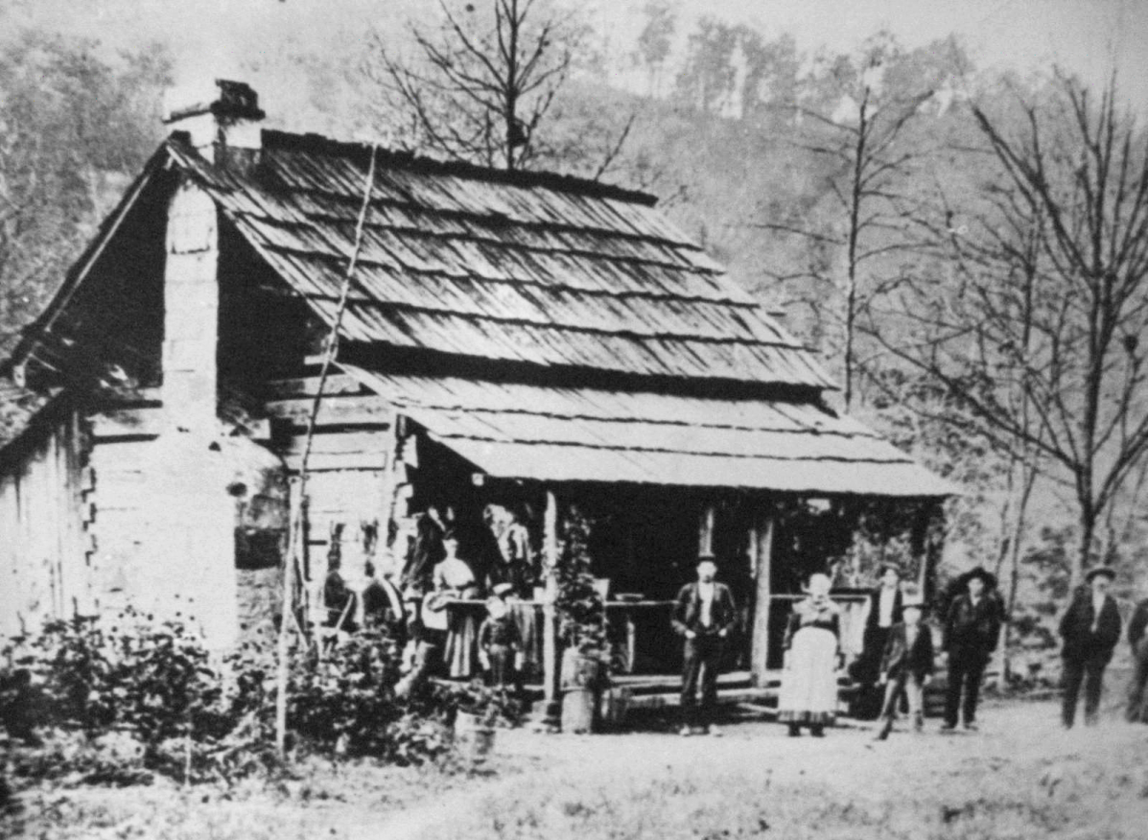
Figure 7. Peter Burke cabin (photo provided by the Big South Fork National River and Recreation Area).
Summer 1863 – Big South Fork area. Tinker Dave Beaty commissioned by Maj. Gen. Burnside to disrupt and spy on Confederate forces.

August-November 1863 – East Tennessee. Most of East Tennessee captured by U.S. Army under Generals Burnside (Knoxville) and Grant (Chattanooga). Union guerrillas go on offensive, but lack of large occupying force lead to continued raiding and killing.

Fall 1863 – Conrad Pile captured and killed by Confederate guerrillas in Fentress County.

September 1863 – Feb 1864 – Wayne and Clinton Counties, Kentucky and surrounding area. Major Confederate and guerrilla raid led by Col. John Hughs, with Capt. Scott Bledsoe and Champ Ferguson, with members of 25th Tennessee Inf. (mounted) and irregulars. They attacked Albany, Glasgow, Monticello, and Scottsville, Kentucky, and Sparta and Livingston, Tennessee. They engaged regular U.S. forces, Kentucky Home Guard, and Tennessee Unionists under Beaty and Rufus Dowdy. Confederates defeated most opponents.

January 1864 – Skirmish between Ferguson’s men and Beaty’s near Forbus. Three of Ferguson’s men killed.

January-February 1864 – Fentress, Overton, White Counties. U.S. Col. William Stokes (5th Tennessee Cav.) and Col. Thomas Harrison (8th Indiana Cavalry) sent to rid the area of Confederate guerrillas. Engaged Col. John Hughs and Champ Ferguson numerous places, often defeated them, but this didn’t end raiding.

January 1864 – East Tennessee. East Tennessee Provost Martial Gen. Samuel P. Carter orders that guerrillas are not to be treated as Prisoners of War (P.O.W.s).

Feb 1864 - East Tennessee Relief Association founded to help fund donations into region from the northern states.

Spring-Summer 1864 – Fountain Frost and Jefferson Pile killed by Beaty’s men near Gilbreath’s Mill, and Three Forks, respectively.

Spring-Summer 1864 – Three U.S. soldiers on leave, George Y. Carpenter, Bruce Martin, and Samuel Huddleston, killed at Poplar Grove and Pickett County.

Summer 1864 – Fentress County. Dave Beaty writes Gov. Andrew Johnson that people in Fentress were starving and livestock gone.

June 1864 – Louisville, Kentucky. Maj. Gen. Wm T. Sherman writes to Maj. Gen. S. G. Burbridge in Kentucky that “guerrillas are not soldiers but wild beasts.”

July 1864 – White, Overton Counties. Maj. Thomas Reeves (4th Tennessee Inf., U.S.) raids Sparta, burns houses, takes livestock, and arrests citizens that won’t inform on Confederate guerrillas. Total war begun by U.S. Army. Pro-Confederate citizens begin to tire of the war and turn against guerrillas.

Winter 1864-1865 – Beaty’s men kill Robert Richardson, who has two sons in the Confederate Army, and a Captain Barton.

April – May 1865 – U.S. Civil War ends and amnesty is given to all Confederate irregulars/guerrillas who will surrender except for Champ Ferguson. Those that fail to surrender will be considered outlaws. Almost all turn themselves in.

April 26 – May 1865 – Fentress County, Clinton County. Champ Ferguson and gang kill Van Duvall and John Hurt in Clinton County, and capture and shoot Dave Beaty in Fentress County, but Beaty escapes.

May 26, 1865 – White County. Champ Ferguson captured. Charged with killing 53 men.

October 20, 1865 – Nashville. Champ Ferguson hanged after trial.

Theme 7. Other Effects on and Responses by Civilians

Persons not in the army or active in guerrilla warfare still participated in the war effort in other ways. Nitre was produced in Upper Cumberland Plateau and shipped to Union troops. A local example is provided by Big South Fork Oral History informant Frona Thompson’s whose grandfather Stevens made gunpowder for the Union. Some people were involved in other clandestine trade and production (transcript on file at Big South Fork National River and Recreation Area).

While women did not join the army, many are known to have contributed their labor as couriers, guides, and spies in other areas of Tennessee, and they may have done so in the Upper Cumberland; these activities hard to document as often were clandestine.
Some local women were involved in violence. The best known example is Julia Marcum (Figure 8), who was from a Pro- Union family from Buffalo Creek, Scott County, Tennessee. When Confederate guerrillas broke in and attacked, 16 year old Julia in the summer of 1862, she defended herself with an ax and killed the attacker. But the attackers shot off her finger and stabbed her in the eye with a bayonet. Two years later, her house was burned down. Wives often ran the farms and businesses while their husbands were gone.

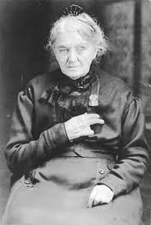
Figure 8. Julia Marcum
(note missing finger and eye)
(photo provided by the Big
South Fork National River
and Recreation Area).

Pro-Union Mary Catherine Sproul, from Overton County, provided documentation of the effects of the Civil War in her personal diary. Likely there are other such examples.

Children are known to have acted as lookouts, and to help hide livestock. Big South Fork Oral History informants Frona Thompson recalled that her mother served as lookout for Confederate guerrillas when she was a young girl. Informant Will Miller told the story of his grandfather France Miller (born in 1856) serving as a lookout for Confederate guerrillas on No Business. He also recalled that during the 1863 raid on Duck Shoals, France Miller was instructed by his father to hide the family livestock. The hiding of livestock was also mentioned by Big South Fork Oral History informants Oscar Blevins and Kirby King (transcripts of these interviews on file at Big South Fork National River and Recreation Area).

Civilians experience other hardships, such as
- the disruption of governmental services, church services, and other community events.
- general breakdown of the social and political structure of society, physical damage to farms and houses.
- disruptions in trade and transportation making if difficult to secure exotics such as sugar and coffe.
- and enhanced rivalries between families.

Some blacks killed by guerrillas, some participate in guerrilla activity. There is little documentation on this, however.

The following quote by Rev. A. B. Wright gives a good description of life in the Upper Cumberland Plateau during the Civil War –

“During four years the country was in the throes of an awful strife. Civil courts were suspended in Tennessee. Anarchy prevailed everywhere. Post offices and post-roads were abandoned. No stores were kept…all kinds of merchandise were things of the past. Pastors abandoned their churches…many homes on both sides, during this dreadful war, were burned in our section.”

Theme 8. The End of Slavery

Relatively few African-Americans lived in Upper Cumberland area before the Civil War, but most were slaves. While the Emancipation Proclamation of Jan 1, 1863 freed all enslaved people in the Confederate states, the practical effects of this are not known in the Tennessee part of the study area, but it is likely that many were freed after the Knoxville Campaign, when the area came under Union control.

Kentucky slaves still enslaved. Some Kentucky slaves freed during and after spring 1864 by joining the U.S. Army at Camp Nelson and other U.S. Colored Troop enlistment stations. The wives and children of the U.S.C.T. in Kentucky were emancipated after the March 3, 1865 Congressional Act. The rest had to await the 13th Amendment of Dec. 1865.

Tennessee (under military government) ratified the 13th Amendment but Kentucky did not ratify it. Kentucky finally ratified this amendment during the U.S. Bicentennial of 1976.

Theme 9. Post-War, Long Term Effects

Loss of life, and wounds.

Emancipation of African-American slaves and exodus of many African-Americans from the region (see Tables 3 and 4).

Animosity between families, general hard feelings.

Much destruction of property, reduction in wealth and agricultural productivity (see Tables 5 to 8). Freedmen’s Bureau distributed food to whites and blacks, but overall less presence in the Upper Cumberland than in areas with heavier black populations.

Different interpretations of the War, eventual dominance of the “Lost Cause” narrative, or “myth”, which denied the role of slavery in secession and emphasized “States’ Rights”, individual valor in battle, and the correctness of the Southern “cause and institutions.” This narrative led to “forgetting” the Unionist stance of the Upper Cumberland Plateau.

The below quote from naturalist John Muir, who walked through the area in 1867, is very informative.
“Passed the poor, rickety, thrice-dead village of Jamestown, an incredibly dreary place. Toward the top of the Cumberland grade, about two hours before sundown I came to a log house, and as I had been warned that all the broad plateau of the range for forty or fifty miles was desolate, I began thus early to seek a lodging for the night. Knocking at the door, a motherly old lady replied to my request for supper and bed and breakfast, that I was welcome to the best she had, provided that I had the necessary change to pay my bill. When I told her that unfortunately I had nothing smaller than a five-dollar greenback, she said, "Well, I'm sorry, but cannot afford to keep you. Not long ago ten soldiers came across from North Carolina, and in the morning they offered a greenback that I couldn't change, and so I got nothing for keeping them, which I was ill able to afford." "Very well," I said, "I'm glad you spoke of this beforehand, for I would rather go hungry than impose on your hospitality."
As I turned to leave, after bidding her good-bye, she, evidently pitying me for my tired looks, called me back and asked me if I would like a drink of milk. This I gladly accepted, thinking that perhaps I might not be successful in getting any other nourishment for a day or two. Then I inquired whether there were any more houses on the road, nearer than North Carolina, forty or fifty miles away. "Yes," she said, "it's only two miles to the next house, but beyond that there are no houses that I know of except empty ones whose owners have been killed or driven away during the war."

Table 3. Population figures from federal census, population schedules (data from http://mapserver.lib.virginia.edu/collections/).
 | 1860 |  |  |  |  | 1870 |  |  |  | 1880
 | Whites | Slaves | Free  Black | Total |  | White | Col’rd | Total |  | White | Col’rd | Total
Wayne | 9,244 | 987 | 28 | 10,259 |  | 9,927 | 675 | 10,602 |  | 11,613 | 899 | 12,512
Whitley | 7,553 | 183 | 26 | 7,762 |  | 8,140 | 138 | 8,278 |  | 11,752 | 237 | 12,000
Pulaski | 15,819 | 1,330 | 52 | 17,201 |  | 16,595 | 1,075 | 17,670 |  | 20,122 | 1,196 | 21,318
Fentress | 4,865 | 187 | 2 | 5,054 |  | 4,547 | 170 | 4,717 |  | 5,838 | 103 | 5,941
Morgan | 3,192 | 120 | 41 | 3,353 |  | 2,868 | 101 | 2,969 |  | 4,867 | 289 | 5,156
Scott | 3,446 | 59 | 14 | 3,519 |  | 4,015 | 39 | 4,054 |  | 5,864 | 157 | 6,021
Overton | 11,452 | 1,087 | 98 | 12,637 |  | 10,747 | 550 | 11,297 |  | 11,811 | 342 | 12,153

Table 4. Population Change, 1860 to 1870 (data from http://mapserver.lib.virginia.edu/collections/).
 | White | Black
Wayne | +7.4% | -33.5%
Whitley | +7.8% | -34.0%
Pulaski | +4.9% | -22.2%
Fentress | -6.5% | -10.1%
Morgan | -10.2% | -37.3%
Scott | +16.5% | -46.6%
Overton | -6.2% | -53.6%

Table 5. Property Values, Real and Personal, for 1860 and 1870 (data from http://mapserver.lib.virginia.edu/collections/).
 | 1860 | 1870 | % change
Wayne | 3,866,920 | 1,414,585 | -63.5
Whitley | 1,414,915 | 988,852 | -30.1
Pulaski | 4,830,251 | 2,258,090 | -53.3
Fentress | 1,163,347 | 362,029 | -70.9
Morgan | 890,775 | 258,846 | -70.9
Scott | 625,943 | 252,671 | -59.6
Overton | 4,125,502 | 1,097,725 | -73.4

Table 6. Farm and farm values from federal censuses of agriculture (data from http://mapserver.lib.virginia.edu/collections/).
 | Number farms |  |  | Value ($) of farms |  |  | Value ($) per farm
 | 1860 | 1870 |  | 1860 | 1870 |  | 1860 | 1870 | %change
Wayne | 795 | 1525 |  | 1,929,375 | 1,198,460 |  | 2426.9 | 785.9 | -67.6%
Whitley | 766 | 1373 |  | 338,607 | 685,940 |  | 442.0 | 499.6 | +13.0%
Pulaski | 1779 | 2690 |  | 2,032,640 | 1,773,628 |  | 1142.6 | 659.3 | -42.3
Fentress | 607 | 646 |  | 501,776 | 527,275 |  | 826.6 | 816.2 | -1.3%
Morgan | 402 | 394 |  | 501,805 | 263,952 |  | 1248.2 | 669.9 | -46.3%
Scott | 278 | 621 |  | 203,910 | 298,248 |  | 733.5 | 480.3 | -34.5%
Overton | 928 | 1828 |  | 1,653,886 | 1,357,263 |  | 1782.2 | 742.5 | -58.3

Table 7. Livestock values, from federal census, agricultural schedules (data from http://mapserver.lib.virginia.edu/collections/).
 | Value Livestock ($) |  | Livestock Value ($) per Farm
 | 1860 | 1870 | 1860 | 1870 | % Change  1860 to 1870
Wayne | 460,443 | 539,209 | 579.2 | 353.6 | -39.0%
Whitley | 257,375 | 342,663 | 336.0 | 249.6 | -25.7%
Pulaski | 675,750 | 800,918 | 379.8 | 279.7 | -26.4
Fentress | 246,675 | 194,839 | 406.4 | 301.6 | -25.8%
Morgan | 141,205 | 133,759 | 351.3 | 339.5 | -3.4%
Scott | 109,188 | 176,947 | 392.8 | 284.9 | -27.5%
Overton | 480,891 | 570,079 | 518.2 | 311.9 | -39.2

Table 8. Improved acreage, from federal census, agricultural schedules (data from http://mapserver.lib.virginia.edu/collections/).
 | Improved Acres |  | Improved Acres Per Farm
 | 1860 | 1870 | 1860 | 1870 | % Change  1860 to 1870
Wayne | 78,620 | 94,380 | 98.9 | 61.89 | -37.4%
Whitley | 40,495 | 58,464 | 52.9 | 42.6 | -19.5%
Pulaski | 108,828 | 128,307 | 61.2 | 47.7 | -22.1%
Fentress | 34,846 | 29,059 | 57.4 | 45.0 | -21.6%
Morgan | 17,702 | 12,248 | 44.0 | 31.1 | -29.3%
Scott | 13,409 | 20,682 | 48.2 | 33.3 | -30.9%
Overton | 73,436 | 82,963 | 79.1 | 45.4 | -42.6%

Resources on the Civil War in the Cumberland Plateau

Published Resources

Arnow, Harriett Simpson
1977 Old Burnside. University Press of Kentucky, Lexington.

Baggett, James Alex
2009 Homegrown Yankees: Tennessee’s Union Cavalry in the Civil War. Louisiana State University Press, Baton Rouge.

Brents, J. A.
1863 The Patriots and Guerillas of East Tennessee and Kentucky. Published by the author, reprinted by Lulu Press in 2011.

n.d. The Veterans of Pickett County. For sale at Pickett County Library, phone 931-864-6281.

Campbell, Mary E. R.
1961 The Attitude of Tennesseans Toward the Union, 1847-1861. Vantage Press, New York.

Civil War Centennial Commission
1964 Tennesseans In the Civil War: A Military History of Confederate and Union Units with Available Rosters of Personnel. Civil War Centennial Commission, Nashville, Tennessee.

Cooling, B. Franklin
1999 A People’s War: Partisan Conflict in Tennessee and Kentucky. In Guerrillas, Unionists, and Violence on the Confederate Home Front, edited by Daniel E. Sutherland, The University of Arkansas Press, Fayetteville, pp. 89-113-132.

Davis, George B., Leslie J. Perry, and Joseph W. Kirkley
1983 Atlas to Accompany the Official Records of the Union and Confederate Armies. Gramercy Books, New York. Originally published 1891-1895, Government Printing Office, Washington, D.C.

Des, Jean, Tom and Nicholas Herrmann
2011 Civil War Effects on the Home Front: Scott County and Areas of the Upper Cumberland Plateau. Big South Fork National River and Recreation Area, Oneida, Tennessee.

Dickinson, W. Calvin
1987 Morgan County. Memphis State University Press, Memphis, Tennessee.

Dollar, Kent T., Larry H. Whiteaker, and W. Calvin Dickinson
2009 Sister States Enemy States: The Civil War in Kentucky and Tennessee. The University Press of Kentucky, Lexington.

Ellis, Daniel
1867 The Thrilling Adventures of Daniel Ellis: The Great Union Guide of East Tennessee for a Period of Nearly Four Years During the Great Southern Rebellion. Harper and Brothers, Publishers, New York, New York.

Fisher, Noel C.
1999 Definitions of Victory: East Tennessee Unionists in the Civil War and Reconstruction. In Guerrillas, Unionists, and Violence on the Confederate Home Front, edited by Daniel E. Sutherland, The University of Arkansas Press, Fayetteville, pp. 89-111.

1997 War at Every Door: Partisan Politics and Guerrilla Violence in East Tennessee, 1860-1869. The University of North Carolina Press, Chapel Hill.

Fowler, John D.
2009 “We can never live in a southern confederacy”: The Civil War in East Tennessee. In
Sister States Enemy States: The Civil War in Kentucky and Tennessee, edited by Kent T. Dollar, Larry H. Whiteaker, and W. Calvin Dickinson, The University Press of Kentucky, Lexington, pp. 97-119.

Freehling, William H.
2007 The Road to Disunion, Volume 11: Secessionists Triumphant, 1854-1861. Oxford University Press, New York, New York.

Freytag, Ethel and Glena Kreis Ott
1970 A History of Morgan County, Tennessee. Specialty Printing Company.

Hafendorfer, Kenneth
2001 Mill Springs: Battle and campaign of Mill Springs, Kentucky. KH Press, Lexington, Kentucky.

Hancock, R. R.
1887 A History of the Second Tennessee Confederate Cavalry with Sketches of First and Second Battalions. In Freytag and Ott, A History of Morgan County, Tennessee, Specialty Printing Company, Reprinted 1970.

Hess, Earl
2012 The Knoxville Campaign: Burnside and Longstreet in East Tennessee. The University of Tennessee Press, Knoxville.

Hogue, Albert R.
1916 History of Fentress County Tennessee. Reprinted in 1979 by Regional Publishing Company, Baltimore, Maryland.

Huddleston, Tim
1973 History of Pickett County. The College Press, Collegedale, Tennessee.

Loewen, James W. and Edward H. Sebesta, editors
2010 The Confederate and Neo-Confederate Reader: The “Great Truth” about the “Lost Cause.” The University Press of Mississippi, Jackson.

McBride, Kim A. and W. Stephen McBride
2000 Big South Fork Historic Context Study. Technical Report No. 412, Program for Archaeological Research, University of Kentucky. Submitted to Big South Fork National River and Recreation Area, Oneida, Tennessee.

McKenzie, Robert T.
1994 One South or Many? Plantation and Up Country Civil War Era Tennessee. Cambridge University Press, New York.

McKnight, Brian
2011 Confederate Outlaw: Champ Ferguson and the Civil War in Appalachia. Louisiana State University Press, Baton Rouge.

2009 “Time by the forelock”: Champ Ferguson and the Borderland Style of Warfare. In Sister States Enemy States: The Civil War in Kentucky and Tennessee, edited by Kent T. Dollar, Larry H. Whiteaker, and W. Calvin Dickinson, The University Press of Kentucky, Lexington, pp. 140-167.

2006 Contested Borderland: The Civil War in Appalachian Kentucky and Virginia. University Press of Kentucky, Lexington.

McPherson, James M.
1988 Battle Cry of Freedom: The Civil War Era. Oxford University Press, New York, New York.

Mays, Thomas D.
2008 Cumberland Blood: Champ Ferguson’s Civil War. Southern Illinois University Press, Carbondale.

O’Brien, Sean M.
1999 Mountain Partisans: Guerilla Warfare in the Southern Appalachians, 1861-65. Praeger Publications, Westport, Connecticut.

O’Neal, Michael R.
1986 The Civil War on the Cumberland Plateau in Tennessee. Scott County Historical Society Newsletter, Huntsville, Tennessee. Also online at http://www.tngenweb.org/Scott/fnb_vTn3_the_civil_war.htm.

Perry, L. E.
1979 Mcreary Conquest, A Narrative History. Whitley City, Kentucky.

Perry, Samuel D.
2003 South Fork Country. Published by the author.

Phillips, Jean
1904 Reminiscence of Pioneer Days in Scott County, Tennessee. Originally published in the Cumberland Chronicles, Spring 1904, now available at http://joepayne.org/remini.htm

Roy, Paul
2001 Scott County in the Civil War. Scott County Historical Society, Huntsville, Tennessee.

Sanderson, Esther Sharp
1974 Scott County, Gem of the Cumberlands. Published by the author, Huntsville, Tennessee.

Sensing, Thurman
1942 Champ Ferguson, Confederate Guerilla. Vanderbilt University Press, Nashville, Tennessee.

Seymour, Digby Gordon
1982 Divided Loyalties: Fort Sanders and the Civil War in East Tennessee. The East Tennessee Historical Society, Knoxville.

Smith, H. Clay
1985 Dusty Bits of the Forgotten Past: A History of Scott County. Scott County Historical Society, Huntsville, Tennessee.

Sproul, Mary Catherine
1950 Writings of a Tennessee Unionist. Tennessee Historical Quarterly 9.

Stephens, Robert E.
2002 A Lost Heritage for a Changing People: McCreary County, Kentucky. McDowell Publications, Utica, New York.

Summer, H. W.
1917 History of Morgan County. Series in the newspaper Morgan County Press, running July to September 1917.

Sutherland, Daniel E., editor
1999 Guerrillas, Unionists and Violence on the Confederate Home Front. The University of Arkansas Press, Fayetteville.

Tarrant, Sergeant E.
1894 The Wild Riders of the First Kentucky Cavalry: A History of the Regiment in the Great War of the Rebellion 1861-1865. Originally published in 1894 and reprinted in 1997 by Genesis Publishing Company, West Jefferson, Ohio.

Tuttle, John W.
n.d. Diary of John W. Tuttle, Monticello, Kentucky. Has data on local sentiments regarding the Civil War, Manuscript at Kentucky Historical Society Frankfort, Spiral bound typescript made available in 2010 from this website: http://harlanogleky.tripod.com/waynecountymuseum/id31.html

Welcher, Frank J.
1993 The Union Army 1861-1865: Organization and Operations. Volume II: The Western Theater. Indiana University Press, Bloomington.

Wright, Rev. A. B.
1896 Autobiography of Rev. A. B. Wright of Holston Conference, M.E. Church. Prepared by his son, Rev. J. C. Wright. Cranston and Curts, Cincinnati, Ohio.

Online Resources.

The Battle for the Bacon, http://tngenweb.org/Scott/battle_for_the_bacon.htm

Big South Fork Country:Historic Sites/Civil War.
http://bigsouthforkcountry.com/historic.html

Borderlands website:
http://www.the borderlands.org.
This site has articles on Hales Mill, Travisville, Stokely, Tinker Dave Beaty, the Monroe Compromise, Camp Myers, Camp Zollicoffer, Pickett County Civil War veterans, a map of Civil War sites in Pickett, Fentress, and Overton Counties.

Census data, accessed via this online source, in 2011 and 2012.
Historical Census Browser.
2004 The University of Virginia, Geospatial and Statistical Data Center. http://mapserver.lib.virginia.edu/collections/

Dalton, Myrtle
1939 History of the Bertram family. Available at http://www.rootsweb.ancestry.com/~kywayne/bertram_history.html

Phillips, Jean
1904 Reminiscence of Pioneer Days in Scott County, Tennessee. Originally published in the Cumberland Chronicles, Spring 1904, now available at http://joepayne.org/remini.htm

Tennesseans in the Civil War. http://www.tngenweb.org/cgi-bin/tn_units.cgi

Tuttle, John W.
n.d. Diary of John W. Tuttle, Monticello, Kentucky. Has data on local sentiments regarding the Civil War, Manuscript at Kentucky Historical Society Frankfort, Spiral bound typescript made available in 2010 from this website: http://harlanogleky.tripod.com/waynecountymuseum/id31.html

Oral Histories

Oral History interviews with Oscar Blevins, Kirby King, Will Miller, and Frona Thompson were mentioned in the above guide. These and others are available at the Cultural Resources office of the Big South Fork National River and Recreation Area, Oneida, Tennessee.

