National Park Service
U.S. Department of the Interior

Amphibians of the Swamp...
Amphibians are animals that live a portion of their life in water. Some, like sirens, live their entire life in water. While the word “moist” may carry a negative connotation to some humans, most frogs and toads rely on keeping their skin moist to survive.

Drums in the Night
Start a walk in the swamp at dusk and imagine listening to a symphony orchestra commence a soft prelude with the timpani drums beating with every step. As the sunlight dims, the music crescendos transitioning into the swamp’s own symphony of croaking. Seemingly on cue, males searching for a mate call out for females, veiled from predators in the darkness. Females hear the male serenades with their tympanum, the frog or toad’s outer ear located behind the eye. Amphibians use this tympanum, an ancient word in Greek meaning drum, because it resembles a piece of cloth stretched over a drum.
Big Cypress National Preserve Florida

Big Cypress Amphibians

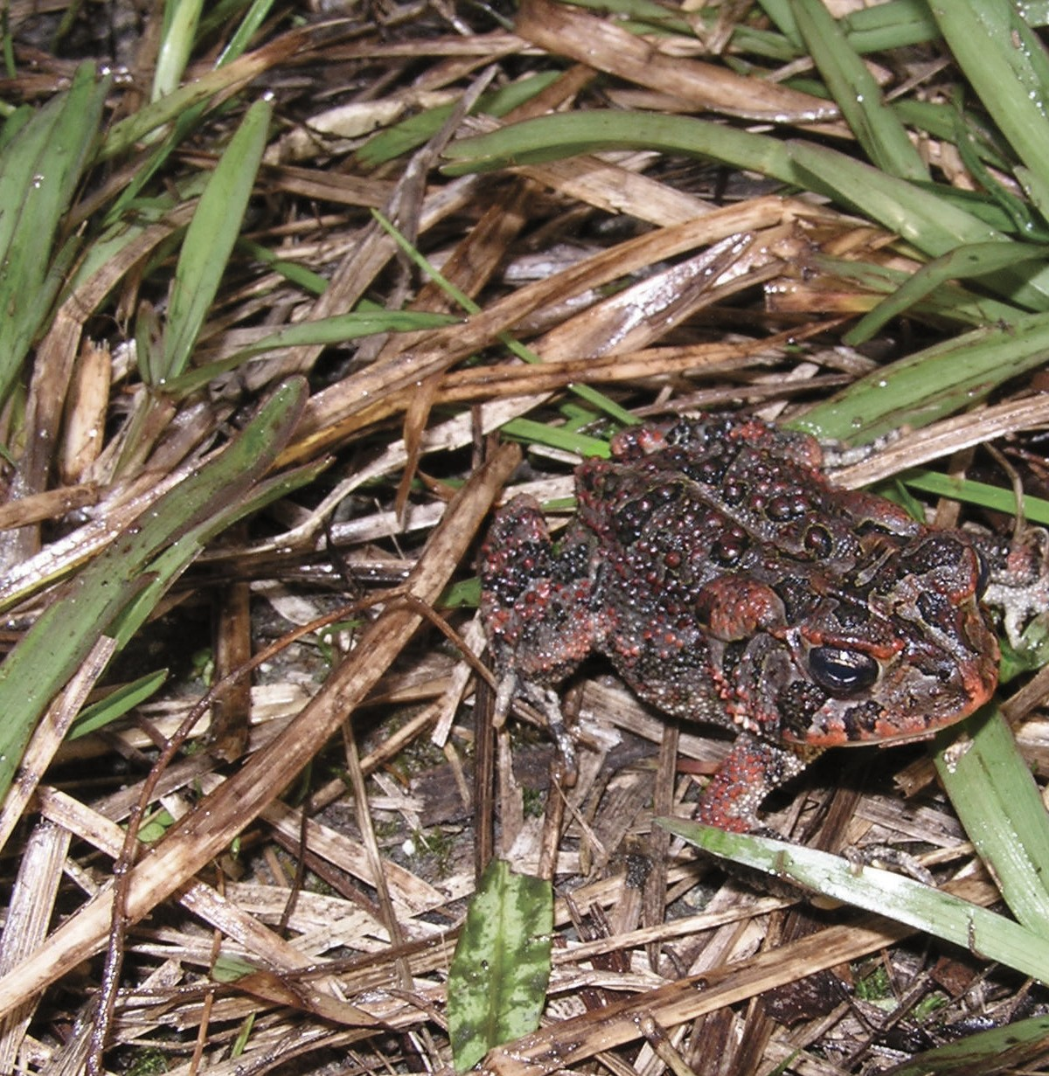
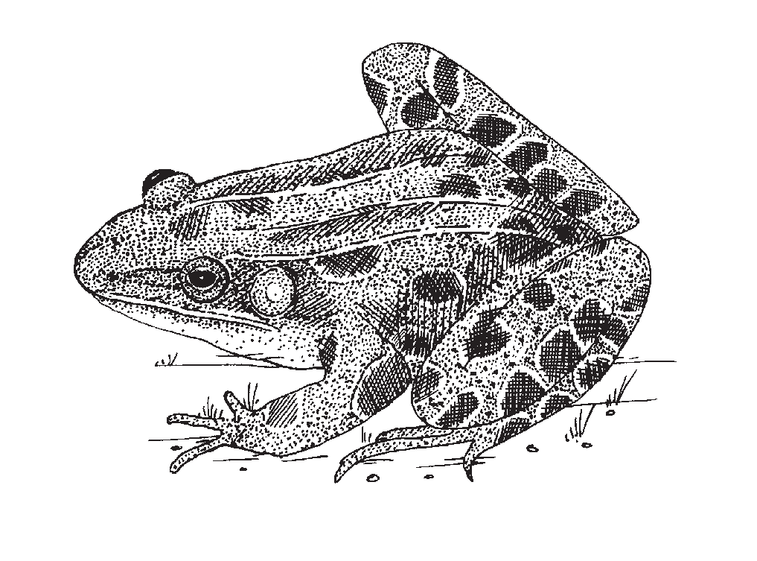

Tympanum
Watching wildlife the responsible way...
The thrill of watching a wild animal in its natural surroundings is spectacular and awe-inspiring, but please remember, you are the guest and they are at home.

While visiting Big Cypress National Preserve, or any other natural area, remember:

- Never feed wildlife.
- View wildlife with respect.
- All wildlife is wild and unpredictable. Stay a safe distance from any wild animal
—15 feet is recommended.
- All plants and animals within National Park Service areas are protected, and it is illegal to collect any wildlife without special permits.
Cover photo: southern toad, NPS/JAN SHIREY

The tympanum of this Southern leopard frog is identified here. The Southern leopard frog can be distinguished because it has a yellow spot in the center of its tympanum.
EXPERIENCE YOUR AMERICA!
How You Behave Can Save
Do Not Feed or
Harass Wildlife
t
P
i
o
—
n
e
v
a
r
l
e
s
P
e
r
r
P
e
s
e
r
v
e
B
i
g
C
y
y
o
j
p
n
r
E
e
—
s
t
s
c
e
N
t
o
a
r

Narrow-mouthed Toads
Scientific Name

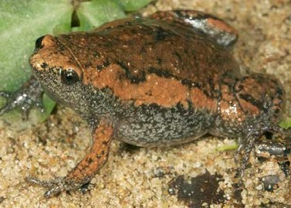
Top to bottom: Eastern narrow-

Eastern narrow-mouthed toad Gastrophryne carolinensis

Toads
Giant, marine, or cane toad* Bufo marinus
Oak toad Bufo quercicus
Southern toad Bufo terrestris

Treefrogs & Chorus Frogs
Barking treefrog Hyla gratiosa
Cuban treefrog* Osteopilus septentrionalis
Florida cricket frog Acris gryllus dorsalis
Green treefrog Hyla cinerea
Greenhouse frog Eleutherodactylus planirostris
Little grass frog Pseudacris ocularis
Southern chorus frog Pseudacris nigrita
Squirrel treefrog Hyla squirella

True Frogs
Pig frog Rana grylio
Southern leopard frog Rana sphenocephala
mouthed toad; Southern leopard frog, one of the larger frogs of the swamp–only the pig frog is larger; barking treefrog.
NPS/TODD PIERSON

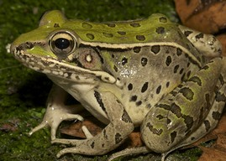
Amphibians tend to be highly sensitive to environmental changes, for that reason scientists often use them to determine the overall health of an area.

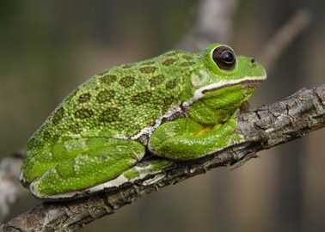
Aquatic Salamanders
Everglades dwarf siren Pseudobranchus axanthus belli
Greater siren Siren lacertina
Two-toed amphiuma Amphiuma means

Newts
Peninsula newt Notophthalmus viridescens piaropicola

* = invasive species

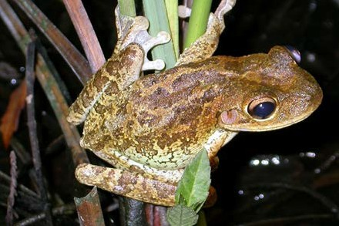
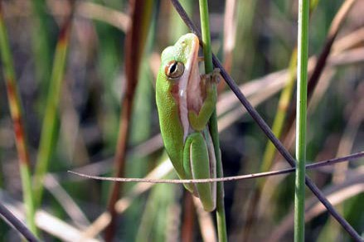
Left: Cuban treefrog, an introduced species that has spread rapidly in Florida. These frogs disrupt the ecosystem because they eat smaller native tree frogs. The native green treefrog (right) can change to brown coloring, thereby confusing identification.
However, the Cuban treefrog has extra large toe pads and much wartier skin than natives. It also has a skin fold starting from the eye towards the tympanum.
NPS/Hardin Waddle, PhD

Amphibian Checklist_FINAL.indd on HQ shareall, interp publications, 2,000 printed, 10/2011, stored at Oasis and WC

