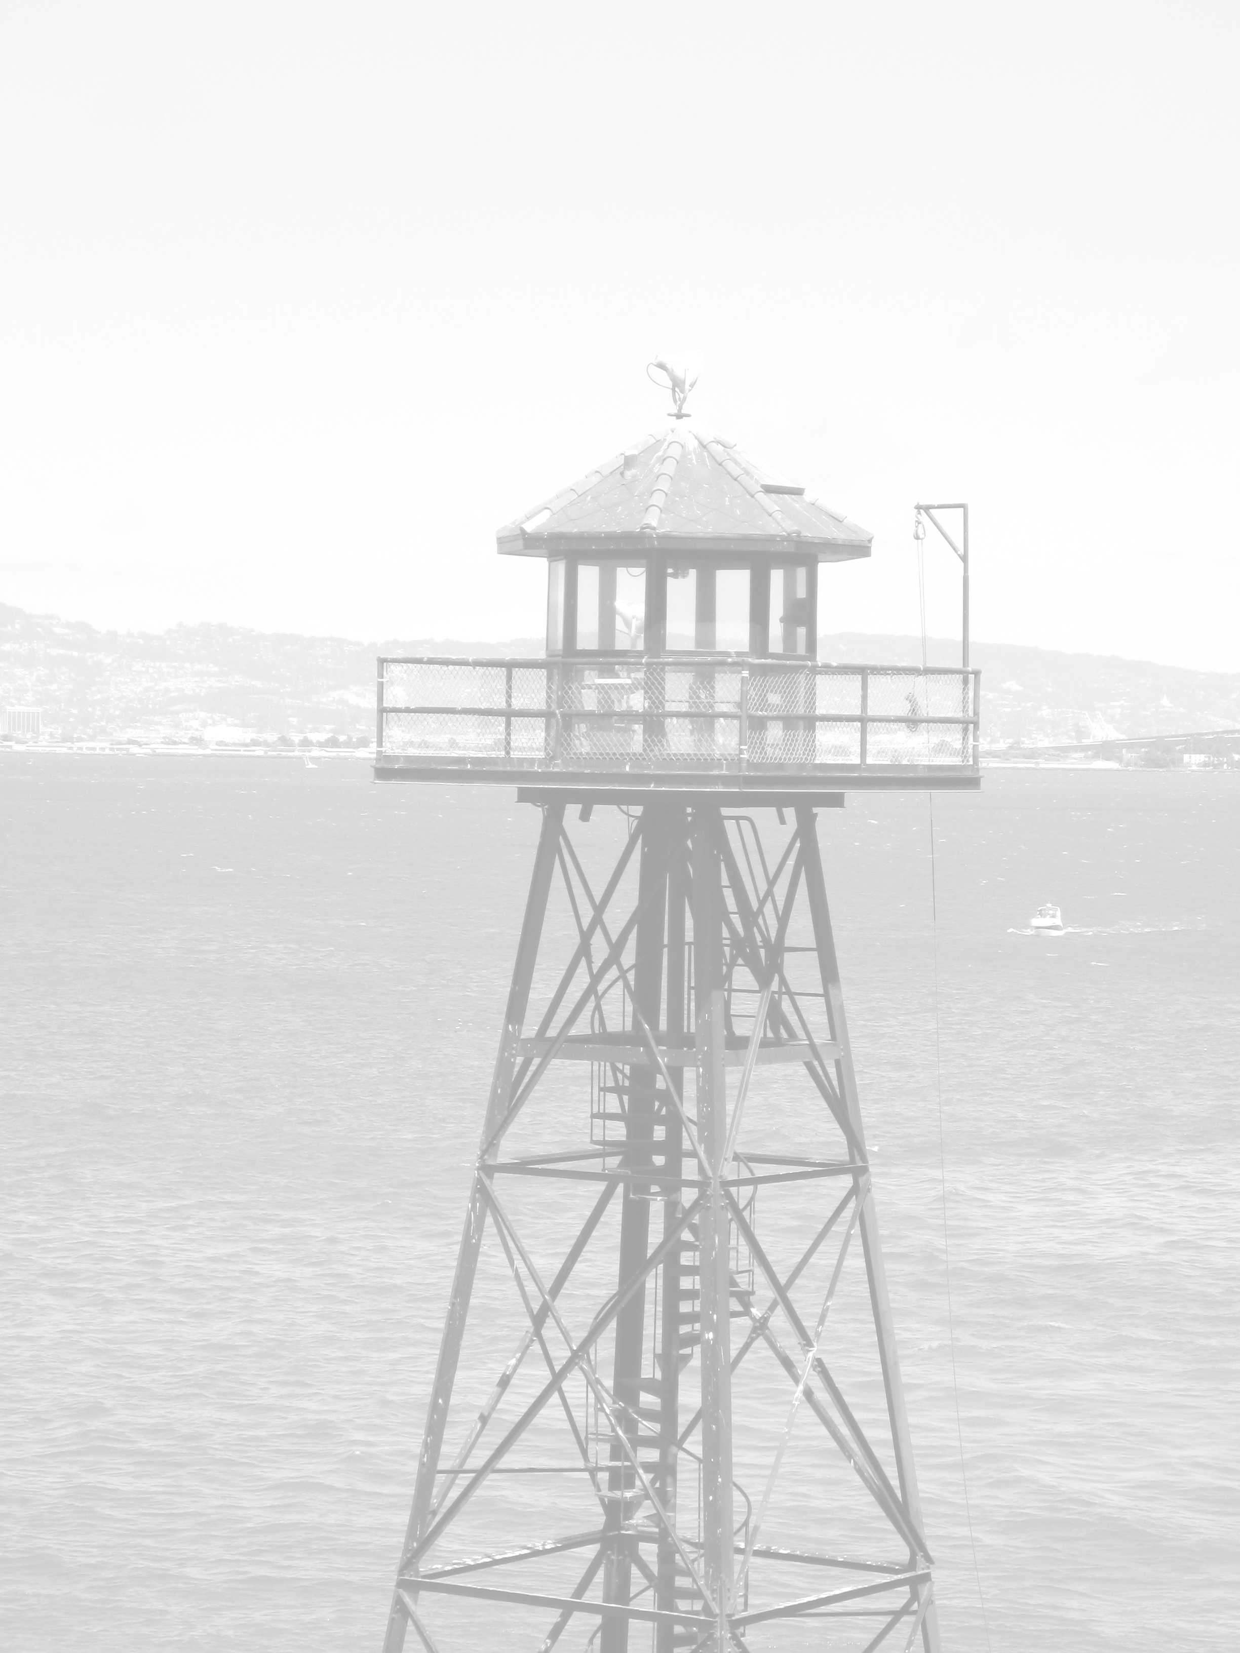
The Secrets of Alcatraz - A GPS Tour of the Rock
(Please stay on the concrete walkway)

Australian Tea Tree - N37° 49.631/W122° 25.336’ - The tree at the entrance to the tunnel is one of the oldest trees on the island - close to 100 years old.

1962 Escape Route – N37° 49.666/W122° 25.411’ – Three inmates that escaped on June 11, 1962 walked past this point after climbing down from the water tower area. Their footprints lead across the road, past the northwest end of the Officers Club, down the hill, and into the Bay. They were never seen again.

Escape from the Industries – N37° 49.675/W122° 25.498’ – In 1938, three inmates tried to escape from this three story building. After killing a correctional officer inside, they climbed to the roof and attacked the guard tower (no longer there). One of the three was shot and killed by the guard inside the tower.

First Prison – N37° 49.640/W122° 25.370’ – The brick foundation under the Electric Shop once supported the first wooden prison on Alcatraz built in 1863.

Hospital Road – N37° 49.624/W122° 25.359’– The road with the chain across the entrance once led to the twelve bed Alcatraz Army Hospital built in 1882.

Guard Cage – N37° 49.645/W22° 25.406’ – The “cage” on the wall to the left of the water tower was a shelter for correctional officers patrolling the recreation yard.

Coal Shute – N37° 49.606/W122° 25.347’ – The arc shaped patterns in the road (next to the wall) were coal chutes that led to the basements of Army Officers’ homes. Foundations of the three homes are still visible below. After the homes were removed in 1941 the foundations were used as flower beds, tended by inmates.

Citadel Door – N37° 49.595/W122° 25.334’ – Look up! The large granite portico that leads into the cellhouse above used to be part of a fort that was built there in 1859. The pulleys, still visible on either side of the top, held chains supporting a drawbridge which spanned a moat surrounding the fort.

Lighthouse Quarters Foundation – N37° 49.563/W122° 25.329’ – The adjacent semi-circular foundation use to support a two story Victorian duplex that housed the lighthouse keepers and their families. The homes burned in an arson fire in June of 1970, along with the Warden’s residence next door.

Old Sewer System – N37° 49.570/W122° 25.362’– Part of the brick sewer system that served the 1859 fort is still visible in the road surface. It eventually led into the Bay.

Tool Shed - N37° 49.585/W122° 25.401’ - This tool shed was built and used by inmate gardeners, who were responsible for planting many of the ornamental flowers, shrubs and trees in this area.

1939 Escape – N37° 49.594/W122° 25.424 - On January 13th, 1939, five inmates escaped and climbed down the steep cliff to the small beach below. One of the five, Doc Barker, refused to surrender and was shot and killed as he swam towards San Francisco. The rest were captured and returned to the cellhouse.

Green House – N37° 49.605/W122° 25.433’ - The foundation visible on the bay side was part of a green house built and used by inmate gardener, Elliot Michner. He eventually completed his sentence and got a job working in a nursery. Also, notice the apple and fig trees next to the sidewalk, which still produce fruit.

Metal Detector – N37° 49.619/W122° 25.444’ – This small building once housed a metal detector that inmates had to pass through when going from the industries building to the cell house.

