
Tour Guide and Commercial Driver’s

Manual
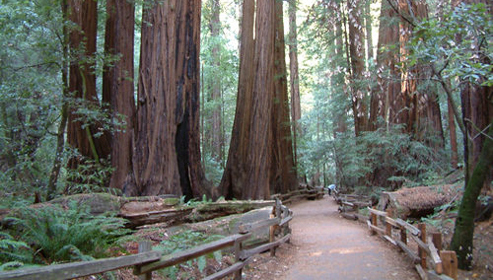
Muir Woods National Monument
Mill Valley, CA 94941-2696

415-388-2596 (Information)
415-388-2595 (Nature Hotline)
415-388-7368 (Fee Collection)
415-388-7059 (Muir Woods Trading Co.)

www.nps.gov/muwo
Twitter: @MuirWoodsNPS

TABLE OF CONTENTS

WELCOME! 2

SELF QUIZ 3, 5, 7, 9, 11 ,1 3, 15 ,1 7, 19 ,21, 23, 25, 27, 29

GENERAL REGULATIONS 4

ENTRANCE FEE 6

VISITOR SERVICES 8

VISITOR GUIDELINES 10

ADMINISTRATION OF THE PARK 12

MUIR WOODS HISTORY 14

REDWOOD ECOLOGY 16, 18

OFTEN ASKED QUESTIONS 20, 22, 24, 26

MUIR WOODS MAIN TRAIL MAP 28

SUGGESTED READINGS 30

MUIR WOODS COMMERICAL CARRIER LOT GUIDELINES 31



WELCOME!

You are an important part of the Muir Woods Team and play a key role in visitor experiences. Each visitor and each partnership contributes to the park’s future legacy. Thank you for your good work in this park.
Included in this manual are some general rules to help ensure everyone has an enjoyable visit while the natural resources of the park are preserved. Also included is information about this old growth grove of redwoods and the history of Muir Woods. | 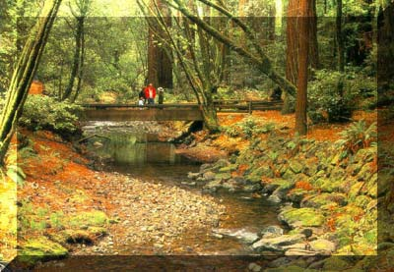

Your cooperation is essential to the management of our traffic and parking congestion. The rules were established to achieve equitable parking and a safe flow of traffic. Obeying the rules is important all the time, but especially during the critical heavy visitation periods of summer, weekends and holidays. Your courtesy and support set a positive example for Muir Woods visitors.

Parking at Muir Woods is very limited. Visiting the park prior to 9:30 am or after 3:00 pm mid-week increases your chances of finding a parking stall and enhances the tour for your passengers. Your Commercial Use Authorization (CUA) does not guarantee you a parking stall. Please respect the loading/unloading zone so that it is available for all. When the Muir Woods Shuttle is operating, the first and second stalls are designated as shuttle stops, a third stall is available for drop-offs.

SELF QUIZ

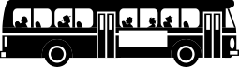

What are the peak visiting hours and days at Muir Woods?
GENERAL REGULATIONS

- Commercial carriers entering the park more frequently than one time per month are required to obtain a Golden Gate National Recreation Area Commercial Use Authorization (CUA). Commercial operation in the park without a CUA is prohibited and subject to citation. For more information please call the Business Management Division at 415-561-4948 or visit http://www.nps.gov/goga/learn/management/cua.htm

- The California Highway Patrol regulates Highway 1 and Muir Woods Road and does not advise commercial vehicles longer than 35 feet. Vehicles longer than 35 feet are prohibited from entering Muir Woods’ parking lots. Violators are subject to citation.

- In order to ensure safety on narrow roads and to minimize congestion, commercial tour carriers should drive into Muir Woods National Monument via upper Muir Woods Road and exit the Monument using the lower Muir Woods Road, via a right turn out of the parking lot toward Muir Beach.

- Please be courteous to other drivers on these narrow and crowded roads. When there are more than four vehicles behind you, pull over into the first pull out you come to and allow them to pass.

- Refrain from using public address systems or loudspeakers in Open-Top Commercial Carriers while in the parking lot and within lands managed and administered by GGNRA.

- Vehicle engines shall not idle while parked in any park area and must be turned off prior to passengers disembarking. Engine idling for more than 30 seconds in any park area is prohibited and subject to citation.

- Commercial carriers between 17 and 35 feet may park only in designated commercial carrier stalls. If all spaces are occupied, safely unload passengers in the commercial carrier loading zone. You may distribute tickets there and orient passengers to Muir Woods, then take vehicle down lower Muir Woods Rd and wait until group is finished.

- Commercial carriers 17 feet in length or less may only park in designated stalls in the Main Parking Lot or in the Conlon Avenue parking area. Access to Conlon Avenue for commercial carrier parking is subject to change at any time. Commercial carriers 17 feet in length or less are prohibited from parking in public stalls and stalls designated for those greater than 17 ft in length unless otherwise instructed by Law Enforcement.

- Commercial carrier parking in the Annex Lot is prohibited.

- Please review park regulations with passengers prior to their departure from the vehicle. Make particular emphasis on no smoking, no collecting of leaves, cones, or other park resources, and the importance of staying on the paths. Please also emphasize respecting the natural soundscape by using quiet voices and making no unnecessary noises.

- Before your passengers leave the vehicle, give them the red pre-paid park entrance tickets (if applicable) and remind them to walk on the pedestrian walkway (not in the roadway or through the parking area). Please instruct your passengers to give their pre-paid tickets to the Fee Collectors at the Visitor Center, and provide evidence to the Fee Collectors of visitor headcount at the entrance via a roster or similar company manifest to verify payment of fees for all passengers. They will receive a park brochure for their group to share.

- Commercial services and guided hikes are not allowed in Muir Woods. Violators are subject to citation. Commercial guides may accompany their visitors only as far as the Visitor Center. Non-commercial groups or groups with special needs may be able to use guides by Special Use Permit only. For further information, please contact the Business Management Division at 415-561-4948.

- Tour operators must possess visual recognition in the form of a uniform or badge that identifies them as commercial tour agents; operators are expected to identify themselves to the fee collector. Operators are expected to exercise courtesy and consideration in their relations with the public and with NPS employees, GGNPC employees, volunteers, and other agents.

- On weekends and holidays from April through October and every day June 22 – August 14, commercial carriers are prohibited from parking at stalls designated for the Muir Woods Shuttle.

SELF QUIZ


Which 4 regulations would the Park Service appreciate special emphasis on?

ENTRANCE FEE
Entrance to Muir Woods is $10 per person 16 years and older. Fees are collected by our park partner, the Golden Gate National Parks Conservancy.

ADVANCE TICKET SALES
Although not necessary, to purchase tickets in advance, please call the Parks Conservancy at 415-388-7368. When tickets are purchased in advance, distribute the pre-paid (red) tickets to each individual over 15 and instruct them to present their tickets at the Visitor Center fee collection window to receive a brochure. It is important that Muir Woods collects all these prepaid tickets individually, especially since we track daily visitation numbers by the number of tickets collected. Your help in this matter is greatly appreciated. Please remember that Muir Woods does not limit the number of visitors per day, and holders of advance tickets are not guaranteed parking or other services.

ENTRANCE FEES AT MUIR WOODS
Entrance fees have been in effect at Muir Woods National Monument since 1997 as part of the Recreation Fee Demonstration Program. This authority was extended in 2004 with the passing of the Federal Lands Recreation Enhancement Act. Both programs allow National Park sites to retain 80% of revenues collected, which are reinvested back to the site of collection to enhance visitor services, reduce the backlog of maintenance needs for recreation facilities and fund major restoration work in the park. The remaining 20% of collected revenues are deposited into an account which distributes funds service-wide to other National Park Service sites that do not collect fees.

HISTORY OF FEE COLLECTION AT MUIR WOODS
1965, under the Land and Water Conservation Fund Act, Muir Woods was designated a federal fee collection area. Revenues were deposited into the Fund for purchase of state and federal recreation areas. The fee was $0.50 per person 16 years and older.
1978, with Muir Woods’ inclusion in the newly created Golden Gate National Recreation Area, the entrance fee was abolished.
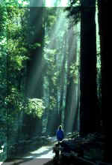
1997, under the Recreation Fee Demonstration Program, the entrance fee was reinstated at $2 per person 17 years and older.
2002, the entrance fee was increased to $3 per person 17 years and older.
2006, the entrance fee was $3 per person 16 years and older.
2007, the entrance fee was increased to $5 per person 16 years and older.
2012, the entrance fee was increased to $7 per person 16 years and older.
2016, the entrance fee was increased to $10 per person 16 years and older.

DONATION BOX
The donation box is located at the entrance. Monies from donations support the Internship program, educational services, outreach, and other general expenses at Muir Woods.

SELF QUIZ

What is the majority of fee monies used for?

Where do passengers redeem their pre-paid (red) tickets?

VISITOR SERVICES

Restrooms are located in the main parking lot and near the concession (second right up the main trail).
Drinking Fountains are located in the annex parking lot, outside the Visitor Center, at the restrooms near the concession, and at the Fern Creek trailhead.
Pay Phone is located in the main parking lot near the restroom. (No cell phone reception!)
Wheelchairs and strollers are available. They may be checked out at the Visitor Center on a first-come, first-served basis.
Shuttle services serving Mill Valley are available on weekends and holidays from the last weekend in March to late October and every day June 22 – August 14 (and also serving the Sausalito ferry from May to early September). Visitors may purchase round-trip tickets for $5 per adult.

MUIR PLAZA

Muir Plaza is the entrance plaza between the parking lot and the Visitor Center. This space: (1) Provides a decompression zone for the visitors as they leave their vehicles and enter the forest. (2) Keeps the smell, fumes, and noise of vehicle engines away from the Visitor Center and the entrance of the park. (3) Provides a staging area for emergency vehicles. (4) Creates a larger riparian area between Redwood Creek and the paved area – protecting wildlife and vegetation in and around the creek. (5) Creates more accessible parking spaces for visitors.

RANGER TALKS

15 minute Ecology Talks are usually given throughout the day. Visitors may check the schedule at the entrance for times and locations. Also, visitors may check the schedule for any special programs.

VISITOR CENTER

The Golden Gate National Parks Conservancy operates the Visitor Center, located at the entrance. It contains exhibits, helpful staff members, and an array of interpretive and educational merchandise, including books, postcards, posters, maps and area information. The Visitor Center staff can be reached at 415-388-7368.
The Muir Woods park brochure, available in Braille, Chinese, French, German, Italian, Japanese, large print, a recorded format, Russian and Spanish translations is free of charge. A downloadable version, in eight languages, is available on the park website, www.nps.gov/muwo under “Plan Your Visit.” As a conservation agency, we encourage groups to share brochures and recycle whenever possible.
A free self-guided Jr. Ranger program for youth is offered at the Visitor Center and online. A QUEST treasure hunt, written in verse, is also available online. A self-guided nature walk (with hiking map) is available for $1.00. A historic walking tour (with map) sells for $1.00.

CONCESSIONAIRE

Muir Woods Trading Company operates the café and gift shop which are located inside the park entrance, first and second rights up the main trail. The concession is committed to sustainable, eco-friendly business practices. The café features locally sourced, organic foods and the gift shop specializes in locally and sustainably made redwood gifts for the home as well as Native American made jewelry, and other classic souvenirs. Please inquire about special benefits for commercial carrier drivers and tour operators. The concession can be reached at 415-388-7059.

SELF QUIZ



Where are the restrooms located?

VISITOR GUIDELINES

Your help in communicating these visitor guidelines is greatly appreciated and goes a long way toward keeping the park a beautiful place for all to enjoy.

No smoking is allowed past the bus parking lot.

The natural soundscape is an important part of the park experience. Please encourage your visitors to respect the peace and quiet of the forest. Remind them to turn off cell phones and talk quietly.

Visitors are not permitted off the trails. Damage to the roots of the trees occurs when visitors are off the trails. Trampled vegetation takes years to grow back.

Picnicking is not allowed anywhere in Muir Woods, but visitors may snack briefly on the benches in Muir Plaza.

Protect park wildlife! Do not feed or try to pet the animals in the park.

Coins should not be thrown in the creek. Coins create toxins in the water that are poisonous to plant and fish life.

Removal of anything from the Monument is not allowed. Nearly 1 million people visit the park every year. If everyone took home a leaf, branch or stick, there wouldn’t be anything left for others to enjoy and there wouldn’t be any decaying matter on the forest floor to nourish other plants and animals.

Pets are not allowed inside Muir Woods. Working service animals are permitted. Have your visitors with service animals speak with a Park Ranger or with the Parks Conservancy staff prior to entry.

No littering please, not even orange or banana peels, sunflower seeds, pistachio shells, or apple cores. Advise visitors to use the trash and recycling containers at the park entrance or, better yet, pack it out.


Thank you!

SELF QUIZ



What are 3 important visitor guidelines?

ADMINISTRATION OF THE PARK

Muir Woods National Monument was established in 1908 under the Antiquities Act and today is a unit of the National Park Service, Department of the Interior. Congress authorizes annual appropriations to maintain the Monument, to provide salaries of employees, purchase supplies and fund park initiatives.

The National Park Service preserves unimpaired the natural and cultural resources and values of the national park system for the enjoyment, education, and inspiration of this and future generations. The Park Service cooperates with partners to extend the benefits of natural and cultural resource conservation and outdoor recreation throughout this country and the world.

- National Park Service Mission Statement

Muir Woods National Monument is administered by the National Park Service as part of the Golden Gate National Recreation Area (GGNRA). The GGNRA was established in 1972.

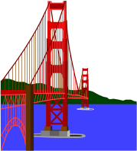The mission of the Golden Gate National Recreation Area is to preserve and enhance the natural environment and cultural resources of the coastal lands north and south of the Golden Gate Bridge for the inspiration, education and recreation of people today, and for future generations. In the spirit of bringing National Parks to the people, we reach out to the diverse urban community, bringing the richness and breadth of the National Park experience to all including those who may never have the opportunity to visit other National Parks. We also work to protect the integrity of our park’s fragile resources in the challenging context of an urban setting. And, we are committed to forging partnerships with the community to strengthen the park’s relevance to our metropolitan neighbors and to engage the public in stewardship of the park’s history and ecology.
- Golden Gate National Recreation Area Mission Statement

SELF QUIZ

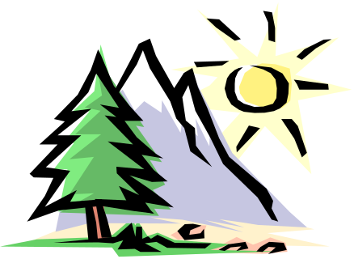

What is the purpose of the National Park Service?

MUIR WOODS HISTORY

The Coast Miwok were the original inhabitants of Marin County. Their largest villages were located at Bolinas Bay, Sausalito and San Rafael. These sites were convenient to estuaries where there was a dependable supply of seafood and to oak groves where the women could gather acorns. The Miwok also started fires to open up the forest. Since deer, elk and birdlife feed primarily on the kinds of vegetation which spring up after fires, this improved hunting. It is thought that seasonal habitations or hunting camps may have been at Big Lagoon (Muir Beach).

Apparently, the native peoples avoided the dark redwood forests. No Miwok artifacts have been found in Muir Woods. According to Miwok myth, a race of little people called “Sekah” lived in the redwood forest. They were believed to have the power to drive humans crazy.

Spaniards were the first European settlers in Marin County, with the establishment of Mission San Rafael in December, 1817. Spanish settlement had limited influence on the land but tremendous impact on the First Peoples, the Miwok.

In 1838, William Richardson, an English immigrant, obtained the land grant Rancho Sausalito. This 19,571 acre tract included Sausalito, parts of Mill Valley, Mt. Tamalpais and Muir Woods. Few changes were made in land use.

With the Gold Rush, a great flood of humanity needed timber, meat, crops and land. Blacktail deer populations diminished; elk and antelope, grizzly and black bear, cougar and coyote disappeared as meat and hide hunters swarmed over the country. Most Bay Area timber, including the accessible redwood stands of Marin County, was logged between 1840 and 1870. Redwood Canyon underwent little logging because of its inaccessibility until the 1950s when neighboring Kent Canyon was repeatedly logged.

By 1890, local conservationists realized how vulnerable Redwood Canyon was to advancing civilization. William Kent, a Marin County resident, was urged to purchase the land. In 1905, the Kents, convinced of the forest’s value to the public as a preserve, purchased Redwood Canyon for $45,000.

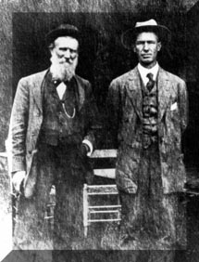
In 1907, the North Coast Water Company, successor to the Tamalpais Land and Water Company, started legal proceedings for a reservoir in Redwood Canyon. Kent realized the Antiquities Act of 1906 allowed the President, without the consent of Congress, to set aside land of scientific or historic value. He began efforts to donate the tract to the government. After frustrating delays, Kent’s offer was accepted. Muir Woods, named in honor of conservationist John Muir, was proclaimed a National Monument on January 9, 1908. The North Coast Water Company suit was thrown out three years later.

Travel increased slowly, but by 1913, 40,000 visitors each year were entering the woods. People wandered freely and cars were unrestricted. It became obvious that the fragile understory vegetation was disappearing. In 1924 cars were excluded from redwood groves, and trails were defined.

From the 1920’s to today, as visitors multiplied, more restrictions were imposed in order to minimize damage to the land. Picnicking was eliminated; fences lined the more heavily used trails, and collecting of plants, animals, or rocks was prohibited. Gradually, small tracts of private land have been added to the Monument to eliminate incompatible uses. Grazing was eliminated from surrounding lands. Most of the nearby lands in the watershed were added to Mt. Tamalpais State Park or to the GGNRA for open space protection, recreational value and to protect the integrity of the watershed. Today, restoration work is in progress to rebuild the soil, revegetate trampled areas, remove non-native weeds, return the abundant biodiversity, revitalize the stream and rebuild populations of endangered species as well as remove un-necessary infrastructure and reduce noise.

SELF QUIZ

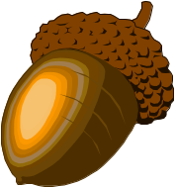

Which native peoples were original inhabitants of Marin County?

Did they live in Muir Woods?

REDWOOD ECOLOGY
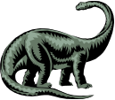
Redwoods belong to a family of coniferous trees called Cupressaceae, which first appeared during the Mesozoic (the age of the dinosaurs) when North America and Greenland were still joined to Europe. They spread across the united northern continent until, by the early part of the age of mammals, they made up a major part of the forests. Then, with the break up of the continent, the advent of colder and drier climates, the competition from more advanced species of trees, their fortune declined. Until recently, botanists classified redwoods with 15 other related conifers (well known ones include the Giant Sequoia, the Dawn Redwood, the bald cypress, the umbrellas pine, the Japanese redwood and the Montezuma cypress) in the family Taxodiaceae but new studies have put them all in Cupressaceae with juniper, cypresses and cedars.

Coast redwoods appear to have evolved in western North America, but their fossils have been found in such widespread places as Greenland, Europe, Russia, China and Japan. Today, however, they are restricted to the California coast from Big Sur to the Oregon border. When the coast redwood was first seen by Spanish explorers in Portolá’s expedition of 1769, there were about two million acres of the tall trees. Of this, less than 4% remains today in virgin stands on both public and private lands. Virgin and second growth redwoods of state and federal parks total about 150,000 acres.

Historically, coast redwood is a species with a shrinking distribution. Nevertheless, many characteristics enable it to compete successfully in many locations in California and around the world.

1. Seed Production: Seeds are produced regularly throughout the range, but vary in number and viability. Seeds germinate readily, but survival is often low in organic litter – perhaps due to the presence of soil fungi or low acidity. On mineral soil, such as a layer of silt from a flood or ash from a fire, seed survival can be quite high. Establishment of seedlings also requires openings to admit sunlight to the forest floor, provided by neighboring trees falling or the cleansing effect of fire.

2. Vegetative Reproduction: Sprouting (vegetative reproduction) directly from the parent tree is common, and in Muir Woods it is the primary method of reproduction. To some botanists, this ability, more than any other characteristic, has enabled redwoods to survive. Most importantly, sprouts use the root system of parent trees to grow faster than seedlings, which enhances their ability to compete with other trees. Sprouts are a remarkably persistent source of reproduction despite repeated fires or other inhospitable conditions.

Sprouts originate from knobby structures called burls. Burls start as auxiliary buds which fail to grow outward but, nevertheless, branch continually until a mass of buds is produced. Burls usually grow on the root crowns, but may occur anywhere on the tree. Eventually some of the buds will begin actively growing, especially if the parent trunk has been destroyed. A few successful sprouts will develop into full sized trees.
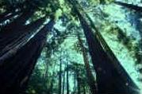
Muir Woods has several fine examples of this process in various stages of growth. Most dramatic are the “family circles”. Sometimes only a gnarly stump remains in the center of a clump of trees which may be hundreds of years old themselves. As they will in turn be replaced by their own sprouts when they die, redwoods are, in effect, immortal.

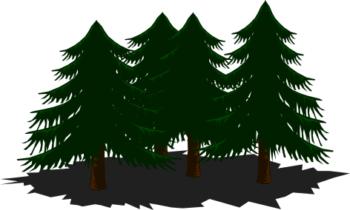SELF QUIZ

What family of trees do the Coast Redwoods belong to?

Which other two trees of this family are found in the United States?

REDWOOD ECOLOGY…continued

3. Fire Resistance: Redwood’s ability to withstand repeated fires complements its sprouting characteristic. Redwood bark is fibrous (an insulating quality) and 3 to 12 inches thick. More importantly, redwoods contain tannins and phenols rather than resins, in both the bark and wood. The tree can burn, but intense, self-sustaining fires rarely occur. Single or widely spaced fires tend to eliminate and hold back competition.

Repeated fires can destroy redwood, but a fire’s advance through trunks is slowed by water-laden
bark and wood. Redwood, then, is remarkably fire-resistant but not free from damage.

Today, we know that fire is an important part of a healthy forest’s ecology and is being slowly
returned through carefully planned prescribed fires (aka “controlled burns”). Fires burn out dead
vegetation, clear space for new plants to grow, slows down disease, add revitalizing ash, and stimulate new growth for many species.

4. Resistance to Pathogens, Insects and Mammals: Redwood resistance is famed. It outlasts most woods even when not chemically treated. The presence of tannins and phenols make the wood’s cells difficult for the insects and microbes to digest. However, a number of insects and two species of fungus can cause minor damage.

5. Growth Response to Temperature and Moisture: Studies reveal that redwood is a warm climate species, but mature trees cannot withstand extreme soil moisture, evaporative stresses from extensive drought nor prolonged dry soils. These requirements restrict it today to the coastal belt of fog, precipitation and cool temperatures. It also makes it potentially vulnerable to projected global climate changes that may influence coastal temperatures and fog patterns.

Redwoods have radial root systems six to ten feet below ground and may spread out over 100 feet in every direction. They rely on abundant water from winter rains (Muir Woods averages 38 inches of rain each year), regular fog and the high water tables found in coastal valleys. Their ability to pump water to such heights is still an unsolved mystery of nature and their ability to draw vast amounts of water from the fog is a current topic of study.

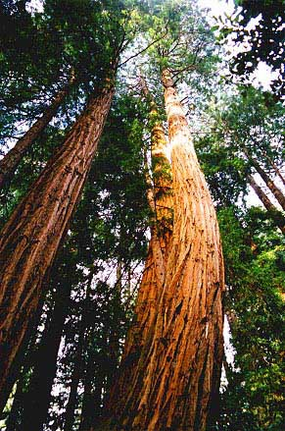
6. Tolerance to Flooding and Silting: Redwoods reach their greatest size on alluvial flats, such as those along Redwood Creek; where flooding and silting occur periodically. These conditions kill most trees, but redwood roots survive, even when the oxygen levels are low. Redwoods send up vertical roots after silting. Lateral roots are later sent out as a replacement system. Exceptional trees in Humboldt County reveal thirty foot deposits of soil and debris around their trunks, with half a dozen or more layers of roots.

Today, excluding destruction by ever-dominant man, death to redwoods comes mostly from windthrow (the tree toppling over due to a big wind) or slopes destabilizing from heavy rain or earthquakes.

SELF QUIZ

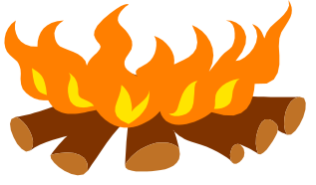

What two characteristics of redwoods prevent them from readily burning up?

What is the main cause of death for redwoods, aside from humans?

OFTEN ASKED QUESTIONS

- How tall is the tallest tree in Muir Woods?
The tallest tree in Muir Woods is almost 260 feet high and is located between bridges two and three on the west side of the creek.

- How tall is the tallest tree in the world?
The tallest tree measured in the world, currently, is a redwood over 379.1 feet tall located in northwestern California. It is not accessible by trail or road.

- How wide is the widest tree in Muir Woods?
The widest tree is about 14 feet in diameter. It is near Bohemian Grove and can be easily seen from the east side of the creek.

- What is the age of the oldest tree in Muir Woods?
Over 1,000 years old. One Northern Californian specimen revealed an age of 2,200 years (the maximum recorded for the species). Many coast redwoods are over 1,000 years old, but the average age of trees in Muir Woods is 400 to 800 years.

- What is the average growth rate of redwoods?
The growth rate of any tree is determined by rainfall, exposure, soil compaction, density, and a host of other factors. When a coast redwood tree reaches age 20, it is often 30 feet tall and 10 inches wide. At this stage, the tree can go through a growth spurt: each year it can rise another two to six feet in height if it has lots of water, partial sun, and wind protection. In a dark forest with competition from other redwoods, the growth rate is much slower. After a redwood reaches maturity (approximately 100 years) the tree gains one inch in radius every 17 years. Redwood trees reach their greatest size on alluvial flats, such as Redwood Creek, where flooding and silting occur periodically.

- Why do Redwoods only grow near the coast?
The redwoods need the fog and moisture to survive. The trees can only grow in certain soils which the coastal area provides. Seedlings studies reveal that redwood is a warm climate plant, but mature trees cannot withstand extreme soil moisture and evaporative stresses. This condition restricts it to the coastal belt of fog, precipitation, and moderate temperatures.

- Why are the insides of the trees burned out?
The last severe fire to be recorded in Redwood Canyon was in the mid 1800’s. The burned out area of the redwoods is the result of this fire and others before it. Remember that carbon is one of the longest lasting substances. The fires were most likely started by natural causes such as lightening strikes on the dry slopes on Mt. Tamalpais instigating a brush fire that burned into the canyon but there is speculation that many were also intentionally started by the Miwok peoples to clear brush, stimulate growth to feed wildlife, and provide tender shoots for gathering.

- Why don’t the Redwood trees burn up in a fire?
Redwood bark is fibrous (an insulating quality) and 3 to 12 inches thick. More importantly, redwoods contain tannin and phenols (rather than resins or pitch) in both the bark and the wood. The tree can burn, but intense, self-sustaining fires rarely occur. Single or widely spaced fires tend to incite competition and also encourage redwood reproduction by clearing out the accumulated duff (leafy, often dead, undergrowth) and leaving a clear, nutrient-rich seed bed.

SELF QUIZ



How tall is the tallest tree in the world?

Where is it located?

OFTEN ASKED QUESTIONS

- How much wood is actually in one redwood tree?
Individual redwoods have been found that measure 100,000 to 200,000 board feet. One tree was reported at 361,000 board feet. This is enough lumber to build a community of thirty or more homes! The above are, of course, extremes. Normal yields from one redwood ranges from 35,000 to 100,000 board feet.

- Where is the walk-thru tree?
The so-called Walk-Thru Tree in Muir Woods was in Cathedral Grove. This tree toppled over in December 1971. The tree survived about 600 years – that is just a quarter of its potential life span. The effects of trampling and the destruction of plant communities deprived the tree of a suitable environment in which to grow. The fence installed since the tree’s demise hopefully will extend the lives of the remaining redwoods in Cathedral Grove. The destruction to the environment over the many years of unrestricted use, however, will take many years to recover.

- Where is the drive-thru tree?
There never was one in Muir Woods. The one most people are referring to is the Wawona Tree, a giant sequoia in Yosemite National Park. The Wawona Tree toppled over during the winter of 1969 from the weight of the heavy snow.

Another drive-thru tree is a coast redwood known as the Chandelier Tree found in Leggett, CA, about 180 miles north on Highway 101. It is in a privately owned stand of redwoods and a fee is required for driving through it. There are also two other drive-thru trees on Hwy 101 north of there.

- Where are the great big trees?
Muir Woods contains the tallest species of trees, the coast redwoods. The big, wide trees are called giant sequoias (or “Sierra redwoods”), located in Yosemite and Sequoia/Kings Canyon National Parks. These trees are larger in diameter than the coastal redwood, but are not as tall.

- What are the trees with the peeling bark along the road?
Blue gum eucalyptus is a native of Australia. It was planted in the 1850s and 1860s in the hopes of introducing a hardwood tree in the Bay Area. They are, however, not usable as hardwood, and instead are providing windbreaks. They grow rapidly and prolifically in the Bay Area, encroaching on the habitats of our native plant life.

- Where does Redwood Creek originate and where does it empty into the ocean?
Redwood Creek originates near Rock Springs on Mount Tamalpais. It drains 10 square miles of the mountain’s southern slopes. Fed by underground streams, the creek flows all year, though in the drier, summer months it is a meandering trickle. It empties into the Pacific Ocean at Muir Beach.

- Are the boardwalks made from redwood?
Most of the boardwalks are made of reused redwood. The entrance area boardwalk is constructed of redwood reclaimed from a planing mill constructed in the 1930s that was dismantled. Structural portions of the boardwalk are made of certified sustainably harvested redwood.
The newest portion of boardwalk from the cross-cut exhibit all the way to the Pinchot tree is sustainably harvested second growth redwood.

SELF QUIZ



What was the Wawona Tree?

Where was it located?

OFTEN ASKED QUESTIONS

- When do the salmon come up Redwood Creek?
Muir Woods has both endangered silver (coho) salmon and threatened steelhead trout. Salmon usually come up after the first heavy rain in mid-December and the spawning runs will usually last through March. Both species come up from the ocean to spawn. The salmon die afterwards, but often the steelhead return to the sea. Fishing is not allowed.

Coho require high quality freshwater and ocean habitats over the course of their three-year lifespan, and, because of this they are excellent indicators of the health of these ecosystems.

- Why don’t we hear or see many birds?
The great amount of shade found in a redwood forest inhibits flowering plants which, in turn, mean fewer flowers, berries and seeds, and a reduced food supply. Redwoods are also resistant to insects, limiting food for insect eating birds.

Birds may be observed more frequently in the open grassland areas and near the creek where a more dependable food supply exists, and fewer people are around to bother them.

Nevertheless, several interesting species of birds can be seen. Steller’s jays, California towhees, ruby-crowned kinglets, Wilson’s warblers, and chestnut-backed chickadees are common near the entrance where there is more understory vegetation. Pacific wrens, dark eyed juncos, and varied thrushes (winter only) may be seen deeper in the forest. Turkey vultures, ravens and red-tailed hawks soar between the surrounding ridges.

- What kind of wildlife is in Muir Woods?
Look for black-tailed (mule) deer, banana slugs, Sonoma chipmunks, squirrels, gray fox, gophers, moles, and an occasional bobcat or river otter. Owls, bats, raccoon and skunk are out at night.

- When is the wildflower season?
The wildflowers are in bloom from January until June.

- How far is the trail?
There are a number of different trails with different lengths. Our main trail has three popular loops. There is a 30-minute walk that starts from the Entrance Arch and crosses at the 2nd bridge. This walk is a quarter of a mile one-way, for a 1/2 mile round trip. For visitors who want a longer walk take the main trail to the 3rd bridge, circle through Cathedral Grove to return to the 3rd bridge, cross over and walk back to the park entrance. This takes about one hour and is 1 mile round trip. A two mile walk is to Bridge 4 and return via Hillside Trail

- How many acres is Muir Woods?
559 acres. Muir Woods is surrounded by Mt. Tamalpais State Park.

- How many people visit Muir Woods annually?
Almost one million visitors come to Muir Woods each year.

SELF QUIZ



What two species of fish spawn in Redwood Creek?

What time of year do they spawn?

OFTEN ASKED QUESTIONS

- Why are there so many visitor restrictions?
All the rules and regulations of the monument are directed toward protecting and maintaining the natural conditions of the area. Our primary purpose is to provide a pristine, old growth redwood forest for people to visit and enjoy forever. As visitation has grown, many rules have become necessary to protect this unique and fragile environment from human impact. We are surrounded by state and national park land where other recreational activities are possible.

- Why isn’t off-trail use permitted?
Human impact (vegetation trampling) is one of the most pressing problems of Muir Woods. The small size of the park and the number of people who visit the park each year make it difficult to protect the fragile plant communities that are essential to the survival of the redwoods, and the regeneration of new trees. Therefore, it is important that visitors to Muir Woods stay on the trails to minimize damage and guarantee the future viability of the forest.

- May visitors take home natural objects or mementos?
Every twig, stem, fallen leaf or piece of bark is a part of the natural processes providing food, shelter, or habitat for other living species in the woods and should not be removed, even from the surrounding parking areas. Each visitor must consider that the impact of taking one keepsake home is combined with that of nearly a million visitors each year. One should be able to appreciate the eventual damage from the removal of natural objects.

- Where is camping and picnicking permitted, and why isn’t it allowed in Muir Woods?
The use of the park by picnickers and campers is just too destructive to plant communities and disruptive to the wildlife. Also, prior to 1964 when picnicking was eliminated, the average picnicker’s stay was 4.5 hours. With the limited parking, picnickers monopolized the area and made it impossible for many persons to visit Muir Woods.

Camping areas are Pantoll Camp at Mt. Tamalpais State Park which is approximately 8 miles north of the Monument and Samuel P. Taylor State Park (30 miles). Picnic areas are at Stinson Beach, Muir Beach, Muir Beach Overlook, Mt. Tamalpais State Park, and Samuel P. Taylor State Park.

- Who was William Kent?
William Kent was a prominent politician and businessman of Marin County, who purchased Muir Woods in 1905 for $45,000. He and his wife, Elizabeth, then donated the land to the U.S. Government to save it from being logged and dammed, and asked that it be named for John Muir, whom they greatly admired. Later, as a congressman from this area, Kent cosponsored the legislation that created the National Park Service in 1916.

- Who was John Muir?
He was an early and influential conservationist, and as well as a writer and inventor. He worked closely with President Theodore Roosevelt and was instrumental in saving five national parks, including Yosemite. He was also the first president of the Sierra Club, and explored much of the earth on foot. These were some of the reasons that Kent admired the man enough to have this park named in his honor.

SELF QUIZ



Is it okay for visitors to take a leaf or stick if they find one on the ground?

MUIR WOODS MAIN TRAIL MAP
(A similar map is printed on the back of the free Muir Woods brochure,
available at the Visitor Center and at www.nps.gov/muwo)
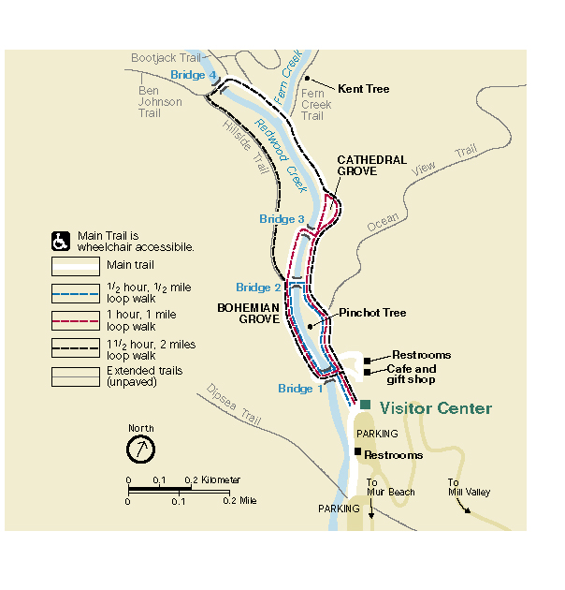
Half hour loop walk: Begin at the entrance just past the Visitor Center. Walk along the creek to Bridge 2. Cross the creek and walk back along the other side of the creek.

One hour loop walk: Begin at the entrance. Walk along the creek to Cathedral Grove. Walk the loop through Cathedral Grove. Walk back to Bridge 3. Cross the creek and walk back along the other side of the creek.

One and a half hour loop walk: Begin at the entrance. Walk along the creek to Bridge 4. Cross the creek and walk back on the Hillside Trail to Bridge 2 and from there back to the entrance on either side of the creek. (The Hillside Trail is not paved).

Extended hiking trails: There are many lovely trails to explore, but it’s essential to bring a map to help navigate the options. Stop by the Visitor Center to pick up a trail map.

The main trail is flat, paved and/or boardwalked from the main entrance up to Bridge 4. Trails other than the Main Trail are not recommended or safe for strollers or wheelchairs.

SELF QUIZ

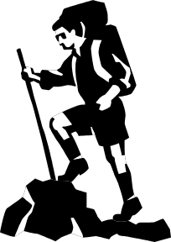

Will I have time to get to Cathedral Grove and back in an hour?

Suggested Readings

Bourne, Joel K. “Redwoods: The Super Trees,” National Geographic Magazine, October 2009.

Clark, Leslie (Producer), Tatge, Catherine (Director) (2011). John Muir in the New World (DVD) United States: Global Village Media and THIRTEEN’s American Masters for WNET.
Donald, J and Rubin, J (Directors) (2009) Climbing Redwood Giants (DVD). National Geographic.

Eifert, Larry and Nancy Cherry. (2006). California’s Coast Redwoods Nature Guide. Estuary Press: Port Townsend, WA.

Evarts, J. and Popper, M. (2001). Coast Redwood: A Natural and Cultural History. Cachuma Press: Los Olivos, CA.

Frank, Susan and Phil. (1999). The Muir Woods Handbook. Pomegranate Communications: Rohnert Park, CA (Out of print)

Hart, John. (2011). Muir Woods National Monument. Golden Gate National Parks Conservancy: San Francisco, CA.

Lyons, Kathleen, Cuneo-Lazaneo, Mary Beth and King, Howard. (1988, 2003). Plants of the Coast Redwood Region. Shoreline Press: Soquel, CA.

Morley, J.M. (1991). Muir Woods: The Ancient Redwood Forest Near San Francisco. Smith-Morley: San Francisco, CA.

Noss, Reed F., editor. (2000). The Redwood Forest, Island Press: Washington, DC and Covelo, CA.

Preston, Richard (2008). The Wild Trees: A Story of Passion and Daring. Random House Trade Paperbacks: New York, NY

Teale, Edwin Way, editor. (1954, 2001). The Wilderness World of John Muir. Houghton Mifflin Company: Boston, MA and New York, NY.

The Wild Muir. Yosemite Conservancy (2013)

White, Fred D., editor. (2006). Essential Muir: A Selection of John Muir’s Best Writings. Heyday Books: Berkeley, CA.

Worster, Donald. (2008). A Passion for Nature: The Life of John Muir. Oxford University Press: New York, NY.

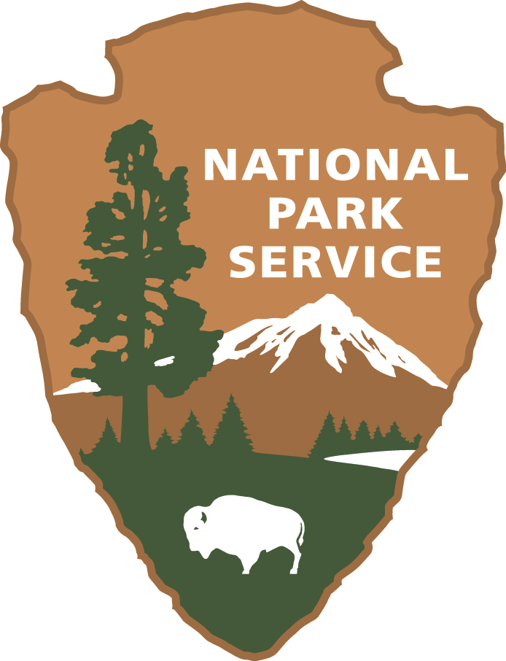
MUIR WOODS COMMERCIAL CARRIER LOT GUIDELINES

- Drive in via upper Muir Woods Rd., from Panoramic Highway, leave via the lower Muir Woods Rd. (right turn out of the parking lot). This is for everyone’s safety on these narrow roads and as a courtesy to minimize congestion.

- Respect the intent of the unloading/loading spaces and move from them as soon as possible so this convenience is available for other tour operators. The unloading/loading spaces are the two marked spaces closest to the restrooms.Please note: The first two unloading/loading spaces are reserved for the Muir Woods Shuttle on weekends and holidays, the last weekend of March to the last weekend of October and every day June 22 – August 14. It is NOT available for commercial carrier use at any time on those weekends and holidays.

- Commercial lot AND unloading spaces full? Pull behind buses to unload when safe. After unloading, leave parking lot, turn right to travel down lower Muir Woods Rd. and park off-road at one of the larger pull-outs. Wait until space becomes available (you will see other buses leave) OR until it is time to return to pick up your passengers. Do not attempt to park your vehicle within the annex parking lot. This lot is strictly for visitor use.

- Do not wait along the red zones.

- Only leave your vehicle unattended if you are in a legitimate parking space.

- No idling of parked vehicles for more than 30 seconds, whether loading or unloading.

- Refrain from using public address systems or loudspeakers in Open-Top Commercial Carriers while in Muir Woods parking lot.

- Please direct your clients to use the pedestrian pathways to approach the Visitor Center. For everyone’s safety, your clients should NOT walk through the parking lot.

- If applicable, advise your clients to give pre-paid (red) admission tickets to Visitor Center.

- Again, avoid parking in the designated Muir Woods Shuttle space on weekend and holidays.

- If you or your agency holds a commercial use permit with Muir Woods, ensure that your commercial tour carrier placard is prominently displayed on the dashboard of your vehicle, on the driver’s side.

- Each company is not allowed more than two commercial carriers at Muir Woods at any one time. Check with the Business Office (415-561-4948) with questions on this matter.

- Commercial services and guided hikes are not allowed in Muir Woods. Violators are subject to citation. Commercial guides may accompany their visitors only as far as the Visitor Center. Non-commercial groups or groups with special needs may be able to use guides by Special Use Permit only. For further information, please contact the Business Management Division at 415-561-4948.

For more information, please review the Tour Guide and Commercial Driver’s Manual.
Copies are available at the Visitor Center and online at www.nps.gov/muwo

