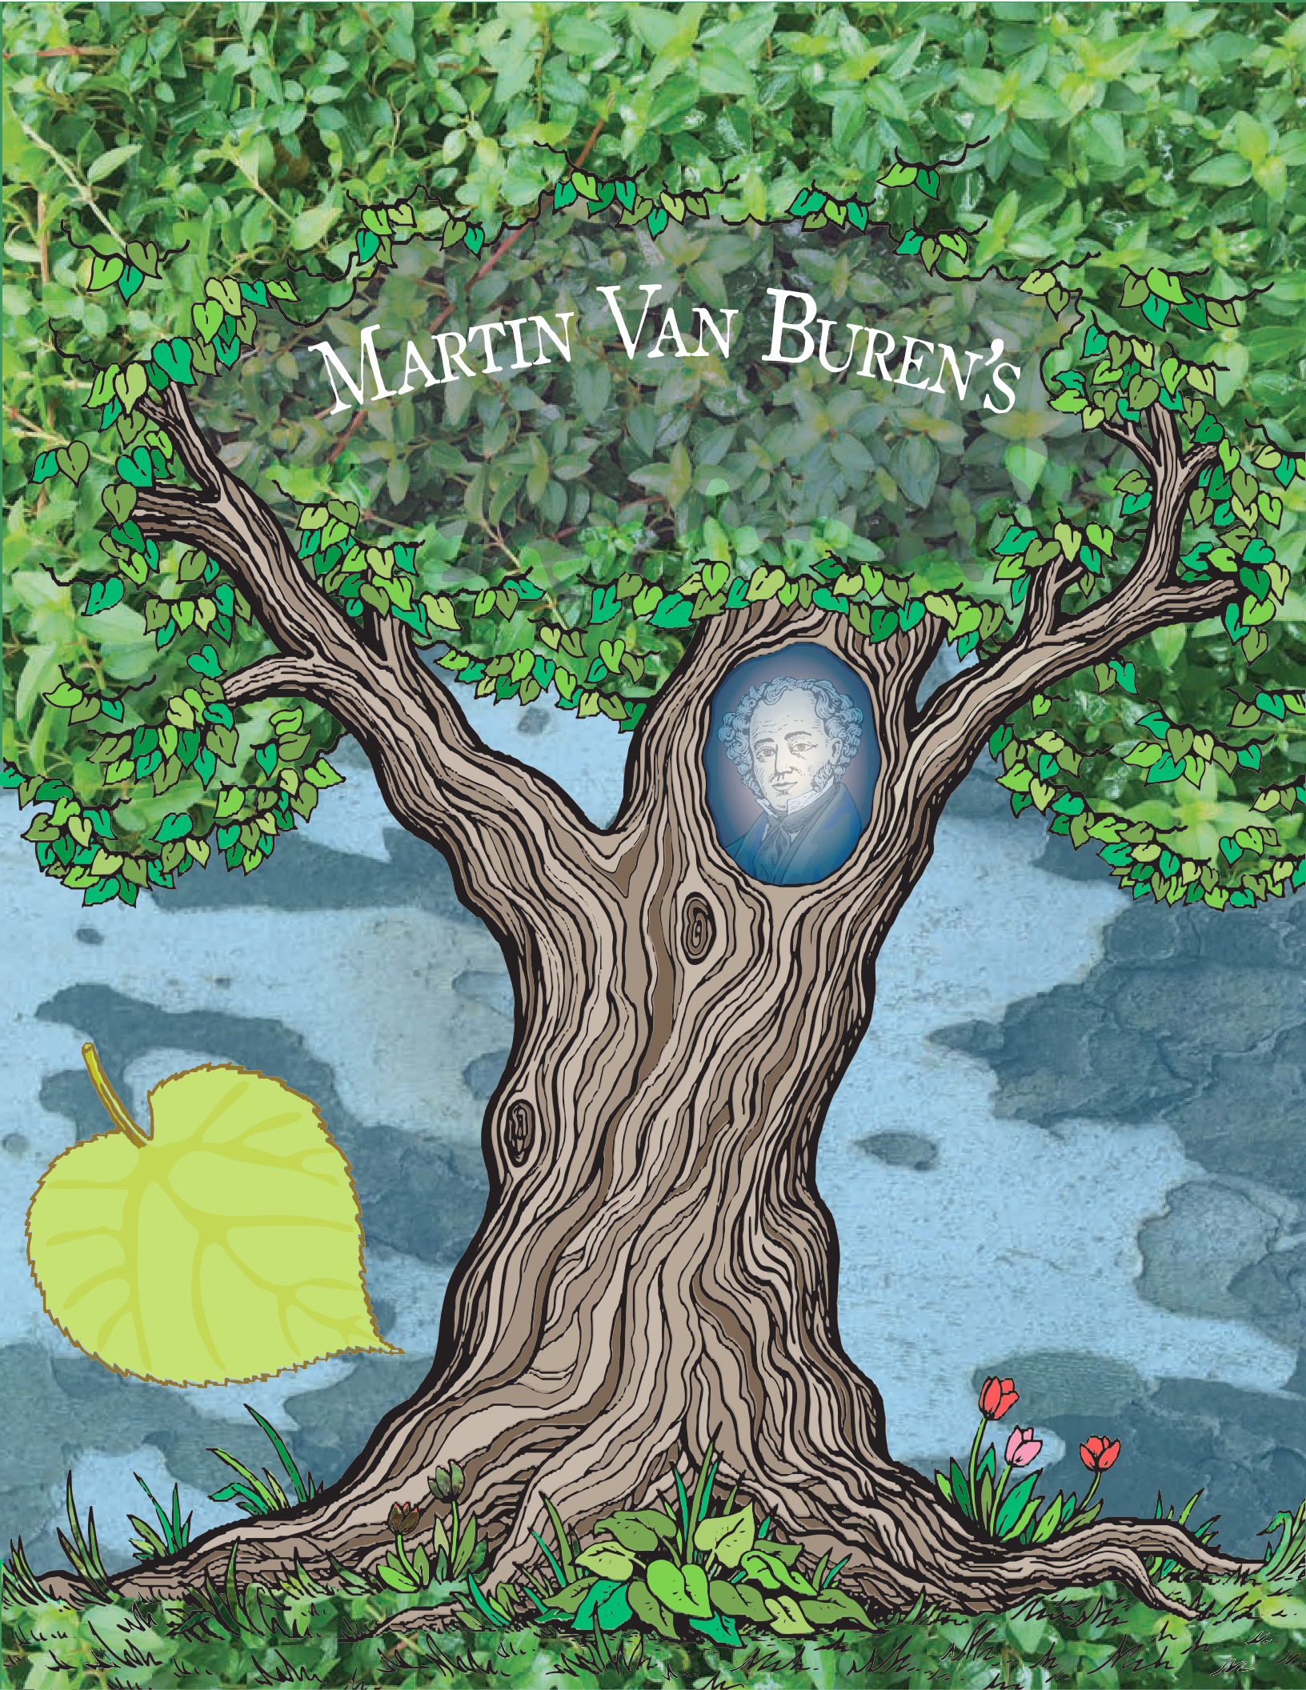

FAMILY TREE

english:
a
r
n
D
u
t
c
h
L
e

family tree
!
dutch:

stamboom

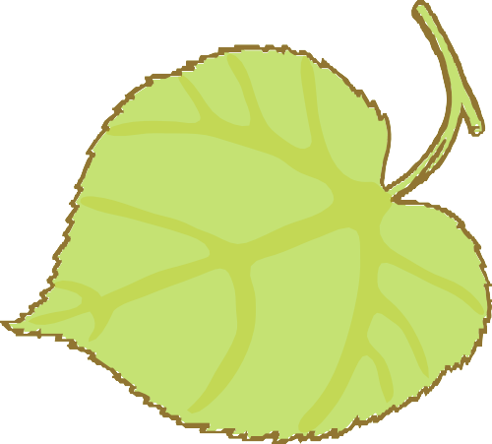
mother/father
D
D
u
u
t
!
t
c
c
h
e
a
L
e
a
r
r
n
n
english:
Married 1770 ? |  |  | Married 1778 ?
Johannes Van Alen  ca. 1740–1777 |  |  | Maria Hoes Van Buren  1743–1817 |  |  | Abraham Van Buren  1737–1817
Abraham Van Buren
b. 1788
Marytje Van Alen  b. 1768  Johannes Van Alen  b. 1770 |  |  | Married 1807 |  |  | Lawrence Van Buren  b. 1786  Hannah Van Buren  b. 1780

mduotcehd:
er/vader
Jacobus Van Alen
b. 1773

Martin Van Buren Hannah Hoes Derike Van Buren
1782–1862 1783–1819 b. 1778
brother/sister
brduotcehr: /zus
english:
h
!
L

Martin Van Buren, Jr. Winfield Scott Van Buren

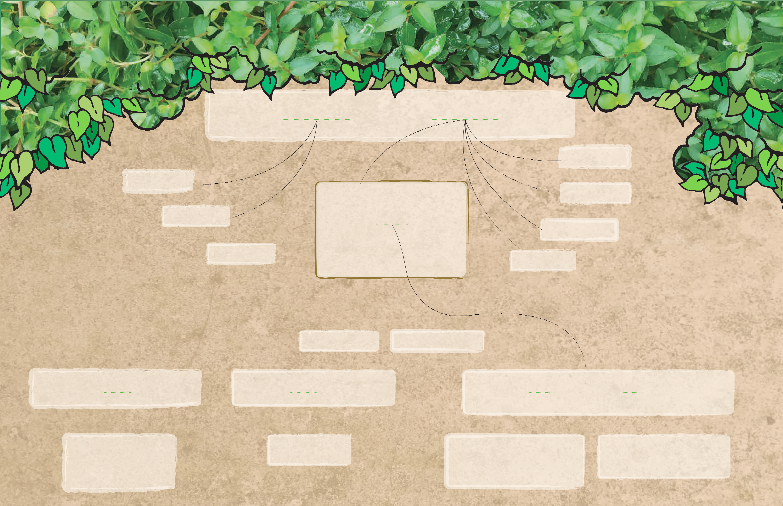
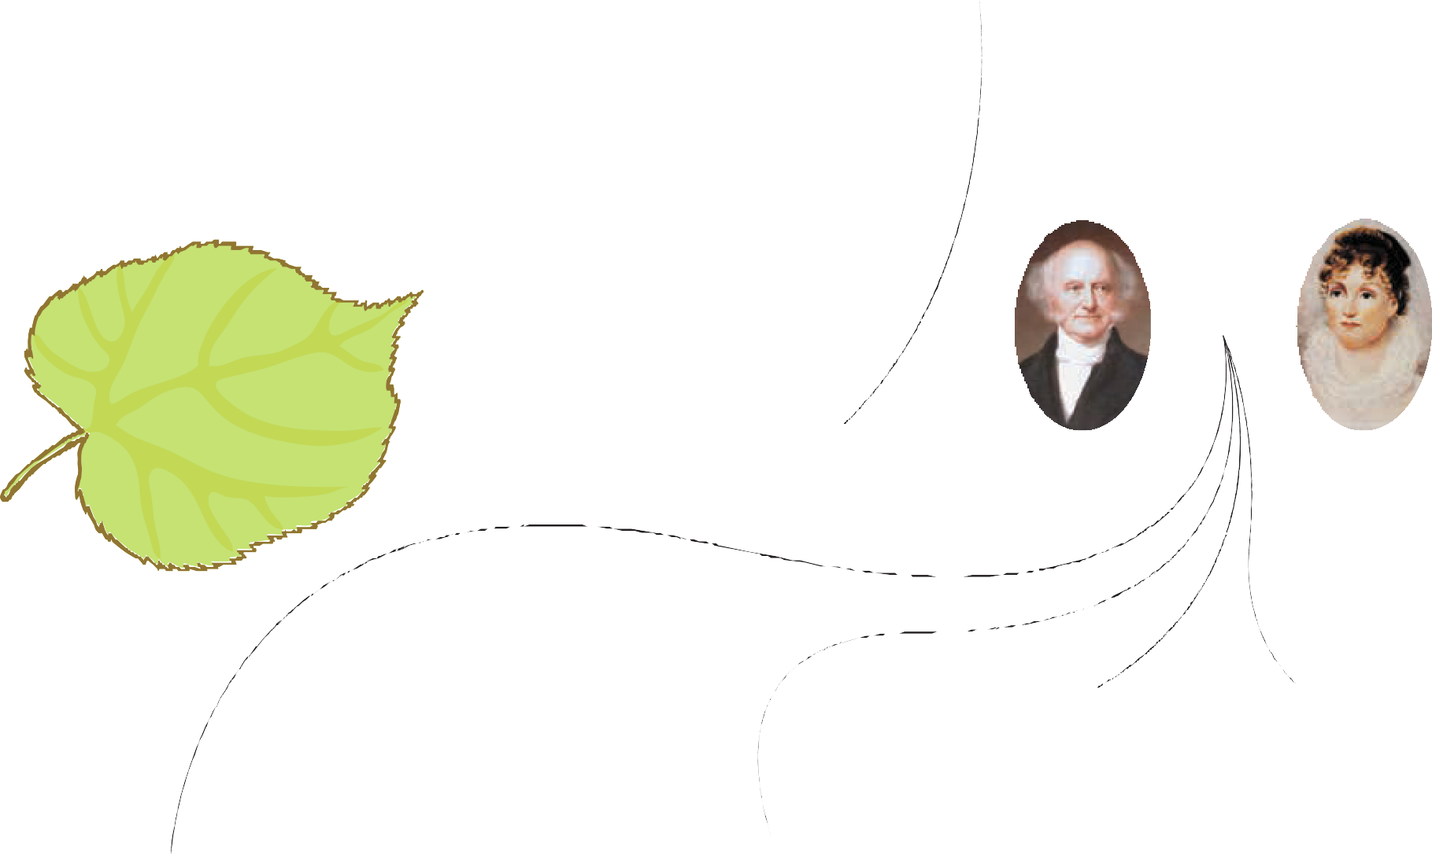
1812–1855 1814–1814

 | Married |  |  | Married |  |  |  | Married | Married
 | 1838 |  |  | 1841 |  |  |  | 1842 |  |  | 1855
 | Abraham Van Buren | Angelica Singleton |  | John Van Buren |  | Elizabeth Vanderpoel |  | Ellen King James | Smith Thompson |  |  |  |  | Henrietta Eckford Irving
 | 1807–1873 | b. 1816 |  | 1810–1866 |  | 1810–1844 |  | 1813–1849 | Van Buren |  |  |  |  | 1832–1921
 |  |  |  |  |  |  |  |  | 1817–1876

 | Rebecca Van Buren 1840–1840 |  |  | Sarah Anna Van Buren |  |  | Ellen James Van Buren 1844–1929 |  |  |  | Martin Van Buren 1856–1942
 | Singleton Van Buren 1840–1879 |  |  | 1842–1923 |  |  | Hannah Van Van Buren 1846–1846 |  |  |  | Eliza Eckford Van Buren 1858–1942
 | Martin Van Buren b. 1844–1885 |  |  |  |  |  | Edward Singleton Van Buren 1848–1873 |  |  |  | Marion Irving Van Buren 1860–1928
 | Travis C. Van Buren b. 1848–1889 |  |  |  |  |  | Katherine Van Buren b. 1849–1942

Create Your Own Family Tree
Write down the members of your family in the sections below. Draw lines between people who are married and between parents and their children. How big is your family compared to Martin Van Buren?

Grandparents

Aunts & Uncles Parents Aunts & Uncles

Brothers & Sisters Me! Cousins

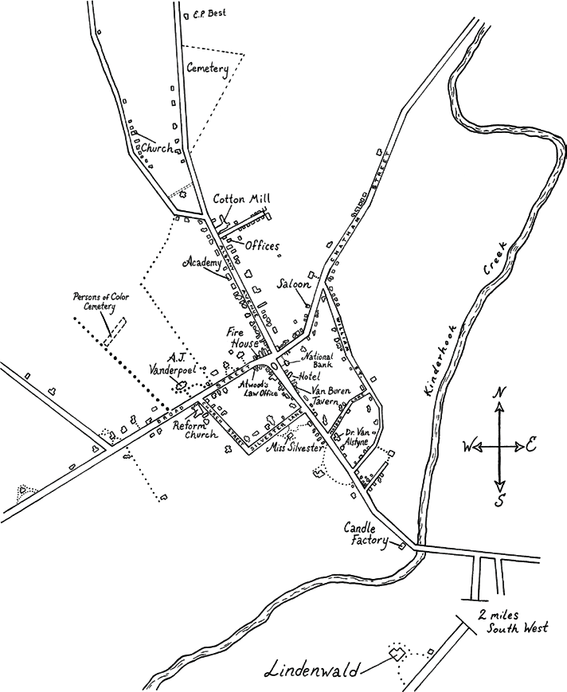
Kinderhook in the Mid-1800s

english:
D
u
!
t
c
h
L
e
a
r
n
church
dutch:
kathedraal

Neighborhood Map
The world has changed a lot since the mid-1800s. What does your neighborhood look like now? Draw a map of notable places below.

Hometown & Community Heritage
L
e
a
r
n
D

english:
u
t
c
h
Academy governess
!

Tin &
,
N
e
w
Y
o
n
d
e
r
h
o
o
IronWorks
i
Cemetery
K
k Cotton Mill
dutch:

gouvernante
r

Family
k
Cook
Fire House

Candle Factory
n
w
a
n
d
e

Governess

Domestic Workers
t
a
n
e
r
d
l
l
i
d
h
C
d
l
a
L
w
i
n
e
d
n
i
L

Hat-Maker

Church Farm Workers
o
H
e
m
Tavern

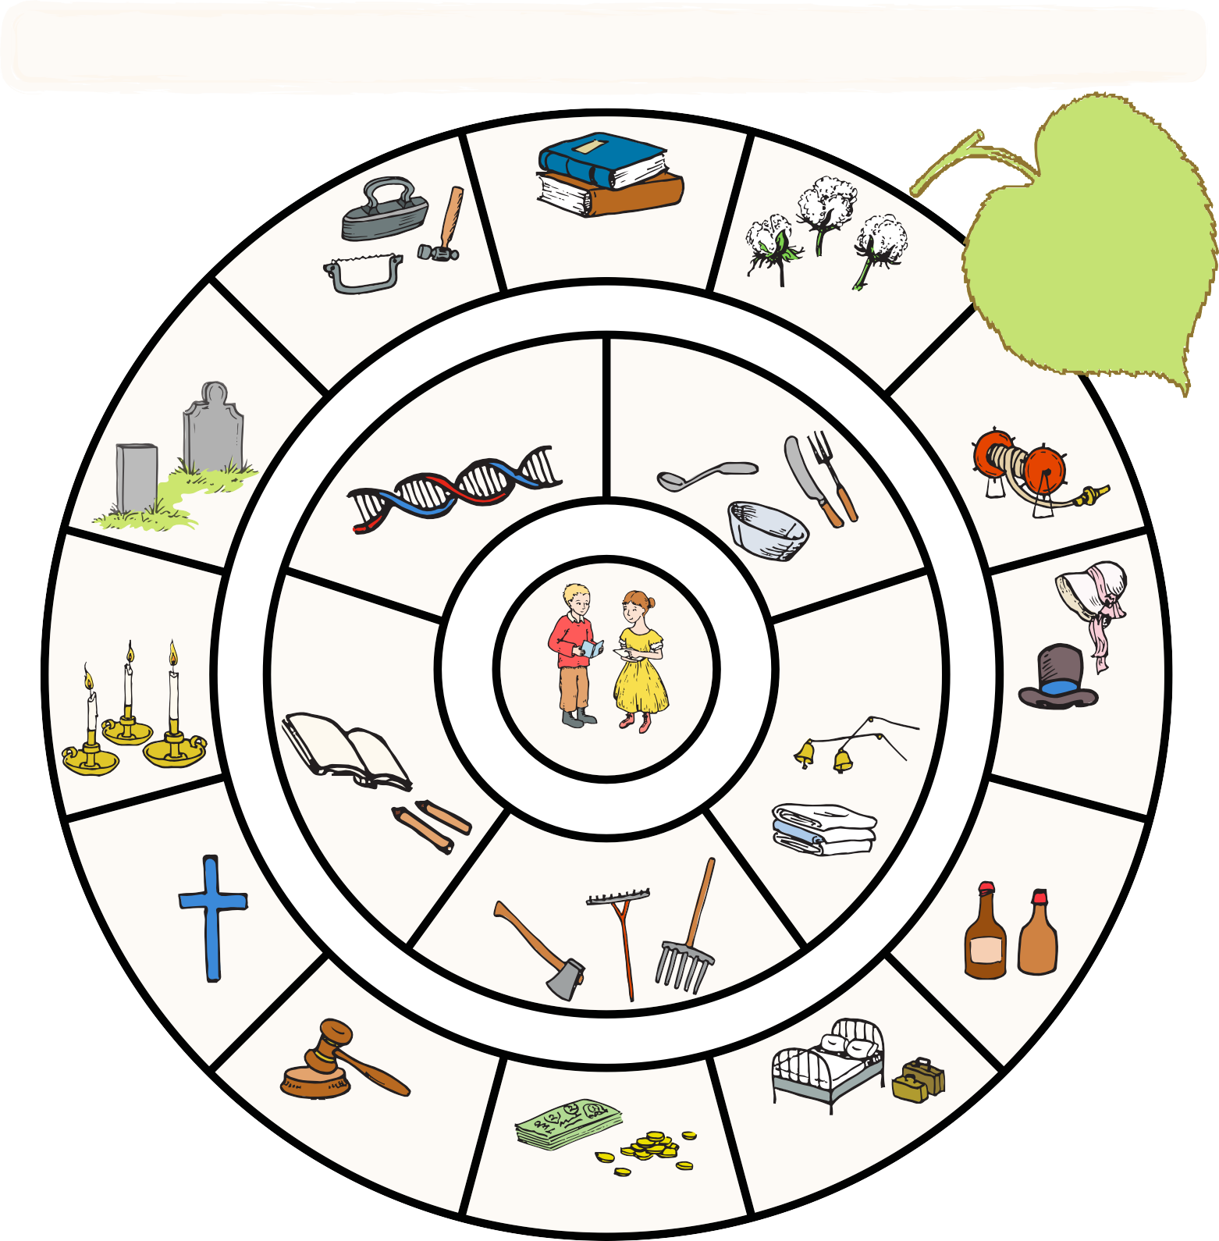
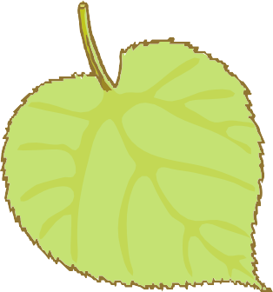

L
-
d
i
e
M
a
r
n
D
s
’
0
0
8
1
english:
u
t

cook
c
h
!
dutch: Law Office
Hotel

keukenmeid
Bank

Martin Van Buren was deeply connected to Kinderhook and later to Lindenwald. He knew each intimately. This fostered a profound love and caring for his communities. The love for Kinderhook and Lindenwald in all their parts - people, structures, the land - created a desire to protect and serve his community, that is a civic sense.
This community wheel shows the people and places that surrounded MVB’s grandchildren at Lindenwald and in the greater Kinderhook community. Compare this wheel with the map of Kinderhook on the previous. Then, think about the people and places that surround you today and create your own community wheel and neighborhood map on the attached activity pages.

Create Your Own
Community Wheel
Using the community wheel about MVB’s grandchildren as a guide, think about the people and places that surround you at home and in your neighborhood or town. Draw yourself in the center and then fill in the wheel!

Me!

Heraldic Symbols
These are some symbols that have been popular throughout history as parts of coats-of-arms, and their meanings. Use them as inspiration for designing your own coat-of-arms, or invent your own!

Colors:
Yellow or Gold : Generosity
White or Silver : Peace and sincerity Black : Constancy, sometimes grief Blue : Loyalty and truth
Red : Strength, military fortitude
Green : Hope, joy and sometimes loyalty in love Purple : Royal majesty, sovereignty and justice Orange : Worthy ambition
Maroon : Not hasty in battle, and yet a victor

Other Symbols: Axe : Dutiful
Bridge : Signifies a governor or magistrate Crosses : Christian sentiments
Crown : Authority Fire : Zeal
Flaming Heart : Passion
Animals:
Bear : Protectiveness Bee : Industriousness Camel : Perseverance Dog : Loyalty
Eagle : Leadership & Decisiveness Dragon : Defender of Treasure Falcon or Hawk : Eagerness
Fox : Cleverness
Griffin (part eagle, part lion) : Bravery Horse : Readiness to Serve
Lion : Courage
Pelican : Generosity & Devotion Raven : Constancy
Snake : Ambition
Stag, Elk, or Deer : Peace & Harmony Tiger : Fierceness & Valor
Unicorn : Extreme courage Wolf : Constant Vigilance

Fleur-de-lis (stylized Iris flower) - Purity (associated with France) Hand : Faith, Sincerity, & Justice
Heart : Sincerity
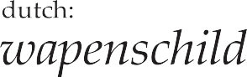
Horns & Antlers : Fortitude Lightning : Decisiveness Moon : Serenity
Oyster Shell : Traveler Ring : Fidelity Scepter : Justice
Star : Nobility Sun : Glory Sword : War-like
Tower or Castle : Fortitude & Protectiveness

Draw Your Own Coat-of-Arms
The Van Buren family coat-of-arms features a sheild and imagery that symbolizes what the family stood for back when it was created. On the left is a greyhound for loyalty and on the right embattled stripes of red and gold for strength and generosity. Use the sheild template below to draw your own coat-of-arms, using symbols that represent you. You can use the list of heraldic symbols on the next page for inspiration, or make up your own!

Mother Goose Children’s Songs and Rhymes

Baa, baa, black sheep, Have you any wool?
Yessir, yes sir, Three bags full;

One for my master, One formydame,
And one for the little boy That lives down the lane.
Hot-crossbuns! Hot-cross buns!
One a penny, two a penny, Hot-cross buns!
If you have no daughters, Give them to your sons; One a penny, two a penny, Hot-cross buns!

Peter Piper picked a peck of pickled peppers;
A peck of pickled peppers Peter Piper picked;
If Peter Piper picked a peck of pickled peppers,
Where's the peck of pickled peppers Peter Piper picked?

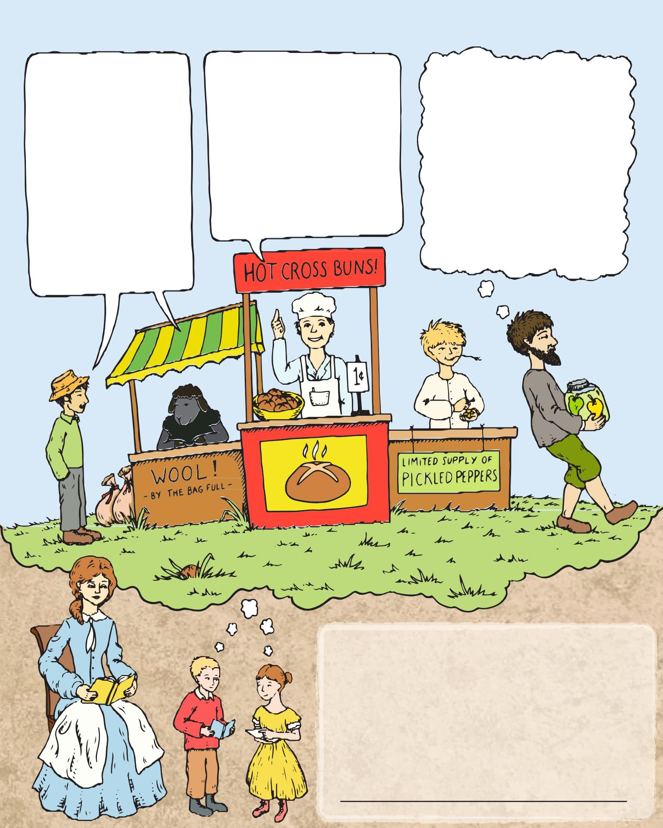

In our 21st century world,wehavemany different ways to learn and entertain ourselves. In the 19th century, President Van Buren’s grandchildren and other children on the farm would read or sing or share rhymes. The children would have learned rhymes such as these from their parents as the family spent time in the parlor after supper. Give them a try!
What doyou dofor funwithyourfamily?

