Tree Brain Check!
Using what you learned today, answer the questions below by circling the correct answer.

- TRUE or FALSE
Evergreen trees are those that lose their leaves each fall and turn pretty colors.

- TRUE or FALSE
A Sycamore tree, like the one at President Van Buren’s home, is a Deciduous tree.

- Circle the correct sentence.
  - Bark is what you eat for breakfast.
  - Cat’s bark at the doorbell.
  - Bark is the hard, outer shell of a tree.

- Circle the correct answer.
- This tree’s nickname is the “sweetheart tree”.
  - Loop De Loop Tree
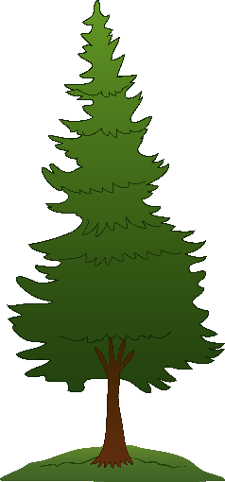
  - Linden Tree
  - Lickety Split Tree

