

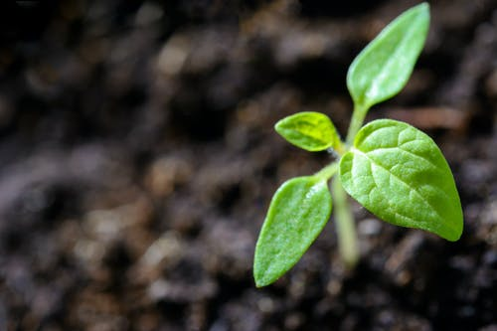

Music helps plants grow.

The sounds of the music wake up parts inside a plant called cells.

We are unable to see them,

but anything that needs air and water to live have cells – even us!

Would you like to

use music to help a plant grow?