

Think &

Predict





You have learned a little about weather and temperature, now let’s play a game using the weather charts.

**Circle what you predict will be tomorrow’s weather.**

   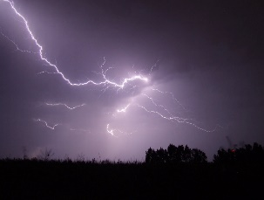

**Sunny** **Cloudy Rainy Thunderstorms**

 

**Ask a grown-up to help you find a weather report tomorrow and check to see if your weather prediction was correct.**

**Windy Snowy**

**Circle your guess for tomorrow’s temperature.**



**Hot Cold**

Weather Chart

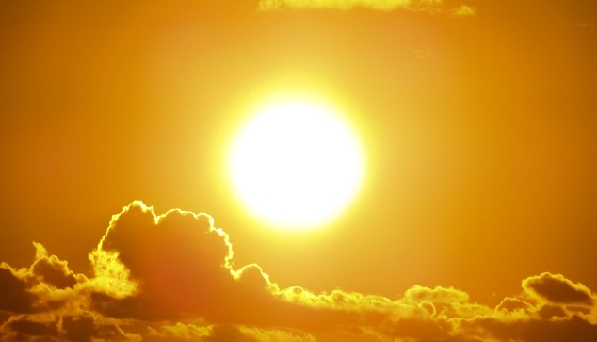

Sunny

The sun is shining brightly, like on a perfect summer day! Clouds may still be seen but there won’t be a lot of them.



Cloudy

Many clouds in the sky. Cloudy days are usually cooler than sunny days.



Rainy

Rain is water that falls from the clouds. A rainy day is a good time to curl up on the couch with your favorite book.

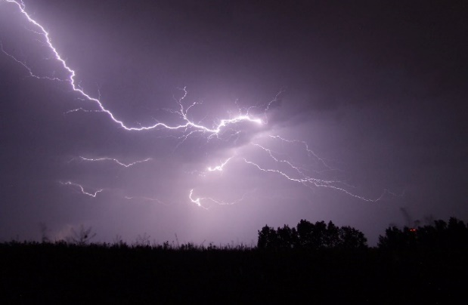

Thunderstorm

Heavy rain and wind with bangs in the sky,called thunder. You may see bright flashes of light - lightning. It may seem scary but is just a fact of nature.

More Weather



Windy

Wind is air around you that is moving fast enough to feel. A windy day can be sunny, cloudy, rainy, hot, or cold. A sunny and windy day is a perfect day to fly a kite!



Snowy

Snow is frozen water that falls from clouds. Snowy days are when a lot of snow has fallen on the ground and real cold! Bundle up with a blanket and some hot chocolate.

Temperature



Hot

Tells us how warm something is. The sun, the beach, and summer are all things we think of when we hear the word ‘hot.’ This is what we call “flip flop weather”.



Cold

How cool something is. Winter, snow, and a freezer are all things that are cold. Don’t forget your scarf!