Make a Snowflake You Can Eat!
Close-up of snowflake
Here’s what you will need:
- Tortillas (flour or corn)
- 3 tablespoons of butter (or vegan alternative), melted
- ½ cup of white sugar (or sugar alternative)
- 2 tablespoons of ground cinnamon
- Scissors
- Microwave
- Baking pan
- Oven
- Make sure a grown up helps you.
Instructions:
- Pre-heat oven to 350 degrees.
- Warm tortillas in microwave for about 5-10 seconds.
- Remove from microwave and fold tortilla in half and then fold it in half again.
- With a grown-ups help, use a pair of scissors to cut your tortilla into a snowflake pattern.
- Carefully unfold your tortilla and brush it with the melted butter.
- Mix your cinnamon and sugar together in a small bowl and then sprinkle it all over your tortilla!
- Repeat the above for as many tortillas as you would like!
- Place your snowflakes on a greased baking sheet and have an adult place them in the oven for you.
- Set a timer for 10 minutes and let the snowflakes bake. You want them to be nice and crispy!
- Have a grown-up remove them from the oven and let them cool completely, then its time for the fun part…snacking!

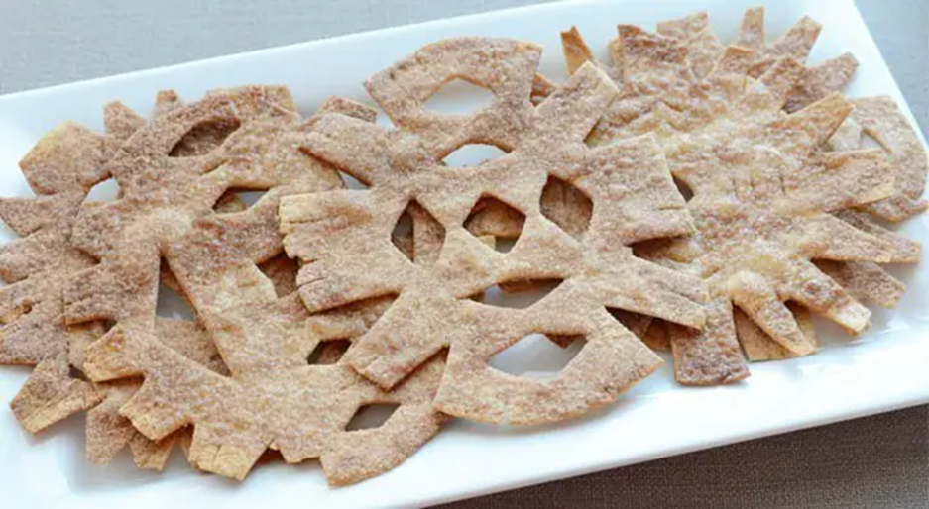
Cinnamon sugar snowflakes/ Jill Dubien

