Four Seasons
Did you know there are four seasons in a year?

Each year, Earth goes through the seasons of Spring, Summer, Fall and Winter.

Why does the Earth change seasons?
Spring Summer Fall Winter

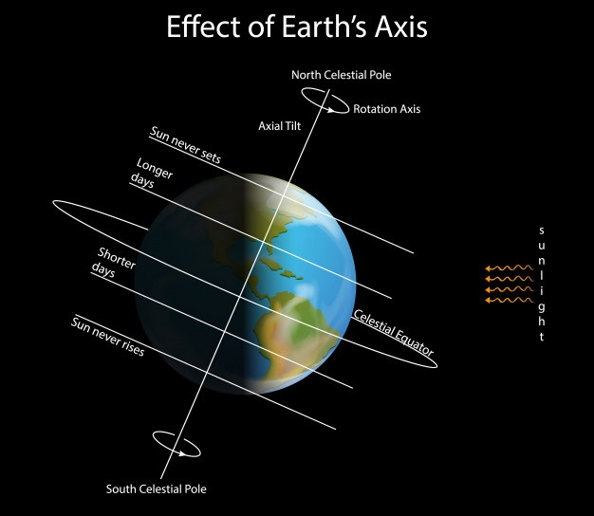
The reason seasons change is because Earth tilts, the same way you might if you tried to walk in snow and ice with flip flops.

This “tilt” means different places around our planet get more sunlight than others depending on the time of year; making it hotter or colder!

When it is Winter for America in December it is Summer for other places, like Australia!

