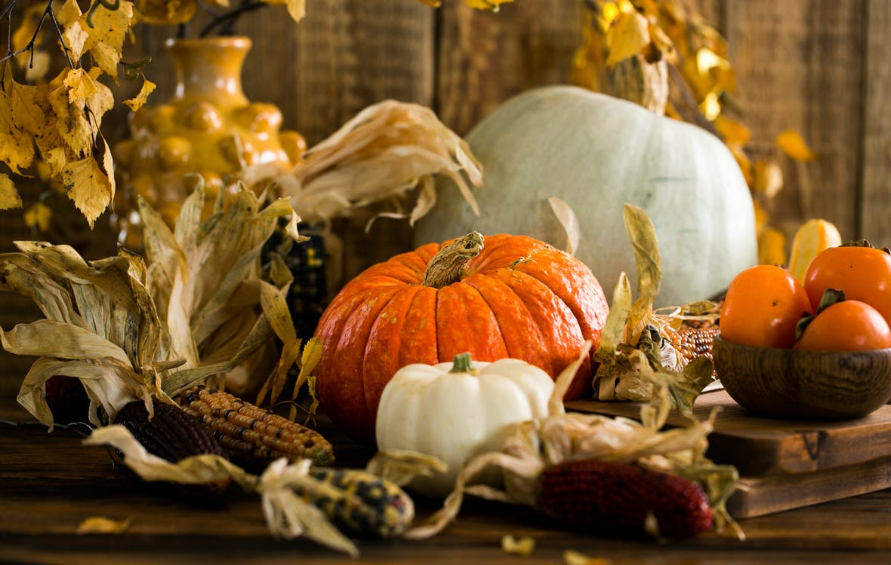
Season:
Autumn, or Fall.
In the United States, Autumn, or Fall, because it is the time when leaves fall,
begins in September
and ends
in December.
The start of this season brings to our skies the Harvest Moon.

Pumpkins On a Table by: A. Tukhfatullina

The Harvest Moon is considered to be an astronomical wonder.
- Astronomical means having to do with space.

The National Aeronautical and Space Administration, or NASA for short, created a very interesting YouTube Video explaining the science of the Harvest Moon.

- Aeronautical means the science of flight.

Did you know that NASA is also where the astronauts work?

We encourage you to watch the video, so the story you will hear later, read by a grown up, will make more sense.

The Science of the Harvest Moon: https://www.youtube.com/watch?v=2M9dMX-P0b8

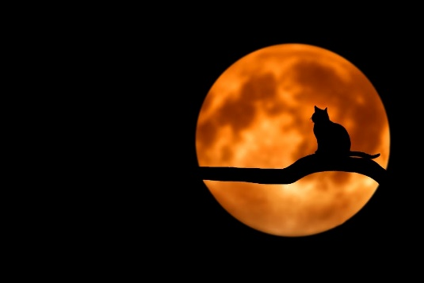
Now that the science of the Harvest Moon has been explained to you, we found a story titled:
“Hello, Harvest Moon”
By: Ralph Fletcher and Illustrated by: Kate Kiesler
We are certain you will enjoy:
https://www.youtube.com/watch?v=5Sziy56YOfo
Photography of Cat at Full Moon

