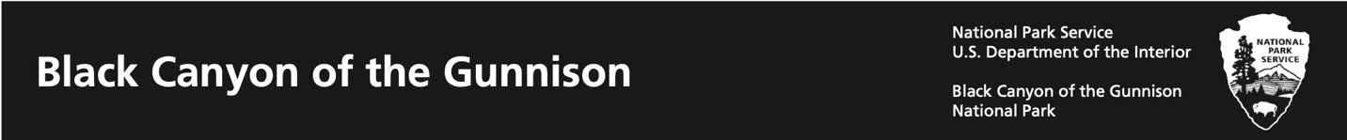

All about National Parks: Make your own Arrowhead

Park rangers keep animals, plants, land, and water safe in our national parks. Look at the National Park Service symbol. Choose what wild animals, plants, land, and water you care about keeping safe and draw those things inside the outline to create your own symbol!
