# Ellis Island Expedition Series Teacher Guide

This guide was created to help teachers get the most out of the five parts of the Ellis Island Expedition Series in their classrooms. The videos and lessons are targeted at upper elementary students but can be easily modified for use with higher grades. *Please feel free to edit and reproduce any of the content in this guide to fit your classroom needs.*

## Learning Objectives

* Students will:
  + Develop an understanding of the concept of immigration
  + Read for detail
  + Compare and contrast the daily life of the past with the present
  + Develop oral history writing skills and conduct student interviews

## Materials Needed:

1. Ellis Island Expedition Series Videos: <https://www.nps.gov/elis/learn/education/eie-series.htm>
2. Copies of student pages or access to online versions (*one per student*):
   1. Inspection Card
   2. Observe and Inspect Observation Sheet
   3. Blank paper for writing a letter “back home”
   4. Crossword Puzzle & Clues
3. Access to class information for students (*one per group*):
   1. Meet the Family Stories
   2. List of Popular Names by Home Country
   3. List of Occupations
   4. List of Push Factors
   5. Location Cards
4. Collection of various objects for sensory activity (Video 3 Activity)

## Navigate this Document

This document can be easily navigated by pressing Ctrl + F to open in the Navigation panel, then click on “Headings,” which will bring up all sections of the document. Click on a heading to move to that spot in the guide.

## Contact Information:

Statue of Liberty National Monument and Ellis Island Education Team

[stli_education_department@nps.gov](mailto:stli_education_department@nps.gov)

(646) 346-2180

## Pre-video Activity

We created these activities were created to help students understand the Ellis Island period, between 1892 and 1924.

### Meet the Family

This activity will help students understand what life was like during the Ellis Island era, and what it was like for children who immigrated during this time. This era was just before electricity, cars, and child labor laws would become common. Technology significantly different, and children often contributed to the income of the family.

Three of these stories are about families on the verge of immigrating to the United States and come from the three countries with the highest number of immigrants that passed through Ellis Island: Italy, Russia, and Austria-Hungary. You might choose to explain to students that Austria-Hungary is no longer a country.

Two of these stories are about children living their daily lives in the United States. One family immigrated long before Ellis Island was an immigration station and is set on a rural farm. The other family recently immigrated and lives in New York City.

Activity Instructions:

1. There are five stories. Break up the class into five groups and assign one story to each group.
2. After the groups have had a chance to read the story, discuss what they think was similar or different to their own lives.
3. Have a reporter from each group share a summary and the major points of these short stories.
4. Ask a few students from other groups to share their reactions to the story.
5. As a class, discuss how different life would be during the Ellis Island era.

#### Meet the Rossi Family

The Rossi family immigrated from Italy in 1907.

The Rossi family lived together in a small cottage on the edge of a small town in Italy. Two young boys and two older girls shared this small space with their parents, where there were only three beds. The two boys shared a bed and the two girls shared one as well. The city that they lived in was by a lake and they knew all of their neighbors. Everyone in the city was very poor.

Mom was the only person in the family with a job. She worked in a garment (clothing) factory, sewing together the long sleeves to the body of elegant pink dresses. The work was very difficult, and her eyes were very tired from ensuring that the stitching was correct. Mom worked ten hours a day, every day, but earned little money. Mom worked very hard but did not make enough to buy enough food. The four children ate potatoes and radishes daily, and everyone often fought over the leftover slices of bread and butter.

However, mom had been saving money for years. Today, she tells the kids that she has saved enough money to buy steamship tickets for the family to immigrate to the United States!

“We are going to America!” mom yells. “There will be lots of opportunities in the new country and we will be able to make more money. They say that you can make more money working in clothing factories there.”

“One catch,” mom says. “We have to leave today.”

#### Meet the Sokolov Family

The Sokolov Family immigrated from Russia in 1903.

Rachel heard that the soldiers were approaching from the nearby mountaintops.

“The soldiers are coming!” she shouts to her sister. She heard that the soldiers were approaching from the nearby mountaintops.

Neighbors had warned the Sokolov family about a war for months. The children of the family had heard whispers at the grocery store, in the classroom, and even in the synagogue where the family worships. Now, the soldiers are nearby.

Dad heard about what to do in case of war from his work at the tanning factory. Several days ago, the owner said they would stop making leather goods until the fighting is over. The neighbors next door, the Ivanov’s, have stayed with the Sokolov family to listen to updates on the radio. But they rarely heard anything. The broadcasts often gave off a lot of muffled sounds like “shhhhss” and “krrrrrs.”

Thankfully, the Sokolov family had prepared to move for months. Mom has purchased five steerage-class tickets on the steamship, the U.S.S. Oceania. With the soldiers nearby, there is not much time for the family to pack.

The children’s parents have allowed them to bring only one item to the United States. Abraham, the youngest boy, has brought a one-eyed brown teddy bear with dark blue suspenders. (The other eye had been lost in a push-and-pull struggle when he snatched it from his sister’s hands). Rachel decides to keep a family photograph with their large gray stone house in the background. Isaak is going to bring a journal.

“Hurry, we have to leave tonight to avoid the soldiers,” mom says. “Also, be patient. We need to travel three days to reach our ship.”

#### Meet the Tóth Family

The Tóth Family immigrated from Austria-Hungary in 1916.

Jazmin could recognize her mother only by the faded photograph. The dark lipstick, the auburn hair tucked in a bun, and the flower dress she wore in the photo is the only way she can now picture her in her mind.

It has been nine years since mother and daughter have been together. Jazmin will never forget the last time she saw her. She gave her a firm hug, brushed her hair back and told her “things will get better.”

Her mother had immigrated to the United States years earlier to earn more money for the family. She shared a tenement apartment with Jazmin’s aunt and devoted her time to working as a milliner (someone who makes women’s hats) at a nearby department store. Her mother wrote her letters often, sharing the new English words she learned at the hat store. “A greenhorn,” she explains “is someone who has just arrived in America. Do not act like a greenhorn.”

The letters arrived at the General Store the last Thursday of every month. Mr. Nagy, the owner, informed Jazmin’s father of any time a new package was delivered. When the parcel reaches the house, Jazmin and your two brothers, Máté and Adam, typically scramble to the front, delicately ripping the package to see what their mother had sent. She often sent clothing, a photograph or two, along with a letter describing her time in America. The children miss their mother greatly and wonder when they will be able to see her in person.

As Adam rips the wrapping, they all notice that this package looks different. The box looks much smaller. As Adam gets to the end, they see only a letter and four fancy wrapped pieces of paper, and they realize inside are steamship tickets!

#### Meet the Johnson Family

The Johnson Family immigrated to the United States in the early 1800s, and had a boy, William, who was 10 years old in 1916, when this story takes place.

William was 10 years old in 1916 and lived in Kentucky.

Even at a young age, he had a lot of responsibilities on the family farm, where they had cows, horses, and grew corn on rented land. Every morning, William gets up early to feed and milk the cows. Then, he turns the cows out to the pasture and carries the milk back to the small family kitchen. Then he checks on the firewood supply, to make sure that his mother has enough wood to cook and heat the house for the day. He does this all before eating breakfast and getting ready to leave for the three-mile-long walk to school.

William goes to school in one-room schoolhouse, and his 18 classmates range in age from kindergarten to eighth grade. Some of William’s classmates miss a lot of class in the fall and spring, when they are needed on their family’s farm for planting and harvesting, but William’s parents make sure that he can get to school as much as possible. After a day of learning, he starts the three-mile walk and gets back home around four in the afternoon.

When William returns home, it’s time to milk the cows again. Then he feeds the horses and cuts more firewood to ensure enough wood for a cold night and cook breakfast the next day. Sometimes he goes to his father’s blacksmith shop to watch him work, and sometimes the family has the weekly farm paper to read. William’s favorite nights are when his father puts a record on the Victrola, a record player that plays music out of what looks like a big horn. The family was able to buy about one new record a year.

By the end of the day, William is usually so tired that he falls asleep as soon as his head hits the pillow. Tomorrow is another school day and he’s going to get up and do it all over again!

#### Meet the Cohen Family

The Cohen family immigrated to the United States in 1892, and have a daughter, Ruth, who was ten years old in 1895. The family lived in New York City.

Ruth wakes up early and helps her older sister light the coal stove in the kitchen in their New York City apartment. It takes nearly an hour for the stove to be hot enough to make the family’s breakfast, so she gets some morning chores done while it’s heating. Later in the morning, the apartment will turn into a factory. A worker will use the coal from the stove to heat an iron the rest of the day, and it will be scorching hot -- the space will quickly reach 100 degrees.

Ruth works at her family sweatshop with her mother, father, sister, and an employee her father hired. The employee is 16 years old and frequently talks about missing her home in Russia. Ruth spends her time as a finisher, sewing decorations onto the sleeves and collars of fancy dresses. Rolls of fabric in bright pink, purple, and red arrive every Thursday. The work is hard. Ruth works ten hours a day, six days a week. Her hands hurt and her eyes are tired every night from looking at the tiny stiches she makes. Ruth also works next to her father, who operates the sewing machine. She knows to be extremely careful – a prick of a needle might produce small drops of blood that can ruin a new dress.

Ruth notices that children her age attend school nearby, but her family needs her to work. Ruth wishes she could play hop-scotch or other street games in the afternoon, and daydreams of one day “going uptown.” Her family celebrates the Sabbath, the religious holiday, every Saturday. Ruth looks forward to this day the most – she knows that her mom will give her sweet treats after morning prayer. She will also be able to see her neighbors, especially her friend Elly, and can spend the afternoon playing on the swings at a nearby park.

## Video 1 Activity

This activity will help students follow along with the immigration process. Some teachers have students pretend to be their immigrant characters; some even have them dress up. However, you can also simply have them create a character and follow along.

### Create Your Immigrant Character (Part 1)

For this activity, students will fill out part of their inspection cards and write two short answers based on some of the options they choose for their character. You can have students work in groups, or you can have students work independently. If you decide to have students in groups, they will need to make decisions as a group.

1. After watching Video 1, each student should receive an **Inspection Card**. There should be at least 3 groups of students, each assigned to one of the home countries: Austria Hungary, Italy, or Russia. There can be more than one group for each country.
2. Fill out the **home country** space and use the **list of popular names** to find a first and last name from the group’s home country. Add the **name** to the inspection card.
3. Next, use the **occupation list** to select a job for the immigrant’s parents.
4. Complete the **age** and **year of arrival** (must be between 1892-1924). Leave the rest of the spaces blank for now.

### Occupations (Inspection Card Activity Part 1)

**Laborer:** usually working in a factory, mine, or farm. These jobs were easy to find and keep but did not pay high wages.

**Farmer:** a farm owner would need to save extra money to be able to buy land, and it was not guaranteed to be successful. There was a higher risk, but you would make more money than a laborer.

**Business owner:** like buying a farm, starting a business required saving more money. There was also ahigh risk in starting a business, it might fail, but you could also earn a lot more money if it is successful.

**Construction worker:** Construction jobs are easy to find, but you had to have serious skills to make a lot of money. Immigrants who had special skills, l;ike stone carving and detailed carpentry could earn very high wages. Low risk, but you only get big rewards if you have special skills.

**Domestic worker (housekeeper):** Domestic work was relatively easy to find but did not have very high wages. Domestic work and factory work were often the only jobs women were able to get. Low risk and low reward, but for many immigrant women it was their only option.

### Popular Names by Home Country

**Austria Hungary**

*Popular girl’s names*

* Jazmin
* Anna
* Hanna
* Nora
* Zsófia
* Lili
* Reka
* Viktoria

*Popular boy’s names*

* Bence
* Máté
* Levente
* David
* Adam
* Peter
* Dominik
* Ambrus

*Popular surnames*

* Nagy
* Kovács
* Tóth
* Szabó
* Varga
* Kiss
* Németh
* Farkas

**Italy**

*Popular girl’s names*

* Sofia
* Giulia
* Giorgia
* Sara
* Emma
* Aurora
* Alessia
* Chiara

*Popular boy’s names*

* Francesco
* Alessandro
* Lorenzo
* Matteo
* Gabriele
* Mattia
* Davide
* Riccardo

*Popular surnames*

* Rossi
* Ferrari
* Esposito
* Bianchi
* Romano
* Colombo
* Ricci
* Marino

**Russia**

*Popular girl’s names*

* Danil
* Artyom
* Ivan
* Alexandr
* Kiryl
* Dmitry
* Andrei
* Mikhail

*Popular boy’s names*

* Anastasiya
* Daria
* Polina
* Elizaveta
* Anna
* Viktoria
* Valeria
* Alissa

*Popular surnames*

* Ivanov
* Kuznetsov
* Popov
* Sokolov
* Lebedev
* Kozlov
* Novikov
* Morozov

### Student Inspection Card

|  |  |
| --- | --- |
| **Pg ____ Line____ Name:** |  |
| **Age:** |  |
| **Year of Arrival:** |  |
| **Country of Origin:** |  |
| **Occupation (Parent’s)** |  |
| **Destination:** |  |
| **Family Members (Name, Age, Relationship)** |  |
| **Reasons for Coming to the United States:** |  |

|  |  |
| --- | --- |
| **Pg ____ Line____ Name:** |  |
| **Age:** |  |
| **Year of Arrival:** |  |
| **Country of Origin:** |  |
| **Occupation (Parent’s)** |  |
| **Destination:** |  |
| **Family Members (Name, Age, Relationship)** |  |
| **Reasons for Coming to the United States:** |  |

## Video 2 Activity

### Create Your Immigrant Character (Part 2)

Activity Instructions:

1. Assign each group a **location card** and have them read it together.
2. Groups come up with a brief pitch to persuade the class that they should move to their location. Groups select one person to share out their location with the class.
3. Have each group share their brief presentation to the class. Students decide as a class, by group, or individually where to settle.
4. After students pick a location, add it to the **destination** field on the **inspection card**.
5. Ask students what they have learned about push factors so far. Have them recall what they learned in Video 2 and Meet the Family stories
6. Fill out the **Reasons for Coming to the United States** field on the inspection cards.
7. Keep the inspection cards ready to use for an activity after video 4.

### Push Factors: Reasons for Leaving the Home Country

**War or corrupt government:** World War I was fought mainly in Europe and impacted many regions across the continent.

**Lack of food due to disease, drought, or other disasters:** Some farmers were unable to grow enough crops if there was not a lot of land available to them, and sometimes the land they did have was worn out and no longer produced as many crops as it once could.

**Religious persecution:** Certain groups of people, like Jewish Russians, were persecuted for their beliefs and fled their home countries to find a place where they felt safe.

**Not enough jobs or wages too low:** The Industrial Revolution meant that many workers lost their jobs to machines. There were fewer jobs available, and the jobs they could find didn’t pay well.

**Large natural disasters:** In 1908, an earthquake that would have measured 7.5 on the Richter scale was the most destructive earthquake ever to hit Europe. Entire villages were lost, mostly in southern Italy. Many people left after their jobs, food, and homes were destroyed.

### Location Cards

#### Location Card 1: Cincinnati, Ohio

**CINCINNATI, OHIO**

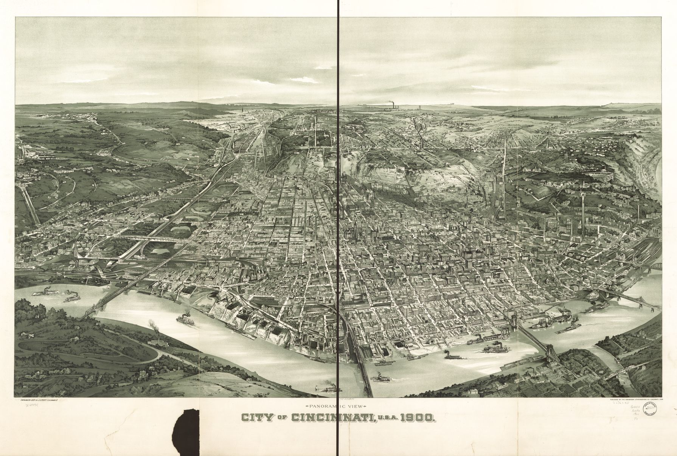

Image courtesy of the Library of Congress

**LIVE IN CINCINNATI!**

**One of the world’s fastest growing cities**

**Plenty of jobs on the waterfront of the Ohio River & butcher shops**

**Train fare $18 per ticket**

**Ride to work on the streetcar**

**Great views of the Ohio River**

**Large German and Irish communities**

#### Location Card 2: Omaha, Nebraska

**OMAHA, NEBRASKA**

Historical painting of two men and a woman spreading hay from a cart pulled by two horses next to a small stream. In the background are large trees, more livestock, and people under a cloudy and dark sky. 

Image courtesy of the Library of Congress

**COME TO OMAHA!**

**Best wages in the country**

**Plenty of Jobs available**

**Farmers needed**

**Plenty of land available for farming, with plots for large houses**

**Train fare $32 per ticket**

**Growing Swedish community**

#### Location Card 3: Chicago, Illinois

**CHICAGO, ILLINOIS**

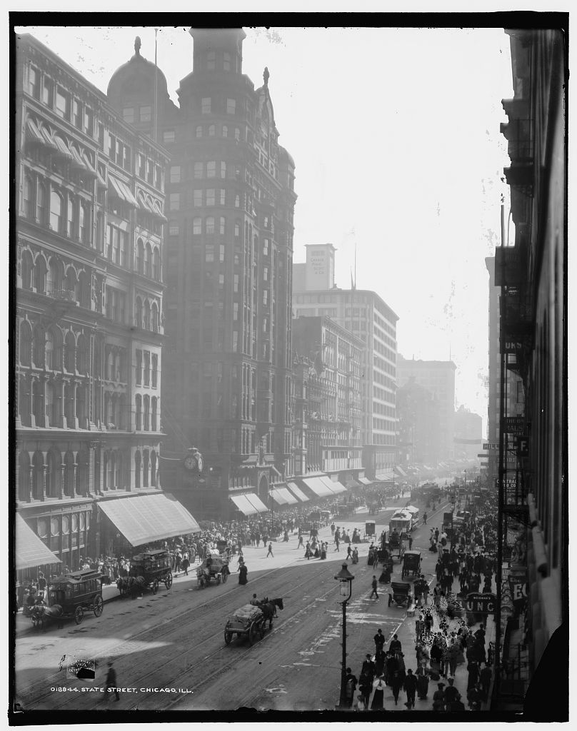

Image courtesy of the Library of Congress

**MOVE TO CHICAGO!**

**Be close to your neighbors, groceries, and restaurants**

**Cheap apartments available, great for new immigrants**

**Jobs available in garment and meatpacking factories**

**Many churches and synagogues, all close by**

**Train fare $25 per ticket**

**Vibrant Russian and Polish communities**

## Video 3 Activity

Medical inspectors on Ellis Island had just six seconds to look at each immigrant and decide if they were healthy. For the activity, you can use many different objects to create sensory activities that allow students to use multiple senses to make observations. You can get very creative with this flexible activity!

### Observe and Inspect Activity Instructions

1. Gather different objects available to you that appeal to different senses, and have students make observations about them. Below are ideas of what you can use, but you do not have to include objects for all the senses listed.
   1. Touch: find items that are safe to touch with different textures; soft, fuzzy, rough, smooth, wet, dry, crunchy. Hide the items inside a box so the students only make observations on how items *feel*.
   2. Hearing: find recordings of different sounds. It’s easy to search online for videos, but don’t show any visuals. Try searching bird calls, ocean sounds, vehicles, footsteps, and foley artists. Foley artists make sound effects for film, TV, and video games.
   3. Sight: visual activities such as “spot the difference” or a hidden object search can be useful in this sense. You could also have them make observations of photos, paintings, or even a physical place on campus.
   4. Smell: be sure to use non-allergenic items that are safe for your students. Try coffee grounds, unlit candles, fruit peels, and gentle essential oils. Put the items in an opaque container and either poke small holes in the lid or cover them with a dark stocking.
   5. Taste: due to safety concerns, you may choose to have students use their lunch for this sense. Have them record observations for one or two of their lunch items.
2. Have students make observations at each of the sensory stations you choose to include.
3. You may also include a brief physical challenge, and even a mental challenge, like a puzzle or riddle. Explain that some immigrants (about 10%) might have had to prove their physically and mentally healthy.
4. Discuss what students observed and how students think inspectors used their senses to look for medical conditions.

### Observe and Inspect Observation Sheet

Name _________________________

Write observations for each station below:

|  |  |
| --- | --- |
| Touch |  |
| Hearing |  |
| Sight |  |
| Smell |  |
| Taste |  |

## Video 4 Activity

The legal inspection used the ship’s passenger manifest to quiz immigrants about their background and plans in the United States. Students will use their inspection cards to create a class manifest of their immigrant characters for this activity.

### Immigrant Interviews

1. Print enough **Class Manifest** pages to fit your class, each page has ten spaces. Prepare the manifest pages and number the pages in the top left corner that has “**Pg#**.”
2. You can have students fill out the manifest by passing it around, or you can have designated recorders to take down students’ information.
3. Instruct students to get the page and line number where their information was recorded and add it to their inspection card. This will be important if you choose to have them conduct student interviews.
4. Once manifests are complete, students can interview one another in a mock legal inspection. You can break-out groups into smaller than 10 by making copies of the manifests – just be sure that groups have the correct pages for the students they are interviewing.
5. Students should be able to easily find each “immigrant’s” information by using the page and line number on the student’s inspection cards. After they have found the students page and line number, they should ask:
   1. What is your name?
   2. How old are you?
   3. What is your home country?
   4. Where will you be going to live in the United States?
   5. Why did you and your family come to the United States?
   6. What job will you (or your parents) be doing to earn money?
6. Students should be able to answer these questions based on their inspection cards.
7. You can give students stickers or stamps to place on their inspection cards after they have passed their “legal inspection.”

### Class Manifest

|  |  |  |  |  |  |  |
| --- | --- | --- | --- | --- | --- | --- |
| **Pg#** | Passenger | Age | Country of Origin | Destination | Reason for coming to U.S. | Job in America |
| 1 |  |  |  |  |  |  |
| 2 |  |  |  |  |  |  |
| 3 |  |  |  |  |  |  |
| 4 |  |  |  |  |  |  |
| 5 |  |  |  |  |  |  |
| 6 |  |  |  |  |  |  |
| 7 |  |  |  |  |  |  |
| 8 |  |  |  |  |  |  |
| 9 |  |  |  |  |  |  |
| 10 |  |  |  |  |  |  |

## Video 5 Activity

For this activity, students will write a letter to their relatives in their home country. Work with students to help them think about how they might feel if they were an immigrant in the Ellis Island era. Remind them that they would not be able to call them, and letters would be the only form of communication.

### Writing the Folks Back Home Activity Instructions

1. Have students close their eyes and imagine what they might feel if they were an immigrant in the Ellis Island era. Remind them of the limitations of technology and that they would only be able to communicate through letters. Ask them if they might miss cousins and friends back home. Would they miss the customs and food? Would it be hard to learn a new language?
2. Show students the following writing prompt, and if necessary, give them a length requirement based on your classroom needs.

### “Writing the Folks Back Home” Prompt

You have settled in your new community, and you or your parents have started to work. You are going to write a letter to someone back in their home country.

Describe the transatlantic journey, and how they felt during the inspection at Ellis Island.

Imagine what you might be excited about in your new home and try to think about some things that may be difficult to adjust to when you move to a new place. Did you meet a new neighbor or classmate? Have you made friends with people from the home country that also immigrated to the United States?

Think about what the family member would be curious about, and what you would want them to know about your new life. Be sure to incorporate any sights, sounds, and smells into your journal Be as creative as possible.

## Post-video Activity

### Ellis Island Expedition Series Vocabulary Crossword Puzzle

Note: some of the answers to the crossword puzzle are two words. When this is the case, there is no space between words. There is also a word bank below the crossword puzzle – feel free to include it with the student’s pages or take it off.

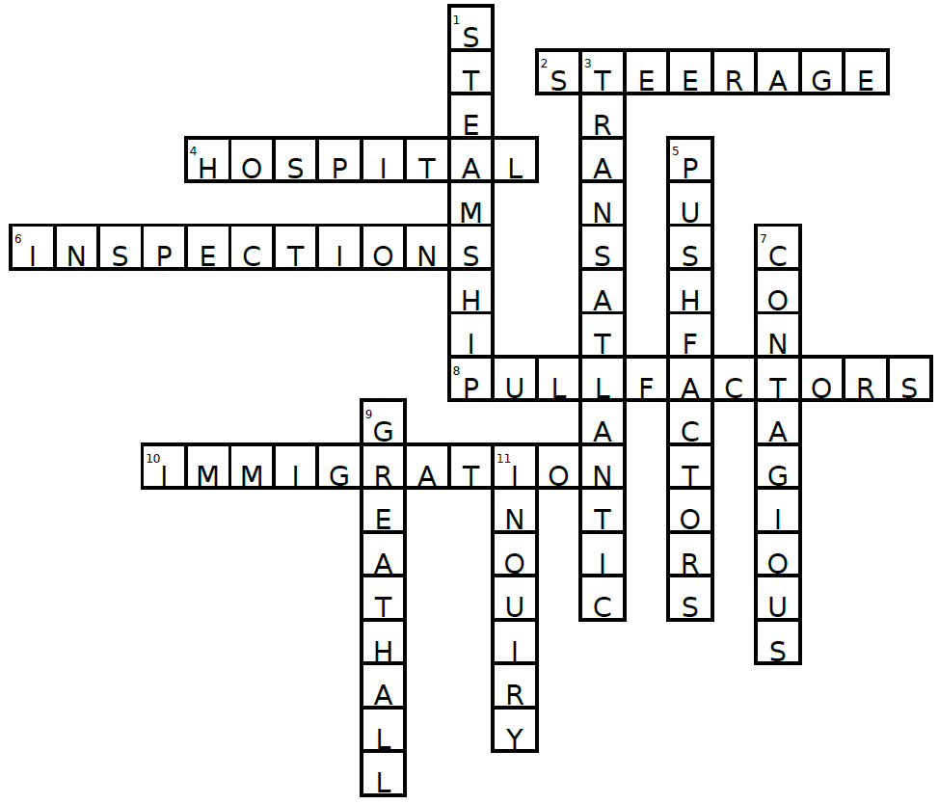

**Down:** 1 STEAMSHIP, 3 TRANSATLANTIC, 5 PUSH FACTORS, 7 CONTAGIOUS, 9 GREAT HALL, 11 INQUIRY

**Across:** 2 STEERAGE, 4 HOSPITAL, 6 INSPECTIONS, 8 PULL FACTORS, 10 IMMIGRATION



**Word Bank:**

IMMIGRATION

GREAT HALL

INQUIRY

STEERAGE

PUSH FACTORS

PULL FACTORS

TRANSATLANTIC

STEAMSHIP

CONTAGIOUS

HOSPITAL

INSPECTIONS

**Down:**

1. The method of transportation that most immigrants used to travel to the United States during the Ellis Island era.

3. Most Ellis Island immigrants arrived in the New York Harbor after a ______________ journey.

5. ____________________ are the reasons that people choose to leave their home country. (two words)

7. If you had a _________________ disease that can be passed from person to person, you would not be allowed to enter the United States right away.

9. Immigrants spend most of their time on Ellis Island waiting in the ____________________. (two words)

11. Immigrants had a chance to explain themselves in a Board of Special _____________ hearing if they did not pass their legal inspection right away.

**Across:**

2. Immigrants that were processed on Ellis Island had this kind of steamship ticket.

4. If you arrived in the New York Harbor with an illness, you would have a chance to recover at the Ellis Island _____________.

6. In order to enter the United States immigrants had to pass the medial and legal ________________.

8. ____________________ are things that immigrants look for when choosing a new country to live in. (two words)

10. The process of moving from one country to another.

## Alternate Lesson Ideas

### Immigrant Research Projects

* Have students interview an immigrant in their community about their immigration experience. You can include sections about:
  + Push Factors: why did this person choose to leave their home country?
  + Pull Factors: why did this person select the United States as their new home country?
  + The process: how long did it take, and what were some of the steps?
  + Comparison: have the student compare their interviewee’s experience to that of Ellis Island immigrants.
* Have students research the life of an Ellis Island immigrant.
  + Oral history library: <https://heritage.statueofliberty.org/oral-history-library>
  + Famous Ellis Island immigrants: there are many famous Ellis Island immigrants that can be found through simple internet searches.
  + Have students research potential push factors from the immigrant’s home country at the time of their immigration, and what brought those immigrants to the United States.
* Students could also compare the experiences of Angel Island immigrants to those of Ellis Island immigrants. There were more restrictions placed on immigrants coming from Asia, so many immigrants arriving to Angel Island on the shores of California were impacted, as immigrants from Asia were likely to land there rather than Ellis Island in the New York Harbor.

### Field Trip to Ellis Island

Below are some tips and ideas for groups that can visit Ellis Island in person.

1. Please be advised that there is a requirement of a ratio of 1 chaperone per 10 children under 18 years of age, which is strongly enforced. *Students must remain with an adult for the entire duration of their visit to the park.*
2. Book your tickets on the official ferry website: <https://www.cityexperiences.com/new-york/city-cruises/statue/>
   1. Click on the “**GROUPS & TOUR OPERATORS**” tab to find out more information about brining a large group to the site.
   2. Note that you can begin your visit from Battery Park in New York City, NY or Liberty State Park in Jersey City, NJ. Boats from NYC go to the Statue of Liberty first, boats from Jersey City go to Ellis Island first.
   3. Both security sites will require all visitors to go through airport-style security, so be sure to leave plenty of time for that when you arrive.
   4. Plan how much time you will spend on each island by looking carefully at the ferry schedule for each island. Note that the times listed are departure times, so arrive to each dock a little early. Plan meeting spots and boat times.
3. Plan your visit:
   1. For alerts, accessibility information, and more, check out the official websites.
      1. Statue of Liberty: [www.nps.gov/stli](http://www.nps.gov/stli)
      2. Ellis Island: [www.nps.gov/elis](http://www.nps.gov/elis)
   2. There is a café on each island, with plenty of space to eat outdoors, but beware of hungry birds (please do not allow anyone to feed them). Indoor dining space is limited and first come, first served.
   3. More education resources and field trip plans are available on our website: <https://www.nps.gov/elis/learn/education/classrooms/fieldtrips.htm>
4. Know the layout.
   1. The first floor of the Ellis Island National Museum of Immigration cover eras of migration before and after the Ellis Island time periods. All the Ellis Island content is on the second and third floors.
   2. On the second floor is the Great Hall where immigrants were processed, flanked by two exhibits that go into detail about the Ellis Island Era:
      1. Through America’s Gate: covers the immigration process on Ellis.
      2. Peak Immigration Years: explore what was happening during the largest migration of people in world history.
   3. The third floor provides an incredible view of the Great Hall from the balcony, a restored dormitory room, and three more exhibits about Ellis Island:
      1. Silent Voices/Restoring a Landmark: what happened at Ellis Island after the station was closed and the island abandoned.
      2. Treasures from Home: items brought from home countries.
      3. Ellis Island Chronicles: details the changes on the island and the leaders that shaped policies and procedures of the immigration process.
   4. For more details about the museum layout: <https://www.nps.gov/elis/planyourvisit/exploring-the-ellis-island-museum.htm>

### Primary Source Analysis

Using the “observe, reflect, question” method, student can explore primary sources to sharpen their historical analysis skills with the same method that historical researchers use. You can do a simple image search of “Ellis Island” to find more photos, or even have students find their own primary source. Below is an example of a photo of immigrants being processed in the great hall that would work well for this activity. Then have students make a chart similar to the one under the photo to record their observations, reflections, and questions.

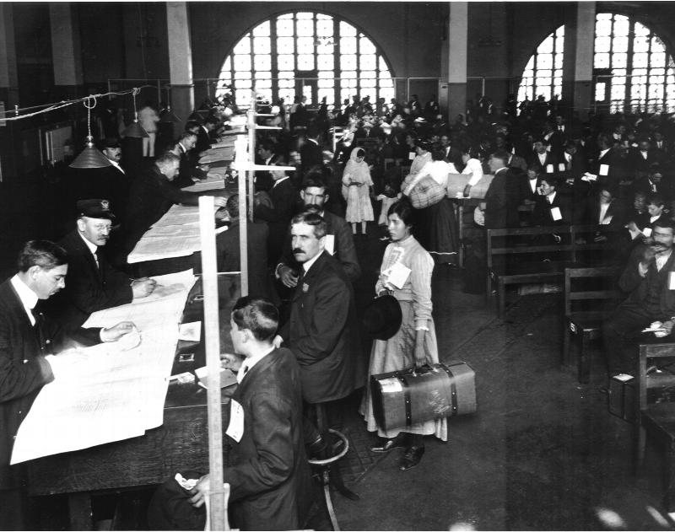

|  |  |  |
| --- | --- | --- |
| Observations | Reflections | Questions |
|  |  |  |
|  |  |  |
|  |  |  |

For more information about leading primary source analysis activities, we recommend resources from the National Archives: <https://www.archives.gov/education/lessons/worksheets> .